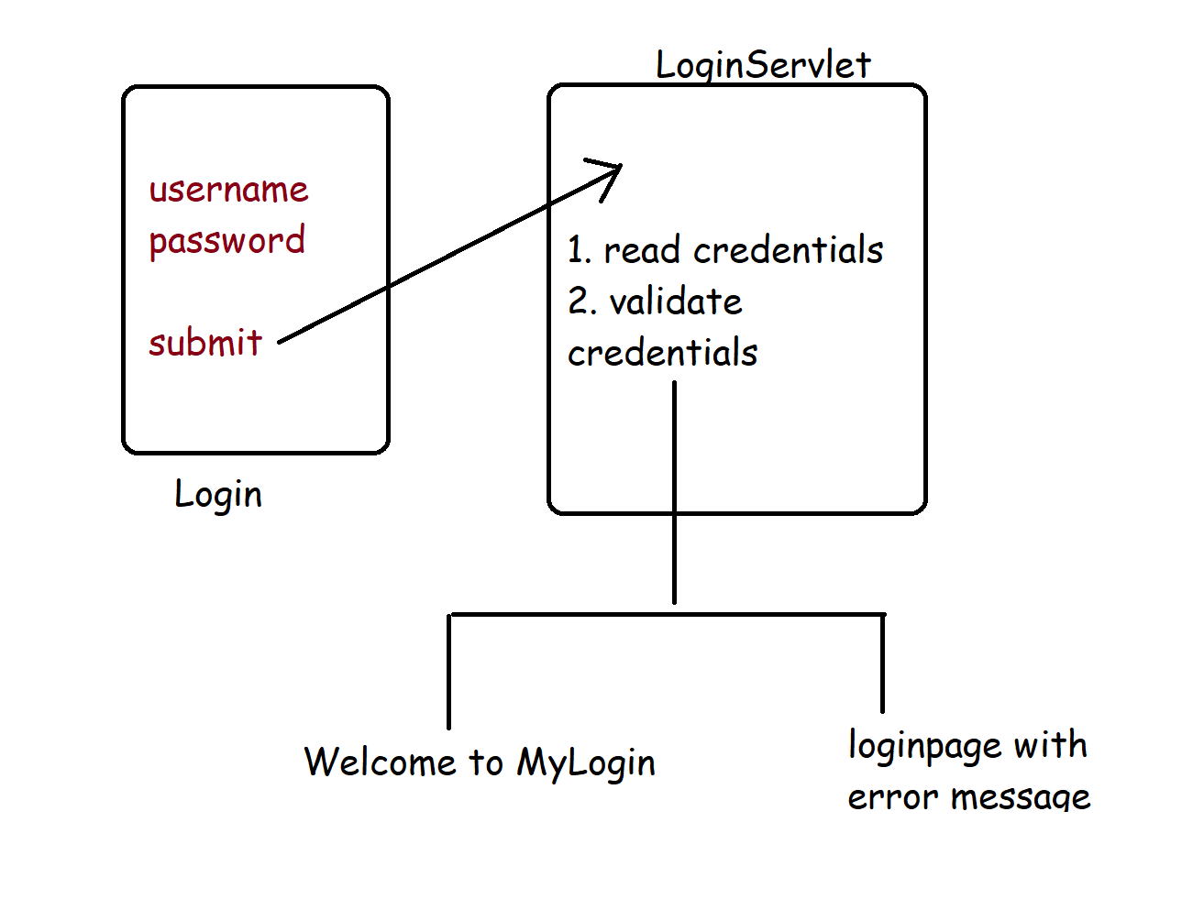

1. HTML Page
2. LoginServlet

Login.html

<!DOCTYPE html>

<html>

<head>

<meta charset=*"ISO-8859-1"*>

<title>Insert title here</title>

</head>

<body>

<div align=*"center"*>

<h1> My Login Page</h1>

<form action=*"login"* method=*"get"*>

Enter User Name : <input type=*"text"* name=*"uname"*/> <br>

Enter Password : <input type=*"password"* name=*"pass"*/> <br>

<input type=*"submit"* value=*"login"*>

</form>

</div>

</body>

</html>

LoginServlet(ServletMapping 🡪 login)

**package** com.sssit.login.servlets;

**import** java.io.IOException;

**import** java.io.PrintWriter;

**import** javax.servlet.RequestDispatcher;

**import** javax.servlet.ServletException;

**import** javax.servlet.http.HttpServlet;

**import** javax.servlet.http.HttpServletRequest;

**import** javax.servlet.http.HttpServletResponse;

/**

* Servlet implementation class LoginServlet

*/

**public** **class** LoginServlet **extends** HttpServlet {

**private** **static** **final** **long** ***serialVersionUID*** = 1L;

/**

* **@see** HttpServlet#HttpServlet()

*/

**public** LoginServlet() {

**super**();

// **TODO** Auto-generated constructor stub

}

/**

* **@see** HttpServlet#service(HttpServletRequest request, HttpServletResponse response)

*/

**protected** **void** service(HttpServletRequest request, HttpServletResponse response) **throws** ServletException, IOException {

// Reading the credentials from HTML

String userName = request.getParameter("uname");

String password = request.getParameter("pass");

PrintWriter pw = response.getWriter();

**if**(userName.equals("user") && password.equals("pass"))

{

// Generating the Dynamic content

pw.println("Welcome to MyLogin Page....." + userName);

} **else** {

pw.println("<font color=red> Invalid credentials </font>");

RequestDispatcher rd = request.getRequestDispatcher("login.html");

rd.include(request, response);

}

}

}

Check servlet configuration in web.xml

<servlet>

<description></description>

<display-name>LoginServlet</display-name>

<servlet-name>LoginServlet</servlet-name>

<servlet-class>com.sssit.login.servlets.LoginServlet</servlet-class>

</servlet>

<servlet-mapping>

<servlet-name>LoginServlet</servlet-name>

<url-pattern>/login</url-pattern>

</servlet-mapping>

How to transfer the control from one resource to another resource?

In Our Use case, if the credentials are invalid, then the control should transfer from LoginServlet to login.html page with some error

We have a predefined interface called REQUEST DISPATCHER used to transfer the control from once resource to another resource

Two methods:

1. Include 🡪 it should include the response of each and every resource during navigation
2. Forward 🡪 transfer a fresh response object to the another resource