Materialized view

* These are special type of views
* The main difference between normal view and materialized view is if we drop the base table then the normal view becomes invalid where as materialized view won’t be invalid.
* Materialized view stores data.
* We can’t perform DML Operations on Materialized view.

How to create a materialized view from emp1 with all the salesman’s

create materialized view msalesman1 as select * from emp1 where job like 'SALESMAN';

PL-SQL

Procedural Language in SQL is called PL-SQL

This is used to write the customized programs

How to write a PL-SQL program?

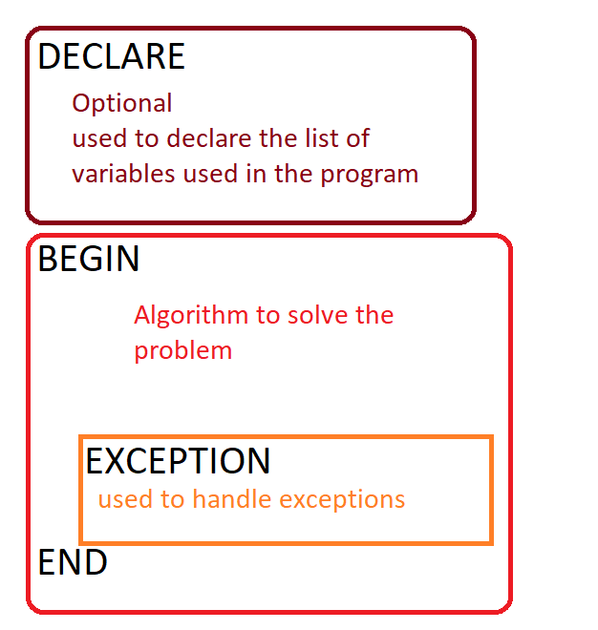

When ever we opened a new sql client window to execute the PL-SQL programs, we must mark the set server output flag as TRUE. Otherwise the PL-SQL won’t display’s any output message.

begin

dbms_output.put_line('Hello World');

end;

/

(2) Write a PL-SQL program that accepts the name and display’s Hello followed by name

declare

uname varchar2(10);

begin

uname:='&uname';

dbms_output.put_line('Hello...' || uname);

end;

/