|  |  |  |
| --- | --- | --- |
| DCL – Data Security and Privileges Language | | |
| All these queries are used to add or remove privileges to the user | | |
| 1. | grant | Add or provide the privileges to the user |
| 2 | revoke | Remove the added privileges to the user |

1. Create a New user called OrclAug23 with the password OrclAug23

Step 1: login into SQL with Admin credentials

Step 2: use the below command to create a new user

CREATE USER OrclAug23 IDENTIFIED BY OrclAug23

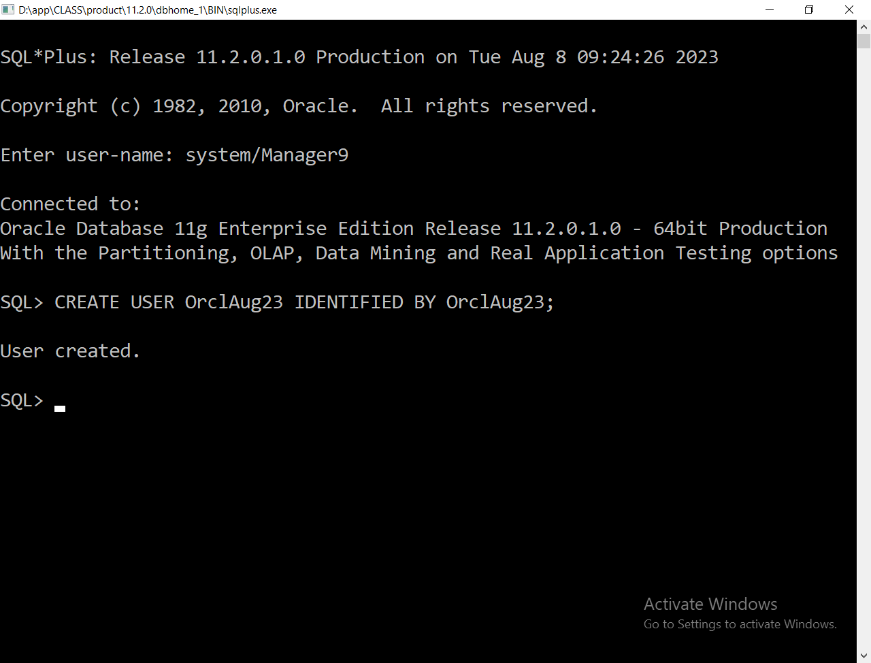

How to navigate between any two users?

CONN or CONNECT query is used to navigate between any two users

Ex: CONN OrclAug23/OrclAug23

How to know the current user name?

SHOW USER is used to retrieve the current user name

Ex: SHOW USER

How to Add the resources and privileges to the created user?

GRANT is used to add the required resources and privileges

Ex: GRANT ALL PRIVILEGES, RESOURCE TO OrclAug23

How to revoke the privileges from the user?

Step 1: login to Administrator

Step 2: use REVOKE query

Ex: revoke all privileges from orclaug23;

Basic SQL Queries

1. Create table
2. Insert query
3. Select query

Create a table called login with the below columns:

Username 🡪 string

Password 🡪 string

CREATE TABLE login(

username varchar2(10),

passwd varchar2(10)

);

How to insert the data into a table?

INSERT query is used to insert a new row into the table

insert into login values('user1','pass1');

insert into login values('pass2','user2');

How to retrieve the data from Table?

SELECT query is used to retrieve the rows from the table

Screen Shots

