

Used to retrieve the complete table information (All Rows)

* 🡪 consider all the columns present in the table

Columns-list 🡪 used to specify the required columns in the result set

Q) SQL Query to retreive the list of countries

select distinct country from customers;

Q) SQL to retreive the customer_id and county from customers

select customer_id,country from customers;

Q) SQL to retreive customer_id, firstname, lastname, billamount from customers.

select customer_id,first_name,last_name, bill_amount from customers;

Q) SQL to retreive the first name and last name as Customer name from customers table

select first_name ||' '||last_name AS customer_name from customers;

-- OR --

select first_name ||' '||last_name "customer_name" from customers;

-- OR ---

select first_name ||' '||last_name customer_name from customers;

Aggregate functions

1. sum() --> add the values of every row present in the column

2. avg() --> average value of the column

3. max()

4. min()

5. count()

Q) SQL Query to find the total bill amout paid by all customers

select sum(bill_amount) "Total sales" from customers;

Q) SQL Query to find the number of customers who paid the bill

select count(bill_amount) from customers;

count(bill_amount) considers or counts all the rows that contains not null value in the column called bill_amount

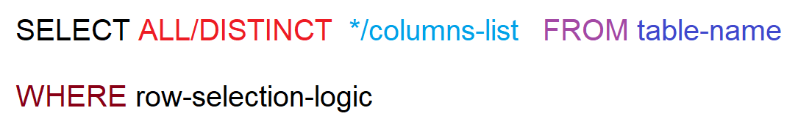

Where clause in the select query or update query or delete query is used to filter the rows present in the table

We can frame the selection logic using below operators:

1. = 🡪 used to fetch the exact row from the table