DML Operations

* Used to manipulate the data
* Different operations are:
  + Create a new data
  + Modify the existing data
  + Remove the existing data

The below are list of queries under DML:

* insert
* update
* delete

Insert Query

* Is used to insert a new row into the table
* We have two different formats of Insert query:

First format:

* User should provide the values to all the columns defined in the table.
* While giving the values, the user should maintain the order of columns defined in the table



Q) Write a SQL query to insert new student information

insert into student values(101,'Ravi','01-Jan-80',250,'M');

insert into student values(102,'Rajitha','01-Feb-85',150,'F');

Second format of insert statement

* It allows to provide the values only to the selected columns. For all unselected columns, the SQL assigns NULL value (empty).
* The user is allowed to define his own order of columns

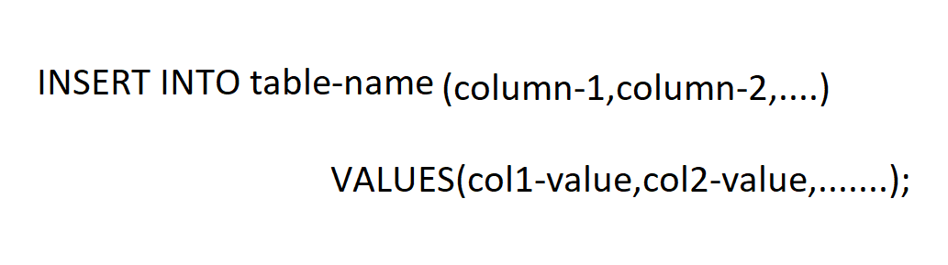

Q) Write a SQL query to insert new student information

insert into student(sname,htno,dob,fees,gender) values('Anil',103,'01-Mar-85',150,'M');

insert into student(htno,sname,dob,fees) values(104,'Kavya','01-Jun-85',150);

Note:

All string and date type of values must be enclosed in single quotes

Update Query

Is used to modify the value of any column(s).

It is available in two different formats:

Format – 1

First format of update query modifies the particular column value in the complete table (effects all the rows present in the table)



Write a SQL query to update the total column with sum of mark1 and mark2 in student table

update student set total=m1+m2

Write a SQL query to update both total and average in student table

update student set total=m1+m2, average=(m1+m2)/2;

Format – 2

Is used to update the selected rows present inside the table



Write a SQL Query to update the result of the student as Pass to all the students who got >35 in m1 and m2

update student set result='Pass' where m1>35 AND m2>35

Write a SQL query to update the total electricity bill value as 0 to all the consumers whose consumed units is < 200

update ebill set billamt=0 where consumedunits<200

Write a SQL Query to update the result of the student as Fail to all the students who got <35 in any one subject

update student set result='Fail' where m1<35 OR m2<35

Write a SQL query to update the name of consumer to Krishna whose consumer number is 1001

update ebill set cname='Krishna' where cid=1001