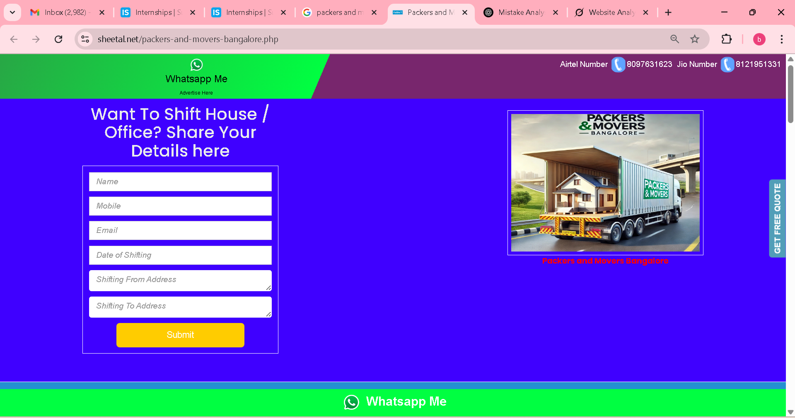

Sign is not set good, we can make better one actually , aligment also

with no centre

centre

Top 5 Packers and Movers in Bangalore – Advertise with Fatshe™

This doesn’t look right—it should fit correctly.

Skywing Cargo (Since 1999) – Packers & Movers Hyderabad

The frame doesn't look appealing, and the red text also doesn't blend well visually

Phone Number

Move Date

From address

To address

Want to Shift Your House or Office? Share Your Details Here

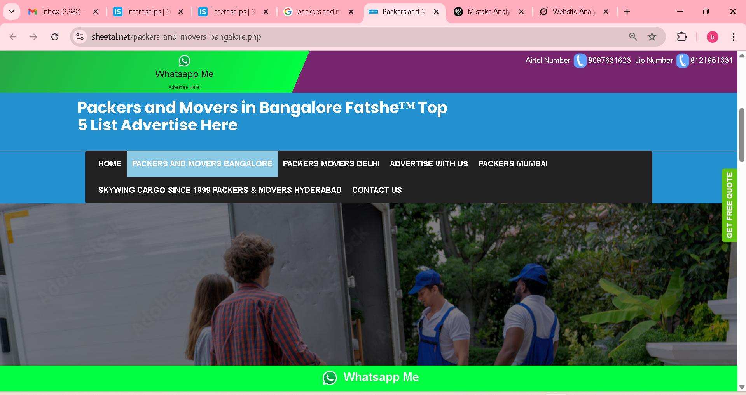

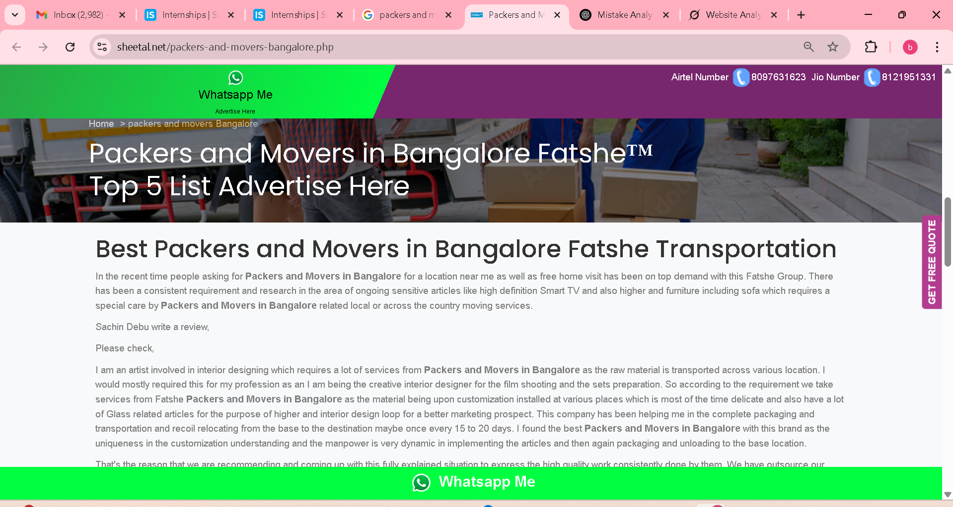

Top 5 Packers and Movers in Bangalore – Advertise with Fatshe™

Top Packers and Movers in Bangalore – Fatshe Transportation

Sachin Debu wrote a review  
Here’s what he had to say

Top Packers and Movers in Bangalore – Fatshe Transportation

Alignment

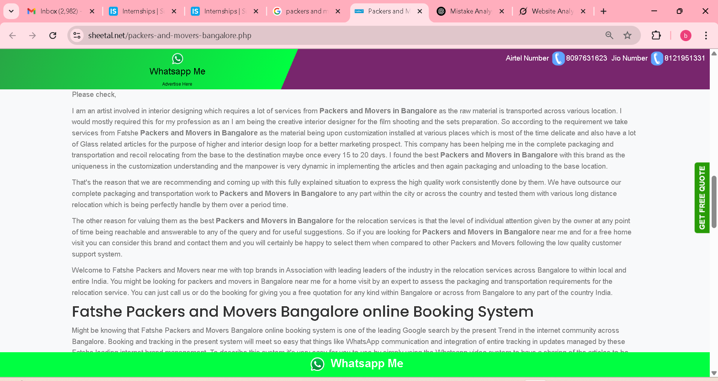

Online (Capital letter)

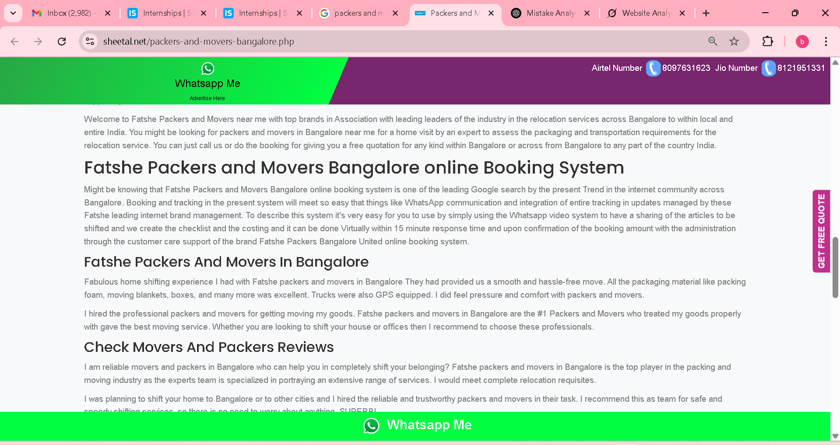

formatting mistake and alignments

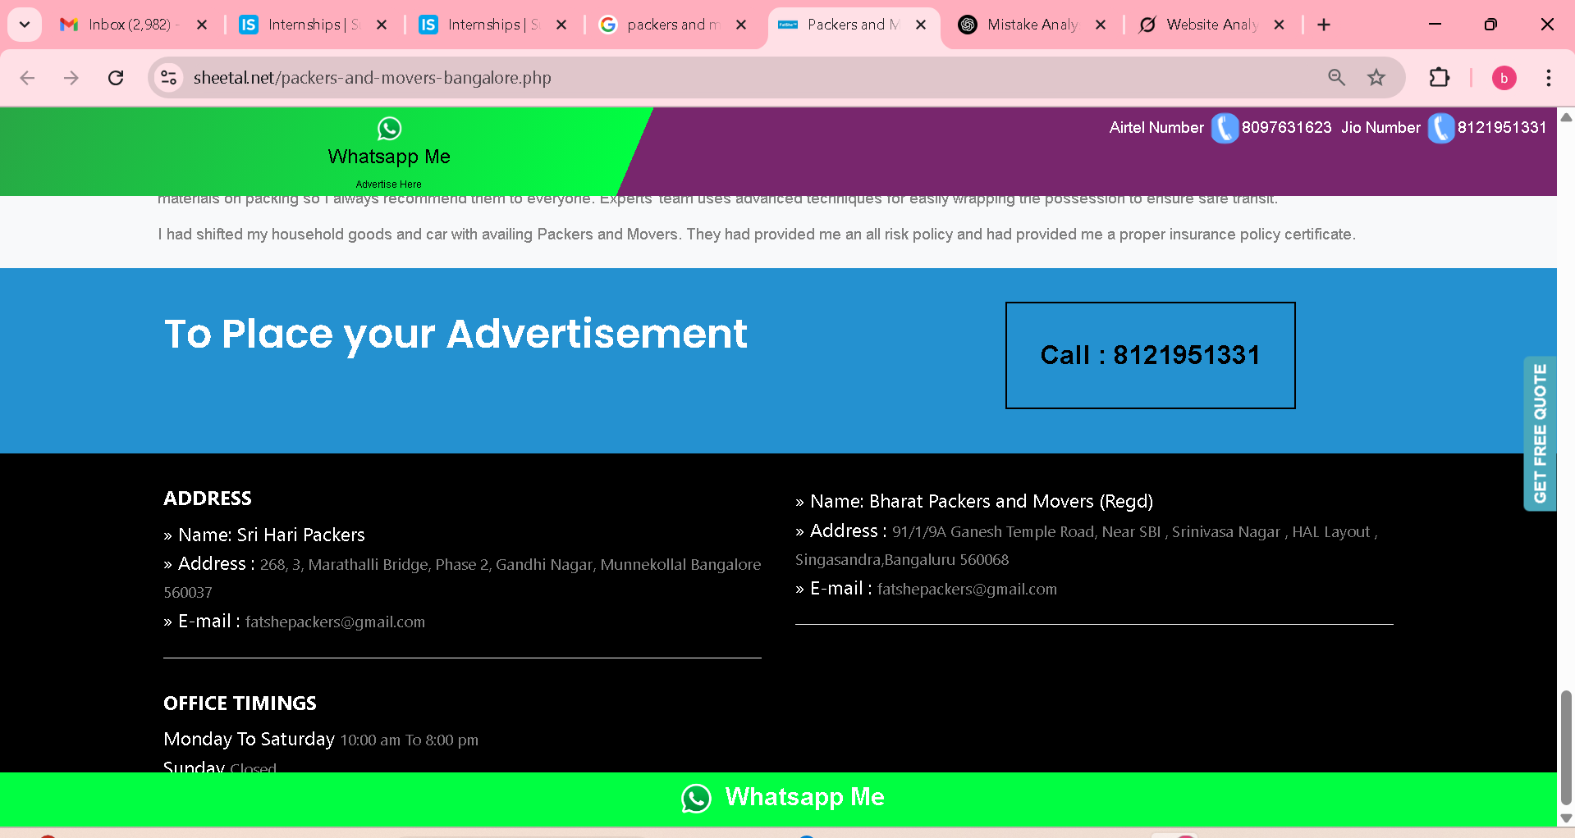

It should be in the center, and the current design doesn’t look good

Email in twice  
no alignments

Sunday no fitted

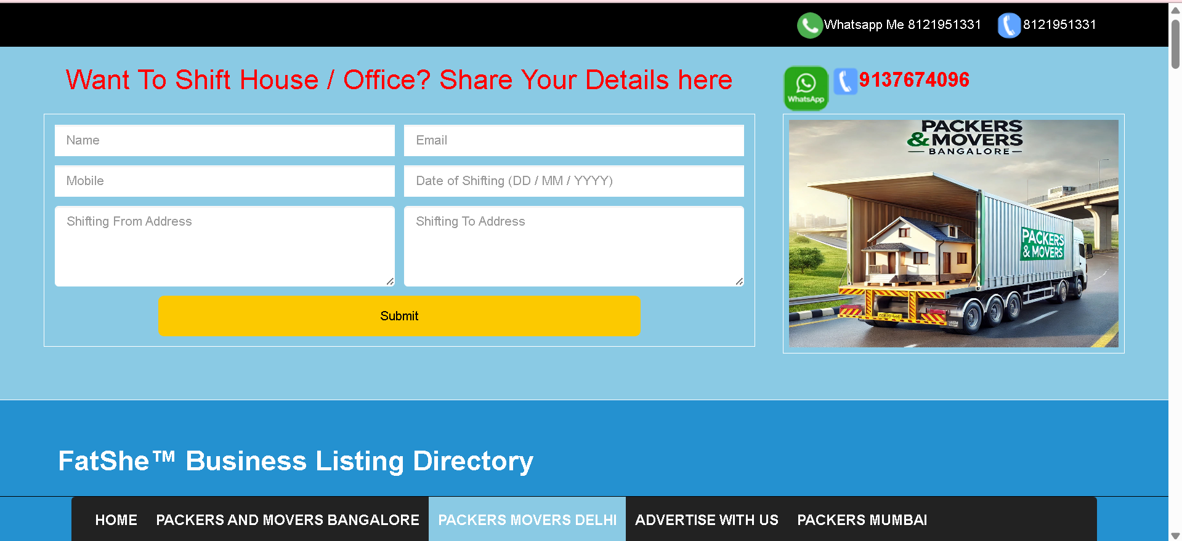



* **Non-semantic HTML elements**

Use semantic elements like <form>, <label>, <section>, <main> instead of just <div> everywhere.

**Missing <label> tags for inputs**

* **. Inconsistent spacing & alignment**

Form fields are not vertically or horizontally aligned properly.

Use flexbox or grid for cleaner layout.

* **Hardcoded Submit button**
* **Color and Contrast issues**
* **Mobile responsiveness missing**
* **Placeholder text used instead of form labels**

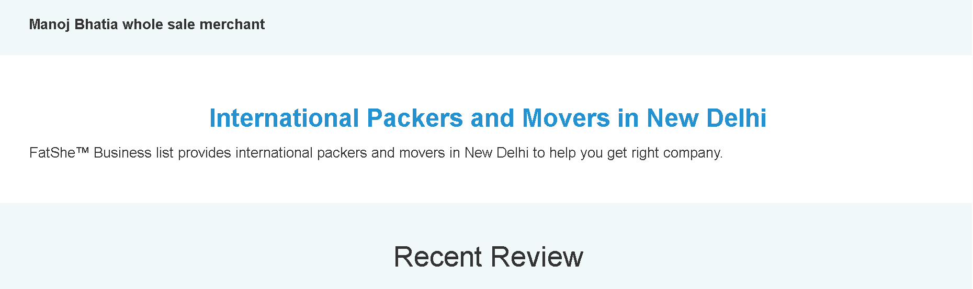



Alignments

* **Brand name inconsistencies**
* **Grammar/spelling errors**
* **No clear call-to-action**
* **Unprofessional testimonials**
* **Missing unique selling point**
* **No visual proof (photos/videos)**
* **Unclear pricing**
* **Contact info errors**
* **Poor navigation structure**
* **Cluttered design**
* **Alignments error**
* **HTML Issues**

**Missing <meta name="viewport">**

* **Form lacks <form> tags & labels**
* **Navigation uses <table> (bad practice)**
* **CSS Issues**

**Inline styles (e.g., <div style="...">)**

* **Poor spacing/alignment**
* **No mobile responsiveness**

**I fixed site error:** [**https://packersbangalore.netlify.app/**](https://packersbangalore.netlify.app/)