# Generic Notification System

## Problem Statement

Most applications have the need to implement notifications for a variety of use cases and scenarios. Create a centralized genericservice for notification that can be used by a variety consuming application for their notification needs e.g. an incident workflow system may use this system when each incident ticket moves from one state to another, similarly a order management system may use this service to notify the customer of the status of the order whenever it changes

The system should allow for the following capabilities:

1. Accept messages including from, to and subject
2. Ability to notify on multiple channels (e.gemail, slack, you can stub out/mock if required)
3. Deliver messages in correct order for each consumer of this

## Deliverables

1. The code for the service in github with instructions on how to set it up and run it

Test output through rest client:

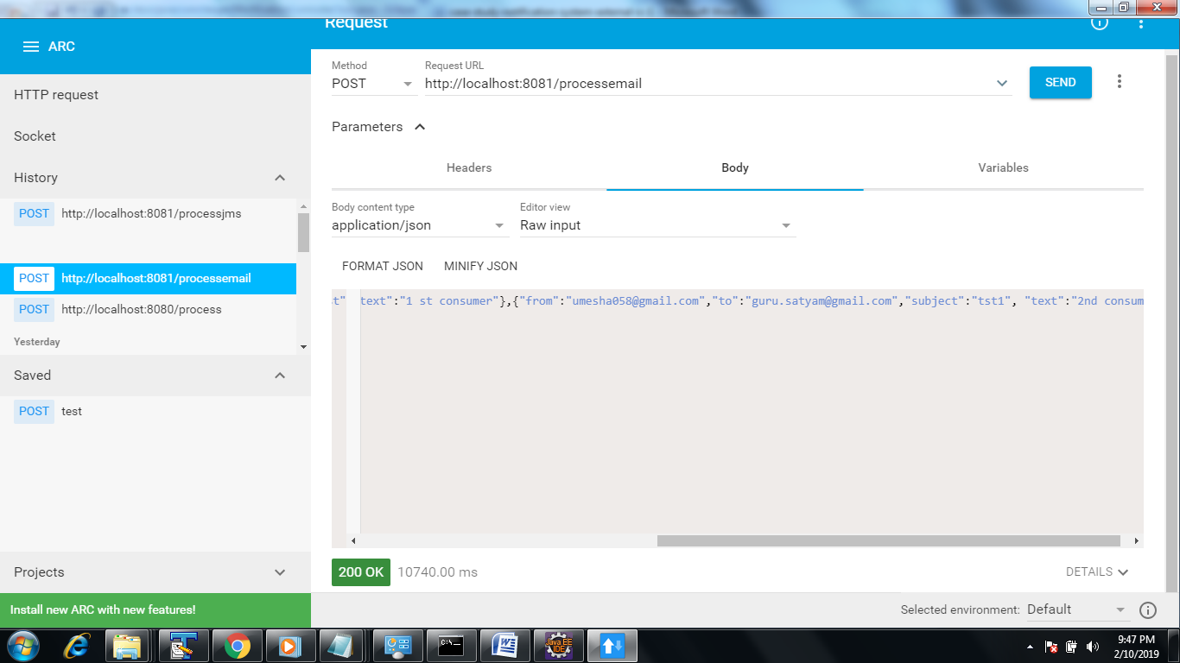

Console output:

com.target.api.NotificationController : Entering processIncomingRequest method

2019-02-10 20:37:54.969 INFO 8068 --- [nio-8081-exec-5] com.target.service.NotificationService : Entering processInputRequest method

2019-02-10 20:37:54.982 INFO 8068 --- [nio-8081-exec-5] com.target.service.NotificationService : Entering sendEmail method

2019-02-10 20:38:01.151 INFO 8068 --- [nio-8081-exec-5] com.target.service.NotificationService : Exiting sendEmail method

2019-02-10 20:38:05.678 INFO 8068 --- [nio-8081-exec-5] com.target.service.NotificationService : Exiting sendEmail method

2019-02-10 20:38:05.679 INFO 8068 --- [nio-8081-exec-5] com.target.service.NotificationService : Exiting processInputRequest method

2019-02-10 20:38:05.679 INFO 8068 --- [nio-8081-exec-5] com.target.api.NotificationController : Exiting processIncomingRequest me

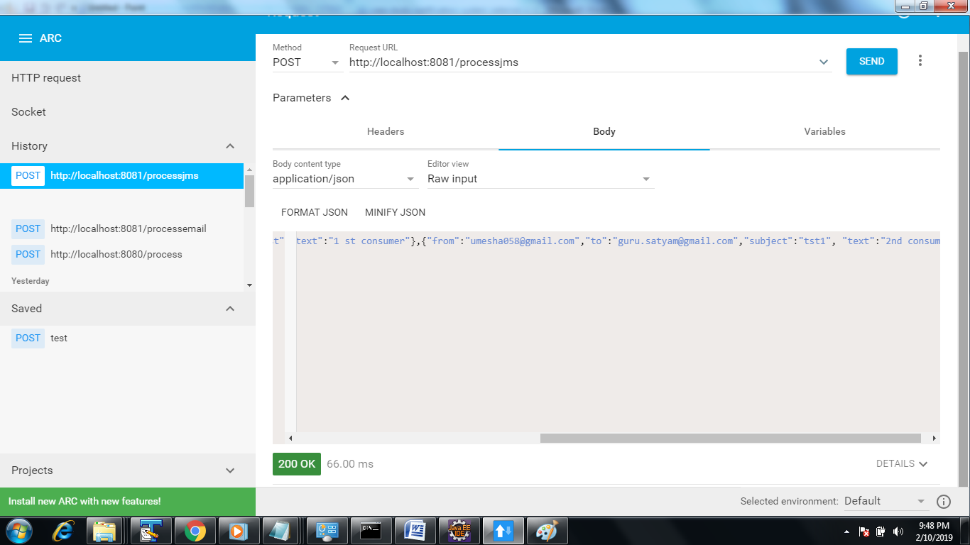

Console output:

2019-02-10 21:48:01.029 INFO 8068 --- [nio-8081-exec-9] com.target.api.NotificationController : Entering processIncomingJmsRequest method

2019-02-10 21:48:01.030 INFO 8068 --- [nio-8081-exec-9] com.target.service.NotificationService : Entering processInputJmsRequest method

2019-02-10 21:48:01.030 INFO 8068 --- [nio-8081-exec-9] com.target.service.NotificationService : Sending a JMS message.

2019-02-10 21:48:01.045 INFO 8068 --- [nio-8081-exec-9] com.target.service.NotificationService : Exiting processInputJmsRequest method

2019-02-10 21:48:01.046 INFO 8068 --- [nio-8081-exec-9] com.target.api.NotificationController : Exiting processIncomingJmsRequest method

2019-02-10 21:48:01.047 INFO 8068 --- [enerContainer-1] com.target.Listener : Received :[{"from":"umesha058@gmail.com","to":"umesha058@gmail.com","subject":"tst","text":"1 st consumer"},{"from":"umesha058@gmail.com","to":"guru.satyam@gmail.com","subject":"tst1", "text":"2nd consumer"}]