DIAGRAM-1

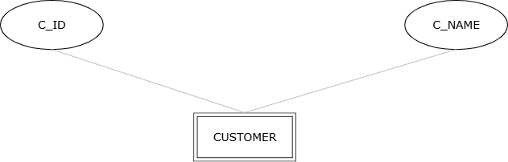
.

DIAGRAM-2




