**Requirement Specification document**

**High School Book Tracking Application**

Authors: Umashankar Rajaram ()

Aishwarya Anand ()

Adnan Haider (A20324647)

Jagruti Vichare (A20378092)

**1 Introduction**

The requirement specification document is designed to specify the user requirements and can be referred in next stages of the development of the software product. It gives the specification of the software product to be developed which are agreed upon by the customer.

**1.1 Goals and Objectives**

The primary goal of this document is to illustrate the High School Book Tracking Application's uses and functionalities to be covered as specified by the customer.

**1.2 Statement of Scope**

The High School Book Tracking Application is intended for high school students, their parents, staffs and teachers. It is basically designed to be able to keep track of books checked out to students, their due dates etc.

A staff when logged into application, should be able to add/edit/delete books, checkout books to students for a particular period of time. A teacher when logged into application should be able to checkout only those books for which he/she takes a class. A student/parent can only see his/her checked out books information and should be able to modify his/her personal details.

**1.3 Software Context**

**TBD**

**1.4 Major Constraints**

**TBD**

**2 Usage Scenario**

**2.1 User Profiles**

All the users of this application should be granted access to the system before they can use it. Based on the access level, there are three types of users :

* Staff/Admin

Staff/Admin should be able to do following functions :

1. Add/Delete a book
2. Checkout book to a student
3. Search books by its department, class, book name or ISBN number.
4. List all authorized users and their access levels.
5. List all students and parents information with amount due

* Teacher :

Teacher should be able to do following functions :

1. Checkout only those books for which he/she teaches classes for.
2. List all the students of his class and their parent information with amount due
3. List all the books of which he/she teaches classes

* Student/Parent :

Student/Parent should be able to do following functions :

1. List all the books that he/she has checked out
2. Add/Update personal information (Parents information, contact information)
3. Search for books in the system
4. Check out books with a limit on the number of books equal to the number of registered classes for the student

**2.2 Use-Cases**

1. Add/Delete a book
   * 1. a) Actor (online catalog) automatically adds books)
     2. b) User (admin) can explicitly add/delete books as well
2. Checkout book
   * 1. a) Users(students/teachers) can checkout books and when they do so our applications
     2. modifies state.
3. Search books by its department, class, book name or ISBN number.
   * 1. a) Users can use search functionality of application to display this information
4. List all authorized users and their access levels.
   * 1. a) Admins can use search functionality for this info
     2. b) Our application also interacts with separate, external person database for this info
5. List all students and parents information with amount due
   * 1. a) Users can collect this info
6. List all books in the system
   * 1. a) Any user can do this
     2. b) Our application information interacts with an external book data base
7. List students with books showing due data and data checked out
   * 1. a) Admin can gather this info

**2.3 Use-Case Diagram**

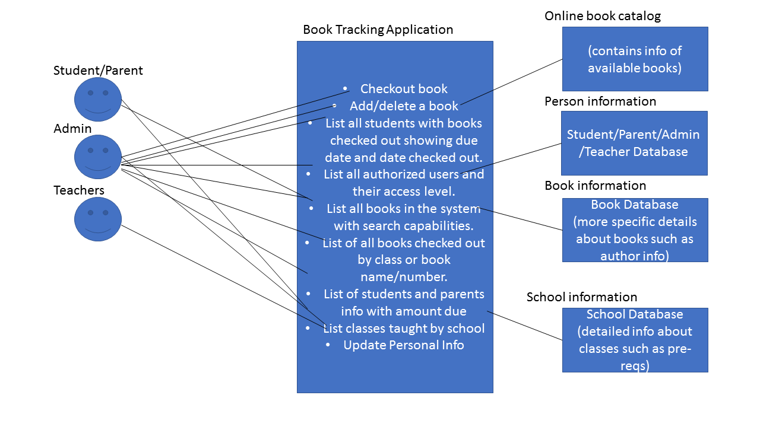

**2.4 Use-Case Descriptions**

1. Description of Add/Delete a book : Book tracking application interacts with an external online catalog to collect data. However, since some books that are available online may not be available at a school, a admin can explicitly modify the set of books available at a school
2. Description of Checkout book: Students/teachers with valid login credentials can check out a book from the list of books that are available at the school.
3. Description: Search books by its department, class, book name or ISBN number: The search bar should be able to filter by department, class, book name, and ISBN number.
4. Description of List all authorized users and their access levels: The admin should be able to get this information.
5. Description of List all students and parents information with amount due: The admin will be able to search and collect this information. The information will include name, id, student or parent, and the amount due in dollars.
6. Description of List all books in the system: This includes all books in the school’s system. This will be a subset of the books available in the *books database and online catalog*.
7. Description of List students with books showing due data and data checked out: The information will include a book id which is an key into the book data base to gather more information such as author and quantity.

**2.5 Special Usage Considerations**

* + Parents and students should be able to pay the fees and amount due information should be updated accordingly.
  + As books are checked out, the total available and total checked out quantities should change for a book
  + Security should be used when adding/updating/deleting information. For e.g. students cannot modify other student’s info.
  + Admin should be able to grant access to students/parents for using the book tracking app.
  + Books must be grouped by the class they are in, also when searching for a book.
  + Books can belong to multiple classes and a class can contain multiple books.

**2.6 Activity Diagram (optional)**

**3 Data Model and Description**

**3.1 Data objects**

A High School Book Tracking Application stores following information :

* Books :

It stores book information along with total available books and total checked out books. Every book is uniquely identified by an ISBN number.

* Classes :

It stores details of all the classes conducted in high school. This information can be used to check which student is registered for which class or which teacher teaches which class

* Users :

It stores details of all the users who are going to use this application. All the users are uniquely identified by their user ID. Users can be of three types 'Staff', 'Teacher' and 'Student/Parent' and based on their type acess level is granted to them.

**3.2 Relationships**

**TBD**

**3.3 Complete data model**

The features of High School Book Tracking Application is shown below in the form of ER-Diagram :

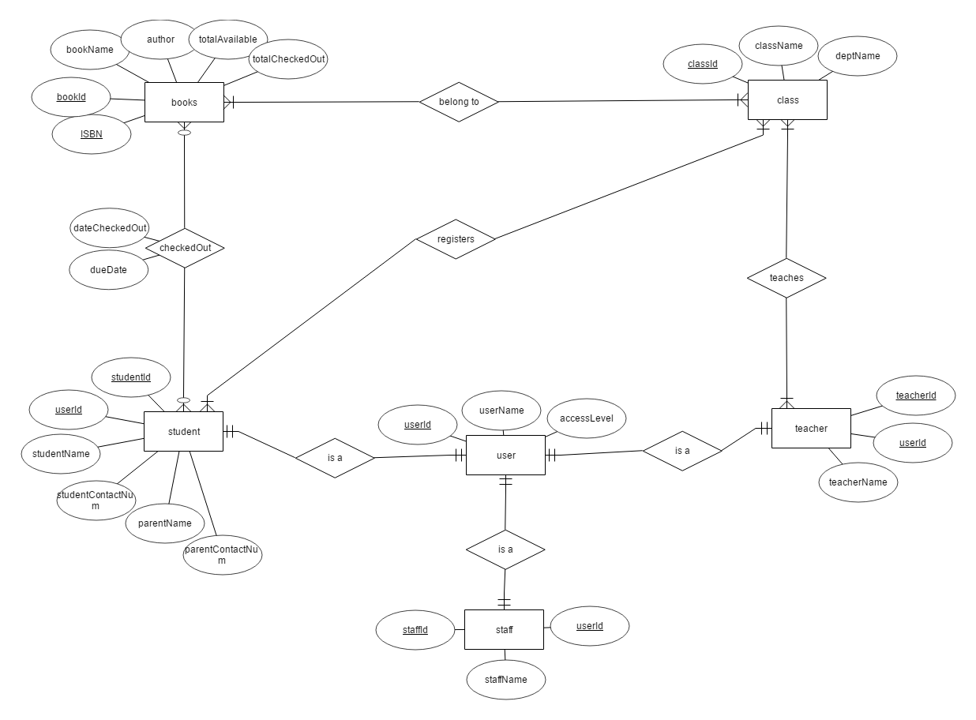

**4 Functional Model and Description (TBD)**

**4.1 Class diagrams**

**4.2 Software Interface Description**

**4.2.1 External Machine Interfaces**

**4.2.2 External System Interfaces**

**4.2.3 Human Interfaces**

**4.2.4 User Interfaces**

* Front-end Software : Java
* Back-end Software :

**4.2.5 Hardware Interfaces**

* Windows 7 onwards
* Supports Chrome and Mozilla

**5 Behavioral Model and Description**

**5.1 Software Interface Description**

The book tracking application will mutate state when actors (both users and external data stores) are updated. Information related to books, classes, people (student/staff/teacher) can be updated. Since the goal of the application is to track books, the events that will trigger such updates are related to actions that would happen on books, such as check out, check in, pay fee, increment fee, add book, delete book, list books.

**5.1.2 Events**

* + Register User
  + Validate User
  + Add book
  + Pay fee
  + Surpass due data
  + Delete book
  + Enable class
  + Remove class
  + Modify info
  + Search
  + Return book
  + Increment fee

**5.2.2 States**

* + Late book
  + Unavailable book
  + Available book
  + On-time book
  + Invalid user
  + Valid user
  + Displayed user
  + Displayed class
  + Valid Class
  + Invalid class
  + Displayed book

**5.2 Statechart Diagram**

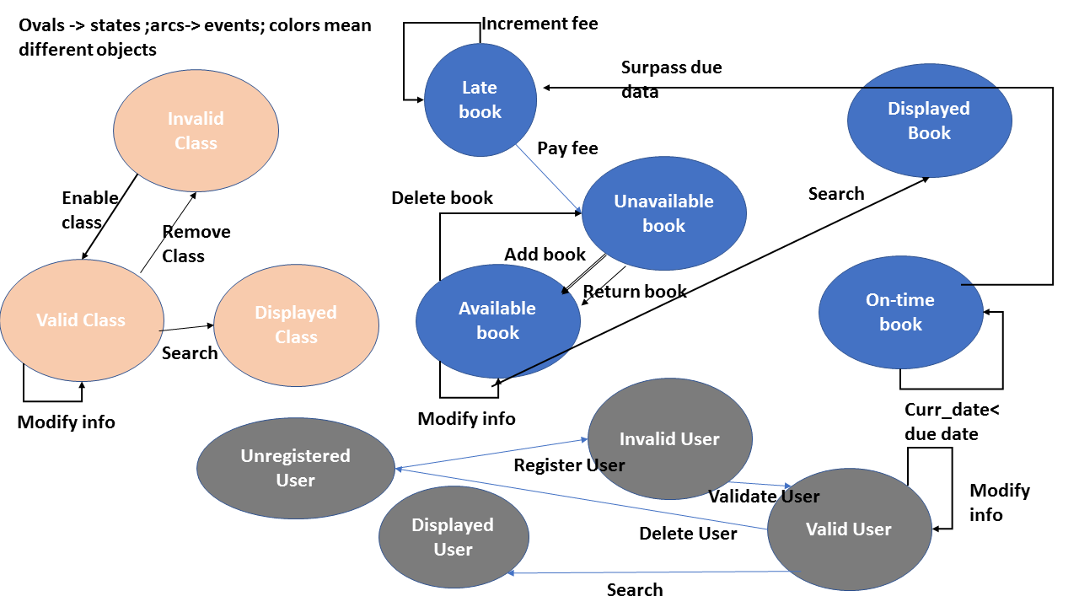

**6 Restrictions, Limitations and Constraints**

There wont be any password recovery/forgot password feature nor any lockout phase after numerous entries of invalid password.

Student can checkout any number of books, also books of a particular class for which he is not registered.

Staff/Admin can not modify book information.

Teacher can not Add/Delete any books.

'Checking out multiple books at time' feature is not available.

'Adding/Deleting multiple books at a time' features is not available

**7 Validation Criteria (TBD)**

**7.1 Classes of Tests**

**7.2 Expected Software Response**

**7.3 Performance Bounds**