Requirements Specification
(Ambulance Dispatch System)

1. Introduction
This document describes the requirements specification for ambulance dispatch system.
This document includes functional requirements, non-functional requirements of the system. The scenarios and the use case model of the ambulance dispatch system are created as a part of requirements analysis. The system models are included in the Requirements Analysis document.

  - Purpose of the system
The purpose of this prototype Ambulance Dispatch System is to cause the entire process to be more efficient and more effective, the net result of which is to save lives. An ambulance dispatch system generally involves multiple people, extremely large amounts of timely communication, and lightening fast decision-making.

Timely communication is a critical issue. Any information transfer that can be expedited can safe a life. Information must be drawn from the caller and entered into the system by the operator and transferred to the dispatcher. The dispatcher must locate the closest available emergency vehicle, determine availability, and dispatch that vehicle to the proper location. After the ambulance arrives at the proper location, if the subject must be taken to the hospital, an adequate hospital must be located, notified of the arriving new patient, and the shortest, fastest route mapped into the ambulance’s map system. Any breakdown in this fragile process can lead to a lost life by consuming excessive time in clearing up confusions or miscommunications. Misinformation can lead to the wrong decision in the rapidly paced environment.

  - Scope of the system
The customer’s scope is as follows. “Calling 911 and asking for the ambulance service would connect the caller to a dispatcher (also called dispatch controller) who feeds the information s/he receives from the caller into the system. The system would allocate and mobilize a suitable ambulance within 3 minutes, transmit details to the selected vehicle, and track and monitor actual performance and position. An exception message shall be generated if no free ambulance is available for at least 11 minutes. The system would show the location of each patient and the nearest three ambulances.” [Ref 2]

  - Objectives and the success criteria of the project
Objectives:
    - Reuse as many existing systems as possible as a part of this system.
    - For all existing systems used, have a possible backup ready in case the existing system temporarily goes offline.
    - Limit the amount of information that must be communicated verbally between each contact in the system.
    - Limit the amount of time spent typing or entering information into a system by using automated means

Success criteria:
- The overall response time from the caller’s call to the time the ambulance shows up is less than that of the current system.
- The system performance adequately based on the customer’s scope mentioned in the section above.
- The product is delivered, deployed, and ready for use in the customer’s required time period.
- The software features, tests, design, and requirements analysis are all traceable back to each other and back to the original customer’s scope.

  - Definitions, acronyms and abbreviations
None
  - References
    - Team Website www.utdallas.edu/~mas027000
    - Project Scope http://www.utdallas.edu/~chung/CS6354/Project.doc
    - Course Home Page http://www.utdallas.edu/~chung/CS6354/
    - Ambulance Dispatch System Case Studies
      - http://www.utdallas.edu/~chung/SE3354Honors/Dalcher--Disaster_in_London.The_LAS_case_study.pdf
      - http://www.utdallas.edu/~chung/SE3354Honors/Finkelstein--A_Comedy_of_Errors--the_London_Ambulance_Service_case_study.pdf
      - http://www.utdallas.edu/~chung/SE3354Honors/Kramer--Succeedings_of_the_8th_International.pdf
      - http://www.utdallas.edu/~chung/SE3354Honors/South_West_Thames--Report_of_the_Inquiry_Into_The_London_Ambulance_Service.pdf

    - Address Lookup Systems by Phone Number
      - http://www.anywho.com/
      - http://www.whitepages.com/10001/reverse_phone

    - Reference mapping systems
      - http://www.mapquest.com/directions/main.adp?bCTsettings=1
      - http://maps.google.com/

    - Automobile real-time tracking systems
      - http://www.lojack.com/
      - http://www.rmtracking.com/
      - http://www.hunterpro.com/
      - http://www.interfleet.com/
      - http://www.interfleet.com/news/EMS%20Insider%20--%20InterFleet%20article.pdf

    - Portable GPS vehicle navigation systems and traffic watchers
      - http://www.tomtom.com
      - http://www.garmin.com
      - http://www.tomtom.com/plus/services/traffic.php
      - http://www.garmin.com/traffic
      - http://www.magellangps.com/
      - http://www.magellangps.com/products/traffic_service.asp

    - Cell phone tracking and locator services
      - http://www.accutracking.com/
      - http://marketplace.publicradio.org/shows/2007/05/31/AM200705315.html
      - http://www.technewsworld.com/story/49933.html

  - Overview
The high level functions of the ambulance dispatch system would be create incident information, locate and allocate the ambulance to the incident, make available all the incident information for the ambulance personnel. The ambulance dispatch system should also satisfy the timing requirements given as a part of project scope.
To be able to find the location of incident and to find the route from ambulance location to incident location, an external GPS system would be used.
The ambulance dispatch system would interact with this GPS system to get the incident location and to find the route to incident location.
Details of high level functions of the ambulance dispatch system are discussed in section 3.2 Functional Requirements

- Current System

Previously, a manual system was in place for the ambulance dispatch system, where control assistants at the call center would write down details of a call on a form, locate the incident coordinates in a map book, and send the completed form to a central collection point using a conveyor belt. At the collection point, an assistant would collect the forms, scan the details, identify potential calls, and allocate them to one of four regional resource allocators. The appropriate resource allocator would consult ambulance status and location information provided by the radio operator, consult the remaining forms maintained in the allocation box for each vehicle, and finally decide on which ambulance to mobilize. These details would be entered on the form. The forms would be passed to a dispatcher who would then phone the relevant ambulance station (if vehicle was there) or pass the mobilization instructions to a radio operator, if the vehicle was known to be mobile.

This procedure had to be completed within the national three minute activation standard! Some of the major deficiencies had the potential to further delay the entire procedure. These included:
a) Manual searching of the map book often requiring a search for a number of alternatives due to incomplete or inaccurate details.
b) Inefficient movement of paper around the control room.
c) Maintaining up to date vehicle status and location information as provided by the radio operators and allocators.
d) Communication procedure and the use of voice communication were slow and inefficient, and could lead to mobilization queues.
e) Over-reliance on human ability and memory to identify duplicate calls and avoid mobilizing multiple units to the same incident.
f) Over-reliance on human ability to note and trace all available units.
g) Call back (caller phoning for second time) which forced the assistants to leave their post to talk to the allocators using up time and introducing physical congestion into the control room.
h) Identification of special incidents (large or extremely urgent) depended on human judgement and memory.

The proposed system in the document will replace the manual process with automated system and hopes to eliminate the problems associated with manual process.

References:
http://www.utdallas.edu/~chung/SE3354Honors/Finkelstein--A_Comedy_of_Errors--the_London_Ambulance_Service_case_study.pdf

http://www.utdallas.edu/~chung/SE3354Honors/Dalcher--Disaster_in_London.The_LAS_case_study.pdf

- Proposed system

The proposed system will replace the manual operations involved in the dispatch system. An automated system will take care of all dispatching operations.

  - Overview
The new system will be used by the dispatcher to handle the dispatching operation. The system allows dispatching the ambulances and also tracking the ambulance location. Major high level functions of the system are described in the following section.

  - Functional requirements

This section describes the high level functionality of the Ambulance Dispatch System.

    - Receiving Incident information from the caller.

When the request for ambulance comes to the operator, he takes information about the incident from the caller. This information is entered into the ambulance dispatch system. This information includes caller phone number, address (any combination of street name, zip code), description/nature of the incident, number of people involved in the incident. If the caller does not know the exact address of the patient, it is found using an external system.
This external system determines the incident address depending on the caller’s phone number.
With this information a new incident is created in the ambulance dispatch system with all the details. The information added to this incident is called “incident information”.

    - Locating nearest ambulance.

Depending on the location of the incident, this function will determine the nearest 3 available ambulances.

    - Allocating the ambulance to the incident.

Depending on the number of people involved in the incident, dispatcher will allocate the ambulance/s to the incident and add the ambulance details to the system. One ambulance is assigned to each person injured.

    - Dispatch of ambulance and resource.

Once the ambulance is allocated to the incident, dispatcher will use the system to send the notification, incident information and the details of the nearest hospital to ambulance personnel. This information is also called “allocation information”. A geographical search of the place around which the incident has taken place will help the dispatcher find the nearest hospital.
The ambulance personnel can view this allocation information assigned to him on an LCD display inside the ambulance.

3.2.5 Finding the route to the incident

Once the allocation information is sent to the ambulance personnel, he can get the route information to the incident using an external GPS system. Ambulance personnel can view the route on his LCD screen inside the ambulance.
Once the ambulance personnel reach the incident location, route to the nearest hospital is also shown on his LCD screen using external GPS system.

3.2.6 Logging and Reporting of incidents.

Supervisors can use the ambulance dispatch system, to get reports and details on each incident.

3.2.7 Displaying timing information and error reporting.

The ambulance dispatch system will calculate and display the time required to dispatch the ambulance for each incident. The time has to be less than 3 minutes.
Also, if no ambulance is available for 11 minutes, the dispatch system will generate exception messages. When an exception is created, a person intervenes and takes care of it.

3.2.8 Tracking and monitoring of ambulance.

This functionality allows dispatcher to track the status of the ambulance. Once the job is completed, the system informs the dispatcher that the job has been executed.
The status of each ambulance is then updated as required.

3.2.9 Manage Users

This functionality allows supervisors to maintain the system and add/remove/update new users for the system. Each user (Dispatcher) will have username and password assigned to him.

External Systems:

The ambulance dispatch system will interact with some external systems which are described blow:

Address Locator:
The address locator will try to locate the address of the incident, when the caller cannot give the exact details of the location.

GPS:
GPS system will be used to get the route details and directions to the incident location. These details will be used by ambulance personnel to reach the incident location.
The GPS system also gives information about the nearest hospital to the incident location.

Assumptions:

- The operator and the dispatcher are assumed to be the same person in this system.

- Creating an exception will solve the problem, when an ambulance cannot be found. It will be diverted to the third party who will take care of the situation.

  - Non functional requirements

    - Usability
Ambulance Dispatch System shall provide mouse and keyboard navigation.
Ambulance Dispatch System shall be easy to navigate by using clear words, menus and drop-down lists.
Ambulance Dispatch System shall be accompanied with a user manual.

    - Reliability
Ambulance Dispatch System shall be available 24 hours a day for application users.

    - Performance
Ambulance Dispatch System shall not take longer than 15 seconds to respond to a page request for members; when using an internet connection that is 56k or higher

    - Supportability
The ambulance dispatch system application should be supportable in current equipment such as computers, monitors, printers etc.

    - Implementation
The software implementation will be performed on Friday evening to minimize impact. The implementation will be performed all on one day rather than in phases.

    - Interface
Ambulance Dispatch System shall be accessible through a web browser such as Internet Explorer 5 or higher and Netscape Navigator 4.7 or higher
Ambulance Dispatch System shall provide printer friendly outputs of reports so that users can have easy to read print outs of the reports.

    - Packaging
The application is internal department use only and will not be packaged and sold as a retail product.

    - Legal
This web site is for Department of Ambulance Dispatch System, and there are no subscriptions, membership fees. Department of Ambulance Dispatch System would appreciate the cooperation in reporting discrepancies and to not misuse or damage any of the functionality, information or contents of this internal use service web page. No external/external party may make an offer to sell or buy this website on behalf of a third party.
If any provision of this agreement is held to be invalid or unenforceable, such provision shall be struck and the remaining provisions shall be enforced. Headings are for reference purposes only.

  - System Models
    - Scenarios
Detailed scenarios are discussed as a part of “Use case model”, in the next section.

    - Use case model
      - Use Case diagram.
The use case diagram describes the high level function of the ambulance dispatch system. It also describes the different actors interacting with ambulance dispatch system.

Ambulance Dispatch System

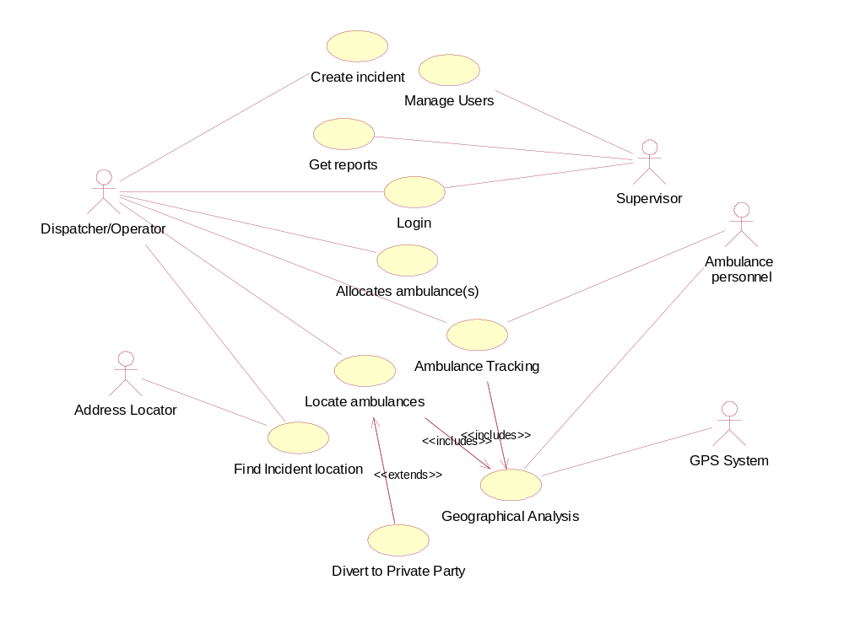

      - Use case template.

Following template describes each use case in the use case diagram.

1. Login

Brief Description
This use case describes how a user logs into the ambulance dispatch system.

Flow of Events

Basic Flow
This use case starts when the actor wishes to Login to the ambulance dispatch system.
The system requests that the user enter his/her name and password.
The user enters his/her name and password.
The system validates the entered name and password and logs the user into the system.

Alternative Flow

Invalid UserID/ Password
If in the Basic Flow, the user enters an invalid userid and/or password, the system displays an error message. The user can choose to either return to the beginning of the Basic Flow or cancel the login, at which point the use case ends.

Special Requirements
None

Pre-Conditions
None

Post-Conditions
If the use case was successful, the user is now logged into the system. If not, the system state is unchanged.

Extension Points
None

- Create Incident
Brief Description
The use case is designed to capture details about the caller as entered by the dispatcher/operator and new incident is crated from this information.
Flow of Events
Basic Flow
1. The Dispatcher receives the details from the caller and enters the details into the system forms.
2. The address of the caller is determined.
3. The details are verified by the system and entered into the database.
Alternative Flow
If there are no complete details available then the system still accepts the details as entered.
Special Requirements
None
Pre-Conditions
The Dispatcher should be logged in before he uses this use case.
Post-Conditions
The caller details are captured by the system.
Extension Points
None

- Find Incident Location
Brief Description
The use case gets the address of the incident from the caller phone number.
Flow of Events
Basic Flow
Dispatcher sends the caller phone number and details to the external system, AddressLocator.
AddressLocator determines the address of the caller and returns the address to dispatcher.
Alternative Flow
If the location cannot be found the system generates an error and returns the nearby locations.
Special Requirements
None
Pre-Conditions
The Dispatcher should be logged into the system before using the use case.
Post-Conditions
The address of the incident is available.
Extension Points
None

- Locate Ambulance
Brief Description
The use case generates the nearest 3 ambulances that are available.
Flow of Events
Basic Flow
1. The Dispatcher tries to locate ambulance in a specific region with relevance to the incident address.
2. The incident address is analyzed.
3. The surrounding area is scanned for all ambulances.
4. All the ambulances are scanned for availability.
5. The nearest 3 ambulances are available.
Alternative Flow
If no ambulances are available the use case diverts the details to a private party
Special Requirements
None
Pre-Conditions
The Dispatcher must be logged into the system.
Post-Conditions
3 nearest available ambulances are located.
Extension Points
The use case extends to use case Divert to Private Party

- Allocate Ambulance
Brief Description
The use case allocates the available ambulances to the incident.
Flow of Events
Basic Flow
1. The nearest 3 ambulances are shown that are available by the system.
2. The Dispatcher scans the incident information.
3. The Dispatcher evaluates the criticality of the situation
4. The Dispatcher allocates ambulances to that location.
5. The route from the ambulance location to the incident location is determined using GPS system.
6. Allocation information containing incident, ambulance and route information is generated.
7. Ambulance personnel are notified.
Alternative Flow
None
Special Requirements
The allocation of operation should take 3 minutes from the incident is created. If it takes more than 3 minutes exception messages should be generated.
Pre-Conditions
The Dispatcher and the Ambulance Personnel should be logged into the system.
Post-Conditions
None
Extension Points
None

- Ambulance Tracking
Brief Description
The system periodically updates the availability and the location of the ambulances
Flow of Events
Basic Flow
1. The Dispatcher requests for ambulance tracking option.
2. The dispatch system generates the details of each and every ambulance in the region, by interacting with GPS system.
3. The location and the availability of these ambulances are listed.
4. The status of ambulances can be changed.
Alternative Flow
None
Special Requirements
None
Pre-Conditions
The Dispatcher should be logged into the system.
Post-Conditions
Tracking information is updated.
Extension Points
The use case Geographical Analysis is included into the use case.

- Get Reports
Brief Description
The use case generates a report of all activities undertaken in a specified period.
Flow of Events
Basic Flow
1. The supervisor enters the period start and end dates.
2. The report is generated from the database.
Alternative Flow
None
Special Requirements
None
Pre-Conditions
The supervisor should be logged into the system.
Post-Conditions
The report is generated.
Extension Points
None

- Geographical analysis
Brief Description
The use case generates the geographical coordinates and driving directions to a place
Flow of Events
Basic Flow
1. The geographical coordinates of a specific location are returned.
2. The driving directions to a place are obtained.
Alternative Flow
None
Special Requirements
None
Pre-Conditions
None
Post-Conditions
The geographic details and the directions are obtained.
Extension Points
None

- Manage Users
Brief Description
This use case allows supervisor to add/remove/update the users for ambulance dispatch system.
Flow of Events
1. Supervisor log in to the system
2. Supervisor selects either add/remove or update option.
3. Supervisor provides the required details to the system
4. Supervisor is notified about the change.
Special Requirements
None.
Pre-Conditions
Supervisor should be logged in to the system
Post-Conditions
Manage user operation is complete
Extension Points
None

- Divert to Private Party
Brief Description
The use case diverts the caller details to another private party.
Flow of Events
Basic Flow
1. The Dispatcher connects to a private party.
2. The case is transferred to the other party.
Alternative Flow
None
Special Requirements
None
Pre-Conditions
There are no available ambulances
Post-Conditions
The case should be successfully forwarded and accepted by the private party.
Extension Points
None

    - Object model

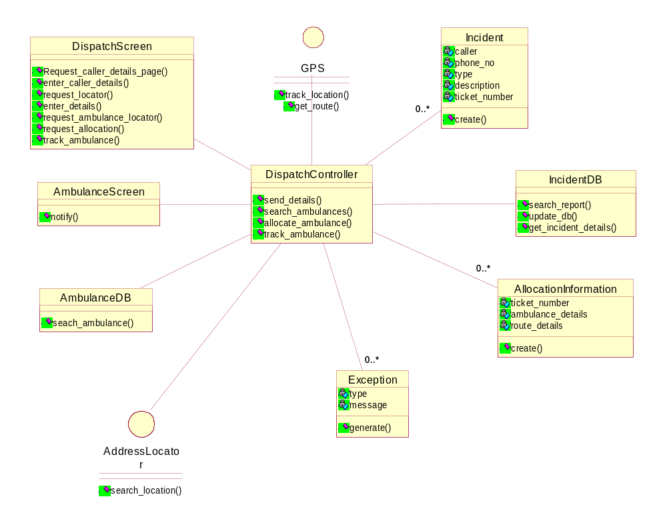

Description:

The class diagram has a dispatch screen which will act as an interface between the system and the dispatcher and will ask for all the details of the caller and the patient with which it can dispatch an ambulance/s as per the requirements after the dispatcher says so. This dispatching is done by the DispatchController. The DispatchController will search for, allocate and track the ambulance. There is a dynamic database which will have the details of all the ambulances. The address locator is an external system which will help find the exact address of the patient. An exception is generated if an ambulance is not assigned even after 11 minutes. GPS is also an external device which is connected to the ambulance which will show the route to the patient’s location and the nearest hospital by taking the address from the allocation information which is visible on the dispatcher’s screen as well as the ambulance’s screen.

    - Dynamic model

3.4.4.1 Sequence Diagrams:

1. Allocate Ambulance:

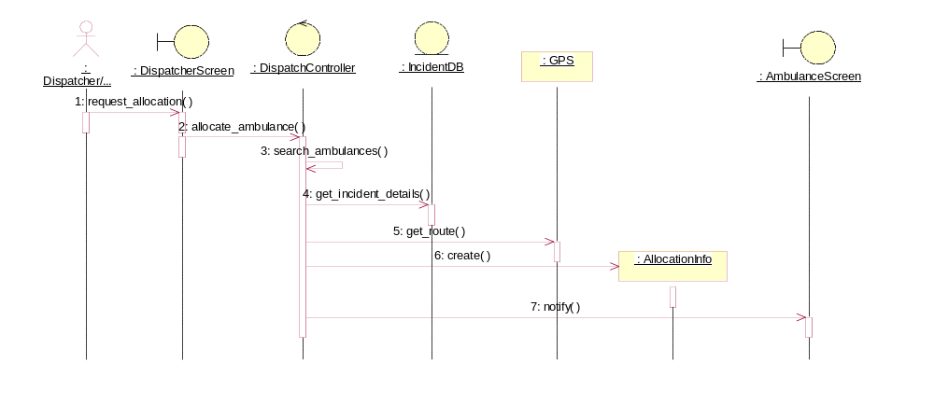

Description:

When the caller calls, the dispatcher requests allocation of an ambulance. The dispatch controller will search for ambulances and return with the 3 nearest and available ambulances. Then it gets the incident details and will notify the ambulance selected, of the route.

2. Ambulance Tracking:

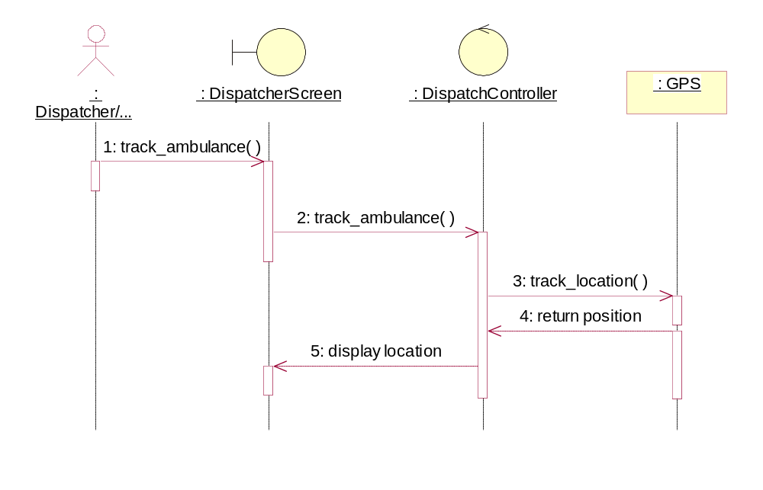

Description:

The Dispatcher can track the position of the ambulance by connecting to the GPS of the ambulance. The location will be displayed on the screen of the dispatcher.

3. Create Incident:

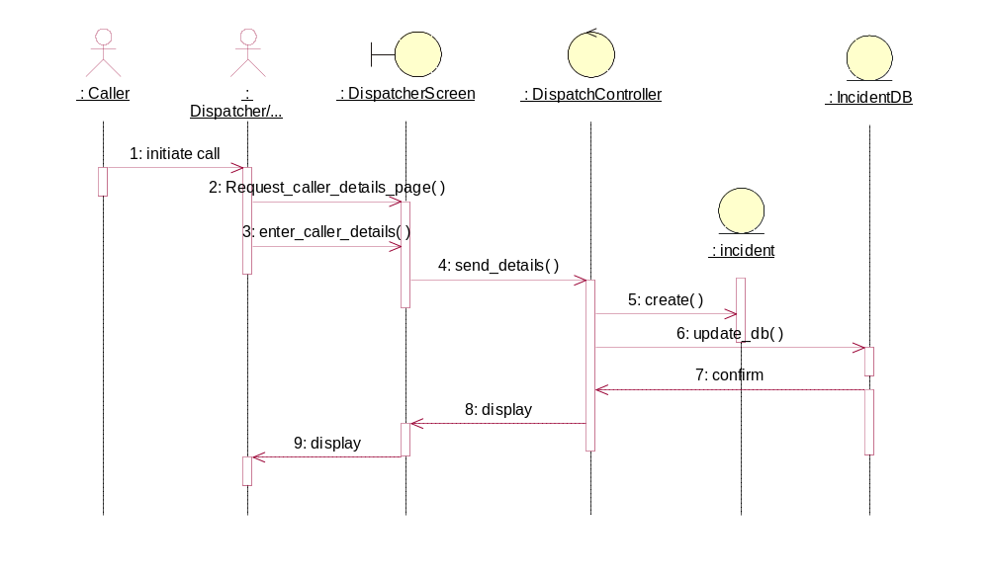

Description:

When the caller calls the ambulance dispatcher, s/he will enter the caller details on his/her screen which is sent to the dispatch controller. The dispatch controller will create a new incident and enter all the details and the database is updated with this new incident.

4. Find Incident Location:

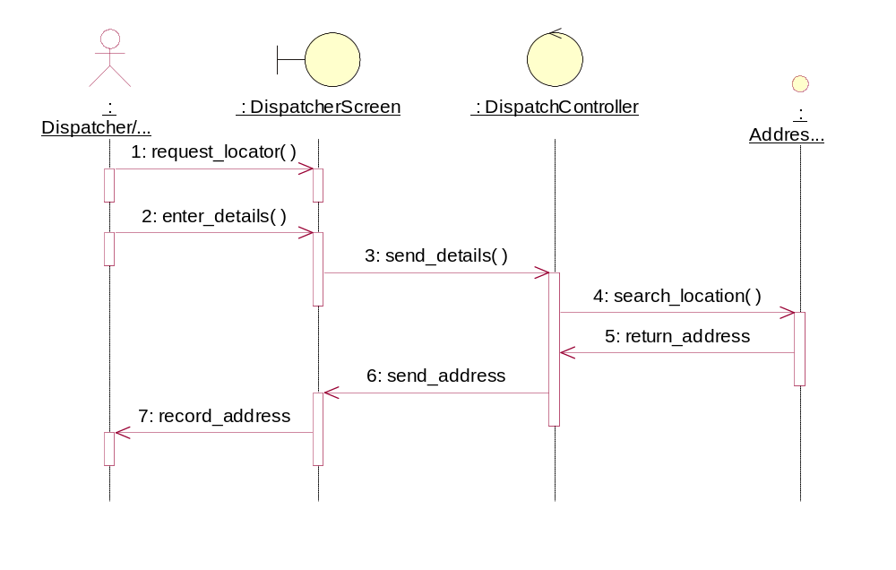
Description:

To find the incident location, an external system called the Address Locator is used. The details like the intersection of the street, state is given and the exact location is given.

5. Get Reports:

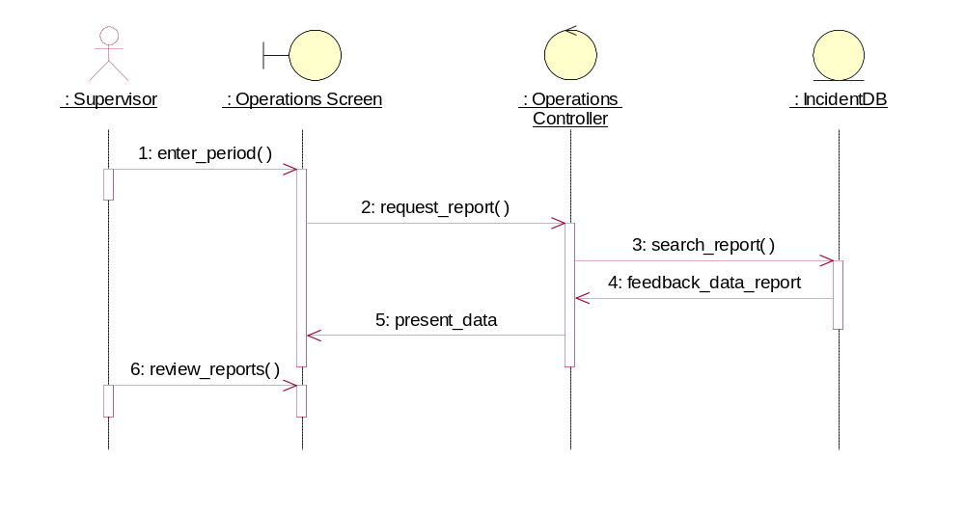

Description:

The Supervisor can get the reports by entering the period that he wants to review. The database will give a feedback data report which is reviewed by the supervisor.

6. Locate Ambulance:

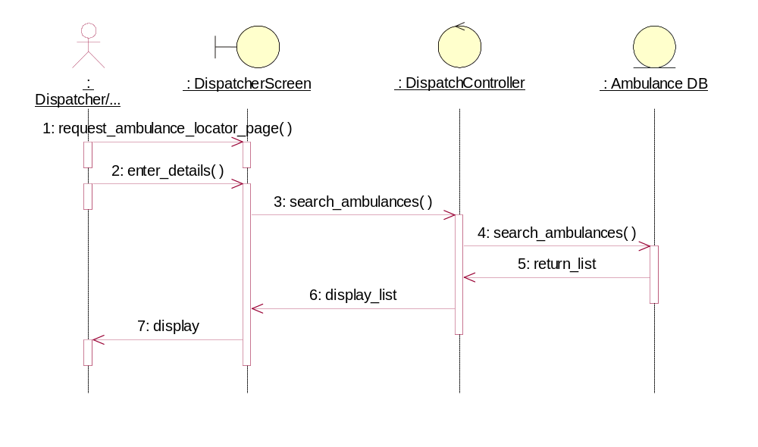
Description:

When the dispatcher enters the details [incident information], the dispatch controller will search for ambulances in that area and return with the 3 nearest and available ambulances.

7. Login:
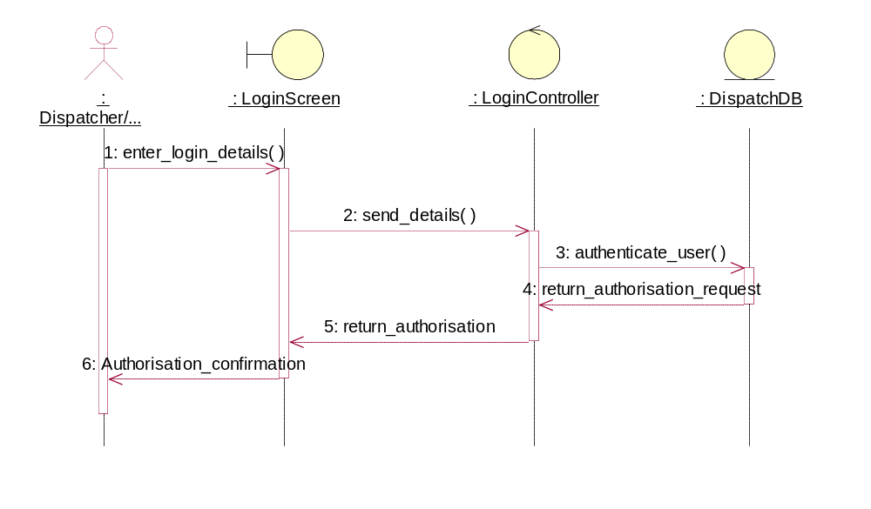

Description:

The Dispatcher can login with his username and password which will be checked with the database and s/he is logged in if the information typed in, is right.

8. Manage Users:

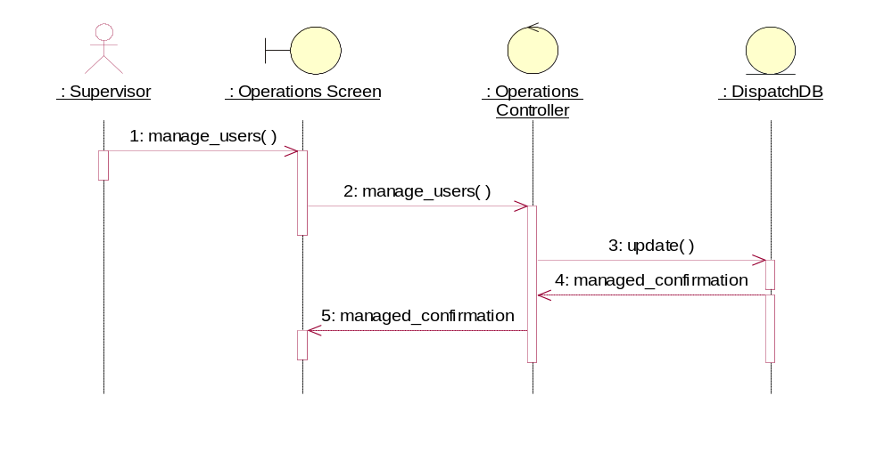

Description:

The supervisor can manage users by promoting them or suspending them, using the operations controller.

3.4.4.2 State Chart Diagram

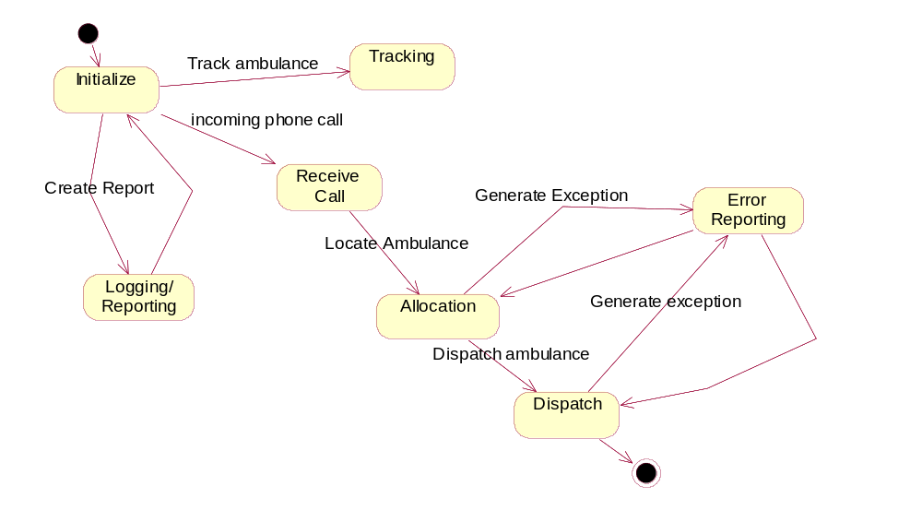

Description:

The state chart diagram shows all the states that the system goes through. When the dispatch system is initialized it can report, track and allocate ambulances when the proper details are given to it. It can also report errors and create exceptions.

    - User Interface

- This the login screen. The ambulance dispatcher will use his/her user ID and password to enter into ADS System.

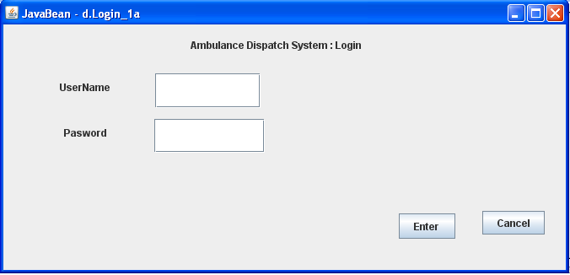

2. This is the screen for creating an incident, monitoring it and creating a report as per the ticket #.

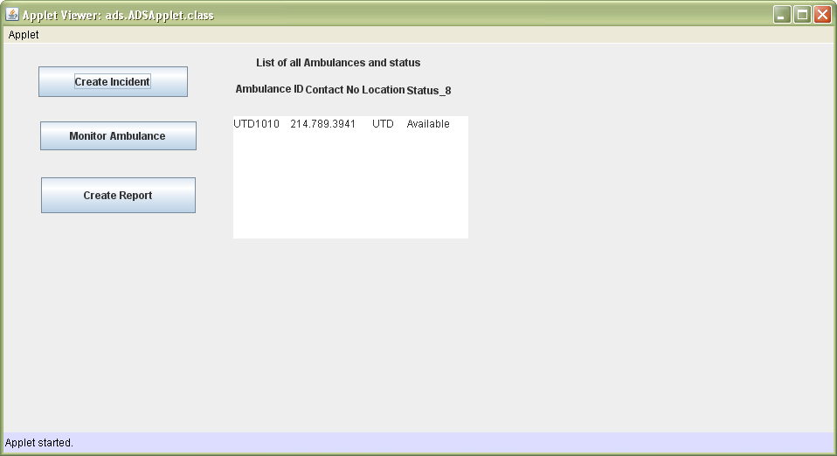

3. The full database for creating an incident.

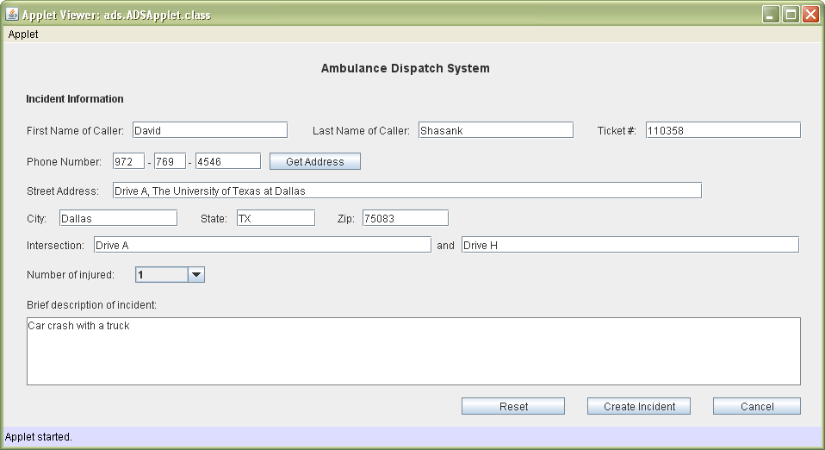

4. List of available ambulances with the distance.

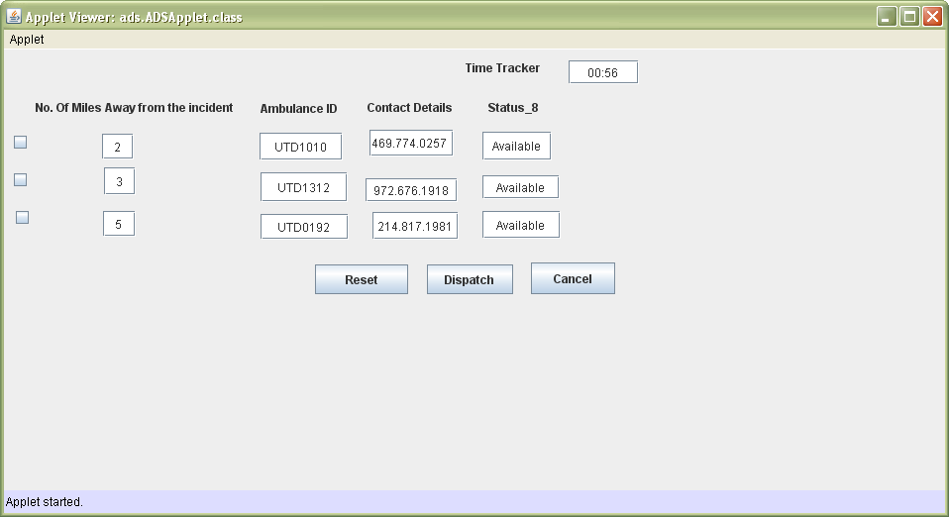

5. Exceptions.

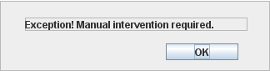

6. This is to manifest how we handle exceptions.

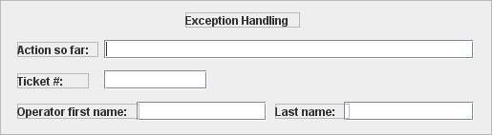

7. To show the data of caller and the respective dispatcher for allocation information.

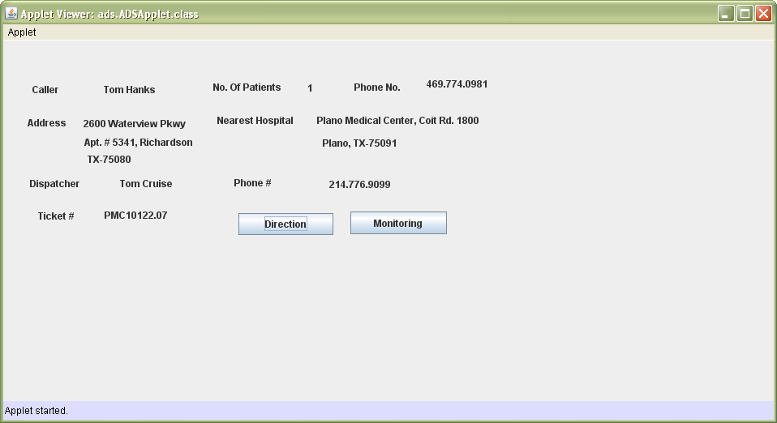

8. The Direction of the incident.

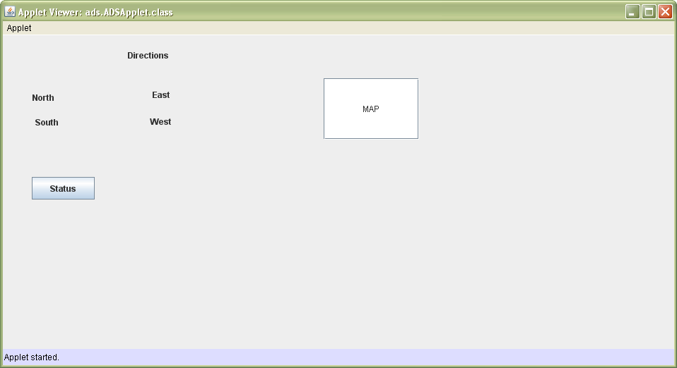

9. Monitoring the status.

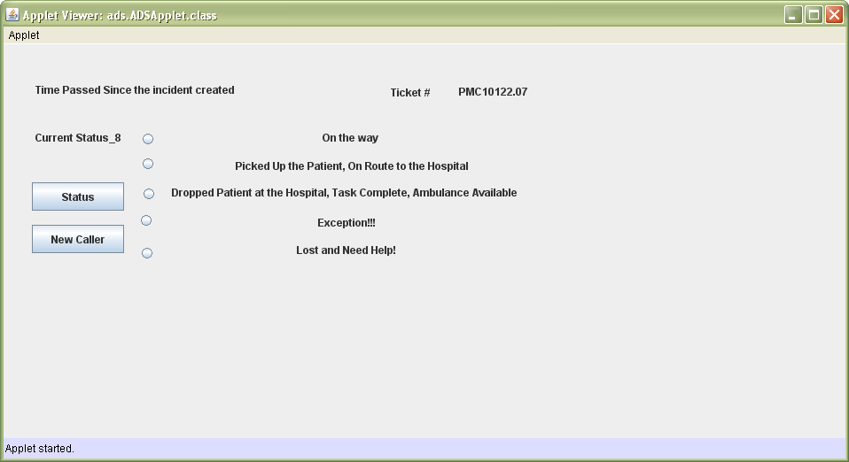

10. The final status of the ADS.

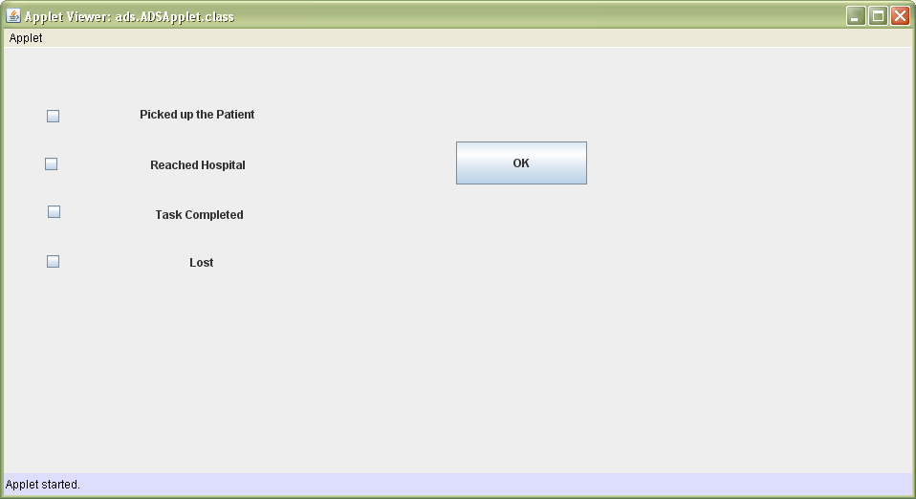

- Glossary

Incident: describes a case where some accident/emergency has taken place.

Allocation Information: Refers to information about the incident and also the route details from ambulance location to incident location.

