1.
Code:
import pandas as pd
from sklearn.model_selection import train_test_split
from sklearn.feature_extraction.text import CountVectorizer
from sklearn.naive_bayes import MultinomialNB
from sklearn.metrics import accuracy_score
# Load dataset
data = pd.read_csv("spam.csv")
# Features and target
X = data['Message']
y = data['Category']
# Convert text to numerical features
cv = CountVectorizer()
X = cv.fit_transform(X)
# Split dataset
X_train, X_test, y_train, y_test = train_test_split( X, y, test_size=0.2, random_state=42)
# Train model
model = MultinomialNB()
model.fit(X_train, y_train)
# Predict
y_pred = model.predict(X_test)
# Accuracy
print("Accuracy:", accuracy_score(y_test, y_pred))
Output:
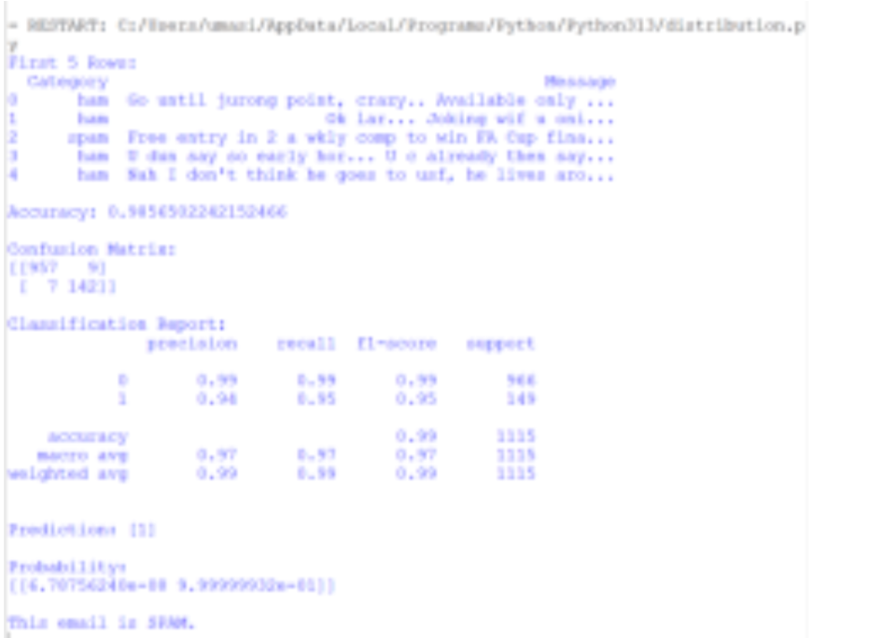
2.
Code:
import pandas as pd
from sklearn.model_selection import train_test_split from sklearn.tree import DecisionTreeClassifier
data = pd.read_csv("student.csv")
X = data[['StudyHours','Attendance','PreviousMarks']] y = data['Performance']
X_train, X_test, y_train, y_test = train_test_split(X, y, test_size=0.2)
model = DecisionTreeClassifier()
model.fit(X_train, y_train)
print(model.predict(X_test))
Output:
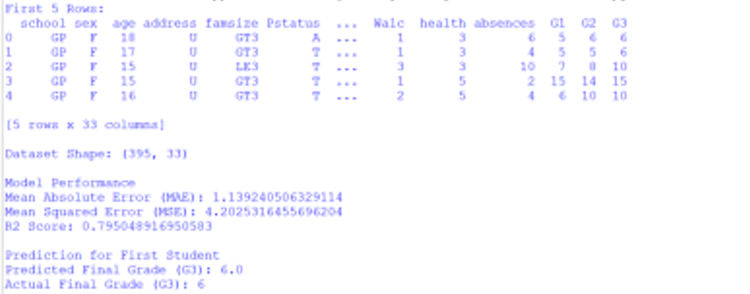
3.
Code:
import pandas as pd
from sklearn.model_selection import train_test_split
from sklearn.naive_bayes import GaussianNB
from sklearn.metrics import accuracy_score
data = pd.read_csv("weather.csv")
X = data[['Temperature','Humidity','WindSpeed']]
y = data['Weather']
X_train, X_test, y_train, y_test = train_test_split(X, y, test_size=0.2)
model = GaussianNB()
model.fit(X_train, y_train)
print(model.predict(X_test))
Output:
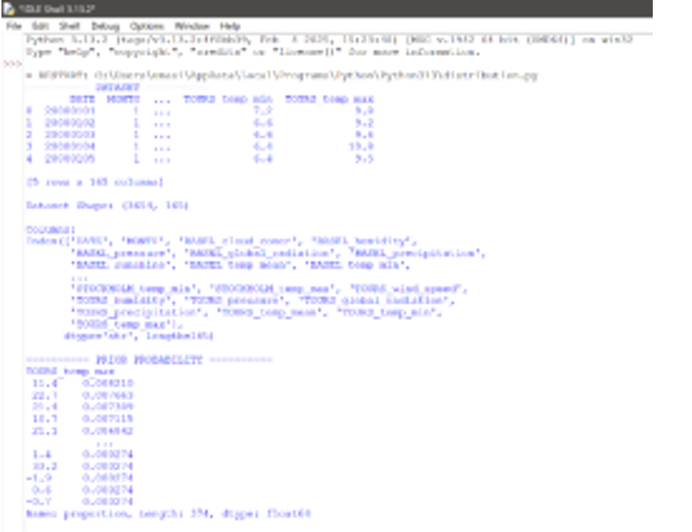
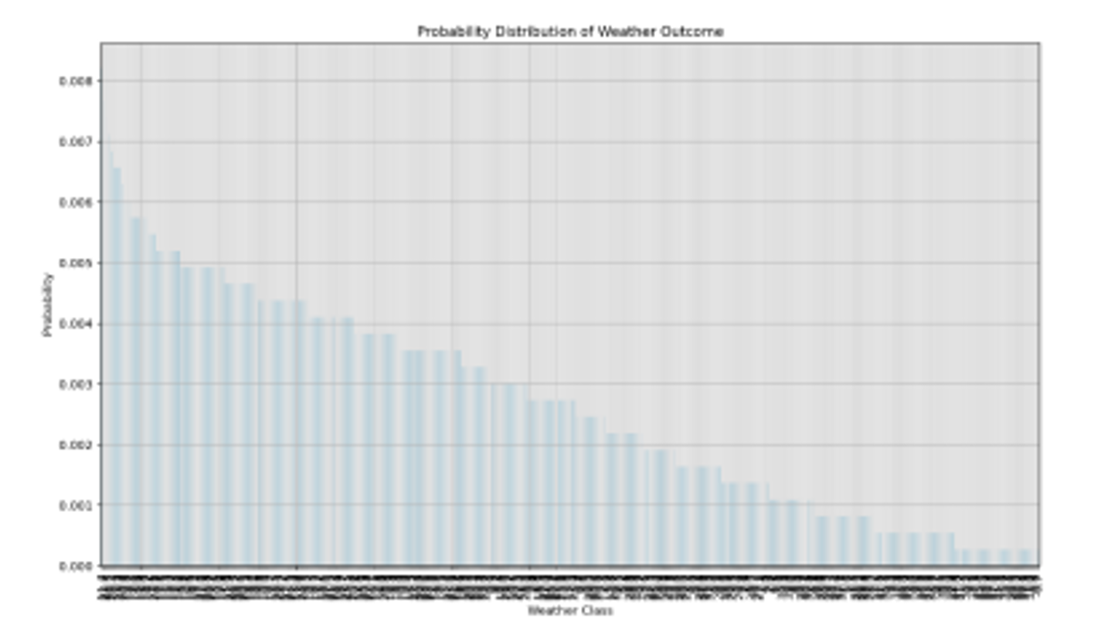
4.
Code:
import pandas as pd
from sklearn.model_selection import train_test_split
from sklearn.preprocessing import LabelEncoder
from sklearn.naive_bayes import GaussianNB
from sklearn.metrics import accuracy_score, confusion_matrix, classification_report data = pd.read_csv("fraud.csv")
le = LabelEncoder()
data['Type'] = le.fit_transform(data['Type'])
X = data[['Amount', 'Type']]
y = data['Fraud']
X_train, X_test, y_train, y_test = train_test_split(X, y, test_size=0.2)
model = GaussianNB()
model.fit(X_train, y_train)
y_pred = model.predict(X_test)
print("Accuracy:", accuracy_score(y_test, y_pred))
print(confusion_matrix(y_test, y_pred))
print(classification_report(y_test, y_pred))
Output:
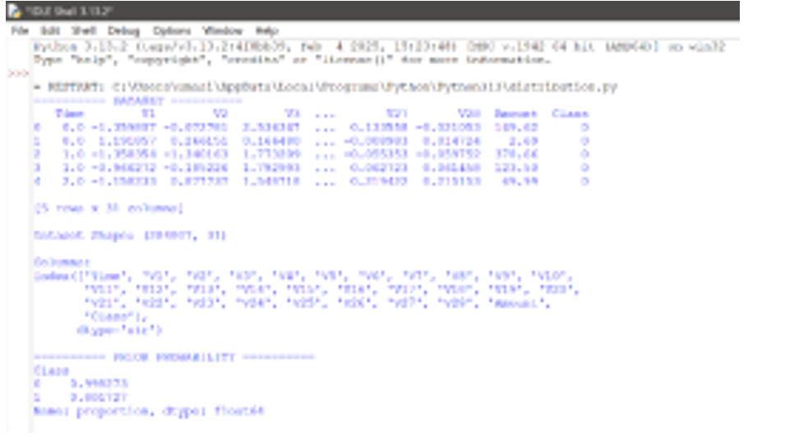
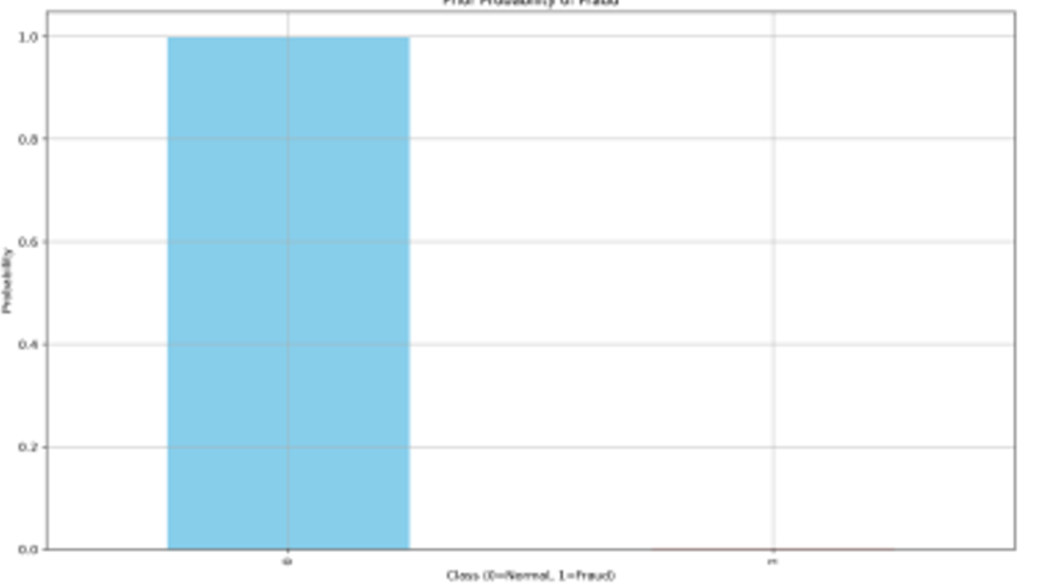
5.
Code:
import pandas as pd
from sklearn.model_selection import train_test_split
from sklearn.preprocessing import LabelEncoder
from sklearn.naive_bayes import GaussianNB
from sklearn.metrics import accuracy_score, confusion_matrix, classification_report data = pd.read_csv("fraud.csv")
le = LabelEncoder()
data['Type'] = le.fit_transform(data['Type'])
X = data[['Amount', 'Type']]
y = data['Fraud']
X_train, X_test, y_train, y_test = train_test_split(X, y, test_size=0.2)
model = GaussianNB()
model.fit(X_train, y_train)
y_pred = model.predict(X_test)
print("Accuracy:", accuracy_score(y_test, y_pred))
print(confusion_matrix(y_test, y_pred))
print(classification_report(y_test, y_pred))
Output:
