Queues
- Classic
- Quorum
Classic mirrored or quorum queues has to be used for scaled, reliable and performance intensive queues
In Classic mirrored queues, all requests are taken only by master while it is in sync with remaining nodes. Other nodes are just for backups and when master node is down a new node is selected as master and serves the request
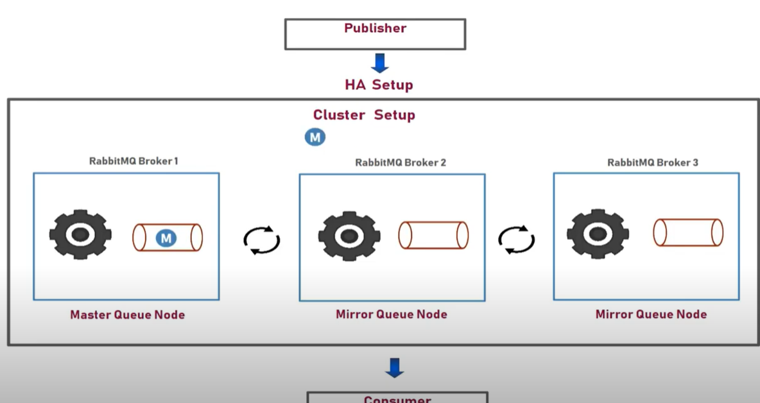

Durable QUEUE
Messages, exchanges, and queues that are not durable and persistent will be lost during a broker restart. If you cannot afford to lose any messages, make sure that your queue is declared as durable and your messages are sent with delivery mode "persistent".

Temporary QUEUE [Transient QUEUE]
Messages are not persisted on service restart. It can heave following settings
- Exclusive (used by only one connection and the queue will be deleted when that connection closes)
- Auto-delete (queue that has had at least one consumer is deleted when last consumer unsubscribes)
- Arguments (optional; used by plugins and broker-specific features such as message TTL, queue length limit, etc)

Dead Letter Exchanges

- The message is negatively acknowledged by a consumer using Basic.reject or Basic.nack with Requeue parameter set to false.
- The message expires due to per-message TTL; or
- The message is dropped because its queue exceeded a length limit

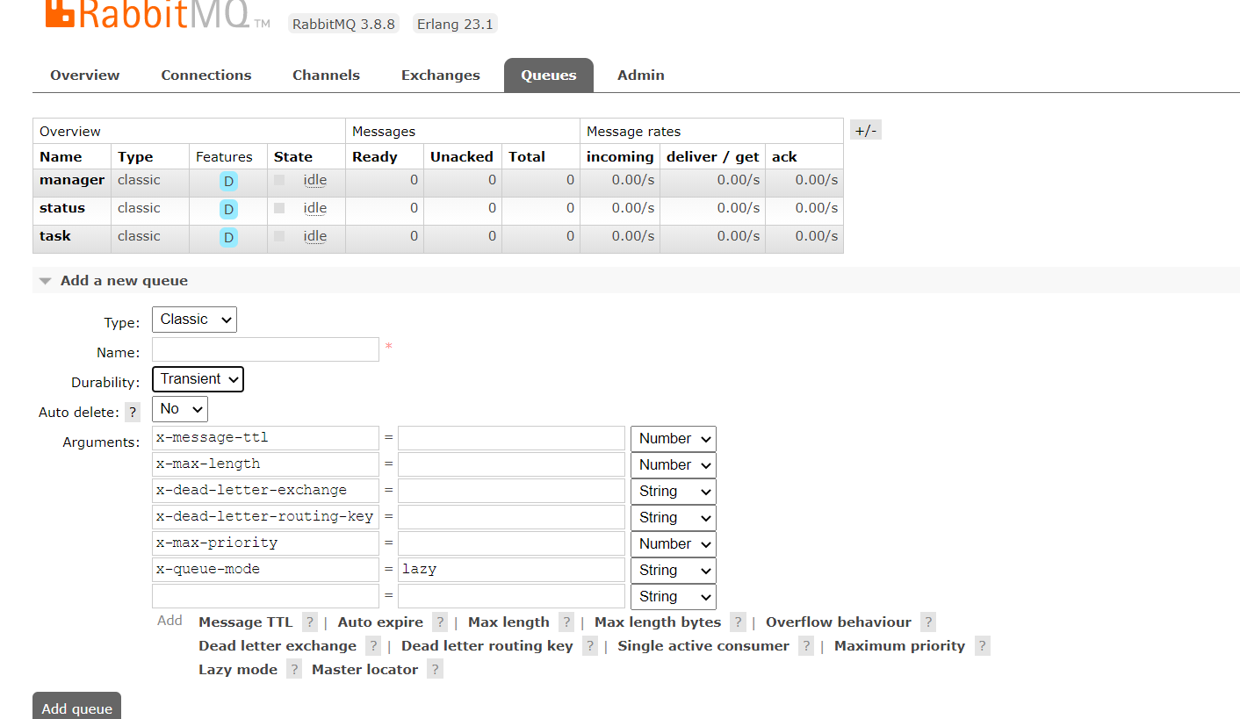

Lazy Queues - queues that move their contents to disk as early as practically possible, and only load them in RAM when requested by consumers, therefore the lazy denomination.
One of the main goals of lazy queues is to be able to support very long queues (many millions of messages). Queues can become very long for various reasons:

Exchanges
Messages are not published directly to a queue. Instead, the producer sends messages to an exchange. Exchanges are message routing agents, defined by the virtual host within RabbitMQ. An exchange is responsible for routing the messages to different queues with the help of header attributes, bindings, and routing keys.
The routing key is a message attribute the exchange looks at when deciding how to route the message to queues (depending on exchange type).
A binding is a "link" that you set up to bind a queue to an exchange.

Fanout:
A fanout exchange routes messages to all of the queues that are bound to it and the routing key is ignored. Simply can be used for broadcasting Broadcasting
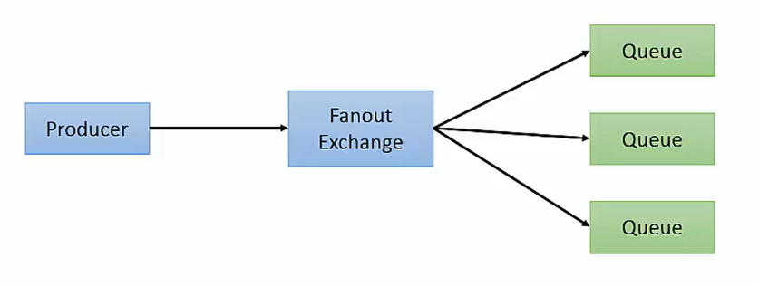
Default or direct Exchange:
Direct Exchange routes a message with a particular routing key to queues bound to that exchange with exact routing key
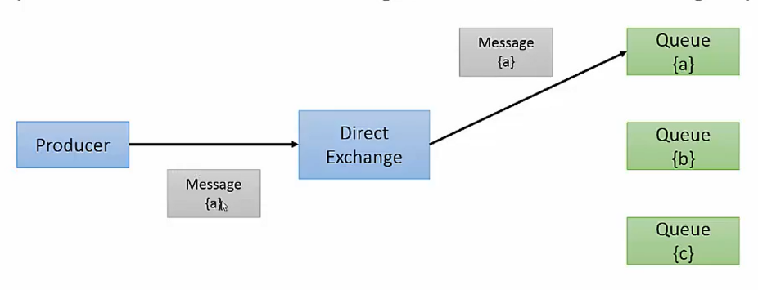

Topic exchange:
Routes a message with a particular routing key to queues whose routing key matches all or portion of routing key using wild cards like *, #
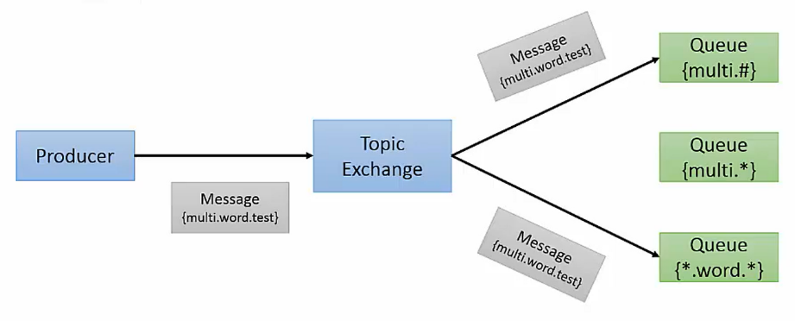

Routing key - multi.word.text
Binding Key – multi.* [N]
multi.*.text [Y]
*.word.* [Y]
multi.# [Y]

Headers Exchange:
Routes messages based on matching of message headers specified by binding queue. Can have ‘any’ or ‘all’ match criteria and can be matched in any order.
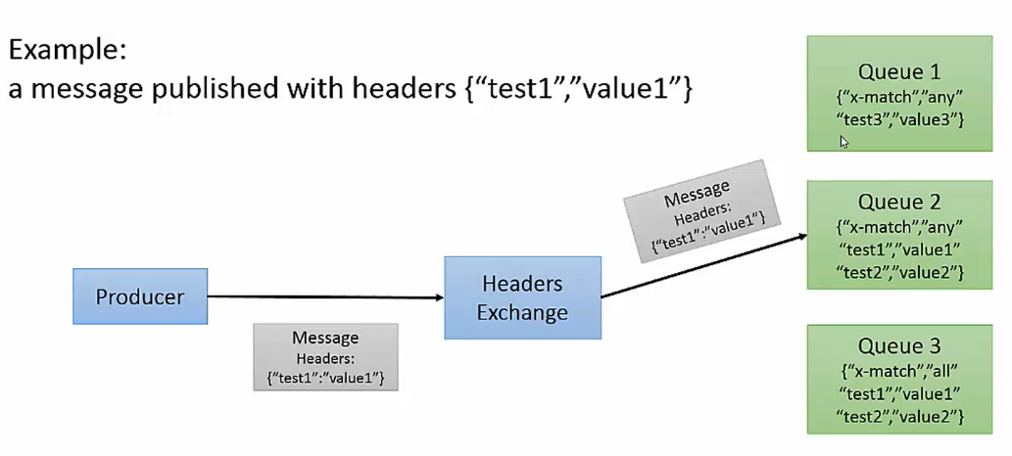

Plugins

Consistent Hash Plugin:
Ex:
  - Used to evenly distribute messages based on hashing.
Q1 - binding key - 10
Q2 - binding key - 10
Q3 - binding key – 10
  - Distributes messages on weightage. Q3 receives 5 times more msgs
Q1 - binding key - 10
Q2 - binding key - 10
Q3 - binding key – 50
Shovel Plugin:
Can reliably move messages from one source to other source [b/w brokers].
