Node.js
Node.js is a runtime environment for javascript. It is single threaded and uses a non-blocking, event-driven architecture, which allows it to handle multiple connections simultaneously without getting blocked.

V8 engine vs Libuv
In the Node.js architecture, V8 handles JavaScript code execution, while libuv handles the I/O capabilities

V8 engine
It is a JavaScript engine developed by Google to provide runtime environments for javascript
- It is responsible for executing JavaScript code and providing the runtime environment for JavaScript applications
- V8 is written in C++ which compiles JavaScript code into optimized machine code using just-in-time (JIT) compilation techniques
- Performance improvement, memory management, garbage collection, and an API for embedding it in other applications.

Libuv
libuv is a multi-platform library that is integrated with V8 in the Node.js runtime. It handles I/O operations, such as file system operations, network sockets, and threading, in a non-blocking manner, allowing Node.js applications to handle many concurrent operations efficiently.

Eventloop: Event loop allows nodejs to perform nonblocking IO operations efficiently. It continuously checks for events and executes the corresponding event handlers
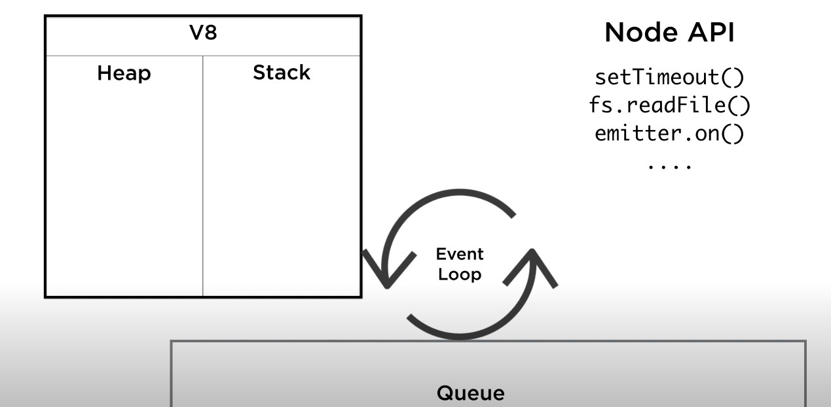

Asynchronous programming

In Node.js, asynchronous programming enables concurrent handling of multiple tasks, ensuring efficient execution without blocking I/O operations.

Async function always returns a promise. It allows the function to use the "await" keyword inside its body, enabling sequential execution of asynchronous operations [tasks that can be executed independently of the main program flow] within the function while maintaining readability and avoiding callback hell.
const func = async () =>{
return "hello"
}
const funcReturns = func();
console.log("type: ",typeof funcReturns)
console.log("value: ",funcReturns)
// output
type: object
value: Promise { 'hello' }

HTTP request with single threading
When Node.js receives an HTTP request, It treats as an event and registers a callback function to handle the request and continues to process other requests. The single threaded event loop is responsible check the events from queue and execute corresponding event handler

Callback
A callback is a function that is passed as an argument to another function and is executed at a later point in time, typically when a certain event or task completes.
function calculateAsync(num1, num2, callback) {
setTimeout(function() {
const result = num1 + num2;
callback(result);
}, 2000);
}

Callback hell
It refers to a situation in asynchronous JavaScript programming where multiple nested callbacks are used, leading to code that is difficult to read, understand, and maintain.
It occurs when you have a chain of asynchronous operations that depend on each other, resulting in deeply nested callback functions.

Error-first callback:
An "error-first" callback pattern is a convention used in Node.js for handling asynchronous operations
function divideAsync(dividend, divisor, callback) {
if (divisor === 0) {
const error = new Error('Division by zero');
callback(error);
return;
}
const result = dividend / divisor;
callback(null, result);
}

function handleResult(error, result) {
if (error) {
console.error('Error:', error.message);
return;
}
console.log('Result:', result);
}

divideAsync(10, 2, handleResult);

Promise
import { readFile } from 'node:fs/promises';

const data = await readFile("./auth.js", "utf-8");
console.log(data)

const fs = require('fs');

function readFileAsJSON(filePath) {
return new Promise((resolve, reject) => {
fs.readFile(filePath, 'utf8', (err, data) => {
if (err) {
reject(err); // Reject the promise with the error
} else {
try {
const json = JSON.parse(data);
resolve(json); // Resolve the promise with the parsed JSON
} catch (err) {
reject(err); // Reject the promise if JSON parsing fails
}
}
});
});
}

readFileAsJSON('data.json')
.then(jsonData => {
console.log(jsonData);
})
.catch(error => {
console.error('Error:', error);
});

Promise.all
const axios = require('axios');

const postData = [
{ title: 'Post 1', body: 'This is the body of post 1' },
{ title: 'Post 2', body: 'This is the body of post 2' },
{ title: 'Post 3', body: 'This is the body of post 3' }
];

const postRequests = postData.map(post => {
return axios.post('https://api.example.com/posts', post);
});

Promise.all(postRequests)
.then(responses => {
console.log('All POST requests completed successfully');
responses.forEach(response => {
console.log('Response:', response.data);
});
})
.catch(error => {
console.error('An error occurred:', error);
});

Streaming
Streaming in Node.js refers to the ability to process data in small, manageable chunks (or streams) as it is being read from or written to a source. It allows for efficient handling of large amounts of data without requiring the entire dataset to be loaded into memory at once.
const fs = require('fs');
const readableStream = fs.createReadStream('input.txt');
readableStream.on('data', (chunk) => {
console.log(`Received chunk: ${chunk}`);
});
readableStream.on('end', () => {
console.log('Finished reading the file.');
});

Event emitter
An event emitter is a design pattern that allows objects to emit named events and register interest in those events.It facilitates communication and coordination between different parts of a Node.js application.
const EventEmitter = require('events');

const myEmitter = new EventEmitter();
myEmitter.on('myEvent', (arg1, arg2) => {
console.log('Event triggered:', arg1, arg2);
});

myEmitter.emit('myEvent', 'Hello', 'World');

Express.js:
"C:\Users\pavan\Downloads\interview\nodejs\simpleindex.js"

Attacks: Helmet
Cross-Site Scripting (XSS): XSS attacks occur when an attacker injects malicious scripts into a web application, which are then executed in the browsers of other users. This allows the attacker to steal sensitive information, manipulate content, or perform other malicious activities.
Cross-Site Request Forgery (CSRF): CSRF attacks occur when a malicious website tricks a user's browser into making unauthorized requests to a different website where the user is authenticated. Attackers exploit the trust that a website has in the user's browser to perform actions on behalf of the user without their consent.
SQL Injection: SQL injection attacks occur when an attacker inserts malicious SQL statements into an application's database query, allowing them to manipulate or disclose sensitive data, modify the database, or even execute arbitrary commands.
Denial-of-Service (DoS) and Distributed Denial-of-Service (DDoS): DoS and DDoS attacks aim to overwhelm a web application or its underlying infrastructure with a high volume of traffic, causing the application to become slow or inaccessible, thus disrupting its normal functioning.
Brute-Force Attacks: Brute-force attacks involve systematically attempting different combinations of usernames and passwords to gain unauthorized access to user accounts.
app.use(bodyparser.urlencoded({ limit: "50mb", extended: true }));
app.use(bodyparser.json({ limit: "50mb" }));
app.use(cors());
app.use(xFrameOptions());
app.use(helmet.frameguard({ action: "sameorigin" }));
app.use(helmet.xssFilter());
app.use(helmet.noSniff());
app.use(helmet.ieNoOpen());
app.use(helmet.hidePoweredBy());
app.use(
helmet.hsts({
maxAge: sixtyDaysInSeconds,
includeSubDomains: false,
})
);
app.use(
helmet.hpkp({
maxAge: ninetyDaysInSeconds,
sha256s: ["AbCdEf123=", "ZyXwVu456="],
setIf: function (req, res) {
return req.secure;
},
})
);
app.use(
helmet.contentSecurityPolicy({
directives: {
defaultSrc: ["'self'"],
styleSrc: ["'self'", "maxcdn.bootstrapcdn.com"],
},
})
);

OAuth
OAuth (Open Authorization) is an open standard for access delegation commonly used as a way for Internet users to grant websites or applications access to their information on other websites but without giving them the passwords.
Flow
- The client requests authorization from the resource owner (user).
- The resource owner authorizes the client and provides a grant.
- The client requests an access token from the authorization server using the grant.
- The authorization server authenticates the client and validates the grant, then issues an access token.
- The client uses the access token to access protected resources on the resource server.
Types
Implicit Grant
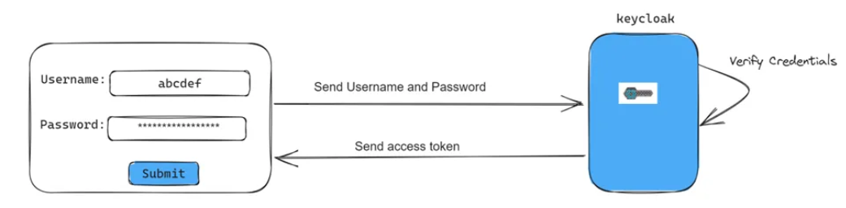
Authorization Code Grant
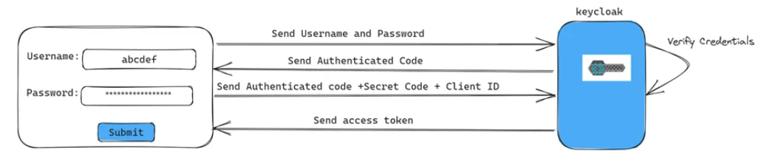
Resource Owner Password Credentials Grant
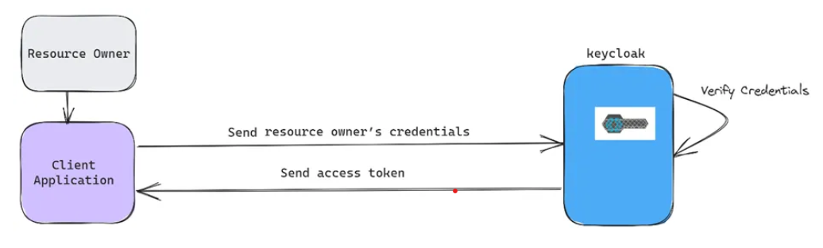
Client Credentials Grant
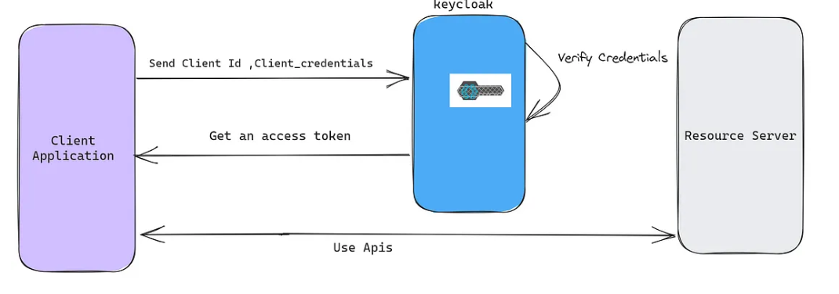
Refresh Token Grant
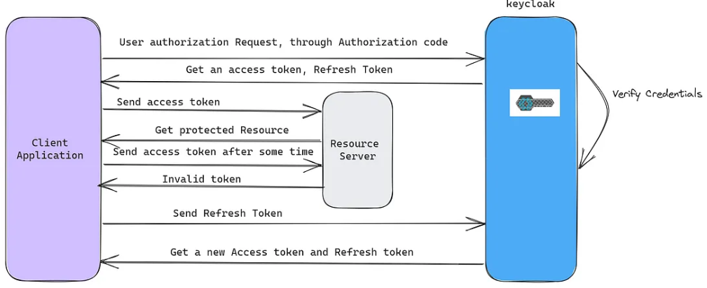

JWT
JWTs is used for authentication and information exchange in web applications. A JWT is composed of three parts: a header, a payload, and a signature. These parts are concatenated with dots to form a compact, URL-safe string.
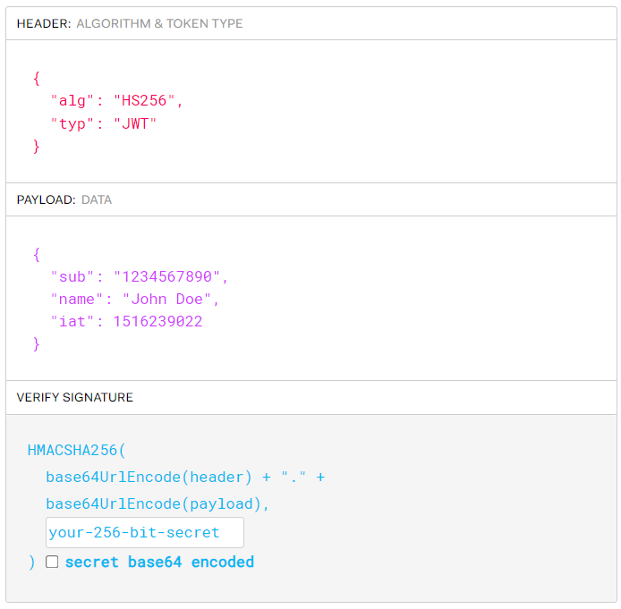
Header: The header of the JWT specifies the algorithm used to create the signature (e.g., HMAC SHA-256, RSA). The algorithm determines how the signature is calculated and verified.
Payload: Data to be communicated
Signature: The signature is a cryptographic hash or digital signature that uniquely represents the contents of the JWT. When the JWT is received and needs to be validated, the recipient recalculates the signature using the same algorithm and the shared secret key or public key. If the recalculated signature matches the one provided in the JWT, it indicates that the token is authentic and hasn't been tampered with.

SSO
Single Sign-On is an authentication process that allows users to access multiple applications or services with a single set of credentials (such as username and password). Once authenticated, users can access other applications without having to re-enter their credentials.
Identity Provider (IdP): is responsible for authenticating users and providing identity information to other service providers. It manages user authentication and issues authentication tokens.
A Service Provider (SP): is an application or service that relies on the Identity Provider for user authentication. It consumes authentication tokens issued by the IdP to grant access to its resources.
SSO protocols and standards
SAML (Security Assertion Markup Language):
- SAML is typically used for web-based SSO scenarios, especially in enterprise environments. It is well-suited for federated identity management across different organizations and domains.
- SAML messages are XML-based and use XML digital signatures for security.
- It uses a browser-based redirection flow (POST or Artifact binding) or a back-channel SOAP-based flow for communication between the identity provider (IdP) and service provider (SP).
OpenID Connect (OIDC)
- OpenID Connect is primarily used for consumer-facing SSO scenarios, such as social login and identity federation for web and mobile applications. It is often used in conjunction with OAuth 2.0 for authorization.
- OpenID Connect messages are JSON-based and use JSON Web Tokens (JWTs) for security.
- IDC uses a RESTful API-based flow and relies on JSON-based messages exchanged between the OpenID Connect provider (OP) and relying party (RP).
OAuth (Open Authorization) :
LDAP (Lightweight Directory Access Protocol)
OAuth 2.0 with OIDC (OpenID Connect)

Axios Interceptors
const axios = require('axios');
// Create an Axios instance
const axiosInstance = axios.create();

// Set the initial JWT token
let authToken = 'initial-token-value';
// Request interceptor
axiosInstance.interceptors.request.use(
config => {
// Add the JWT token to the Authorization header
config.headers['Authorization'] = `Bearer ${authToken}`;
return config;
},
error => {
return Promise.reject(error);
}
);
// Response interceptor
axiosInstance.interceptors.response.use(
response => {
// Process successful responses
return response;
},
async error => {
const originalRequest = error.config;

// Check if the response status is 401 (unauthorized) and the error message is "Token expired"
if (error.response.status === 401 && error.response.data.message === 'Token expired') {
try {
// Perform a request to refresh the JWT token
const refreshTokenResponse = await axiosInstance.post('https://api.example.com/refresh-token', {
refreshToken: 'your-refresh-token'
});

// Update the JWT token
authToken = refreshTokenResponse.data.accessToken;

// Update the Authorization header of the original request
originalRequest.headers['Authorization'] = `Bearer ${authToken}`;

// Retry the original request
return axiosInstance(originalRequest);
} catch (refreshError) {
// Handle the refresh token request error
return Promise.reject(refreshError);
}
}
// For other errors, reject the promise
return Promise.reject(error);
}
);

// Make a request using the Axios instance
axiosInstance.get('https://api.example.com/protected-endpoint')
.then(response => {
console.log('Response:', response.data);
})
.catch(error => {
console.error('Error:', error);
});

