Box model
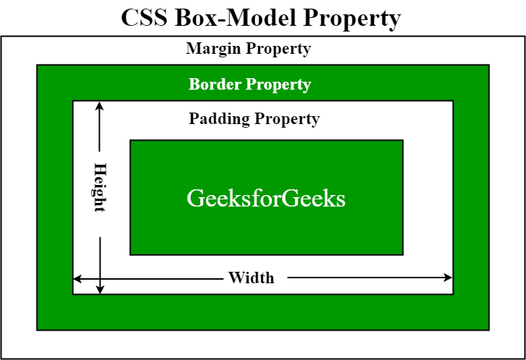

Display property
- block: takes the full width available and starts on a new line. stack vertically by default, and you can set properties like width, height, margin, and padding on them.
- inline: don't start on a new line and only take up the necessary space for their content. You cannot set width, height, margin-top, margin-bottom, and padding-top, padding-bottom
- inline-block: This value combines the characteristics of inline and block. Allows the setting of width, height, margin, and padding.
- none: This value makes an element disappear from the document flow.
- flex: This value enables a flex container
- grid: This value enables a grid container, and the element becomes a grid item.

Position
- static: This is the default value. Positioned according to the normal flow of the document. No effect for Top, right, bottom, left, and z-index properties
- relative: Positioned relative to their normal position in the document flow. You can modify their position using the top, right, bottom, and left properties. No effect on other element positions
- absolute: Positioned relative to their nearest positioned ancestor, or the initial containing block if no positioned ancestor is found. It is taken out of the normal document flow, and its position can be set using the top, right, bottom, and left properties. No effect on other elem
- fixed: Positioned relative to the viewport and remain fixed in their position even when the page is scrolled. They are not affected by scrolling. You can use the top, right, bottom, and left properties to position them.
- sticky: Elements with position: sticky are positioned based on the user's scroll position. They behave like position: relative until the element reaches a specified threshold, then they become position: fixed. This allows elements to "stick" to a specific position as the user scrolls.

- What are media queries in CSS? How are they used for responsive web design?
- What is the purpose of the z-index property in CSS? How does it work?

Pseodo classes
Psuedo functions

Vendor prefixes
-webkit-border-radius: 5px;
-moz-border-radius: 5px;
-ms-border-radius: 5px;
-o-border-radius: 5px;
border-radius: 5px;

Z-index:
- The z-index property only works on positioned elements, i.e., elements with position set to relative, absolute, or fixed.
visibility: hidden (or) opacity: 0 = hide an element visually without affecting its layout.

Center divs
Apply these styles to parent div
.page-center {
position: absolute;
top: 50%;
left: 50%;
transform: translate(-50%, -50%);
}
.horizantal-center {
margin: 0;
position: absolute;
left: 50%;
transform: translateX(-50%);
}
.vertical-center {
margin: 0;
position: absolute;
top: 50%;
transform: translateY(-50%);
}

.horizantal-flex-center {
display: flex;
justify-content: center;
}
.vertical-flex-center {
display: flex;
align-items: center;
height: 100px;
}
.flex-center {
display: flex;
justify-content: center;
align-items: center;
height: 100vh;
}

SCSS
- It is a preprocessor that allows you to write CSS code in a more organized and efficient manner.
- SCSS introduces additional features like variables, nesting, mixins.
- SCSS supports the @import directive for importing other SCSS files into a main SCSS file.
- SCSS introduces the @use directive for importing modules, which provides better scoping and avoids global namespace conflicts.
Nesting: Nesting in SCSS is a powerful feature that allows you to nest CSS selectors inside one another, following the visual hierarchy of your HTML structure
Improves readability by clearly reflecting the relationships between parent and child elements.
‘&’ refers the immediate parent selector
.navbar {
background-color: #333;

ul {
list-style: none;

li {
display: inline-block;

&:hover {
text-decoration: underline;
}
}
}
}

/* Output */
.navbar {
background-color: #333;
}
.navbar ul {
list-style: none;
}
.navbar ul li {
display: inline-block;
}
.navbar ul li:hover {
text-decoration: underline;
}

Keys
- & - refers to parent selector where it can be used for
- @ - annotated before builtin function
- $ - Declare variable
Note:
- you cannot directly import a CSS file into an SCSS file. Instead copy css in to that scss file
- commenting is same in css and scss except, comments cant be seen in scss compiled output file
Data Types:
$number: 42;
$string: "Hello, world!";
$color: #ff0000;
$boolean: true;
$list: 1, 2, 3;
$map: (name: "John", age: 30);
$null: null;

Control Directives
For
.button {
@for $i from 1 through 3 {
&:nth-child(#{$i}) {
margin-left: 10px * $i;
}
}
}

If ElseIf Else:
$color: green;

.button {
@if $color == red {
background-color: red;
}
@else if $color == blue {
background-color: blue;
}
@else {
background-color: green;
}
}

@each:
$breakpoints: (
small: 480px,
medium: 768px,
large: 1024px
);

@each $breakpoint, $size in $breakpoints {
@media (min-width: $size) {
.container-#{$breakpoint} {
width: 100%;
}
}
}

Partials
- Partials in SCSS are separate SCSS files that are intended to be imported into other SCSS files.
- They are typically used to modularize stylesheets into smaller, more manageable pieces.
- Partial files are identified by prefixing their filenames with an underscore (_), which tells the SCSS compiler not to compile them into separate CSS files.
@import 'variables';
@import 'mixins';

@use: It provides improved scoping and modularity, making it the recommended approach for including external stylesheets or modules in your SCSS code.
@use 'buttons' as btns;
.btn-primary {
@extend btns.primary;
}

Import vs Use
@import | @use
Deprecated from Sass 3.5.
No scoping & no private name space  imported styles will be at current file's global scope | Scope :  creates a private namespace, means the imported styles or members are not accessible outside the current file.  @use 'buttons' as btns;  Explicit global scoping  @use 'global-styles' as *;
No Selective imports  Imports entire file that an lead to naming conflicts | Selective imports also known as member forwarding  @use 'colors' with (  $primary-color,  $secondary-color  );

Mixins are a powerful feature that allows you to define reusable blocks of CSS code.
@mixin text-style($font-size: 14px, $color) {
font-size: $font-size;
color: $color;
}
.heading {
@include text-style(24px, #333);
font-size: 10px;
}

/* Output */
.heading {
font-size: 10px;
color: #333;
}

Inheritance: It is typically used when you want to apply a common set of styles to multiple selectors, maintaining consistency and reducing code duplication
1) Responsive Styling:
.container {
display: flex;
justify-content: center;
}
@media (min-width: 768px) {
.large-container {
@extend .container;
padding: 20px;
}
}
@media (min-width: 1024px) {
.extra-large-container {
@extend .large-container;
padding: 40px;
}
}

2) Themes:
.theme-base {
background-color: #f0f0f0;
color: #333;
}
.light-theme {
@extend .theme-base;
background-color: #fff;
}
.dark-theme {
@extend .theme-base;
background-color: #222;
color: #fff;
}

