StoryBook
It is used to develop UI components in isolated environment. We can build, test, and showcase UI components in various states without needing to integrate them into a full application.
Addon Ecosystem: Storybook provides a rich ecosystem of addons that enhance its capabilities. Addons allow you to perform tasks like live documentation generation, testing, accessibility checking, and more.
eslint-plugin-storybook
Story: Each story represents a different state or variation of a component
Installation:
npx sb init

.storybook
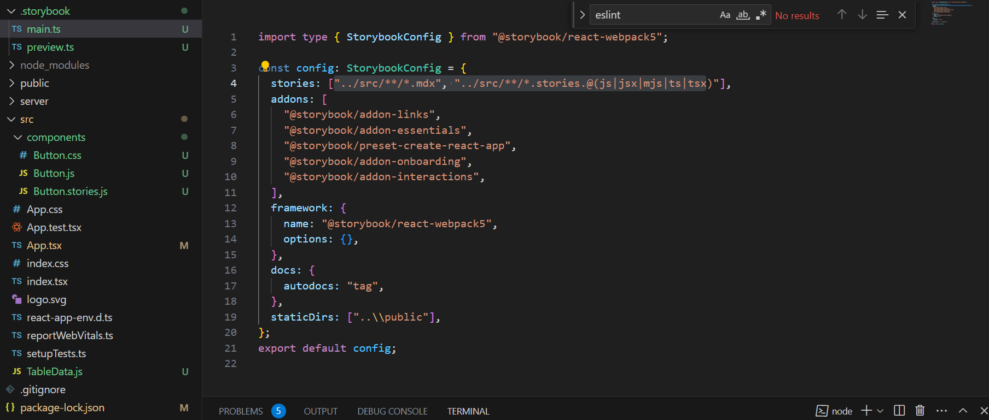
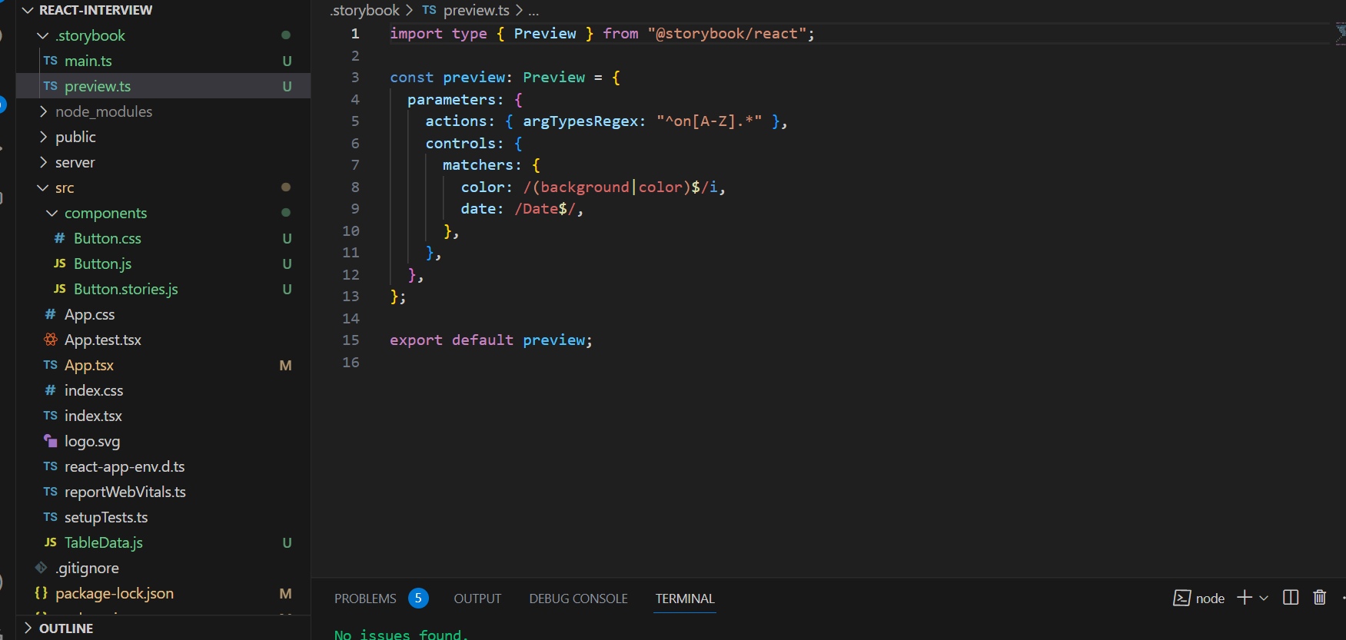

Button Story
import React from "react";
import Button from "./Button";

export default {
title: 'Form/Button',
component: Button
}

export const Primary = () => <Button variant="primary" label='mylabel'></Button>
Primary.storyName = "primarybtn"

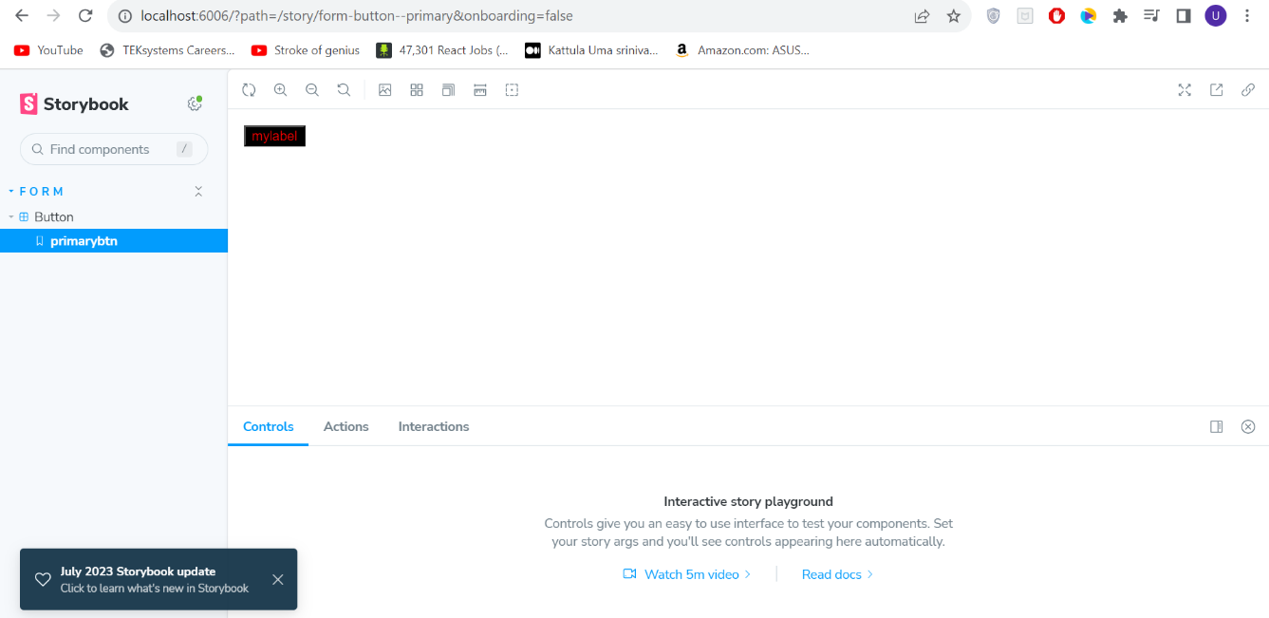

Args
Args allow us to specify default values for component props when defining stories. Also we can easily create variations of components and showcase them with different prop values without writing separate stories for each variation
const Template = args => <Button {...args} />
export const defaultTemplate = Template.bind({})
defaultTemplate.storyName="default"
defaultTemplate.args = {
variant:"lprimary",
label:'lmylabel'
}

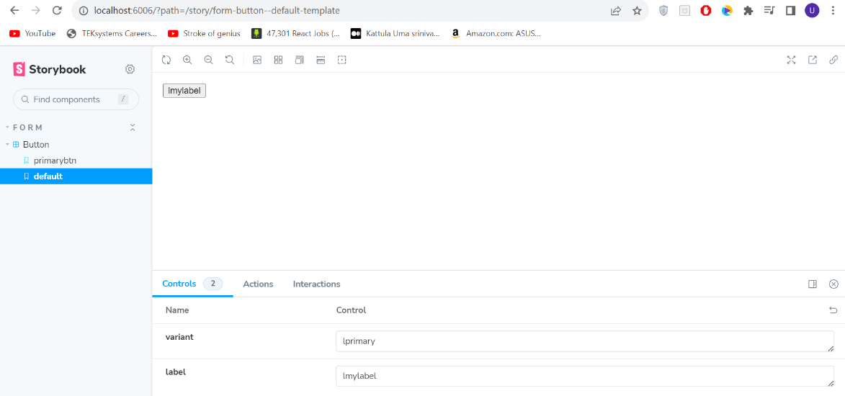
Decorators:

decorators are higher order functions that wraps component stories. They allows us to modify their appearance, behavior, or context. Decorators are useful for applying common styles, setting up contexts like themes or data providers

export default {
title: 'Form/Button',
component: Button,
argTypes: {
onClick: ()=>{return ({})}
},
decorators: [story=><Center>{story()}</Center>]
}

AddDecorator: Multiple decorators can be added using this function

AddOns

Viewport addon add on is used to test in mobile and other devices
Addon-console: to console log in panel instead of in dev console
Addon-docs: can generate docs from compoenent
Knobs allow us to dynamicslly change the values

