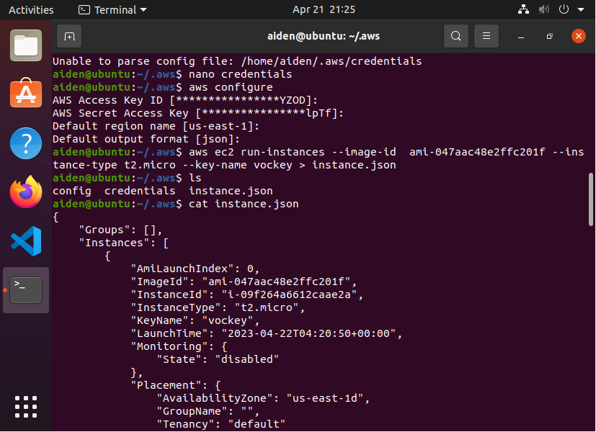

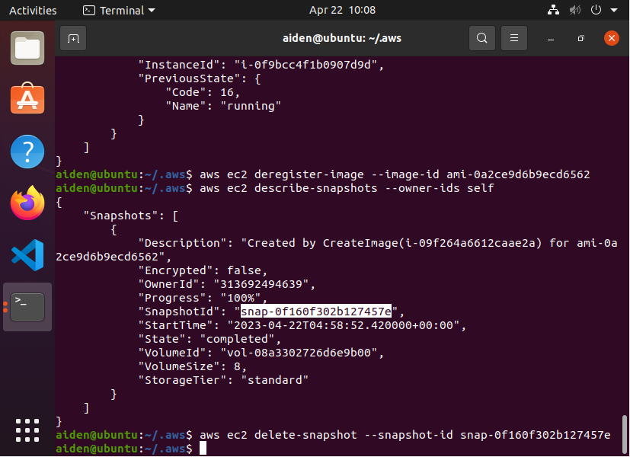

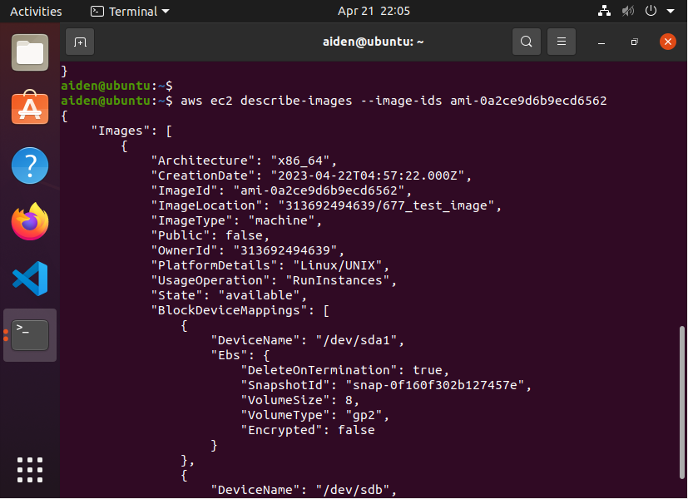

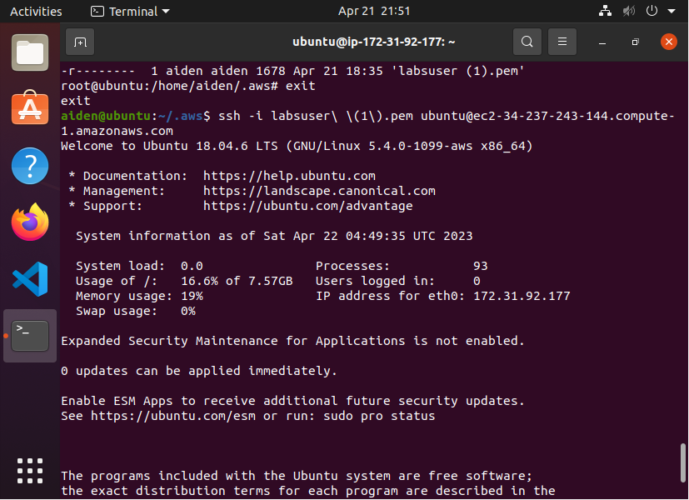

Create instance:3.5s

Discribe instance:2.5s

Set firewall:1s

Ssh login:2.5s

Create image:2s

Check image state:2s

Time for image become available:4min

Terminate instance:1.5s

First instance id:i-09f264a6612caae2a

Ami of ubuntu18.04:see website

Second instanc id:i-0f9bcc4f1b0907d9d

Ami of umass-677-test:ami-0a2ce9d6b9ecd6562

The aws charge 0.0116 per hour for t2.micro type instances, and will give each customer 100GB free data usage for data transfer out from the ec2 to the internet, and all ingoing traffic are free.

Overall, this lablet costs less than 1 cent.