**Introduction to Computer Science**

Reference: Gaddis 1.1, 1.2, 1.4, 1.6

The 4 requirements of a computer:

Which of these is a computer?

C:\Program Files\Microsoft Office\MEDIA\CAGCAT10\j0212957.wmf  

Most computers today are based on the von Neumann machine:

Why do we need languages like Java for programming a computer?

What is a program?

Programming Languages (see pg. 7 for a larger list)

**The Programming Process**

High Level Steps

1. Design
2. Implement with correct syntax and style
3. Test & Correct

A. Design Steps in Detail

What is an Algorithm?

Is this an Algorithm?

**Algorithm to earn an "A" in this course**

For every class meeting

be on time

be prepared

participate

complete all assignments

Is this an Algorithm?

**Algorithm to determine Lab grade**

For every lab in course

take lab grade and add to MyTotal

take possible lab points and add to Total

Divide MyTotal by Total to find percentage

Let’s Practice! Write an algorithm to make a peanut butter sandwich (assume all of your ingredients are on your table)

B. Implement with Correct Syntax and Style – Step Detail

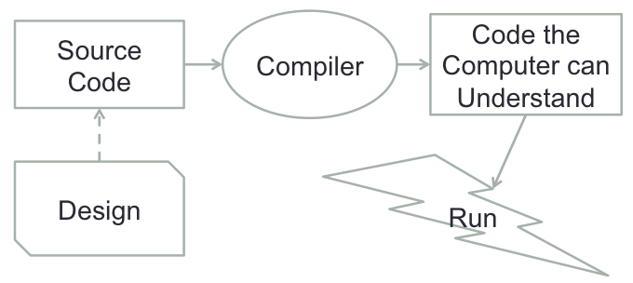

1. Write the code & compile it
2. Correct compiler errors

import java.util.Scanner;

public class Mystery

{  
 public static void main( String [ ] args )  
 {  
 int testGrade;

int betterGrade;

Scanner myScan = new Scanner (System.in);

System.out.println ("What is your test grade?");

testGrade = myScan.nextInt();

betterGrade = testGrade + (100 - testGrade) * 0.5;

System.out.println("Your new grade is " + betterGrade);

}

}

C. Test & Correct - Details

1. Run program to see if it works right
2. Correct any problems found while running it
3. Make sure the program solves the original problem

*Summary of Steps*

1. Clearly define what the program should do
2. Visualize the program running on the computer
3. Use design tools to represent the program
4. Test if the design works
5. Write the code & compile it
6. Correct compiler errors
7. Run program to see if it works right
8. Correct any problems found while running it
9. Make sure the program solves the original problem