**Human Computer Interaction**

**What is HCI?**

Goals:

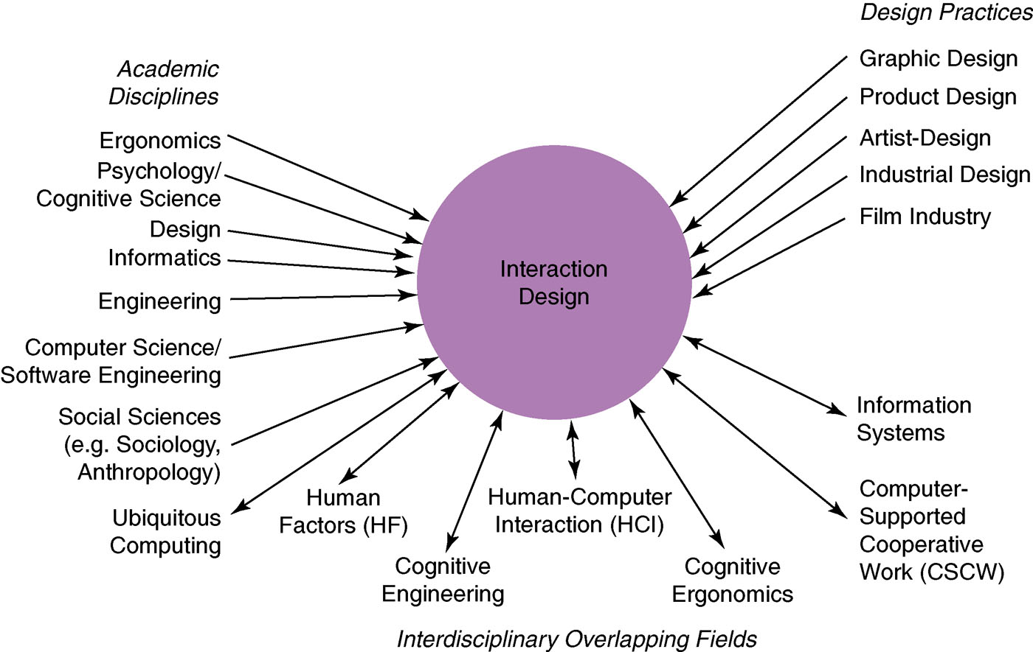

What are examples of interfaces you like?

What are examples of interfaces you don’t like?

**How can we design interfaces like the ones we like?**

*Six Principles*

Example: <http://www.loyola.edu>

Pros Cons

**How do we analyze a design?**

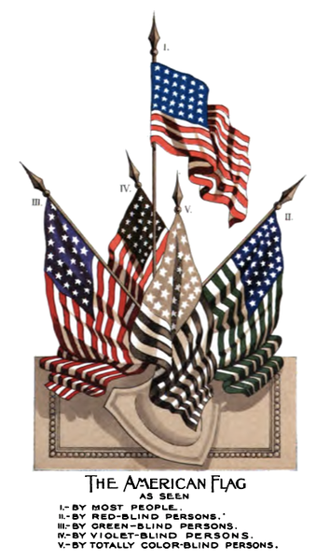**Universal Usability**

GOAL:

Differences:

**What about Usability in CS201?**

**Summary:**

* What is HCI
* Who does HCI
* Six Principles
* Universal Usability
* How we’ll use it in class