**MCj03612680000[1]Making Decisions**

Reference: Gaddis 3.1

Topics: if statements, flow charts

**Problem:** We need to calculate the average temperature in our dorm room over three days, and only tell the administration it is too hot if the average temperature is at least 70. The temperatures will be input through console input.

Algorithm:

**How do we turn this into code?**

* To make a decision, we use relational operators to compare
* To have the code make the decision, we put the relational operators into an

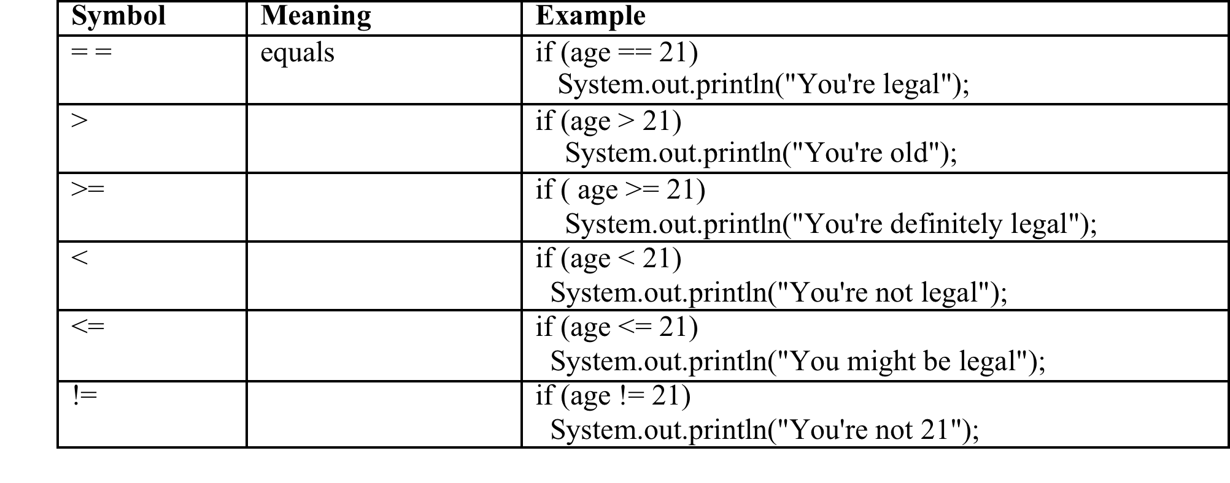

**Code for 1 choice, with no alterative (2 ways to do it):**

if( grade >= 60)

{

System.out.print(“You passed with a score of “ + grade);

}

OR, using a boolean variable:

boolean test = (grade > = 80);

if (test)

{

System.out.print("You passed with a score of " + grade);

}

**Let’s write the code that follows our algorithm**

Scanner input = new Scanner(System.in);

short temp1, temp2, temp3; //declare 3 temperature variables

//input the three temperatures

System.out.println(“Please enter the first day’s temperature”);

temp1 =

System.out.println(“Please enter the second day’s temperature”);

temp2 =

System.out.println(“Please enter the third day’s temperature”);

temp3 =

//calculate average

double average =

//output average

System.out.println(“The temperature in the room is on average “ + average + “ degrees”);

//output that it’s too hot if at least 70 degrees

**We can represent this solution as a flowchart**

* Decisions (choices) are shown as
* Statements are shown as
* Arrows are labeled when
* The start is at the and finish is at the

**Testing: Control Paths**

* We’ve talked about test cases before
* With regular code, we try to think about special cases
* With decision code (if statements), we need to use control paths

|  |  |  |
| --- | --- | --- |
| **Control Path** | **Input** | **Output** |
|  | Temps = | Average =  Output too hot? |
|  | Temps = | Average =  Output too hot? |
|  | Temps = | Average =  Output too hot? |
|  | Temps = | Average =  Output too hot? |