**What is Version Control?**

**Why does anyone use it? What problems does it solve?**

**Who uses it?**

**Examples of Version Control:**

**File Naming/Foldering/Emailing**

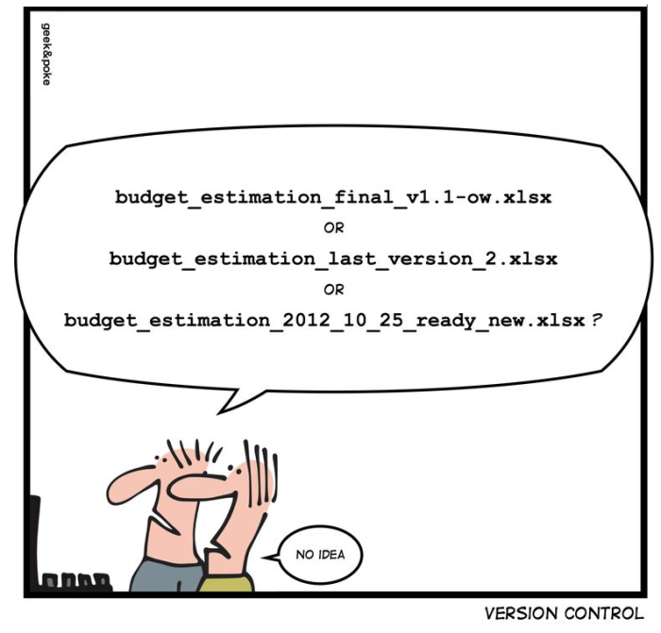

Problem #1: Edit same file at same time

Problem #2: Undo changes – go back to a different version

Problem #3: Accidentally deleted a file and need it back

Problem #4:Your computer dies and all of the files on it are lost

**Dropbox/Google Drive**

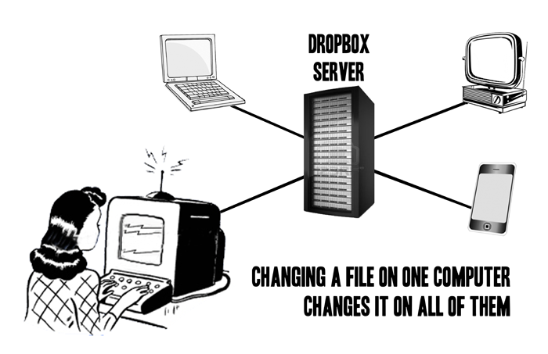

Problem #1: Edit same file at same time

Problem #2: Undo changes – go back to a different version

Problem #3: Accidentally deleted a file and need it back

Problem #4:Your computer dies and all of the files on it are lost

**GitHub**

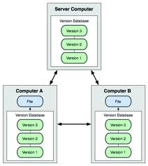

Problem #1: Edit same file at same time

Problem #2: Undo changes – go back to a different version

Problem #3: Accidentally deleted a file and need it back

Problem #4:Your computer dies and all of the files on it are lost

**Comparisons**

|  |  |  |
| --- | --- | --- |
| **System** | **Pros** | **Cons** |
| Copying/Labeling Files |  |  |
| Dropbox / Google Drive |  |  |
| GitHub |  |  |