**Repetition**

Reference: Gaddis 4.2-4.3, 4.6

Topics: Why repetition & how we use it, Common loop errors,

Sentinel-controlled loops, Input validation

**When do we need Repetition?**

Goal: Average together 3 test grades

Scanner scan = new Scanner(System.in);

final int NUM_SCORES = 3;

int sum = 0;

System.out.println(“Please enter grade 1”);

sum += scan.nextInt();

System.out.println(“Please enter grade 2”);

sum += scan.nextInt();

System.out.println(“Please enter grade 3”);

sum += scan.nextInt();

double average = sum / (double) NUM_SCORES;

System.out.println(“The average test grade is “ + average);

What if I wanted to do 100 grades in my average?

Is there a better/easier way?

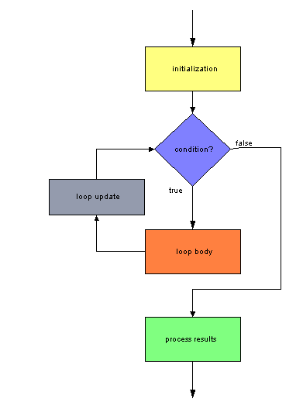

**A While Loop**

Condition must be true for the loop body to be entered

Generic format:

while( *boolean_expression* )

{

//statements that happen each time through the loop

}

//rest of code that happens after loop is completely done

Our Example:

counter = 0;

final int NUM_SCORES = 3;

**while** **( )**

{

counter < 3

}

int average = sum / (double) NUM_SCORES;

How many times does this loop execute?

What if I change the last line?

counter = 0;

final int NUM_SCORES = 3;

**while** **( )**

{

}

int average = sum / (double) NUM_SCORES;

* How many times will it run?
* This is called an
* What happens when we try to run code like this?

**A More Advanced Problem**

What if I don’t know how many grades they are going to enter?

Use a special constant to determine when we STOP looping

This is a -controlled loop

*Algorithm:*

*Code:*

//Set up the code

int count = 0;

int sum = 0;

final int SENTINEL = -999; // some nonsense value

//

String input = JOptionPane.showInputDialog(“Give a test score (-999 to end): ”);

int score = Integer.parseInt (input);

//continue reading in scores until the user says to stop

while (score

{

//

input = JOptionPane.showInputDialog(null, “Give a test score: ”);

score = Integer.parseInt (input);

}

What happens if the user inputs “one hundred” instead of “100” for a grade?

**Protecting Your Program**

You need to protect your program from crashing at run time due to bad input

*For Interactive programs*

**REMINDER:** Program only does what you tell it to do

* It won’t ignore something just because it’s the wrong type!

*Algorithm*:

*How?*

Scanner scan = new Scanner( System.in );  
System.out.print ( "Enter your age as an integer: " );

while ( ! scan.hasNextInt( ) ) //   
{  
 String garbage = scan.nextLine( );  
 System.out.print( "\nPlease enter an integer " );  
}

int age = scan.nextInt( );

*We can instead wait until the number is in a range we want:*

String input = JOptionPane.showInputDialog(“Please enter your age (0-120):”);

byte age = Byte.parseByte(input);

while ( )   
{

input = JOptionPane.showInputDialog(“Please enter your age (0-120):”);

age = Byte.parseByte(input);

}