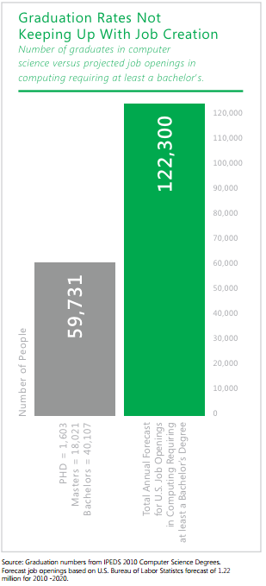There are more jobs in CS than CS graduates

Current People

Needed People

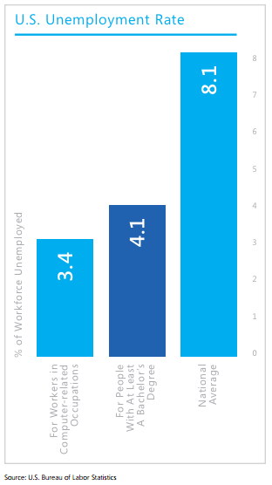

There is a lower unemployment rate in CS than there is nationally

% of Workforce Unemployed

Workers in Computing Occupations

Workers with at least a Bachelor’s degree

National Average

You can solve interesting problems in CS

Any field you work in, you will be better off from knowing CS

Three of the fastest growing fields require a CS degree

(see the Top 10 list handed out the first week, which is also on Moodle)

**Computer Science at Loyola**

* BS or BA in Computer Science
  1. BA makes it easier to double-major or minor in a non-science
  2. BS lets you take more CS classes
* Interdisciplinary major in Computer Science (pair with almost any major on campus)
* Minor in Computer Science (only 5 more CS courses)
* Certificate in Computer Science (only 2 more CS courses)
* How?
  1. Next semester: CS202 & CS295
  2. Next semester: Science w/Lab if you plan to get BS (we recommend Physics)
  3. Next spring: CS301 (at this point you have the certificate!)
  4. More course options after that, lots of electives

http://www.loyola.edu/academic/computerscience/undergraduate/degrees

Come talk to me if you have any questions or concerns!

Everyone can benefit from at least the programming certificate!