**When you hear “artificial intelligence” what do you think of?**

**What might we mean by intelligence?**

More than just

Can the world, deriving new rules

Can more about a topic and new skills

Has and can react to about the world

We can talk about an **agent** being intelligent



perception

action

An agent can be

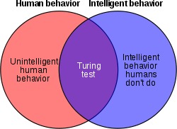

**Goal of Artificial Intelligence**

We do not have perfect artificial intelligent systems yet

* Our goal is *not* to re-create humans
* Our goal is to enable machines to

**Example: AI in Game Playing**

How does a computer agent play against a human?

* Agent learns how to play the game well
* Once the agent has learned, it plays against a human by:
  + Perceiving the state of the game
  + Following rules it learned to reason about the world
  + 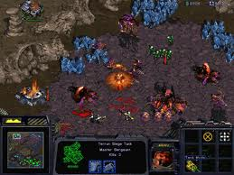Perform its chosen action

Examples:

Is this the same as creating a computer game?

**Example: Autonomous Vehicles**

