CS201: Computer Science I
Final Exam Practice Questions
Spring 2015

- In each of the below classes:
  - Circle the data members (aka instance variables) where they are declared
  - Underline the variables that are local where they are declared
  - Draw boxes around each method header
public class PracticeProblem
{
public static void main(String[] args)
{
HotTea[] teas = new HotTea[10];
HotTea tea = new HotTea();
String type = “Dragon Green”;
int temp = 180;
tea.setType(type);
tea.setTemp(180);

teas[0] = tea;

teas[1] = new HotTea();
teas[1].setType(“Earl Grey”);
teas[1].setTemp(212);
}
}

public class HotTea
{
private String type;
private int steeping_temperature;

public HotTea()
{
type = “”;
steeping_temperature=-1;
}
public void setType(String t)
{
type = t;
}
public void setTemp(int temp)
{
steeping_temperature = temp;
}
public String getType()
{
return type;
}
public int getTemp()
{
return steeping_temperature;
}
}
- Draw memory boxes for the code in PracticeProblem above.

- An algorithm is defined as following what four requirements?

- Characters (char) in Java are represented as _________________ (be specific).
- What is stored in each variable?

short y = (short) (13/2 + 5.4); y=______________

double d = (5%2) + 13.3; d=______________

- Mark all of the control paths in the below flowchart, and then list the test cases you would use for each control path.
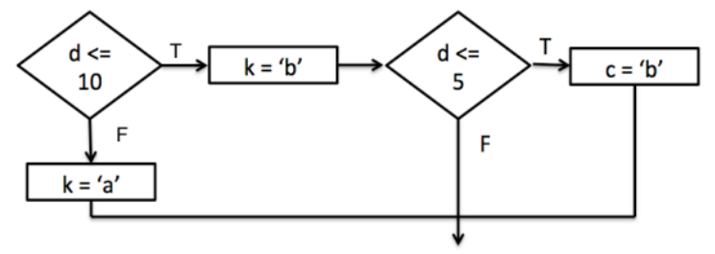

- What does the following code output:
Output:
String s2 = “Jane”; String s3 = “Lizzy”;
if(s2.compareTo(s3) > 0)
System.out.println(s2);
else
System.out.println(s3);

- The following code outputs the phrase “Almost Easter” how many times?
for(int i=0; i<10; i++)
for(int j=0; j<20; j++)
System.out.println(“Almost Easter”);

- ______(True/False) The scope of a method’s parameter is the entire class.

- A method must be _____________ for it to be called in the form of ClassName.MethodName( );
- Answer the following questions about the method whose header is
public static void findSize(int k, String n)
  - What is the return type of this method?__________________
  - How many parameters does it have?________________
  - _______(True/False) The following code will compile, assuming that findSize is in the same class as main.
public static void main(String[] args)
{
findSize(“plastic”, 3);
}
- A class with 3 instance fields should have ______ accessor methods.
- In a UML class diagram, indicates the __________________ relationship.

- Design the classes you would use to solve the following problem. List the class names AND their data members.
Jim and Dawn want to start a new club on campus for fans of cherry blossom trees, and need a program to keep track of all of their members. For each member they need to know their name and student ID number, as well as whether or not they have paid their dues.

- Analyze the morality of Nancy and Jim’s decision using either Kantianism or Rule Utilitarianism:
Jim and Nancy are the proud parents of a baby girl. Both were on parental leave, but now are returning to their full-time jobs, and they have hired a nanny after interviewing her and calling her references. Jim and Nancy’s friends tell them horror stories about abusive nannies, and they recommend a software program called LiveSecurityWatch that lets them monitor what’s happening at home from a remote computer. Jim and Nancy purchase LiveSecurityWatch and install it on a laptop computer placed in the family room. With the system in place, Jim and Nancy can use their workplace computers to see and hear how the nanny interacts with their baby. The nanny has no idea that their computer is being used as a surveillance system.

Was their decision to monitor their nanny moral or not, according to either Kantianism or Rule Utilitarianism (state which one and why)?

- Show the array below after the first 3 passes of Selection Sort (ascending order).

0 1 2 3 4 5 6
15 | 8 | 43 | 18 | 41 | 10 | 20

- _______(True/False) The last index of an array named “names” is names.length
- Assume you have a class named Friend. Create an array that will hold 50 Friend objects.

- Draw and fully label (at the right) a diagram showing memory locations involved and data stored as a result of the following code segment.

int [ ] red = new int [5];
for (int i = 0; i < red.length; i++)
red [i] = 50*i;

- Assume that an array of doubles named values has already been declared, and has numbers stored in it. Complete the following code to make the array named values 5 bigger than it currently is.

double[ ] copy = new double[

for(int i=0;
- Complete the below method that finds the maximum value in an array of test scores. The method should return that maximum value. Assume you have the following data members, and a method to store data into the array has already been called:

private double testscores[ ] = new double[2000]; //array of scores
private double numScores; //holds number of scores stored in the array
Algorithm:

public findMaxScore(
{

- Complete the class below to represent a course. It needs to keep track of the course number (such as 201), and department (such as Computer Science). Write all appropriate instance fields, mutators, and accessors. You do not need to write an additional constructor.

public class Course
{
private String
private

public Course()
{

}

