PHYSICS-AWARE MACHINE LEARNING FOR BIO-OIL PYROLYSIS: PREDICTION MODELS AND A PYROLYSIS ADVISOR FOR HIGHER YIELD AND LOWER OXYGEN
A PROJECT REPORT
Submitted by
MOHALRAJ SHIVANETHRAN (CB.AI.U4AIM25020)
PRANESH SUBRAMANIAN (CB.AI.U4AIM25030)
SRINATH BALAKRISHNAN (CB.AI.U4AIM25040)
UMASUTHAN PALANIAPPAN (CB.AI.U4AIM25041)
in partial fulfillment for the award of the degree
of
BACHELOR OF TECHNOLOGY
IN ARTIFICIAL INTELLIGENCE AND DATA SCIENCE ENGINEERING

AMRITA SCHOOL OF ENGINEERING, COIMBATORE
AMRITA VISHWA VIDYAPEETHAM
COIMBATORE 641 112
OCTOBER 2026

AMRITA VISHWA VIDYAPEETHAM
AMRITA SCHOOL OF ENGINEERING, COIMBATORE 641112
BONAFIDE CERTIFICATE
This is to certify that the project report entitled "PHYSICS-AWARE MACHINE LEARNING FOR BIO-OIL PYROLYSIS: PREDICTION MODELS AND A PYROLYSIS ADVISOR FOR HIGHER YIELD AND LOWER OXYGEN" submitted by Mohalraj Shivanethran (CB.AI.U4AIM25020), Pranesh Subramanian (CB.AI.U4AIM25030), Srinath Balakrishnan (CB.AI.U4AIM25040) and Umasuthan Palaniappan (CB.AI.U4AIM25041) in partial fulfillment of the requirements for the award of the Degree of Bachelor of Technology in Artificial Intelligence and Data Science Engineering is a bona fide record of the work carried out under my guidance and supervision at Amrita School of Engineering, Coimbatore.
_____________________________ | _____________________________
Signature of Supervisor | Signature of Student
Dr. Akhil Mohan | Mohalraj Shivanethran  (CB.AI.U4AIM25020)
Assistant Professor | Pranesh Subramanian  (CB.AI.U4AIM25030)
School of Artificial Intelligence,  Amrita Vishwa Vidyapeetham University | Srinath Balakrishnan  (CB.AI.U4AIM25040)
Amritanagar, Coimbatore 641112,  Tamil Nadu, India | Umasuthan Palaniappan  (CB.AI.U4AIM25041)
_____________________________
Signature of the Chairperson of the Department with date
[Name of Chairperson]
This project report was evaluated by us on ......................... (Date).
_____________________________ | _____________________________
INTERNAL EXAMINER | EXTERNAL EXAMINER

ACKNOWLEDGEMENT
We express our sincere gratitude to our faculty guide, Dr. Akhil Mohan, for his continuous guidance, technical insight and encouragement throughout this project, and for directing this work towards a problem of genuine relevance to his own research on bio-oil separation strategies.
We thank the Department of Artificial Intelligence and Data Science, Amrita School of Engineering, Coimbatore, and Amrita Vishwa Vidyapeetham for providing the academic environment, computing resources and the course framework (24AIM201, Mechanics and Fluidized Systems) within which this project was carried out.
We also acknowledge the authors of the two public datasets used in this study — Zhang et al. (2022) and Pascarella et al. (2025) — whose openly shared literature data made this analysis possible, and whose own notes on data sparsity motivated the additional unseen-biomass test used here.
Team 2

ABSTRACT
Machine learning (ML) is increasingly used to predict bio-oil yield and quality from biomass composition and pyrolysis conditions, and published models often report R² above 0.75. This project builds physics-aware ML models for bio-oil O/C ratio (Zhang et al. 2022 dataset) and bio-liquid yield (Pascarella et al. 2025 dataset, 1,046 rows) and benchmarks them against published results. On the standard 80/20 random train/test split used in the literature (Test 1), the best O/C model (XGBoost with physics-informed features) reaches R² = 0.90, level with Zhang et al.'s 0.895 and ahead of six other model types; yield models reach R² up to 0.69, and the final Advisor models average R² ≈ 0.61 for both targets over ten random splits. As a second, stricter check (Test 2), whole biomasses were held out of training: the final Advisor models score lower (O/C R² 0.27, yield 0.07), mainly because the compiled yield data mixes about 160 laboratories, and this tells the user when a calibration experiment is needed.
The models use heat-transfer, kinetic and molar-ratio features and physical constraints. Physics features raised O/C accuracy for every model in both tests (for example GPR from 0.43 to 0.63 in Test 1, and from −0.14 to 0.23 in Test 2). The final models reproduce known physics: yield peaks near 525 °C and O/C falls from 0.28 to 0.21 between 350 and 700 °C. These models power a Pyrolysis Advisor that recommends reactor settings balancing high yield and low oxygen, flags biomasses outside its knowledge, and improves its predictions with one or two real experiments. A supporting FastAPI/React web application, built on an earlier single-dataset iteration of this work, is also documented as a demonstration of deployment engineering. The work addresses the lack of transferable, physics-consistent ML noted in Dr. Akhil Mohan's review of bio-oil separation strategies, and prepares lower-oxygen oil for the separation stage.
Keywords: bio-oil, pyrolysis, machine learning, model validation, physics-informed features, Gaussian process regression, decision support.

TABLE OF CONTENTS

LIST OF FIGURES
Figure 6.1: O/C test R² of seven model types on the 80/20 test (Test 1), with Zhang et al.'s published result
Figure 6.2: Predicted vs. measured O/C and yield for the final models (Test 1, 5-fold random cross-validation)
Figure 6.3: Test-set R² under Test 1 (random split) and Test 2 (grouped by biomass)
Figure 7.1: Average model response to temperature, with kinetic tar selectivity for comparison
Figure 7.2: Yield error for a new biomass with 0, 1 or 2 real experiments
Figure 7.3: Held-out biomasses; the circled point is the single experiment used for calibration
Figure 7.4: Advisor output for a pine-like wood (C 50, H 6.1, O 43.5, N 0.2 wt%; particle 0.5 mm)

LIST OF TABLES
Table 2.1: Summary of six literature datasets and published ML models for bio-oil pyrolysis
Table 3.1: Summary of the two datasets used in this study, after cleaning
Table 3.2: Row-level cleaning actions applied to D1b and D3
Table 4.1: Physics-informed features engineered from raw inputs
Table 5.1: Model families and hyperparameters used
Table 5.2: Train/test protocols: Test 1 (standard) and Test 2 (unseen biomass)
Table 6.1: Main results at a glance: the three headline R² values
Table 6.2: Accuracy of each individual algorithm under Test 1 (random split) and Test 2 (unseen biomass)
Table 7.1: Final model selection: level/shape yield model vs. alternatives
Table 7.2: Final O/C model selection: GPR, constrained XGBoost and their blend
Table 7.3: Case studies: three biomasses withheld entirely from training
Table 7.4: Pyrolysis Advisor recommendations for four example feedstocks

LIST OF SYMBOLS, ABBREVIATIONS AND NOMENCLATURE
A — Pre-exponential (frequency) factor in an Arrhenius rate expression
ASE — Amrita School of Engineering
C, H, O, N — Mass percentages of carbon, hydrogen, oxygen and nitrogen in the feedstock (ultimate analysis)
Ea — Activation energy
FeedID — Internal grouping identifier assigned to rows sharing the same (near-duplicate-corrected) biomass composition
GPR — Gaussian Process Regression
HHV — Higher Heating Value
HR — Heating rate (°C/min)
k — Reaction rate constant
MAE — Mean Absolute Error
MedAPE — Median Absolute Percentage Error
ML — Machine Learning
O/C, H/C — Molar oxygen-to-carbon and hydrogen-to-carbon ratios
PS — Feedstock particle size (mm)
R — Universal gas constant, 8.314 J mol⁻¹ K⁻¹
R² — Coefficient of determination
RF — Random Forest
S_tar — Kinetic tar selectivity (share of biomass forming tar/oil rather than gas or char)
T — Pyrolysis (process) temperature (°C)
TSI — Thermal Severity Index
XGBoost — Extreme Gradient Boosting
θ — Heating-regime parameter (log₁₀ of conduction time over heating time)

CHAPTER 1: INTRODUCTION

1.1 Background
Pyrolysis heats biomass to 400–600°C without oxygen to produce bio-oil, char and gas. Crude bio-oil carries 31–52 wt% oxygen and 15–30 wt% water, making it acidic, unstable and low in heating value (Mohan et al. 2026), so it must be upgraded or separated before use. Dr. Akhil Mohan's review of bio-oil separation strategies identifies phase separation as the most promising upgrading route, and notes (Section 8.5) that no published work yet integrates ML with the separation stage, because separation datasets do not exist.
This project therefore targets the stage immediately upstream of separation: the pyrolysis reactor. A reactor operated to produce inherently lower-oxygen bio-oil reduces the solvent, adsorbent and energy demand of the downstream separation stage — predicting and recommending conditions that trade off yield against oxygen content is a natural precursor to the separation problem Dr. Mohan's review identifies.

1.2 Problem Statement
- No separation data — public pyrolysis datasets cover only the reaction stage, not the separation stage.
- Limited validation on new feedstocks — 65% of published pyrolysis ML studies validate only with random cross-validation (da Costa et al. 2027), so little is known about accuracy on a feedstock the model has not seen.
- Little physics — most studies feed raw numbers into black-box regressors with no physical grounding and no basis for trusting a prediction on an unfamiliar feedstock.

1.3 Objectives
- Part A: build and benchmark ML models for bio-oil yield and O/C on two public datasets, matching published accuracy on the standard test (Test 1) and also checking them on unseen biomasses (Test 2).
- Part B: build final physics-aware models for yield and O/C that respect known pyrolysis physics, with uncertainty estimates and calibration for new biomasses.
- Package the models into a Pyrolysis Advisor that recommends reactor conditions, flags unfamiliar feedstocks, and improves with 1–2 calibration experiments; and, as supporting engineering, a deployable web application.

CHAPTER 2: LITERATURE REVIEW
Six recent datasets and their associated studies were surveyed to situate this project (Table 2.1). A common pattern is visible: reported accuracy is consistently high (R² typically 0.75–0.97), models use little explicit process physics, and none address the separation stage.
Table 2.1: Summary of six literature datasets and published ML models for bio-oil pyrolysis
ID | Source | Data | Predicts | Best model | Reported accuracy
D1a | Tang et al. 2020, Energy & Fuels 34(9) | ~262 rows | Yield, H in oil | Random Forest | R² 0.92 (yield)
D1b ★ | Zhang et al. 2022, Fuel 312:122812 | 232 O/C rows | Yield, viscosity, HHV, H/C, O/C | Random Forest | All R² > 0.75
D2 | Ortiz-Alvarez et al. 2022, Energy Sources A | 329 rows, 34 biomasses | Yield | Neural network | R = 0.97, MAE 1.7
D3 ★ | Pascarella et al. 2025, Fuel 394:135000 | 1,137 rows, ~160 studies | Bio-liquid yield | XGBoost | R² 0.80 (0.66 all rows)
D4a | Zhao, Xia et al. 2025, J. Energy Inst. | 122 rows | Co-pyrolysis yield | Deep neural network | R² 0.93
D4b | Xia et al. 2026, J. Energy Inst. | 109 rows | Oxygenated compounds | Deep neural network | R² 0.91
Two sources were used directly in this project. Zhang et al. (2022, Fuel) compiled bio-oil yield, viscosity, HHV, H/C and O/C from biomass composition and conditions, modelled with Random Forest on a 70/30 random split; O/C was their weakest target (errors often above 20%). This dataset (D1b) supplies the O/C target here. Pascarella et al. (2025, Fuel) assembled the largest yield dataset surveyed — 1,137 rows from ~160 source studies (Zenodo 10.5281/zenodo.19205977) — and explicitly caution that the data is sparse and recommend physics-informed modelling, a recommendation this project takes up directly (Chapters 4, 7). This dataset (D3) supplies the yield target.
Methodological grounding also came from: da Costa et al. (2027), whose survey finding that 65% of studies use random cross-validation motivated the grouped-validation protocol (Chapter 5); Chan, Kelbon & Krieger (1985), whose wood-pyrolysis kinetic scheme underlies the tar-selectivity feature (Chapter 4); Ren, Wu & Weng (2023), on monotonic physics-informed constraints; and Aye et al. (2026), whose thermal-severity-index formulation is adapted in Chapter 4.
Relative to these six studies, this project's contribution is threefold: physics-aware models that match published accuracy on the standard test (O/C R² 0.90 vs. 0.895), backed by a second test on unseen biomasses that also uncovered a previously undocumented near-duplicate problem in D3; a physics-informed feature and constraint layer built from heat-transfer and kinetic first principles; and an explicit calibration mechanism using one or two real experiments on a new biomass.

CHAPTER 3: DATASETS AND DATA PREPARATION
Table 3.1: Summary of the two datasets used in this study, after cleaning
ID | Source | Rows used | Biomasses | Inputs → Output
D1b | Zhang et al. 2022, Fuel 312:122812 | 223 | 122 | Feed C, H, O, N, particle size, heating rate, T → bio-oil O/C
D3 | Pascarella et al. 2025, Fuel 394:135000 | 1,046 | 118 | Same (+ ash, VM, FC, cellulose, hemicellulose, lignin) → yield (wt%)

3.1 Cleaning — D1b (O/C)
320 raw rows. Gas_yield/Char_yield (empty) dropped; 6 numeric columns corrected from stray text (non-breaking spaces, dashes); 4 exact duplicates removed; 13 physically implausible rows excluded (H%>15 or N%>30 or particle size>20mm suggesting corruption; C%≈15% suggesting a column shift; N%≈20% transcription errors; char-like feed at <200°C or any row <300°C with non-char composition). Rows were grouped by identical (C,H,O,N) into 122 FeedIDs. The final modelling set keeps only complete, unflagged rows: 223.

3.2 Cleaning — D3 (Yield)
1,057 raw rows; 11 exact duplicates removed (1,046 remain). Grouping by exact composition gives 651 apparent biomasses — but every composition value carries tiny decimal differences for what is evidently the same biomass (e.g. C = 49.2073% vs 49.2074%), an artefact of the source compilation. Hierarchical single-linkage clustering of (C,H,O,N,Ash) at a 0.2 wt% threshold reduces this to 118 true biomasses, stable across the 0.1–0.3 wt% range (120–116 groups). This distinction matters directly for Chapter 6: grouping by exact value still leaks the same biomass across folds under its differing decimals.
Table 3.2: Row-level cleaning summary
Dataset | Rows raw | Duplicates | Other exclusions | Rows retained | Biomasses
D1b (O/C) | 320 | 4 | 13 (implausible) | 223 | 122
D3 (Yield) | 1,057 | 11 | 0 | 1,046 | 118 (near-dup corrected)

CHAPTER 4: PHYSICS-INFORMED FEATURE ENGINEERING
Rather than feeding raw composition/process columns directly into a statistical learner, these are first converted into physically meaningful quantities derived from heat-transfer theory, reaction kinetics and stoichiometry (Table 4.1), so the model is told in part how pyrolysis behaves physically rather than relying purely on correlation from a small, heterogeneous sample.
Table 4.1: Physics-informed features engineered from raw inputs
Feature | Formula | Physical meaning
Feed O/C, H/C (molar) | (O/16)/(C/12), (H/1.008)/(C/12) | Oxygen / hydrogen atoms per carbon atom in the feedstock
Feed effective H/C | (H/1.008 − 2·O/16)/(C/12) | Hydrogen remaining after O is consumed forming water
Heating regime θ | log₁₀(t_cond/t_heat); t_cond=r²/α, t_heat=(T−25)/HR | Whether the particle heats evenly (θ<0) or lags at its core
Tar selectivity S_tar | k_tar/(k_gas+k_tar+k_char), Arrhenius (Chan et al. 1985) | Fraction of biomass predicted to form tar/oil vs. gas or char
Pyrolysis number | log₁₀(reaction time / conduction time) | Reaction-rate-limited vs. heat-transfer-limited process
Thermal severity index | log₁₀(T·ln(HR+1)/PS) | Combined measure of process thermal aggressiveness (Aye et al. 2026)
log HR, log PS, T, N | As given, log-transformed where skewed | Process conditions on a scale suited to the regressors

4.1 Reaction Kinetics: Tar Selectivity
Based on the classical three-reaction wood-pyrolysis scheme of Chan, Kelbon & Krieger (1985): gas, tar and char each follow a first-order Arrhenius law, k_gas=1.43×10⁴·exp(−88,600/RT), k_tar=4.13×10⁶·exp(−112,700/RT), k_char=7.38×10⁵·exp(−106,500/RT) (T in K, R=8.314 J mol⁻¹K⁻¹). Tar selectivity S_tar = k_tar/(k_gas+k_tar+k_char) rises with temperature because the tar channel has the highest activation energy of the three — a direct kinetic explanation for why moderate-to-high temperatures favour liquid oil, given to the model as a feature rather than left to correlation alone.

4.2 Heat Transfer: Heating Regime
The conduction timescale t_cond=r²/α (α=1.0×10⁻⁷ m²/s, representative biomass thermal diffusivity) is compared with the heating timescale t_heat=(T−25)/HR to give θ=log₁₀(t_cond/t_heat). Negative θ means the particle heats faster than the reactor programme changes (evenly-heated, kinetically-controlled); every experiment in D3 has θ<0 (max −0.86) at a median heating rate of only 25°C/min, confirming the compiled data is dominated by slow pyrolysis of small, evenly-heated particles (Chapter 7) and explaining why particle-size effects are small and noisy in the final models.

4.3 Physical Constraints
Beyond input features, physical reasoning is built directly into the O/C model as monotonicity constraints during training (Chapter 5): predicted O/C can never increase with process temperature, thermal severity or tar selectivity, and can never decrease as feedstock O/C increases — preventing predictions that contradict elementary pyrolysis chemistry even outside the dense training region.

CHAPTER 5: MODEL DEVELOPMENT AND VALIDATION PROTOCOL

5.1 Model Families
Table 5.1: Model families and hyperparameters used
Model | Configuration | Implementation
Mean (no model) | Predicts training-set mean for every input | — (baseline)
Random Forest | 400 trees, min 2 samples/leaf, 60% feature subsampling | scikit-learn
XGBoost | 500 trees, depth 3, lr 0.03, 80% subsampling, min child weight 5, L2=5.0 | xgboost
GPR | Matérn kernel (ν=1.5) + white noise, standardised, target normalised | scikit-learn

5.2 Validation Protocols
Table 5.2: Train/test protocols: Test 1 (standard) and Test 2 (unseen biomass)
Protocol | Mechanism | Risk / Rationale
Test 1: random split | 80/20 random split, 10 repeats with different seeds (one held-out split for the 7-model benchmark). | Standard literature protocol (Table 2.1); directly comparable with published results.
Test 2a: grouped, exact values | All rows with identical (C,H,O,N) kept together (5 folds × 5 repeats). | Intermediate check; affected by hidden near-duplicates (Section 3.2).
Test 2: grouped by biomass | All rows of a biomass, incl. near-duplicates, kept together (5×5; 10 splits for GPR yield). | Stricter check that simulates a brand-new feedstock.

5.3 Physics-Constrained O/C Model
An XGBoost regressor with monotonicity constraints (predicted log₁₀(O/C) non-increasing in T, thermal severity index and tar selectivity; non-decreasing in feed O/C) is blended 50/50 with an unconstrained GPR on the same features. The GPR alone under-responds to temperature while constrained XGBoost alone is higher-variance across folds; the blend generalised best to unseen biomasses (Chapter 7).

5.4 Level-Plus-Shape Yield Model
72% of D3's yield variance lies between biomasses rather than within one biomass across conditions (Section 6.2), so a plain model under-uses the reactor-condition features. The final design separates a level GPR (biomass-composition features only, predicting a biomass's characteristic yield) from a shape XGBoost (process-condition features only, predicting deviation from that biomass's own average); the final prediction sums the two. This separates “which biomass” from “how yield responds to conditions,” which Chapter 7 shows is necessary for useful, condition-responsive advice.

5.5 Uncertainty, Calibration and Applicability
- Uncertainty: 80% intervals derived empirically from grouped out-of-fold errors on unseen biomasses, not a parametric assumption.
- Calibration: with 1–2 real experimental points, the prediction is shifted to match the measured offset, then used for the remaining conditions.
- Applicability check: a candidate's composition (feed O/C, H/C, N), z-score standardised, is compared via k-d tree nearest-neighbour search against training biomasses; flagged out-of-domain if its distance exceeds the 95th-percentile training nearest-neighbour distance.

5.6 Pyrolysis Advisor Search and Scoring
Given composition and particle size, the advisor evaluates 156 settings (26 temperatures 400–650°C × 6 heating rates 5–300°C/min), predicts yield and O/C for each, identifies the Pareto-optimal frontier, and scores each setting with 50/50 weighted normalised yield and inverted O/C to select the top recommendation.

CHAPTER 6: RESULTS AND DISCUSSION — PART A: PREDICTION ACCURACY
Every R² in this report is fixed by three things: what is predicted (O/C or yield), which model, and which test (Table 5.2). Test 1 is the standard 80/20 random split used in the literature; Test 2 is a stricter check in which whole biomasses are held out of training. Table 6.1 gives the three headline results; the other values in this chapter compare individual algorithms along the way (Table 6.2).
Table 6.1: Main results at a glance: the three headline R² values
Result | Test 1: standard 80/20 split | Test 2: unseen biomass
O/C, best single model (XGBoost, 7-model benchmark) | 0.90 | not run
O/C, final Advisor model (log scale) | 0.61 | 0.27
Yield, final Advisor model | 0.61 | 0.07

6.1 Test 1: Accuracy on the Standard Benchmark
Seven model types were trained on the Zhang et al. O/C data with physics-informed features and scored on a held-out 20% test set (Figure 6.1). XGBoost reached R² = 0.90 (RMSE 0.21), level with the 0.895 published by Zhang et al.; Random Forest (0.89), GPR (0.86) and LightGBM (0.85) were close behind, while linear models and the MLP were clearly weaker. Without the physics features XGBoost scored 0.886.
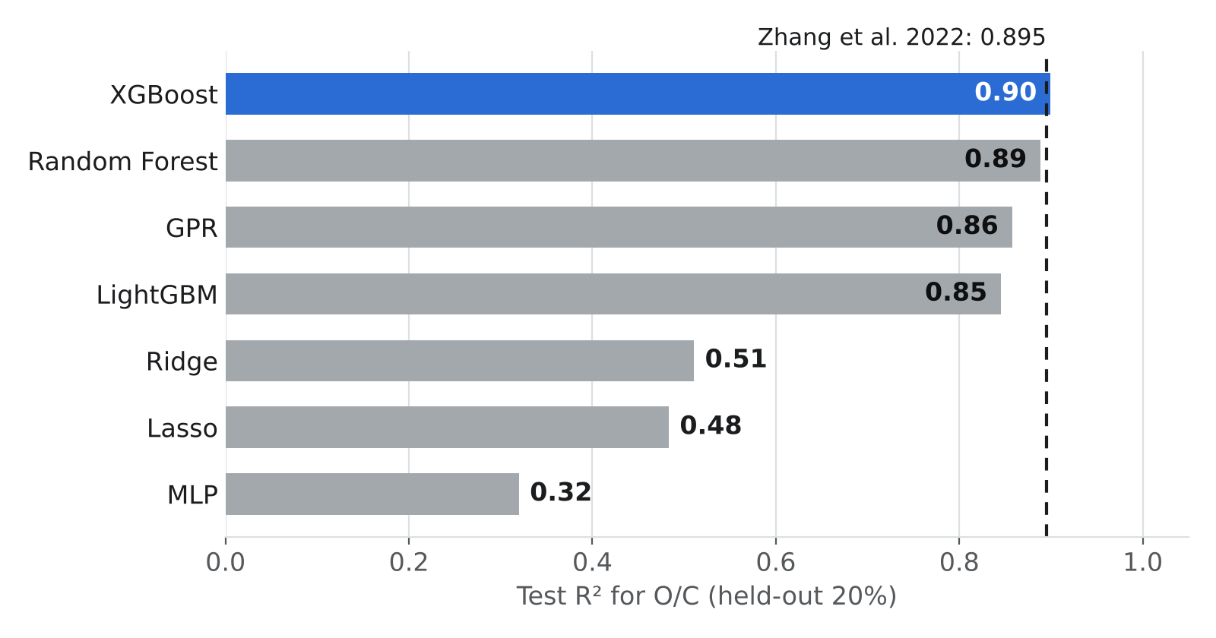
Figure 6.1: O/C test R² of seven model types on the 80/20 test (Test 1); dashed line, Zhang et al. (2022).
Averaged over ten random 80/20 splits, yield models reached R² = 0.69 (Random Forest, MAE 3.8 wt%), 0.66 (XGBoost) and 0.60 (GPR). The final Advisor models of Chapter 7 averaged R² = 0.61 for O/C (log scale; best split 0.85, typical error 18%) and 0.61 for yield (best split 0.67, MAE 4.2 wt%). The two O/C values differ for three reasons: 0.90 is the best of seven models on one held-out split of the original 232-row data with O/C on its natural scale, whereas 0.61 is the physics-constrained Advisor model averaged over ten splits of the cleaned 223-row data on a log scale, where low-O/C samples count as much as high ones. Figure 6.2 shows the Advisor model's predictions against measured values.
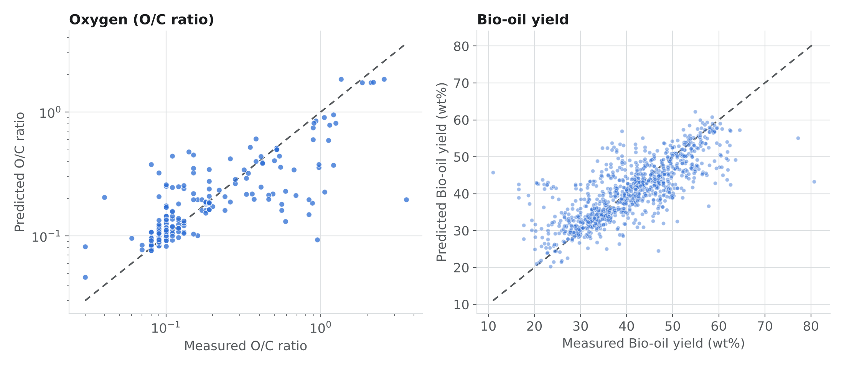
Figure 6.2: Predicted vs. measured O/C and yield for the final models (Test 1, 5-fold random cross-validation).
Table 6.2: Accuracy of each individual algorithm under Test 1 (random split) and Test 2 (unseen biomass), physics-informed features
Target | Model | Test protocol | R² | MAE (wt% yield)
Yield | Random Forest | Random split | 0.69 | 3.8
Yield | XGBoost | Random split | 0.66 | 4.2
Yield | GPR | Random split | 0.60 | 4.3
Yield | Random Forest | Grouped, exact values | 0.20 | 6.2
Yield | XGBoost | Grouped, exact values | 0.23 | 6.3
Yield | Random Forest | Grouped by biomass | −0.25 | 8.7
Yield | XGBoost | Grouped by biomass | −0.18 | 8.3
Yield | GPR | Grouped by biomass | 0.01 | 7.7
O/C (log scale) | Random Forest | Random split | 0.52 | —
O/C (log scale) | XGBoost | Random split | 0.51 | —
O/C (log scale) | GPR | Random split | 0.63 | —
O/C (log scale) | Random Forest | Grouped by biomass | 0.19 | —
O/C (log scale) | XGBoost | Grouped by biomass | 0.14 | —
O/C (log scale) | GPR | Grouped by biomass | 0.23 | —

6.2 Test 2: Accuracy on Unseen Biomass
When every row of a biomass is kept on one side of the split, yield R² falls from 0.66 to −0.18 (XGBoost) and O/C R² from 0.63 to 0.23 (GPR), as Figure 6.3 shows. Grouping D3 by exact values alone gives an intermediate 0.23, because hidden near-duplicates (Section 3.2) still place the same biomass on both sides. The main reason yield transfers poorly is that 72% of D3's yield variance lies between biomasses rather than within one biomass across conditions: D3 compiles about 160 studies, each with its own reactor and collection method, and no recorded column separates these laboratory effects from genuine biomass differences. Test 2 therefore sets the uncertainty bands and calibration step used by the Advisor (Section 7.3).
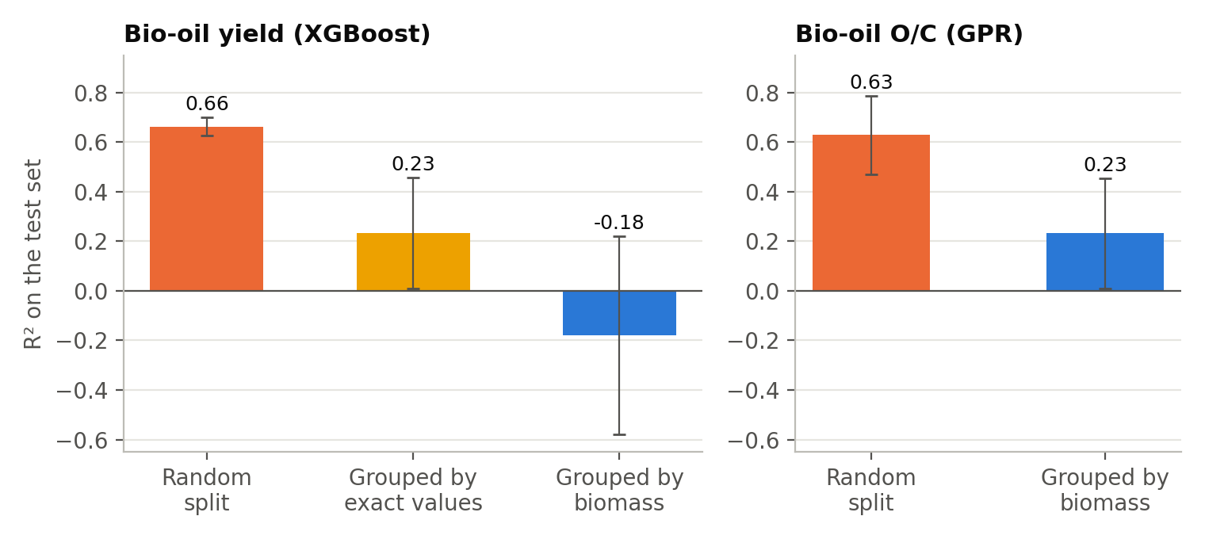
Figure 6.3: Test-set R² under Test 1 (random split) and Test 2 (grouped by biomass).

6.3 Physics Features Improve Every Model
Physics-informed features raised O/C accuracy for every model in both tests. Under Test 1, GPR rose from R² = 0.43 (raw inputs) to 0.63, Random Forest from 0.45 to 0.52 and XGBoost from 0.44 to 0.51. Under Test 2 the relative gain is larger: GPR rose from −0.14 to 0.23, supporting Pascarella et al.'s (2025) recommendation of physics-informed approaches for sparse compiled data.

CHAPTER 7: RESULTS — PART B: PHYSICS-AWARE MODELS AND THE ADVISOR

7.1 Final Model Selection
Final models were selected on Test 2 (grouped by biomass), the setting that matters when the Advisor meets a new feedstock; on Test 1 the selected models score R² ≈ 0.61 for both targets (Section 6.1). Table 7.1 compares yield candidates. “Shape R²” measures how well a model captures the within-biomass response to conditions — what the Advisor needs. A plain GPR achieves shape R²≈0.01 (ignores conditions); level-plus-shape was selected for its shape R² = 0.12.
Table 7.1: Final yield model selection (Test 2, grouped by biomass)
Model | R² | MAE (wt%) | Shape R²
Mean only | −0.09 | 8.21 | 0
GPR only | 0.01 | 7.70 | 0.01
GPR + XGBoost average | 0.07 | 7.48 | 0.07
Level + shape — final | 0.07 | 7.50 | 0.12
Table 7.2: Final O/C model selection (Test 2, grouped by biomass)
Model | R² (log) | Typical error (MedAPE)
GPR only | 0.23 (log) | 27.7% typical
XGBoost, physics constraints | 0.14 (log) | 37.5% typical
Blend — final | 0.26 (log) | 32.1% typical

7.2 Physics Consistency Checks
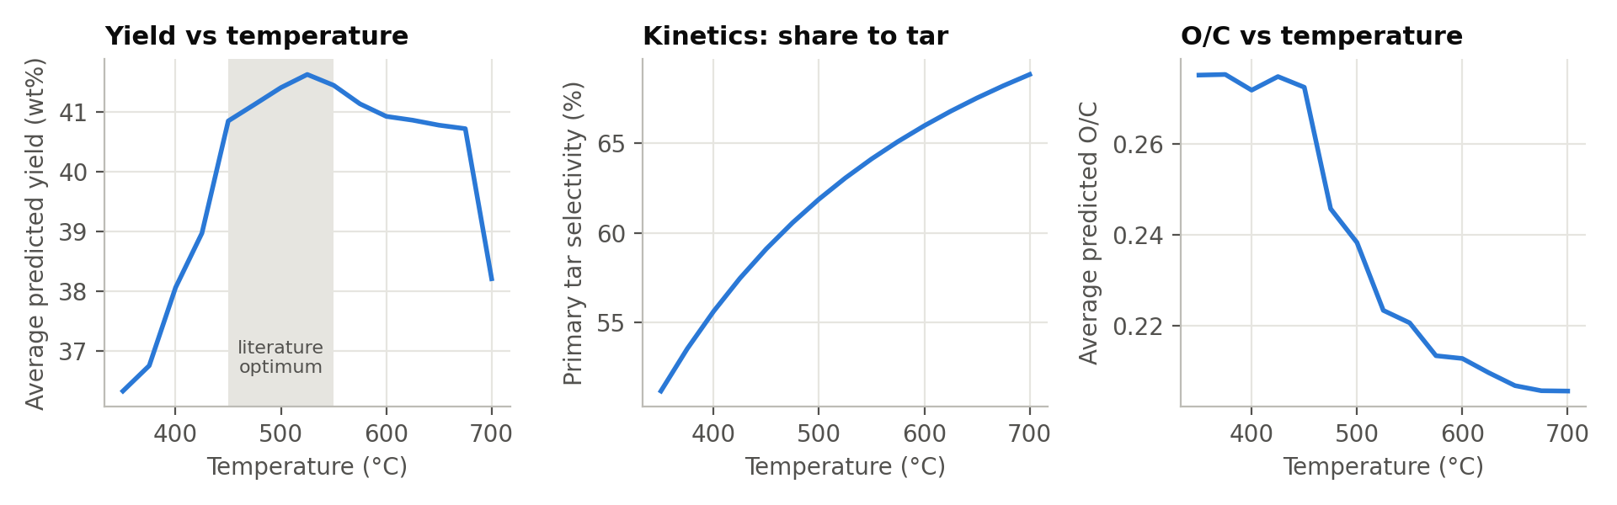
Figure 7.1: Average model response to temperature, with kinetic tar selectivity.
- Yield peaks at 525°C (41.6 wt%, rising from 36.3 at 350 and falling to 38.2 at 700) — matching the literature's 450–550°C optimum.
- Tar selectivity rises monotonically (51%→69% across 350–700°C), so the yield fall above ~600°C is consistent with secondary cracking of hot vapours into gas — a two-step behaviour reproduced from data, not told to the model explicitly.
- O/C falls 0.28→0.21 (350–700°C), consistent with stronger deoxygenation at higher severity, and is guaranteed never to rise with T by the monotonicity constraint.
- Every D3 experiment has θ<0 (slow, evenly-heated pyrolysis; median HR 25°C/min), so particle-size effects are small and noisy.

7.3 Uncertainty and Calibration
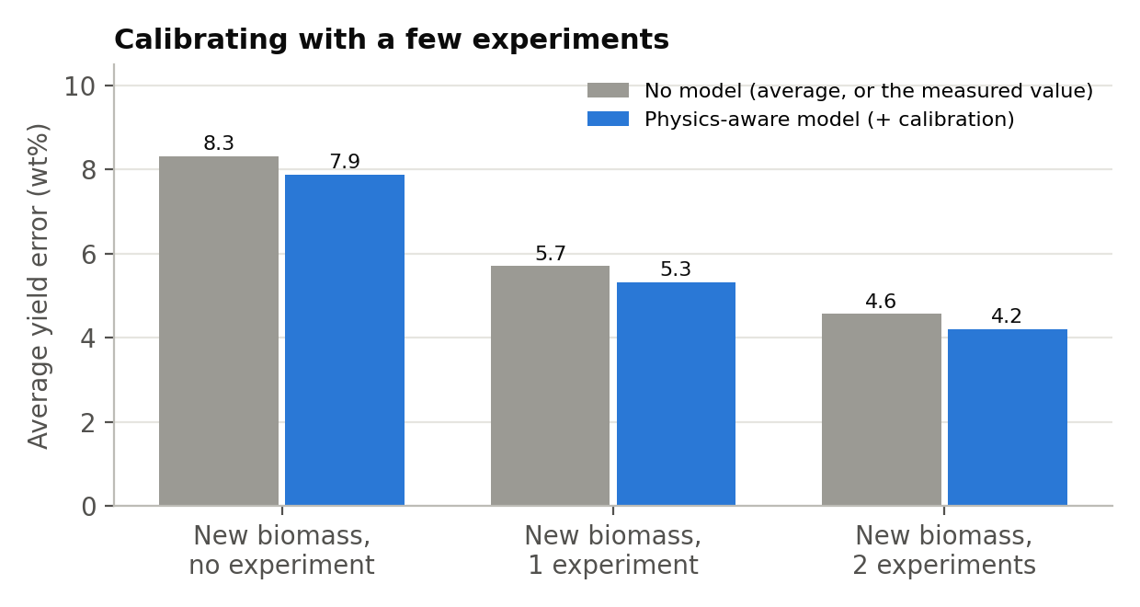
Figure 7.2: Yield error for a new biomass with 0, 1 or 2 real experiments.
80% intervals for a brand-new biomass (Test 2): yield ±12.6 wt%, O/C within a factor of 2.2. One calibration experiment cuts yield error from ~8 to 5.3 wt%; two bring it to 4.2 wt% — beating simple reuse of the measured value (5.7, 4.6 wt%) because the model adds learned condition-response. For O/C the reverse held (reuse: log error 0.087 vs. model 0.104), since O/C varies little within a biomass in D1b.

7.4 Case Studies: Three Unseen Biomasses
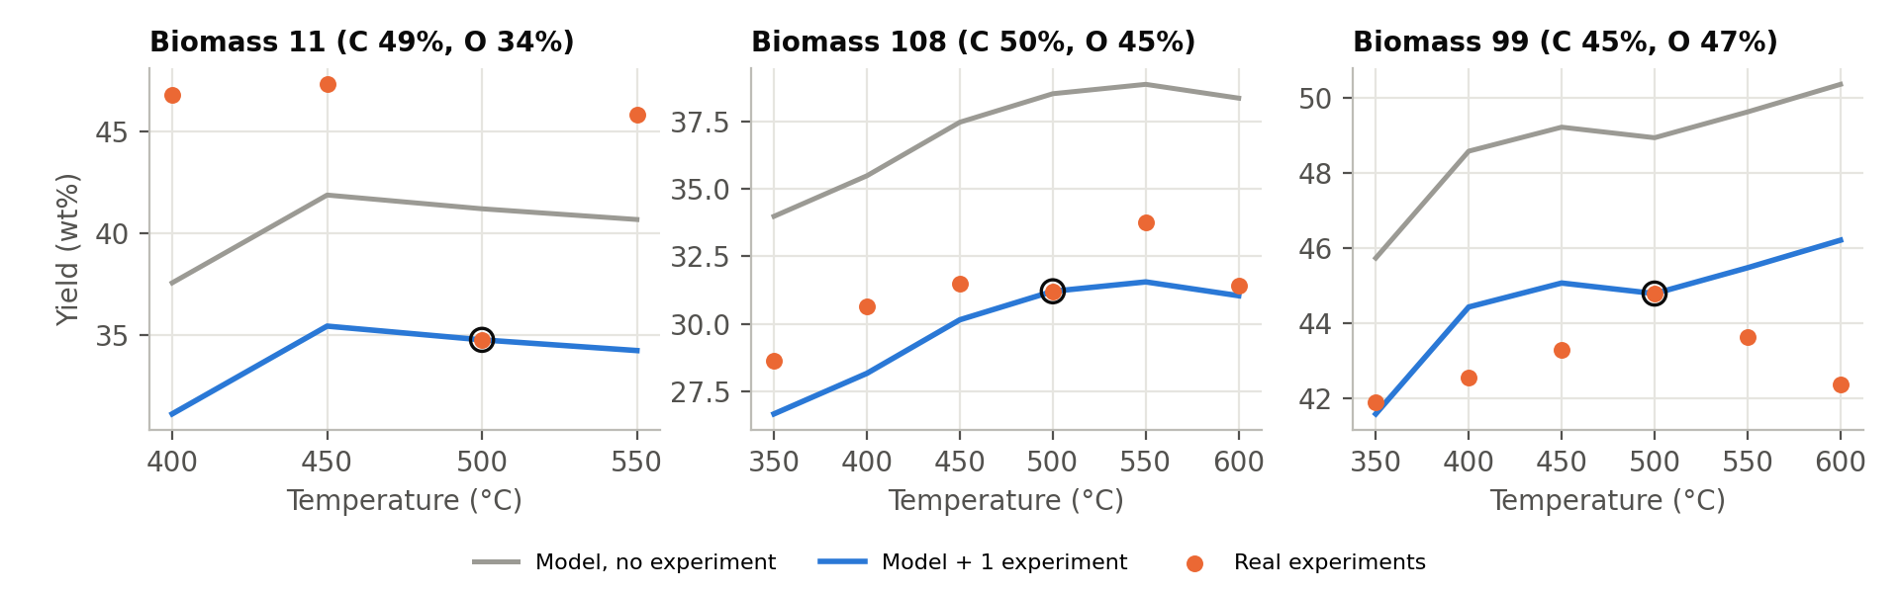
Figure 7.3: Held-out biomasses; the circled point is the calibration experiment.
Table 7.3: Case studies — biomasses withheld entirely from training
Biomass | Best T (real) | Best T (model) | Error, no exp. | Error, 1 exp.
11 (C 49%, O 34%) | 450°C | 450°C ✓ | 6.6 wt% | 13.0 wt%
108 (C 50%, O 45%) | 550°C | 550°C ✓ | 5.6 wt% | 1.7 wt%
99 (C 45%, O 47%) | 500°C | 600°C | 6.0 wt% | 1.9 wt%
The model found the correct optimum temperature for 2 of 3 biomasses with zero experiments; calibration cut error below 2 wt% for biomasses 108 and 99. Biomass 11's calibration point was an outlier relative to its neighbours (likely a data inconsistency), making calibration worse — the practical lesson being to calibrate with at least two points where possible.

7.5 The Pyrolysis Advisor
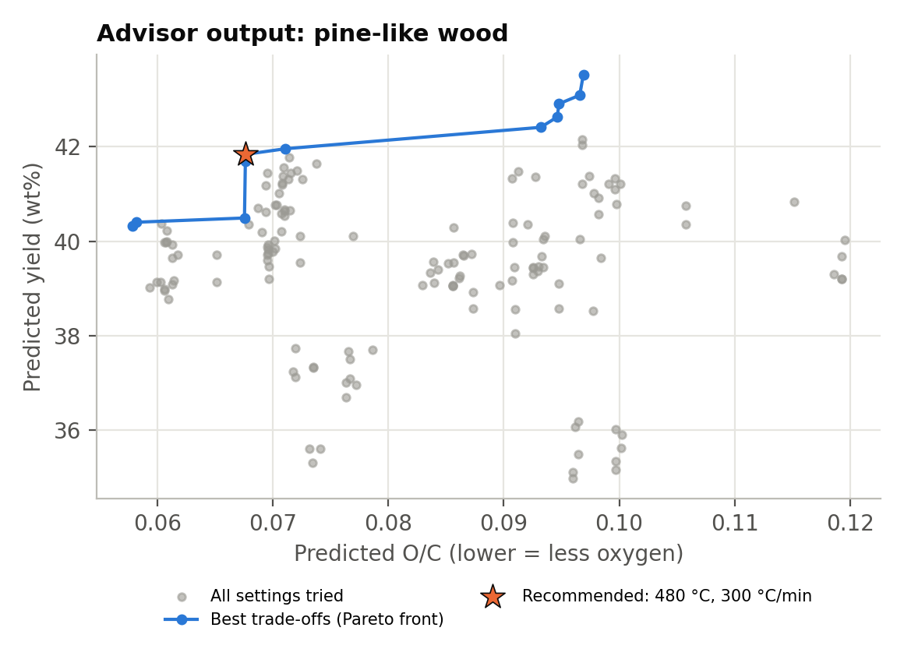
Figure 7.4: Advisor output for a pine-like wood.
Table 7.4: Advisor recommendations for four example feedstocks
Feedstock | Known? | Recommended | Alternative (max yield)
Pine-like wood | Yes | 480°C, 300°C/min → 41.8 wt%, O/C 0.068 | Max yield: 570°C, 100°C/min → 43.5 wt%, O/C 0.097
Rice husk-like | Yes | 510°C, 10°C/min → 41.6 wt%, O/C 0.062 | Max yield: 570°C, 100°C/min → 44.7 wt%, O/C 0.113
Microalgae-like (N 8.5%) | No: flagged | Shown with a warning | Needs 1–2 experiments first
Coal-like (C 80%) | No: flagged | Shown with a warning | Outside biomass composition range
The Pareto front makes the trade-off explicit: for pine, the last 1.7 wt% of yield costs ~40% more oxygen. The applicability check correctly withholds confident recommendations for the nitrogen-rich microalgae-like and carbon-rich coal-like feedstocks, both well outside either training dataset's composition range.

CHAPTER 8: SUPPORTING ENGINEERING — A DEPLOYABLE PREDICTION TOOL
Alongside the modelling study (Chapters 6–7), a separate full-stack application was built to make an earlier iteration of the O/C model usable outside a notebook: a FastAPI backend serving trained models via REST, and a React/TypeScript frontend for real-time prediction, batch scoring, model comparison and SHAP-based explanation.

8.1 Independent Physics Layer
This earlier iteration developed its own physics-informed features — distinct in formulation from Chapter 4 but built on the same principle: Arrhenius kinetics (independent parallel reactions) per pseudo-component; a competitive Broido-Shafizadeh cellulose pathway; a secondary tar-cracking severity index; an ash-catalysed devolatilisation correction; and the Modified Dulong HHV formula.

8.2 REST API
Key endpoints: POST /predict (O/C, confidence interval, secondary properties, physics-validation flags); POST /batch-predict (bulk CSV/Excel scoring); POST /explain (per-prediction SHAP attribution in plain chemistry language); POST /drift-check (out-of-range input flagging); POST /compare-models (all seven trained model types side by side).

8.3 Reported Accuracy
The application serves the seven-model benchmark of Section 6.1: its best O/C model, XGBoost, scores R² = 0.90 on the 80/20 test (0.886 without physics features), level with Zhang et al.'s 0.895. Re-checking this model under Test 2 is listed as future work (Chapter 9).

CHAPTER 9: CONCLUSION AND FUTURE WORK

9.1 Conclusion
Physics-aware ML models predict bio-oil O/C and yield at the accuracy reported in the literature: on the standard 80/20 test (Test 1), the best O/C model reaches R² = 0.90 against a published 0.895, yield models reach up to 0.69, and the final Advisor models about 0.61 for both targets (Chapter 6). Physics-informed features improved every model. A second, stricter test on unseen biomasses (Test 2) gives lower scores, mainly because compiled yield data mixes many laboratories; this is handled through uncertainty bands, an applicability check, and calibration with 1–2 experiments, which cuts yield error to 4–5 wt% (Section 7.3). The final models follow known physics (Section 7.2). The resulting Pyrolysis Advisor gives practical, trade-off-aware guidance for more bio-oil with less oxygen, directly supporting the separation strategies in Dr. Akhil Mohan's review (Section 1.1).

9.2 Relation to Dr. Mohan's Separation Review
- Lower-O/C bio-oil reduces the solvent, adsorbent and energy demand of the separation stage; the Advisor (Section 7.5) makes this upstream choice explicit.
- Section 8.4 of the review calls for interpretable, physics-informed ML; this project supplies it and quantifies why purely data-driven literature models often fail to transfer (Chapter 2).
- Figure 11 of the review proposes a data→clean→feature→train→evaluate→validate→recommend pipeline, implemented here end to end including the unseen-biomass validation step Chapter 2 shows is often skipped.

9.3 Limitations
- Compiled literature data mixes labs and measurement conventions; residence time, condensation conditions and product water content are not consistently reported.
- O/C and yield come from two separately trained models (no dataset reports both); the Advisor combines them rather than one jointly trained model.
- Uncertainty for a genuinely new biomass remains wide; the models are most useful refined by 1–2 real experiments, not as a replacement for them.
- No separation-stage dataset exists in the surveyed literature, so that stage is discussed but not modelled.
- Accuracy on a brand-new biomass (Test 2) is modest without calibration; the supporting web app (Chapter 8) has so far been scored only under Test 1.

9.4 Future Work
- Recover a source-study identifier and test leave-one-study-out validation, isolating the inter-lab effect (Section 6.2).
- Model organic yield (bio-liquid minus water) on the 413 D3 rows reporting water content.
- Collect internally consistent single-reactor data recording residence time and condensation temperature, and retrain.
- Extend the Advisor to the separation stage once suitable data exists.
- Re-check the supporting web app's model under Test 2 (Chapter 5).

REFERENCES
1. Mohan, A., Emmer, Å., Engvall, K. and Jonsson, M. (2026). Recent progress in separation strategies for upgrading bio-oil: mechanisms, challenges and a way forward. Separation and Purification Technology, 392, 137146.
2. Zhang, T., Cao, D., Feng, X., Zhu, J., Lu, X., Mu, L. and Qian, H. (2022). Machine learning prediction of bio-oil characteristics quantitatively relating to biomass compositions and pyrolysis conditions. Fuel, 312, 122812.
3. Pascarella, A. E., Coppola, A., Marrone, S., Chirone, R., Sansone, C. and Salatino, P. (2025). Critical assessment of machine learning prediction of biomass pyrolysis. Fuel, 394, 135000. Data: Zenodo, 10.5281/zenodo.19205977.
4. Aye, H. Y., Scala, F., Stepanec, L., Zin Lin, O. and Juchelkova, D. (2026). Mechanistic machine learning for biomass pyrolysis. Energy Conversion and Management: X.
5. da Costa et al. (2027). Artificial intelligence in biomass pyrolysis: a structured synthesis of modeling practices, performance and research gaps. Biomass and Bioenergy, 216, 109717.
6. Chan, W. R., Kelbon, M. and Krieger, B. B. (1985). Modelling and experimental verification of physical and chemical processes during pyrolysis of a large biomass particle. Fuel, 64, 1505–1513.
7. Ren, S., Wu, S. and Weng, Q. (2023). Physics-informed machine learning methods for biomass gasification modeling by considering monotonic relationships. Bioresource Technology, 10.1016/j.biortech.2022.128472.
8. Tang, Q. et al. (2020). Prediction of bio-oil yield and hydrogen contents based on machine learning method. Energy & Fuels, 34(9), 11050–11060.
9. Ortiz-Alvarez et al. (2022). Machine learning prediction of bio-oil yield from biomass pyrolysis. Energy Sources, Part A. [Full citation to be confirmed before final submission.]
10. Zhao, Xia et al. (2025). Machine-learning prediction of co-pyrolysis product yield. Journal of the Energy Institute. [Full citation to be confirmed before final submission.]
11. Xia et al. (2026). Machine-learning prediction of oxygenated compound content in bio-oil. Journal of the Energy Institute. [Full citation to be confirmed before final submission.]

APPENDIX 1: PROJECT FILE STRUCTURE
Per the report-format guidelines, complete source code is not reproduced in the body of this report; the full project (code, cleaned data, trained models, results, figures) is provided separately on CD/DVD or the accompanying repository, structured as follows.
Folder / file | Contents
data_raw/, data_clean/ | Original and cleaned datasets with assigned biomass (FeedID) groups
src/01_clean.py, features.py, common.py | Cleaning, physics-feature functions, shared model/split utilities
src/02_leakage_study.py, 04_figures_A.py | Part A: Test 1 and Test 2 accuracy study and its figures (Chapter 6)
src/09_random_split_eval.py, 10_figures_C.py | Test 1 scores and figures for the final models (Section 6.1)
src/05, 06 | Model-selection studies for the final O/C and yield models (Chapter 7)
src/07_final_advisor.py, 08_figures_B.py | Part B: final models, calibration, case studies, Advisor, figures (Chapter 7)
results/, models/ | All result tables, figures and serialized final models

