Physics-Aware Machine Learning for Bio-Oil Pyrolysis
An honest benchmark and a Pyrolysis Advisor for higher yield and lower oxygen
Umasuthan Palaniappan (CB.AI.U4AIM25041)
B.Tech Artificial Intelligence and Data Science, Amrita Vishwa Vidyapeetham, Coimbatore
Course: 24AIM201 Mechanics and Fluidized Systems
Faculty guide: Dr. Akhil Mohan | October 2026

Abstract
Machine learning (ML) is increasingly used to predict bio-oil yield and quality from biomass composition and pyrolysis conditions, and published models often report R² above 0.75. This project re-examines two public literature datasets: bio-oil O/C ratio (Zhang et al. 2022, 223 clean rows) and bio-liquid yield (Pascarella et al. 2025, 1,046 rows). We show that the usual random train/test split lets rows from the same biomass appear in both training and testing, which inflates scores. For yield, R² falls from 0.66 (random split) to 0.23 when rows are grouped by exact composition, and to −0.18 when hidden near-duplicate rows of the same biomass are also grouped. For O/C, R² falls from 0.63 to 0.23.
We then built physics-aware models using heat-transfer, kinetic and molar-ratio features, physical constraints, and honest grouped validation. Physics features raised the unseen-biomass R² for O/C in all three model types (for example GPR from −0.14 to 0.23). The final models reproduce known physics: yield peaks near 525 °C and O/C falls from 0.28 to 0.21 between 350 and 700 °C. These models power a Pyrolysis Advisor that recommends reactor settings balancing high yield and low oxygen, flags biomasses outside its knowledge, and improves its predictions with one or two real experiments. The work addresses the lack of transferable, physics-consistent ML noted in Dr. Akhil Mohan's review of bio-oil separation strategies, and prepares lower-oxygen oil for the separation stage.
Keywords: bio-oil, pyrolysis, machine learning, data leakage, physics-informed features, Gaussian process, Bayesian decision support

1. Introduction

1.1 Background
Pyrolysis heats biomass at 400 to 600 °C without oxygen to produce bio-oil, char and gas. Crude bio-oil contains about 400 compounds, 31 to 52 wt% oxygen and 15 to 30 wt% water, which makes it acidic, unstable and low in heating value (Mohan et al. 2026). It must therefore be upgraded or separated before use. Dr. Akhil Mohan's review identifies phase separation using solvents and adsorbents as the most promising route, and notes in Section 8.5 that no published work yet integrates separation with ML because separation datasets do not exist.

1.2 The problem this project addresses
- No separation data: public data covers only the pyrolysis stage (making the oil), not separation.
- Over-optimistic ML: a 2027 review found that 65% of pyrolysis ML studies use random cross-validation, which can inflate accuracy when related rows land in both training and test sets (da Costa et al. 2027).
- Little physics: most studies feed raw numbers into black-box models, so predictions can break physical laws and cannot be trusted outside the training data.

1.3 Objectives
- Measure how much the testing method inflates ML accuracy for bio-oil yield and oxygen (Part A).
- Build physics-aware models that are honestly tested and follow known physical trends (Part B).
- Use them in a Pyrolysis Advisor that recommends conditions giving more oil with less oxygen, so the downstream separation step has less work to do.

2. Datasets
ID | Source | Rows used | Inputs → output
D1b | Zhang et al. 2022, Fuel 312, 122812 ("data" sheet) | 223 rows, 122 biomasses | Feed C, H, O, N, particle size, heating rate, temperature → bio-oil O/C
D3 | Pascarella et al. 2025, Fuel 394, 135000 (Zenodo 10.5281/zenodo.19205977) | 1,046 rows, 118 biomasses | Same inputs (plus others) → bio-liquid yield (wt%)

2.1 Cleaning
- D1b: 320 rows; 4 exact duplicates removed; 6 numbers stored as text fixed; 13 implausible rows excluded (corrupted values, shifted columns, charcoal-like feeds at 185 °C, feed N about 20%, temperature below 300 °C). Rows with all seven inputs and O/C give 223 rows.
- D3: 1,057 rows; 11 exact duplicates removed, leaving 1,046.

2.2 A hidden trap: near-duplicate biomasses
In D3, every composition value carries tiny differences (for example carbon 49.2073% vs 49.2074%), probably from processing in the source data. Grouping rows by exact values gives 651 "biomasses"; clustering compositions that differ by less than 0.2 wt% gives 118. The count is stable between 0.1 and 0.3 wt% (120 to 116), so 118 is the true number of biomasses. Section 4 shows why this matters.

3. Methods

3.1 Physics-based input features
Both models use the same seven measurable inputs (feed C, H, O, N, temperature T, heating rate HR, particle size PS), converted into features with physical meaning:
Feature | Formula | Physical meaning
Feed O/C, H/C (molar) | (O/16)/(C/12), (H/1.008)/(C/12) | Atoms of oxygen or hydrogen per carbon
Feed effective H/C | (H/1.008 − 2·O/16)/(C/12) | Hydrogen left after oxygen forms water
Heating regime θ | log10(t_cond / t_heat), t_cond = r²/α, t_heat = (T−25)/HR | Whether the particle heats evenly (θ < 0) or lags inside (heat transfer)
Kinetic tar selectivity | k_tar/(k_gas + k_tar + k_char), Arrhenius rates | Share of biomass turning into liquid first (Chan et al. 1985)
Pyrolysis number | log10(reaction time / conduction time) | Whether chemistry or heat transfer is slower
Thermal severity index | log10(T·ln(HR+1)/PS) | Combined heating intensity (Aye et al. 2026)
log HR, log PS, T, N | As shown | Process conditions on a sensible scale
α = 1×10⁻⁷ m²/s (typical thermal diffusivity of biomass); r = particle radius.

3.2 Models
- Baselines: mean only (no model), Random Forest, XGBoost and Gaussian Process Regression (GPR, Matérn kernel).
- Final O/C model: average of GPR and an XGBoost model with physical constraints (O/C may not rise with temperature, thermal severity or tar selectivity, and may not fall with feed O/C). Target: log10(O/C), because O/C is strongly skewed.
- Final yield model (level + shape): yield = level + shape. The level is a GPR on biomass composition ("how much oil this kind of biomass tends to give"); the shape is an XGBoost model on reactor-condition features trained on each biomass's deviation from its own average ("how yield changes with temperature, heating rate and particle size").

3.3 Testing protocols
Protocol | How it works
Random split | 80/20 random split, 10 repeats. Rows of one biomass can appear in both training and test (common in literature).
Grouped by exact values | Rows with identical composition are kept together (5 folds × 5 repeats). Near-duplicates can still leak.
Grouped by biomass | All rows of a biomass, including near-duplicates, are kept together (5 folds × 5 repeats; GPR yield 10 splits). This simulates a truly new biomass.

3.4 Uncertainty, calibration and the advisor
- Honest uncertainty: 80% prediction bands are taken from the errors the models made on unseen biomasses (grouped out-of-fold errors).
- Calibration: for a new biomass, 1 or 2 real experiments are used to shift the model's level; the model then predicts the remaining conditions.
- Applicability check: a biomass is flagged as "outside the model's knowledge" if its composition (O/C, H/C, N) is farther from any training biomass than 95% of training biomasses are from their nearest neighbour.
- Advisor: for a given biomass and particle size, it scans 26 temperatures (400 to 650 °C) × 6 heating rates (5 to 300 °C/min), predicts yield and O/C, finds the best trade-offs (Pareto front) and recommends the setting with the best balanced score (50% yield, 50% low O/C).

4. Results Part A: How Testing Changes the Score
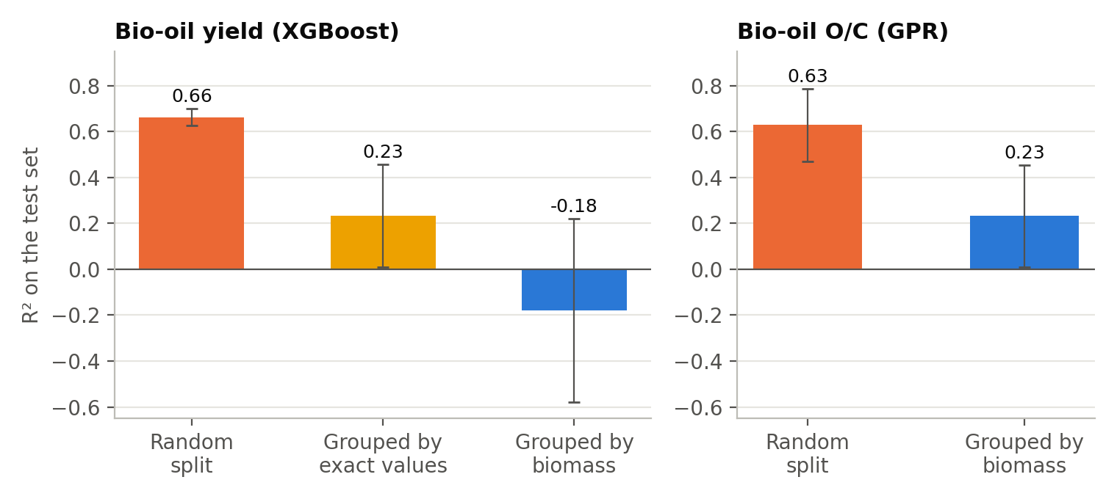
Figure 1. Test-set R² under different testing methods (physics inputs). Error bars: spread over repeats.
Target | Model (physics inputs) | Random split | Grouped, exact values | Grouped by biomass
Yield | Random Forest | R² 0.69, MAE 3.8 | R² 0.20, MAE 6.2 | R² −0.25, MAE 8.7
Yield | XGBoost | R² 0.66, MAE 4.2 | R² 0.23, MAE 6.3 | R² −0.18, MAE 8.3
Yield | GPR | R² 0.60, MAE 4.3 | not run | R² 0.01, MAE 7.7
O/C | Random Forest | R² 0.52 | (same as grouped) | R² 0.19
O/C | XGBoost | R² 0.51 | (same as grouped) | R² 0.14
O/C | GPR | R² 0.63 | (same as grouped) | R² 0.23
MAE in wt% yield. O/C R² is on log10(O/C). For D1b, exact and biomass grouping are the same because its values have no hidden noise. No-model baseline: yield MAE 8.3 wt%, O/C R² about 0.

4.1 Findings
- Random splits inflate scores strongly. Yield R² 0.66 drops to −0.18 for unseen biomass; O/C 0.63 drops to 0.23.
- Near-duplicates hide leakage. Grouping by exact values still gives R² 0.23 for yield, because the same biomass hides under slightly different numbers. Only near-duplicate grouping reveals the true score.
- Physics features help where it matters. On unseen biomass, physics inputs raised O/C R² for every model (Figure 2).
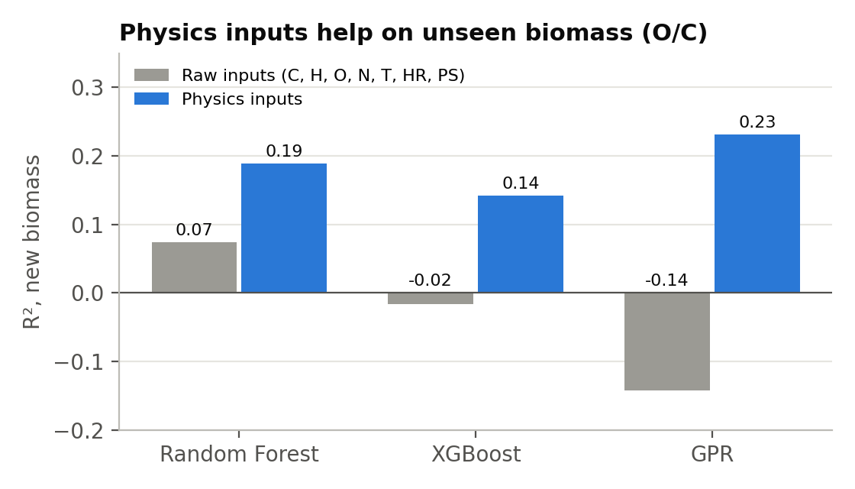
Figure 2. O/C on unseen biomass: raw inputs vs physics inputs.
- Why yield does not transfer: 72% of the variation in D3 yield lies between biomasses, and in literature data each biomass usually comes from a different lab, reactor and liquid-collection method. These lab differences are not recorded in any column, so no model can learn them.

5. Results Part B: Physics-Aware Models and the Advisor

5.1 Choosing the final models
Model (unseen biomass, same splits) | R² | MAE | Shape R²*
Yield: mean only | −0.09 | 8.21 wt% | 0
Yield: GPR only | 0.01 | 7.70 wt% | 0.01
Yield: GPR + XGBoost average | 0.07 | 7.48 wt% | 0.07
Yield: level (GPR) + shape (XGBoost) ✔ | 0.07 | 7.50 wt% | 0.12
O/C: GPR only | 0.23 (log) | 27.7% typical | -
O/C: XGBoost with physics constraints | 0.14 (log) | 37.5% typical | -
O/C: GPR + constrained XGBoost ✔ | 0.26 (log) | 32.1% typical | -
*Shape R²: how well the model predicts how yield changes with conditions within one biomass. GPR alone ignored the reactor conditions (shape R² 0.01), so it could not guide temperature choice. The level + shape model captures the condition effects best (0.12).

5.2 Physics checks
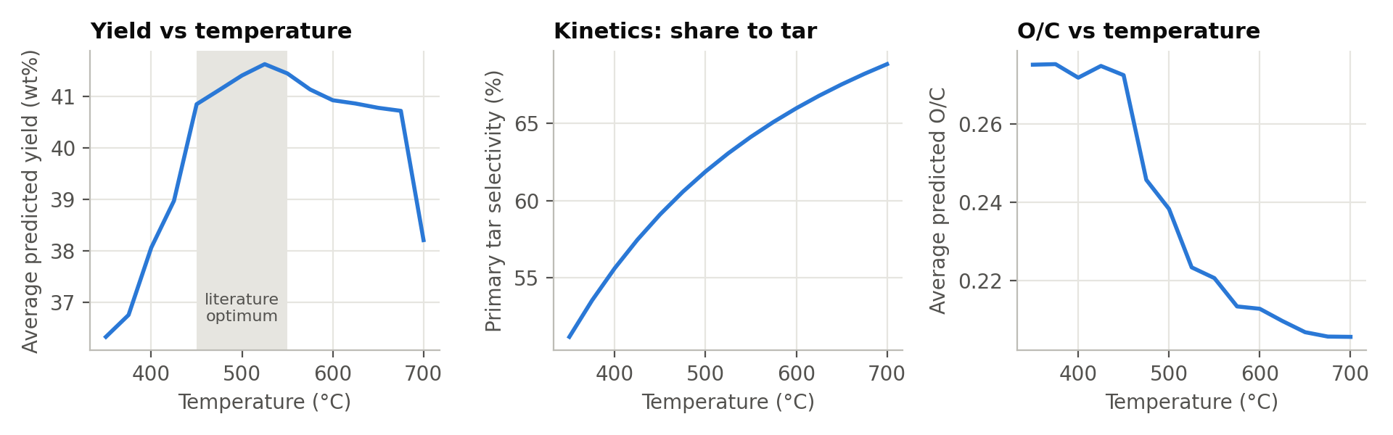
Figure 3. Average model response to temperature, with kinetic tar selectivity for comparison.
- Yield optimum: predicted yield rises from 36.3 wt% at 350 °C to a peak of 41.6 wt% at 525 °C and falls to 38.2 wt% at 700 °C, matching the known optimum of 450 to 550 °C.
- Why a peak: kinetics says the share of biomass turning into tar keeps rising (51% at 350 °C to 69% at 700 °C), so the fall above about 600 °C must come from secondary cracking of hot vapours into gas. The model learned this two-step behaviour from data.
- Oxygen: predicted O/C falls from 0.28 to 0.21 between 350 and 700 °C, as expected from stronger deoxygenation (CO, CO₂, water release) at higher temperature, and is guaranteed never to rise with temperature.
- Heating regime: every experiment in D3 has θ < 0 (maximum −0.86) and the median heating rate is only 25 °C/min, so the data is dominated by slow pyrolysis of evenly heated particles. Particle-size effects are therefore small and noisy.

5.3 Honest uncertainty and calibration
- 80% bands for a brand-new biomass: yield ±12.6 wt%; O/C within a factor of 2.2. These are wide, and the advisor shows them so users do not over-trust a single number.
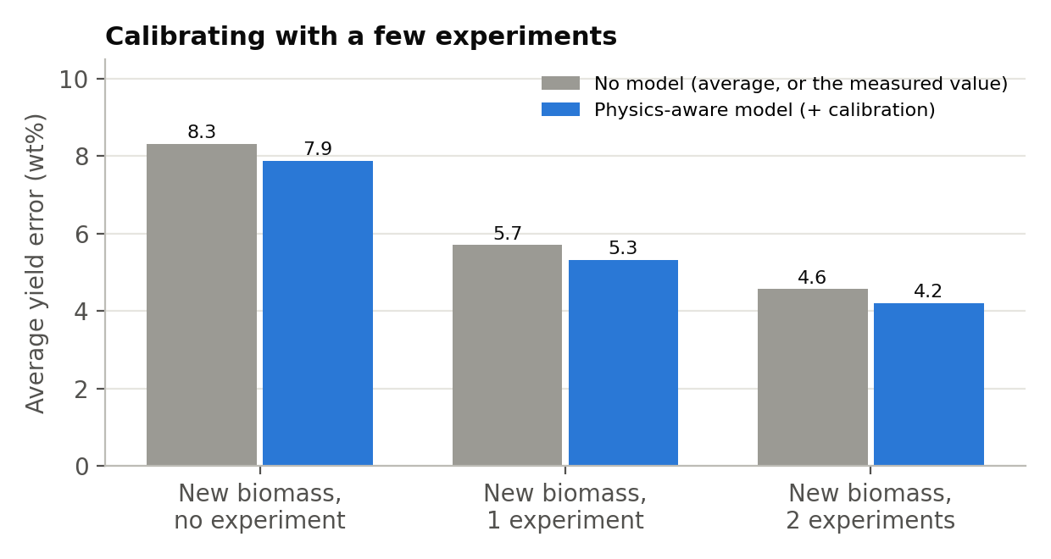
Figure 4. Yield error for a new biomass with 0, 1 or 2 real experiments.
One real experiment cuts the yield error from about 8 to 5.3 wt%; two bring it to 4.2 wt%. In both cases the model beats simply re-using the measured value (5.7 and 4.6 wt%), because it adds how yield changes with conditions. For O/C, re-using the measured value was slightly better than the model (log error 0.087 vs 0.104), because O/C changes little within one biomass in this dataset.

5.4 Case studies: three biomasses never seen in training
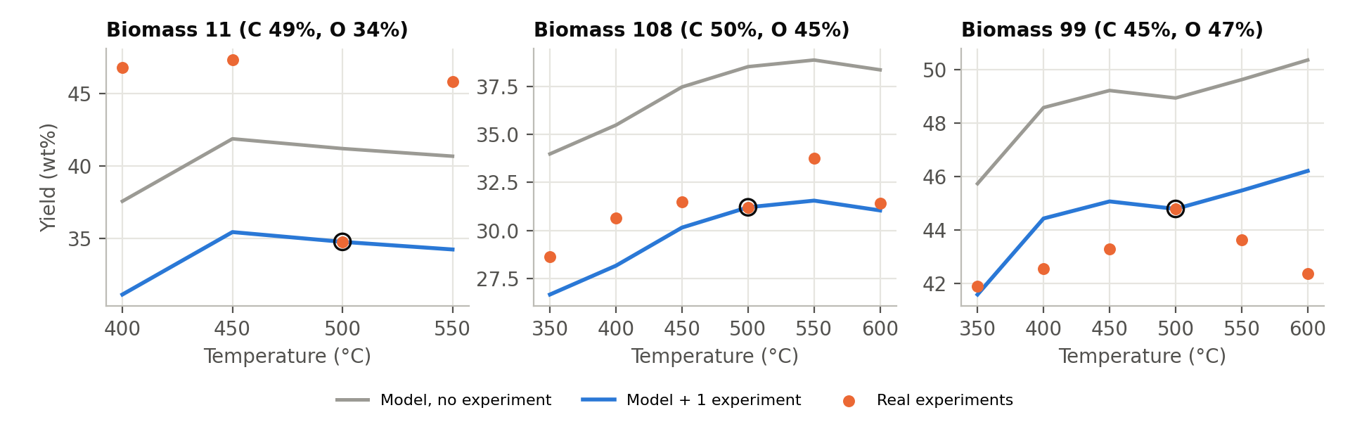
Figure 5. Held-out biomasses. The circled point is the single experiment used for calibration.
Biomass | Best T (real) | Best T (model) | Error, no experiment | Error, 1 experiment
11 (C 49%, O 34%) | 450 °C | 450 °C ✔ | 6.6 wt% | 13.0 wt%
108 (C 50%, O 45%) | 550 °C | 550 °C ✔ | 5.6 wt% | 1.7 wt%
99 (C 45%, O 47%) | 500 °C | 600 °C | 6.0 wt% | 1.9 wt%

The model found the best temperature for two of three biomasses without any experiment. Calibration cut errors to under 2 wt% for biomasses 108 and 99. For biomass 11, the calibration point (34.8 wt% at 500 °C) is far below its neighbours (46 to 47 wt%), probably a measurement or reporting inconsistency, so calibrating on it made things worse. Lesson: calibrate with at least two experiments.

5.5 The Pyrolysis Advisor
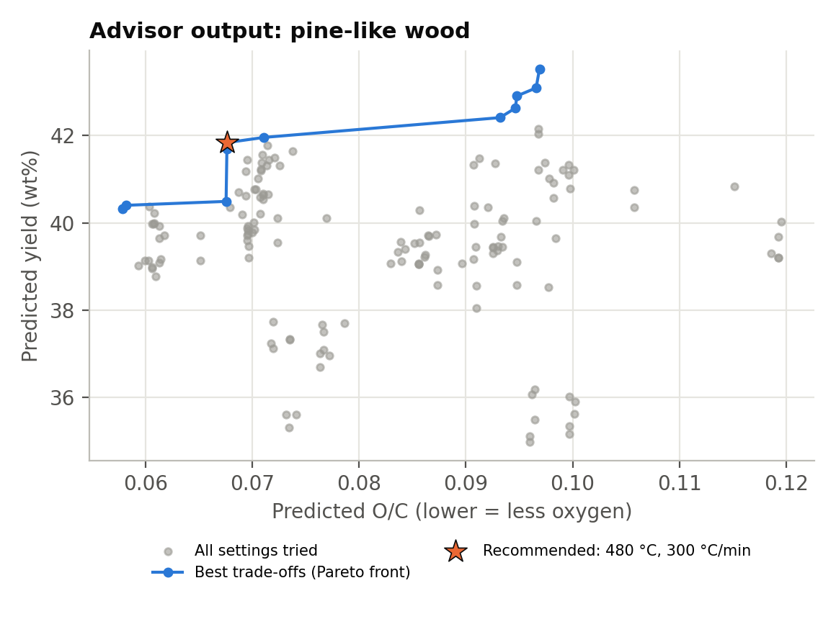
Figure 6. Advisor output for a pine-like wood (C 50, H 6.1, O 43.5, N 0.2 wt%; particle 0.5 mm).
Biomass | Known type? | Recommended setting | Alternatives
Pine-like wood | Yes | 480 °C, 300 °C/min → 41.8 wt%, O/C 0.068 | Max yield: 570 °C, 100 °C/min → 43.5 wt%, O/C 0.097
Rice husk-like | Yes | 510 °C, 10 °C/min → 41.6 wt%, O/C 0.062 | Max yield: 570 °C, 100 °C/min → 44.7 wt%, O/C 0.113
Microalgae-like (N 8.5%) | No: flagged | Shown with a warning | Needs 1 to 2 experiments first
Coal-like (C 80%) | No: flagged | Shown with a warning | Outside biomass range

The Pareto front (Figure 6) shows the real trade-off: the last 1.7 wt% of extra yield costs about 40% more oxygen in the oil. The advisor makes this trade-off visible instead of hiding it, and it correctly refuses to be confident about feedstocks unlike its training data.

6. Discussion

6.1 Link to Dr. Akhil Mohan's separation review
- Upstream preparation: lower-O/C oil carries fewer oxygenated compounds into the separation stage, reducing solvent, adsorbent and energy demand. The advisor makes this choice explicit.
- Section 8.4 of the review: the review calls for interpretable, physics-informed ML. This project uses physics features, physical constraints and physics checks, and shows quantitatively why purely data-driven literature models do not transfer.
- Fig. 11 of the review: the proposed pipeline (data collection, cleaning, feature engineering, training, evaluation, validation, optimal conditions) is implemented here end to end for the pyrolysis stage, including the validation step that is often skipped.

6.2 Limitations
- Literature data mixes labs, reactors and measurement bases; vapour residence time, condensation conditions and water content are not reported.
- O/C and yield come from different datasets, so the advisor combines two separately trained models.
- Uncertainty for brand-new biomasses is wide; predictions are most useful after one or two real experiments.
- No separation data was available, so the separation stage itself is discussed, not modelled.

7. Conclusion
Published ML accuracy for bio-oil prediction is largely an artefact of random testing: on truly new biomasses, yield prediction drops to the level of guessing and O/C prediction to R² about 0.2 to 0.3. Hidden near-duplicate rows make this worse because they defeat simple grouping. Physics-based features, constraints and a level-plus-shape design produce models that are honestly tested, follow known pyrolysis physics, report realistic uncertainty and become useful with one or two experiments. The resulting Pyrolysis Advisor turns these models into practical guidance for producing more bio-oil with less oxygen, the starting point for the separation strategies studied by Dr. Akhil Mohan.

8. Future Work
- Add a "source paper" column from the original supplementary tables and test leave-one-paper-out.
- Model organic oil yield (bio-liquid minus water) on the 413 rows with water content.
- Collect consistent data from one reactor, including vapour residence time and condensation temperature, and retrain.
- Extend the advisor to the separation stage once separation data becomes available.

References
- Mohan A., Emmer Å., Engvall K., Jonsson M. (2026). Recent progress in separation strategies for upgrading bio-oil: mechanisms, challenges and a way forward. Separation and Purification Technology 392, 137146.
- Zhang T., Cao D., Feng X., Zhu J., Lu X., Mu L., Qian H. (2022). Machine learning prediction of bio-oil characteristics quantitatively relating to biomass compositions and pyrolysis conditions. Fuel 312, 122812.
- Pascarella A.E., Coppola A., Marrone S., Chirone R., Sansone C., Salatino P. (2025). Critical assessment of machine learning prediction of biomass pyrolysis. Fuel 394, 135000.
- Aye H.Y., Scala F., Stepanec L., Zin Lin O., Juchelkova D. (2026). Mechanistic machine learning for biomass pyrolysis. Energy Conversion and Management: X. Dataset: Zenodo 10.5281/zenodo.19205977.
- da Costa et al. (2027). Artificial intelligence in biomass pyrolysis: a structured synthesis of modeling practices, performance and research gaps. Biomass and Bioenergy 216, 109717.
- Chan W.R., Kelbon M., Krieger B.B. (1985). Modelling and experimental verification of physical and chemical processes during pyrolysis of a large biomass particle. Fuel 64, 1505–1513.
- Ren S., Wu S., Weng Q. (2023). Physics-informed machine learning methods for biomass gasification modeling by considering monotonic relationships. Bioresource Technology, 10.1016/j.biortech.2022.128472.
- Tang Q. et al. (2020). Prediction of bio-oil yield and hydrogen contents based on machine learning method. Energy & Fuels 34(9), 11050–11060.

Appendix: Project Files
Folder / file | Contents
data_raw/ | Original datasets, untouched
data_clean/ | Cleaned D1b (O/C) and D3 (yield) with biomass group IDs
src/01_clean.py | Cleaning and near-duplicate grouping
src/features.py | Physics features (heat transfer, kinetics, molar ratios)
src/02_leakage_study.py | Part A: random vs grouped testing
src/05, 06 | Model selection for O/C and yield
src/07_final_advisor.py | Part B: final models, uncertainty, calibration, case studies, advisor
results/ | All tables (CSV/JSON) and figures
models/ | Saved final models

