**Week6 React HandsOn**

**6. ReactJS-HOL**

**Objectives**

* Explain the need and benefits of React Router
* Identify the Components in React Router
* List the types of Router Components
* Parameter passing via url

Folder Structure

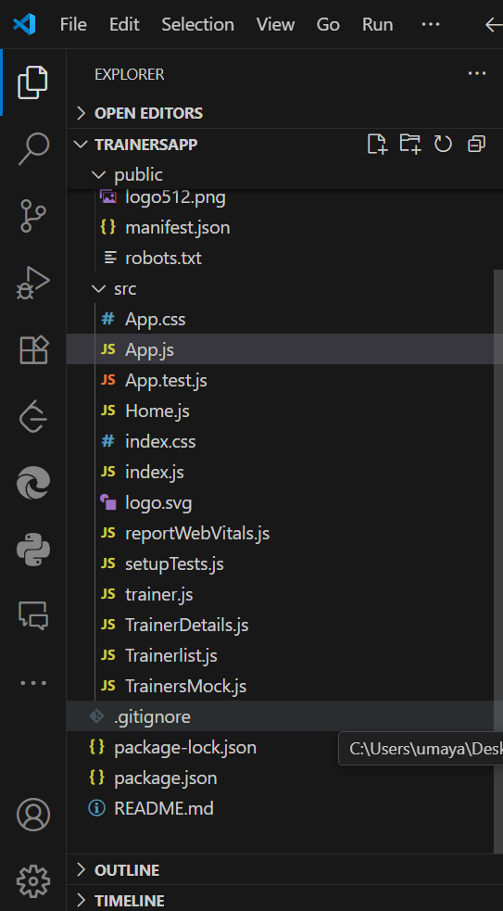

**Output Screens:**

