**Week6 React HandsOn**

**7. ReactJS-HOL**

Create a React Application named “shoppingapp” with a class component named “OnlineShopping” and “Cart”.

Folder Structure

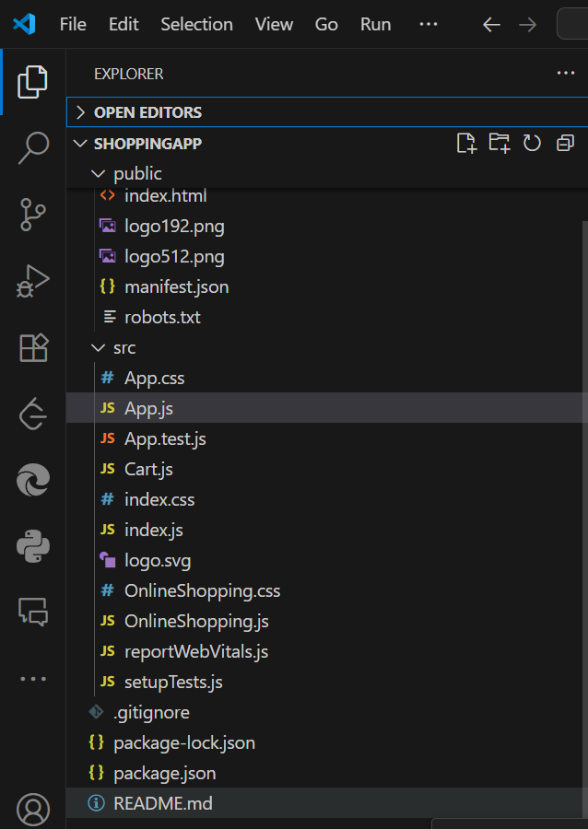

**Output Screens:**

