**Week6 React HandsOn**

**8. ReactJS-HOL**

Create a React App “counterapp” which will have a component named “CountPeople” which will have 2 methods.

UpdateEntry() 🡪 which will display the number of people who entered the mall.

UpdateExit() 🡪 which will display the number of people who exited the mall.

Use Constructor and state to Store the entrycount and exitcount.

The component has 2 buttons

1. Login 🡪 when clicked, the entrycount should get incremented by 1
2. Exit 🡪 when clicked, the exitcount should get incremented by 1

Folder Structure

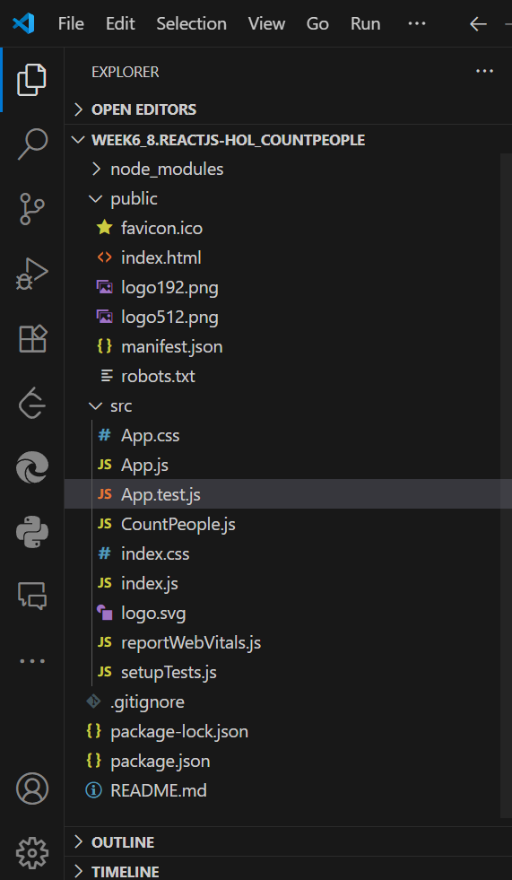

**Output Screens:**

