Part 1: What actually happened (in plain English)
Walk through this mentally, because this is your answer when someone asks "walk me through your project":
- You made an authenticated web request. An API is just a website's data endpoint that returns structured data instead of a rendered webpage. app_id and app_key are like a username/password combo — they prove to Adzuna's server that you're allowed to ask for data. requests.get(url, params=params) sent that request over HTTP.
- You got data back as JSON. JSON is just a nested, structured text format — dictionaries inside dictionaries, lists inside dictionaries. Real-world APIs almost never hand you a flat table; they hand you nested objects like company.display_name or location.area[0]. Learning to "reach into" nested JSON is a core data engineering skill.
- You respected pagination and rate limits. APIs don't give you all data in one shot — they cap results per call (Adzuna: 50/page) and cap total calls per day/month (Adzuna free tier: ~1,000/month). Your script looped through pages and added time.sleep(1) between calls — that's you being a responsible API consumer, not hammering their servers.
- You flattened nested JSON into a tabular structure. This is the "ETL" (Extract, Transform, Load) pattern in miniature: Extract (API call) → Transform (flatten JSON, extract skills, clean types) → Load (save to CSV, later SQLite). This exact pattern is used in real data engineering pipelines, just at bigger scale.
- You did lightweight NLP via regex. Since job descriptions are unstructured free text, there's no "skills" field handed to you — you had to infer skills by searching for keyword patterns. This is a real (simplified) technique called keyword-based entity extraction, a stepping stone to more advanced NLP (like spaCy's named entity recognition).
- You made real data cleaning decisions — deduplicating by job_id, converting "0"/"1" strings to actual booleans, parsing date strings into real datetime objects, handling missing salary fields. This is what "data cleaning" actually means day to day — not glamorous, but it's 70% of real analyst work.

Part 2: How to explain it in an interview
The framing that works best: don't say "I followed a tutorial" (even though I guided you) — say "I designed a pipeline to solve a specific question." That's true — you made real decisions (which countries, which skills to track, how to handle missing salary). Own it as your design, because it is.
A strong 30-second answer if asked "walk me through this project":
"I wanted to know what skills employers actually look for in Data Analyst roles, so I built a small pipeline. I used Python to pull live job postings from a jobs API across India, US, and UK, saved the raw JSON responses for reproducibility, then wrote a cleaning script that flattened the nested JSON into a table and used regex pattern matching to extract mentioned skills — like SQL, Python, Power BI — from each job description. That gave me a clean structured dataset I could then load into SQL and analyze in Python, and visualize in Power BI."
That's it. Confident, accurate, no jargon overload.

Likely follow-up questions and how to answer them
"Why did you save raw JSON separately instead of going straight to CSV?"
"Reproducibility. If my cleaning logic had a bug, I didn't want to have to re-call the API and burn my rate limit — I could just re-run cleaning against the raw files. It also mirrors how real pipelines separate raw/bronze data from cleaned/silver data."
"How did you handle missing data?"
"Not every posting has salary listed, so rather than dropping those rows and losing data, I kept them and made salary-based analysis conditional — I only compute salary stats on rows where it's present, and I flagged Adzuna's salary_is_predicted field so I could distinguish real employer-stated salaries from the API's own estimates."
"Why regex instead of a real NLP library?"
"For a known, finite list of skill keywords, regex is fast, transparent, and doesn't need external models. It has real limitations — it can't understand context or catch synonyms — I'm aware a proper NLP approach (like spaCy NER) would generalize better, but for this scope regex gave good precision on a defined skill list."
(This shows self-awareness — a green flag, not a weakness.)
"What would you do differently at scale / in production?"
"I'd move from local JSON files to something like cloud storage or a proper database with incremental loading, add retry logic and logging for failed API calls, and probably schedule the collection with a cron job or Airflow instead of running it manually."
(You don't need to have built this — just show you understand what's next.)
"What was the hardest part?"
Be honest — pick something real, e.g.:
"Handling inconsistent JSON structure — not every job posting has every field, so I had to write defensive code using .get() with defaults instead of direct key access, or it would crash on missing fields."

Gaps to shore up before interviews (be honest with yourself here)
Since you're new to this, spend 30–60 minutes reviewing these concepts so you're not just reciting — you actually get them:
- What .get("key", default) does on a Python dict and why we used it everywhere instead of job["key"] (crashes if missing)
- The difference between a JSON object {} and a JSON array [], and how that maps to a Python dict vs list
- What a regex pattern like \bsql\b actually means (word boundaries) — you don't need to master regex, but you should be able to explain the ones in your own script
- Basic HTTP concepts: what a GET request is, what a status code is (200 = success, 401 = auth failed, 429 = rate limited)
- Why pd.to_datetime(..., errors="coerce") — it converts unparseable dates to NaT (missing) instead of crashing the whole script
Everything about data cleaning:
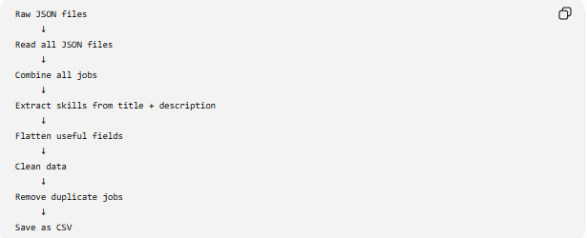

Script 2 – Clean_data.py
Sure — here's the whole script told as a story, no code, just what's happening step by step.

The big picture
This script is a data cleaning pipeline for job listings. Imagine you've been scraping job postings from a job site, for three countries, over several days — so you've got a folder full of messy JSON files. This script's job is to take that mess and turn it into one clean, tidy spreadsheet (CSV) that's ready for analysis.

Step by step, in plain English
1. It looks at the folder of raw files. Inside data/raw, there are a bunch of JSON files — probably named like in_page1_20260808.json, us_page3_20260809.json, and so on. Each file is one "page" of job results from one country.
2. It figures out which country each file belongs to. It looks at the start of each filename (in, us, gb) and translates that code into a real country name — "India," "United States," "United Kingdom" — using a lookup dictionary.
3. It opens every file and pulls out the job listings. Each JSON file has a bunch of individual job postings inside it. The script opens the file, grabs every job posting, stamps it with the country it came from, and dumps it into one giant combined list. So after this step, instead of 20 separate files, you have one big pile of every job ever scraped.
4. For each job, it reads the title and description, hunting for skills. It smushes the job title and description together into one blob of text, then checks that text against a list of ~18 known skills — Python, SQL, Excel, AWS, Tableau, etc. Each skill has a little pattern designed to catch different ways it might be written (like "Power BI" vs "PowerBI"). Whatever skills it finds get tagged onto that job.
5. It builds a clean row for every job. For each job posting, it carefully extracts the important fields — title, company, location, category, salary range, contract type, date posted, and the skills it just found. If any field is missing (some job postings might not list a company, for example), it fills in "Unknown" instead of breaking.
6. It tidies up the data. Once everything's collected into a table:
- Dates get converted into a proper date format
- A new "average salary" column gets calculated from the min and max salary
- Any duplicate job postings (which can happen if the same job showed up on two different scraped pages) get removed
7. It saves the result and reports back. The clean table gets written out as jobs_clean.csv inside data/processed. Along the way, it prints progress messages — how many raw jobs were loaded, how many rows made it into the final file, and a little preview showing a few job titles next to the skills that were detected for them.

The one-sentence version
Read messy scattered job files → combine and label them by country → scan each job for mentioned skills → organize everything into one clean table → save it as a CSV you can actually work with.
That's really it — everything else in the code (the .get() defaults, the regex patterns, the errors="coerce") is just defensive plumbing to make sure messy real-world data doesn't crash the script along the way.

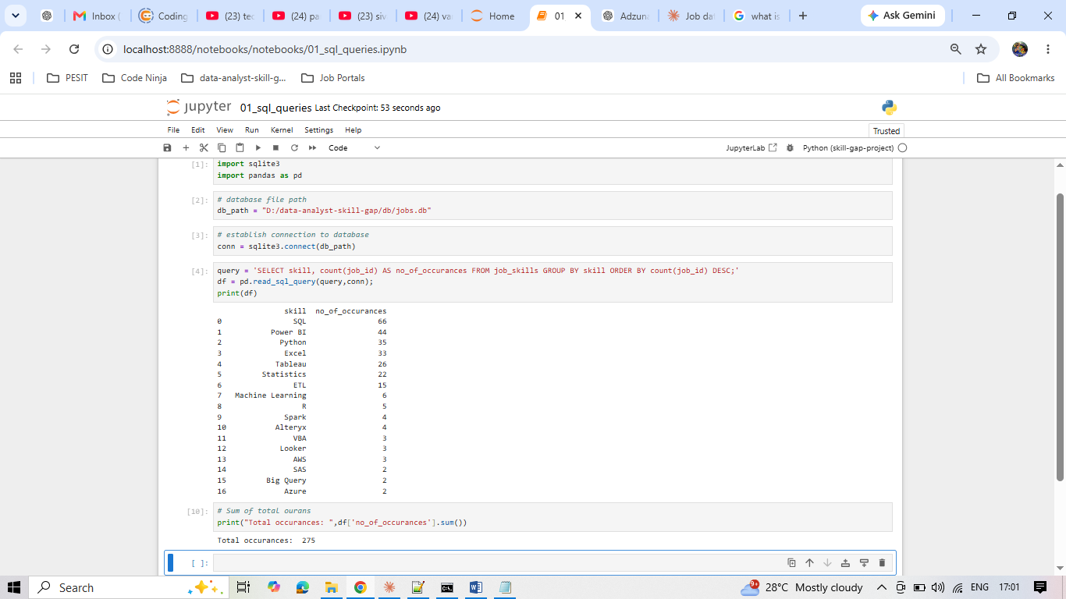
Data limitation to keep in mind
Notice the counts don't add up to huge numbers relative to 450 job postings — e.g., only 66 SQL mentions out of 450 jobs. This confirms what we flagged earlier: many job descriptions are truncated by the API, so skill detection has a real coverage gap. Keep this in your back pocket as a documented limitation for your README/EDA notes.
Explanitation:
Adzuna's search results often return truncated/short descriptions (not the full job ad) — so skill keywords that would appear later in a real job post may simply not be in the text we have
Some genuine "Data Analyst" postings just don't explicitly mention tool names in the blurb (they might say "strong analytical skills" without naming SQL/Python)

This is actually a good talking point for interviews ("I noticed my regex extraction had a coverage gap because Adzuna returns truncated descriptions — I considered fetching full descriptions via the redirect_url but decided that was out of scope/against ToS for scraping, so I documented the limitation instead"). Real projects have real data limitations — acknowledging them is a strength, not a weakness.

