DIVING DEEPER INTO THE UMBANE SYSTEM

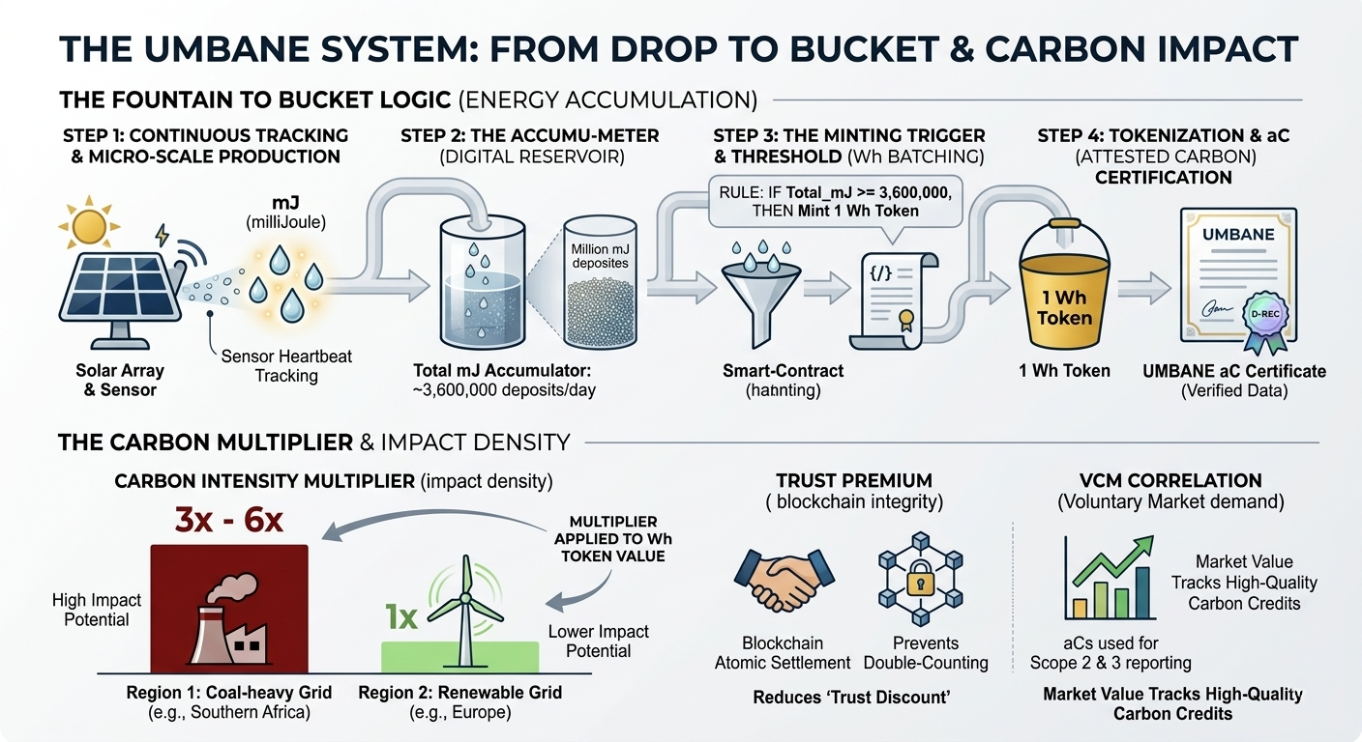
This deep dive illustrates how the Umbane system transforms high-resolution energy data into high-value environmental assets. By measuring at the millijoule (mJ) level, we capture the "heartbeat" of energy production, ensuring no electron is left uncounted before it is "batched" into a tradable Watt-hour (Wh) token.

The Umbane Accumulator: From Drops to Buckets
The system operates as a precision digital meter. While standard RECs often ignore small-scale production, our smart contract ensures every drop counts.
- The Micro-Scale (mJ): The sensors record energy in real-time. Since 1 Joule=1 Watt-second, a millijoule is 0.001 Joules. This allows for extreme precision, capturing even the smallest fluctuations from a single solar panel.
- The Threshold (Wh): To keep the blockchain "clean" and gas-efficient, we don't mint a token for every mJ. Instead, the contract acts as a reservoir.
- The Minting Rule:
IF ∑mJ≥3,600,000⟹Mint 1 Token (1 Wh Equivalent)
(Note: 1 Watt-hour=3,600 Joules, or 3.6 million mJ).

Value Drivers: The "Impact Density" Premium
Not all kilowatt-hours are created equal. The Umbane system applies a "Carbon Multiplier" to the energy produced based on where it happens.
Value Driver | Description | Impact on Price
Carbon Intensity | Replacing coal-heavy power in Southern Africa prevents more CO2​ than replacing wind-heavy power in Europe. | 3x – 6x Multiplier on "Impact Density."
VCM Correlation | aC certificates track high-quality Voluntary Carbon Market credits used for Scope 2 and 3 reporting. | Premium Pricing as corporate ESG demand rises.
Trust Premium | Blockchain eliminates "double-counting" and provides an immutable audit trail to the specific device. | Reduced "Trust Discount" compared to paper credits.

Comparison: Standard REC vs. Umbane aC
The traditional market is built for industrial-scale plants (1 MWh blocks). Umbane brings that same institutional rigor to the "edge" of the grid.
- Standard REC: 1 Megawatt-hour (MWh) threshold. Small producers are effectively locked out.
- Umbane aC: Granular tracking (mJ) that bundles into Wh. It acts as a bridge that translates raw energy production into the language of global carbon offsets (tCO2​).

Visualizing the Flow
Imagine a fountain filling a bucket:
- mJ: The individual drops of water falling from the sensor.
- The Accumulator: The bucket catching every drop.
- The Token: A digital voucher issued only when the bucket is full (3.6M mJ) and poured into the Polygon network.

Gettting to grips with measurements and standards

In this system, the millijoule (mJ) is the high-resolution "counter," while the Watt-hour (Wh) is the "threshold" for a payout. Because , the system acts like a digital piggy bank that requires millions of tiny deposits before it drops a single coin.

Visualising the System
1. Continuous Tracking: The sensors measure energy production in real-time. Since
- is a very small amount of energy (roughly the energy of a single heartbeat), it allows the system to record even the tiniest fluctuations in power.
2. The Accumulator: The system adds these millijoules to a running total (a "buffer" or "meter").

3. The Minting Trigger: The smart contract or software is programmed with a specific rule:
  - IF Total_mJ >= 3,600,000
  - THEN Mint 1 Token AND Subtract 3,600,000 from Total Energy Produced
4. Tokenization & aC Verification: The Bridge Unlike standard Renewable Energy Certificates (RECs) that often track 1 MWh blocks, the Umbane aC (Attested Carbon) certificate provides a granular bridge. It converts the energy data (Wh) directly into the corresponding carbon value. A crucial "D-REC" validation verifies the data's authenticity, linking it to the specific device.

Why use mJ for tracking?
Using millijoules instead of Watt-hours for the internal measurements provides precision. If the system only measured in Wh, any production less than a full Wh (like 0.5 wH) might be ignored or "lost" to rounding. By tracking in mJ, the system ensures that every tiny bit of energy produced counts toward the next token.

Real-World Comparison
Think of it like a fountain filling a bucket:
- mJ: The individual drops of water.
- Wh: A full bucket.
- The Token: A voucher you receive only once the bucket is completely full and poured out.

The Standard Renewable Energy Certificate (REC) typically tracks energy (1MWh), our aC (Attested Carbon) certificate acts as a bridge that translates that energy into the language of carbon markets (tCO₂ offsets).

Price Relationship & Value Drivers
The price of your token relative to the broader carbon market is generally influenced by three factors:
- Carbon Intensity (The Multiplier): Unlike a fixed 1:1 energy-to-token ratio, the value of an aC certificate is often "weighted" by the local grid's carbon footprint. For example, a D-REC generated in a coal-heavy region (like Southern Africa) can have 3 – 6 times the carbon reduction potential of a similar project in Europe. This higher "impact density" allows your tokens to command a premium price.

- Voluntary Carbon Market (VCM) Correlation: Since aCs are often used for "Scope 2" (indirect emissions) and "Scope 3" (supply chain) reporting, their price tends to track with high-quality voluntary carbon credits. As demand for "BBB+" or trusted nature-based/tech-based credits increases, the market value for verified, high-fidelity tokens like yours typically rises in tandem.

- Liquidity and Transparency Premium: By using blockchain for "atomic settlement" (immediate issuance), your system reduces the "trust discount" often applied to traditional carbon credits. Market participants often pay more for tokenized assets because they eliminate the risk of double-counting and provide a transparent, immutable audit trail back to the specific device.

Document Prepared For: Umbane Stakeholders
Date: March 20, 2026
Version: 1.0
Authors: Umbane Research Team
Contact: 082 4251454

