**PathBubbles User Menu**

**5/31/2014**

PathBubbles is an interactive visualization tool for exploring and analyzing biological pathways. This user menu is for installing, running, and testing PathBubbles source code and executable.

Run PathBubble in VS project or by double-clicking the downloaded executables. You will see the PathBubbles interface (Fig. 1) as below. Right click empty space to bring up a drop-down menu. Please refer to [PathBubbles Wiki](https://sites.google.com/a/umbc.edu/pathbubbles/release/pathbubbles-1-0/pathbubbles-wiki) for a pathway rudiments and key concepts of Pathbubbles.

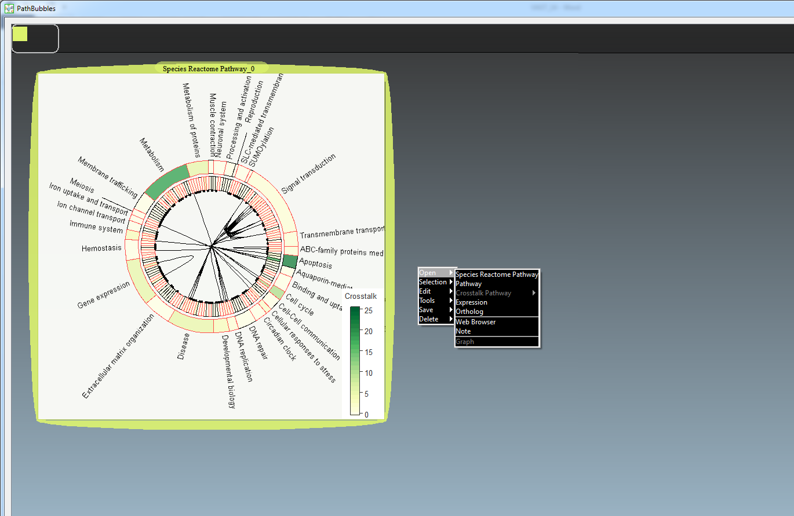

Fig. 1 Initial Interface. Left: A tree ring bubble show [Reactome](http://www.reactome.org/PathwayBrowser/) pathways available in PathBubbles. Right: right click brings up the main menu.

**1. Load data**

You can open “Reactome Pathways”, a single pathway, and expression data in bubbles. You can also input ortholog table to map orthologous proteins to pathways.

(0) Data format.

Pathway dataset: current PathBubbles provides all pathway datasets downloaded and converted to PathBubbles specific data format by our developers. Therefore, we do not accept user input pathway data at this point.

Expression dataset: PathBubbles accepts user provided expression data set in specified format.

Please check the sample data set [here](http://www.csee.umbc.edu/~keqin/PathBubbles1.0/Sample_data/TGF0expression.txt).

Ortholog table: PathBubbles accepts user provided ortholog data set in specified format.

Please check the sample data set [here](http://www.csee.umbc.edu/~keqin/PathBubbles1.0/Sample_data/gallus_gallus_ortholog.txt).

(1) Load “Reactome Pathways”

A tree ring bubble showing an overview of pathways from Reactome database is shown in the initial interface. You can open more tree rings by clicking “Species Reactome Pathway” under “Open” in the drop-down menu.

(2) Load a single pathway

PathBubbles provides three ways to open individual pathways.

First, open a pathway through file dialog. Clicking “Pathway” under “Open” in the drop-down menu will open a file dialog and you can select a pathway file from the “data\Reactome\_Pathway\_Data\pathwayTable” folder (Fig.2).

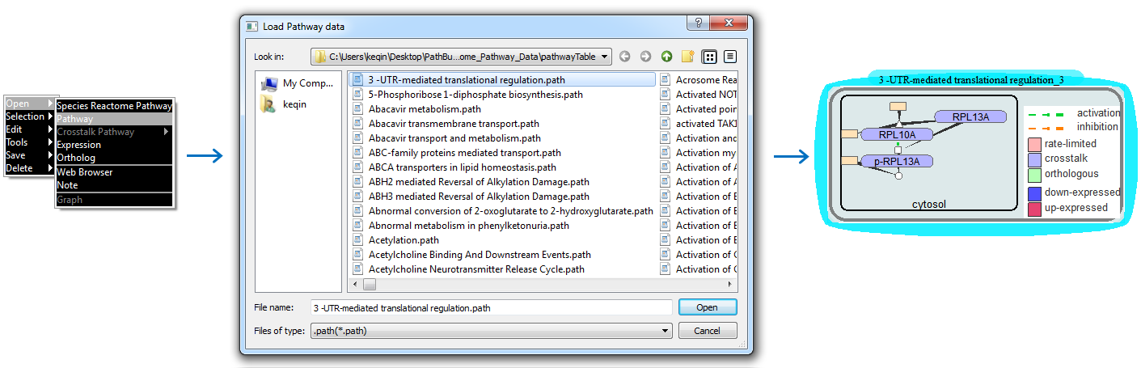

Fig. 2 Select a pathway through file dialog to open it in a pathway bubble.

Second, open cross-talking pathways through a cross-talking protein. If you mouse-over a cross-talking protein (colored in purple) and open menu, you are allowed to open any or all of the cross-talking pathways with this pathway though the protein. Mouse over a purple protein, right-click to open the menu, click “Open”, then “Cross-talking Pathways”, all the cross-talking pathways with current pathway through this protein will be shown in the menu (Fig. 3). Then, you can click any of them or “Open all” to open the pathways of your selection.

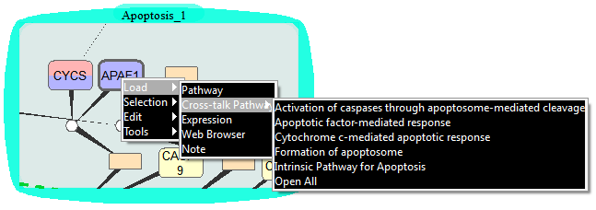

Fig. 3. A pathway bubble with both cross-talking and rate-limiting proteins. You can open any cross-talking pathway by using the menu opened at the protein location.

PathBubbles adopts a hierarchical graph layout with tapered edges. An example of the hierarchical graph layout and Symbols, including tapered edges, used to present pathway components are shown in Fig. 4.

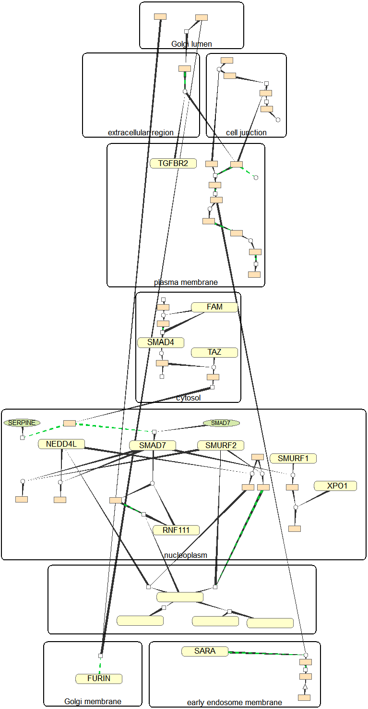 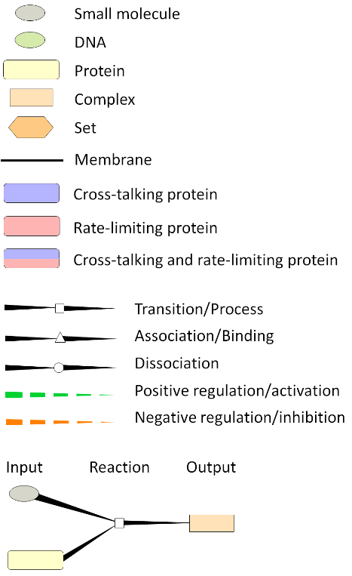

Fig. 4. A pathway graph (left) and symbols for pathway components (right).

Third, open a pathway by dragging a tree-ring node out of tree-ring bubbles (Fig. 5). You can use right mouse button to drag a tree ring node out of tree ring bubble to open the pathway graph in a new bubble.

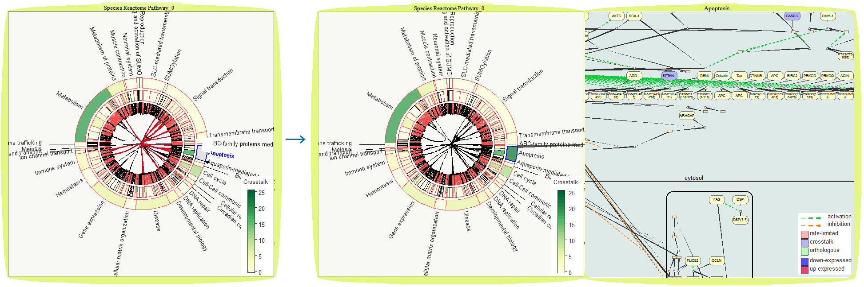

Fig. 5 Select a pathway through tree ring to open it in a pathway bubble.

(3) Load expression data

Clicking “Expression” under “Open” will open a file dialog which allows you to select your expression data (Fig. 6).

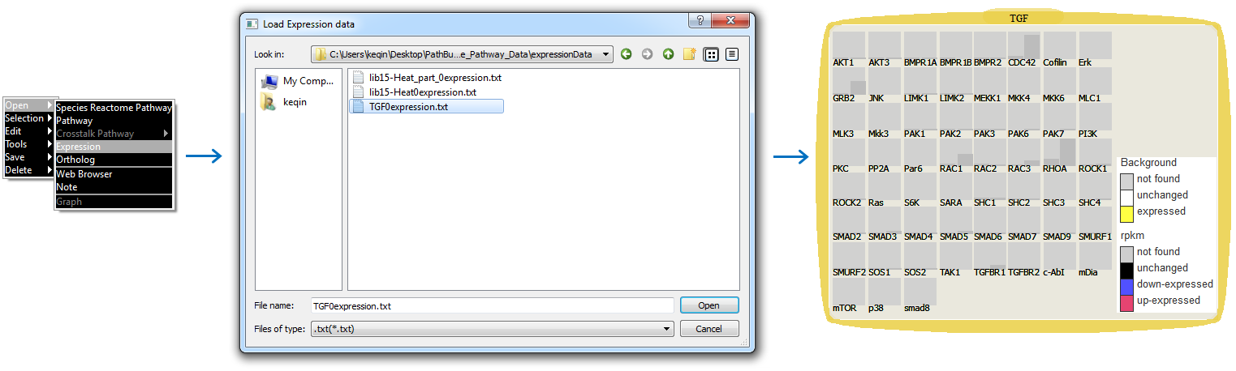

Fig. 6 Select an expression dataset through file dialog to open it in an expression bubble.

(4) Load ortholog table

The way to map an ortholog table is to load an ortholog file through selecting on a menu opened at the tree ring and/or pathway group location. Clicking “ortholgy” under “Open” will open a file dialog which allows you to select the orthology table of different species. The pathway bubble and a tree ring bubble mapped with ortholog table are shown in Fig.8.

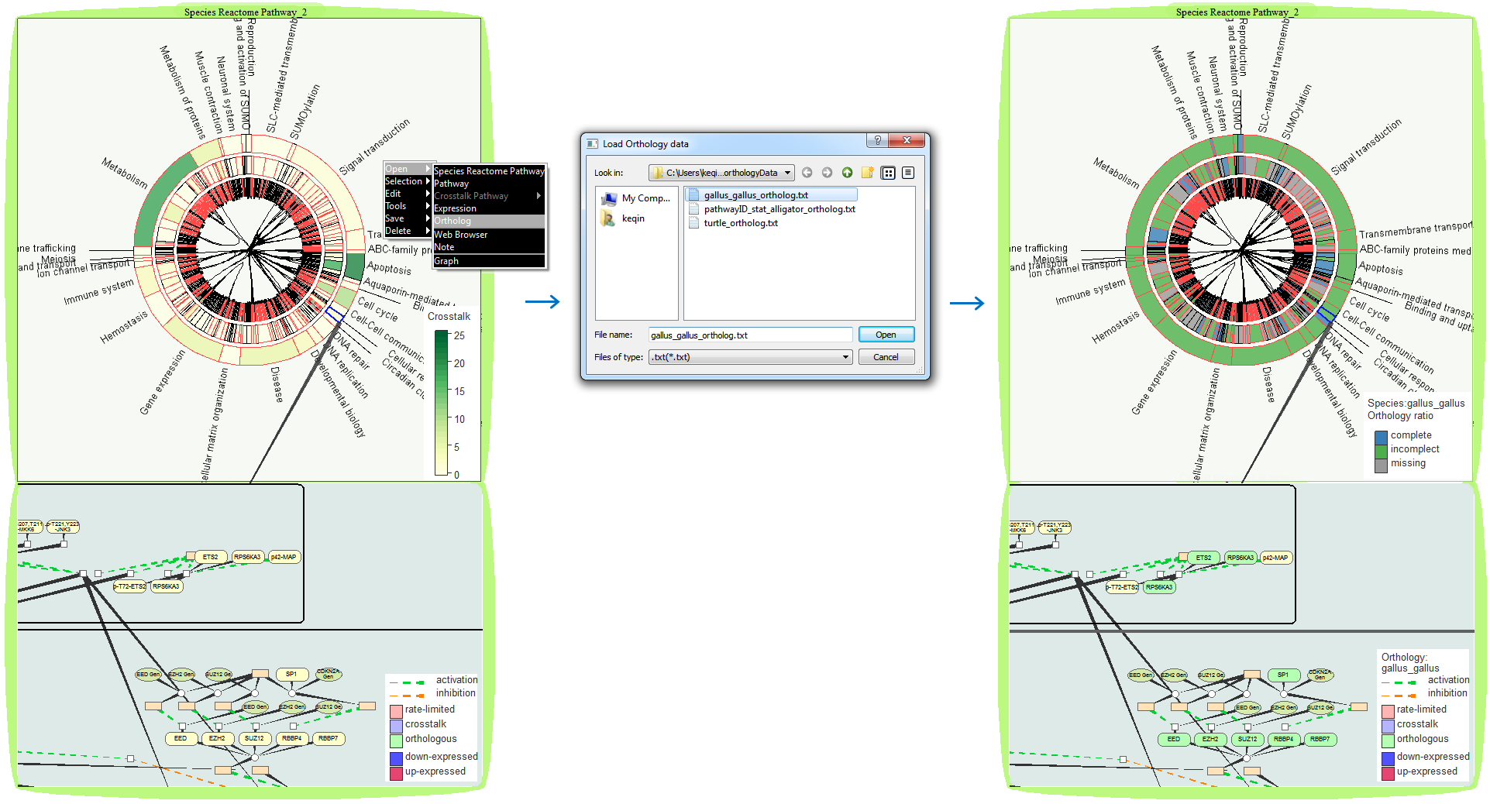

Fig. 8. Tree ring and pathway inference

**2. View management**

Pathbubbles provide several interactions to construct multi-view visualizations. It also provides an automatic space management — whenever a bubble is created, moved, resized, grouped, ungrouped, or deleted, a spacer algorithm is automatically invoked to incrementally modify bubble locations if overlap between bubbles or disconnection between grouped bubbles happens.

(1) Grouping/ungrouping. You can group bubbles together by dragging a bubble to a location overlapping with other bubbles (Fig. 8). Once grouped, data are automatically linked in such a way that interacting in one bubble activates the same interactions in all other grouped bubbles. It is also the way to like expression data with pathways.

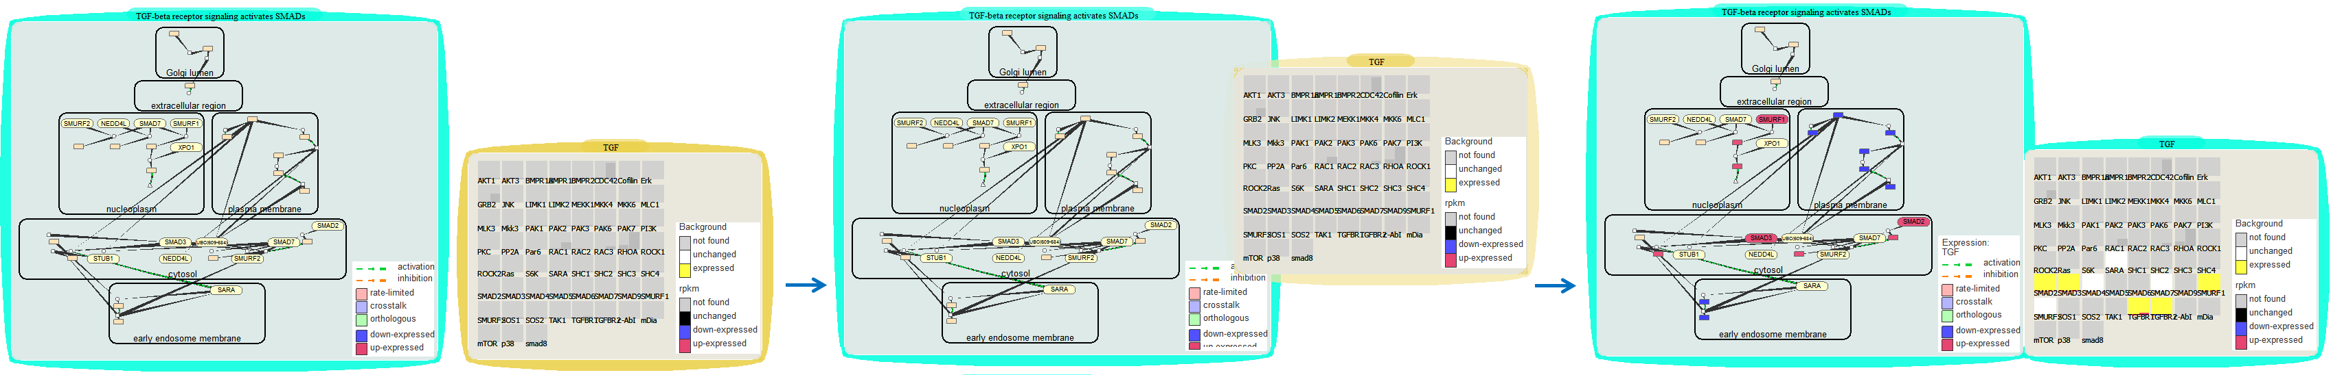

Fig. 8. Linking a expression dataset to a pathway by grouping them together

To ungroup a bubble from a group, you move mouse to the left middle boarder of the bubble and drag the bubble to other location once the mouse cursor changes its shape to a [Split Cursor](http://qt-project.org/doc/qt-4.8/qt.html#CursorShape-enum) .

(2) Zooming. You can resize a bubble by click-and-drag of the bubble's boundary.

(3) Dragging and panning on pannable workspace bar.

Pathbubbles provides a pannable workspace — a panning bar which shows an overview of the entire workspace for users to pan the screen and to change bubble locations. The thumbnails of bubbles are shown in the bar as small rectangles with same color as the bubble boarders.

You can move a bubble directly to other locations by dragging the bubble itself or dragging its corresponding rectangle on the bar by mouse.

You can move the whole display horizontally by dragging the bar to get more space. You can name current desktop space by: mouse over the virtual desktop on the bar and right click to bring up a menu “Name the current view”; then, click on it and type in the name (Fig. 9).

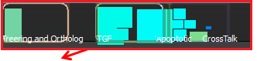 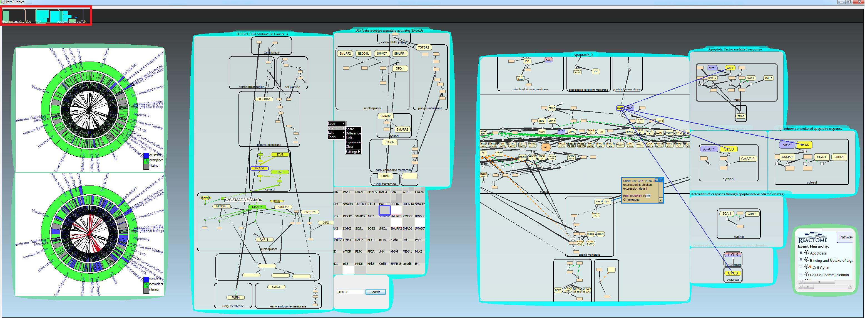

Fig. 9. The pannable bar is on the top of the screen with two named virtual desktops shown from left to right.

(4) Deletion.

You can delete a single bubble, a bubble group, or all the bubbles using menu. Take Fig. 10 for example, after opening the menu at bubble (3) location, users have three options: delete “Bubble”, delete “Group”, and delete “Scene”. Choosing “Bubble” will delete bubble (3) only; choosing “Group” will delete the bubble group of bubble (1-3); choosing “Scene” will clear all the bubbles in the scene.

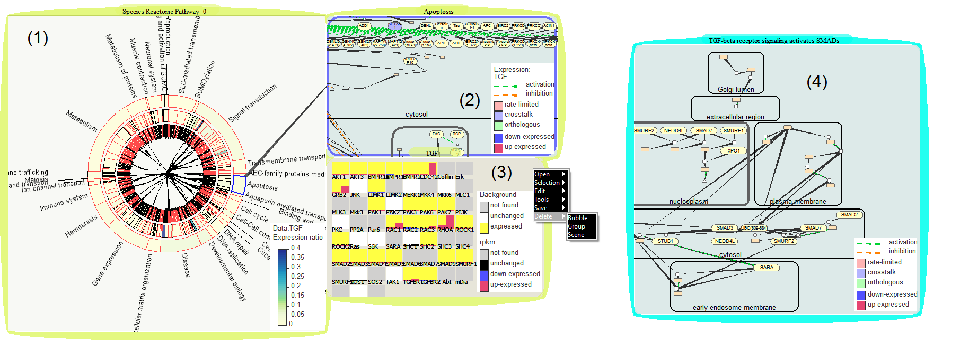

Fig. 9. Illustration of deletion options.

**3. Explore Pathways through Tree Ring**

A tree ring encodes the hierarchical relationship of pathways through ring layer and cross-talk through edges. In a tree ring view, each pathway is rendered as a tree ring node, namely a ring sector. Initially, the node color is assigned according to the number of cross-talking proteins. When linked with input expression or ortholog table, it encodes ratio of differentially expressed protein to total number of protein or completeness of orthologous proteins found in an input ortholog table.

A tree ring is shown in a bubble and allows users to select a tree ring segment to show in a new tree ring bubble or a single pathway to display in pathway bubbles.

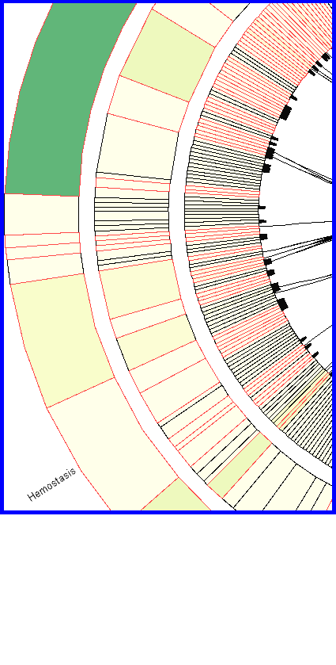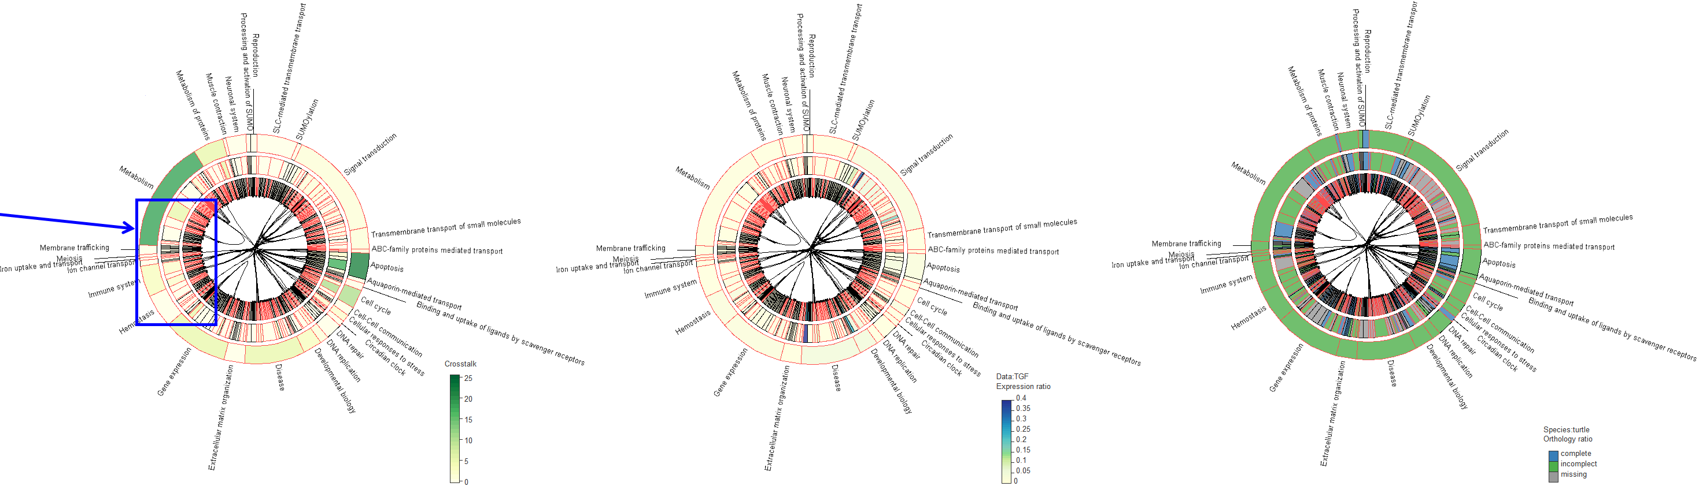

(a) (b) (c) (d)

Fig. 11. Node color encoding. (a) Tree ring nodes with red boundaries indicate the pathways containing rate-limiting proteins while those with black boundaries do not. (b) Number of cross-talking proteins. (c) Ratio of differentially expressed proteins to the total number of proteins. (d) Completeness of orthologous proteins found in an input ortholog table.

A tree ring reveals the hierarchical relationships between pathways. As shown in Fig. 11, the nodes in the outer ring represent top-level pathways. The sub-pathways are represented as smaller node in a lower level ring under the node representing its parent pathway. Note that there are more layers for some pathways, but we only take 3 levels in current version. For pathways have sub-pathways not shown in the tree-ring, a black wedge is attached to their inner side (Fig. 11a).

**3. Explore cross-talking and hierarchical relationship on tree ring**

Pathbubbles provides several interactions to manipulate tree rings.

(1) Find sub-pathways: You can highlight pathway name and edge connecting a node by mouse-over. A top-level tree ring node can be spanned or narrowed when you use mouse to drag one of its two handles apart and close (Fig. 12). This provides a way to inspect in detail about the size (child pathway numbers) and hierarchical information of the selected pathway.

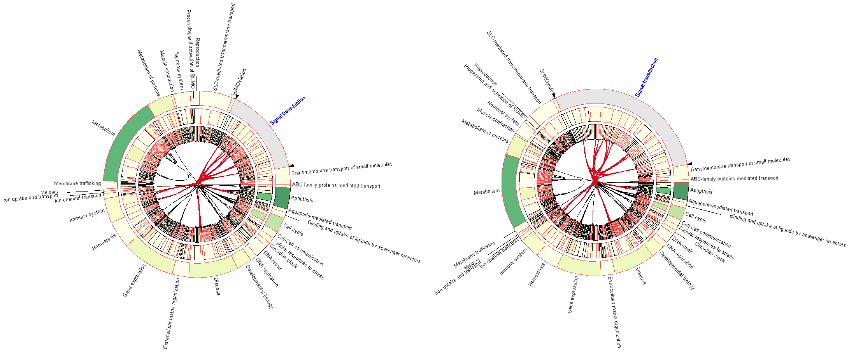

Fig. 12. Highlighting and spanning selected tree ring node. The node being hovered over by mouse is highlighted in light gray along with its name and edges highlighted in red. Left: before spanning. Right: after spanning

(2) Get sub set of pathways by tree ring segmentation: You can select a segment of tree ring. Use “control + right mouse button” to select tree ring segments and drag the segments out of the current tree ring bubble to form a new tree ring bubble only containing the segments.

On the other hand, you can combine two tree rings to form a new tree ring by move one tree ring bubble towards another tree ring bubble until one contains the other. To get a simpler view, users can delete any of existing tree ring including the original one. Fig. 13 shows a tree ring before and after sub-tree ring dragged out. Deep gray edges and the highlighted ring segments indicate the correspondence between the original tree ring and the sub-tree rings.

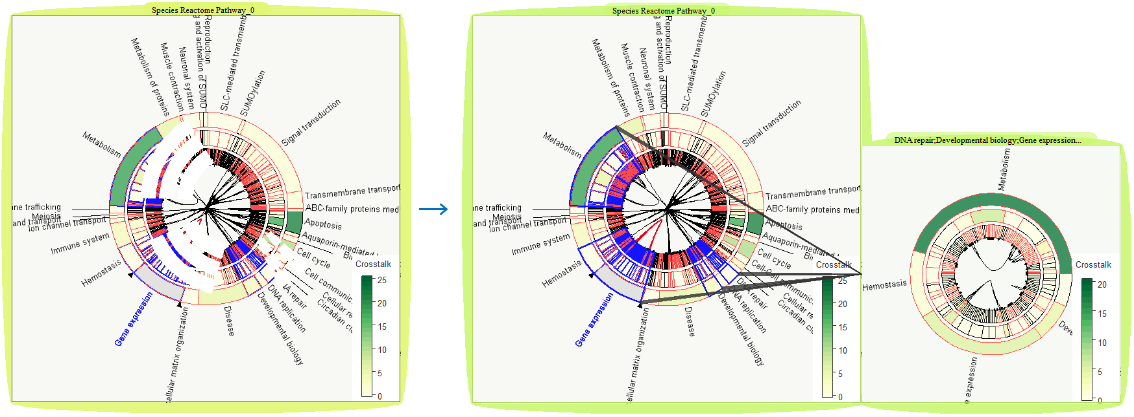

Fig. 13 Select tree ring segments through right mouse bubble and create a new tree ring bubble containing the selected segments.

(3) Access pathway: As discussed previously, you use right mouse button to drag on node out of tree ring bubble to open the pathway graph in a new bubble. As shown in Fig. 5, a pathway is dragged out of tree ring 1 and shown on the right. A dark gray edge is linked to where the pathway has been as a tree ring node in the tree ring.

(4) Tree ring grouping: dragging one tree ring to overlap other tree rings will group the tree rings so that most operations applied to one tree ring will be automatically applied to other tree rings in the group. Those operations include linking expression data and mapping ortholog table.

The way to link expression data is to open an expression data set in an expression bubble and then group it with the tree ring bubble group. The way to map an ortholog table is to load an ortholog file through selecting on a menu opened at the tree ring group location.

**4. SubGraph Operation**

We provide two ways of extracting sub-graph from an opened bubble, using pen to circle your selection or direct dragging an items out of a bubble.

(1) You can pick a group of nodes using a pen after select “Pen Selection” under “Tools” on the menu. You can use mouse cursor (which will become pen shape C:\Users\keqin\Desktop\PathBubble\igraph_22\winQt_Test\icon\pencil_1.png) to draw circles in the bubble. Draw a region on the bubble and drag the selected nodes to an empty space to open a bubble showing the selected sub-graph (Fig. 14). Right Click mouse button will disable the pen.

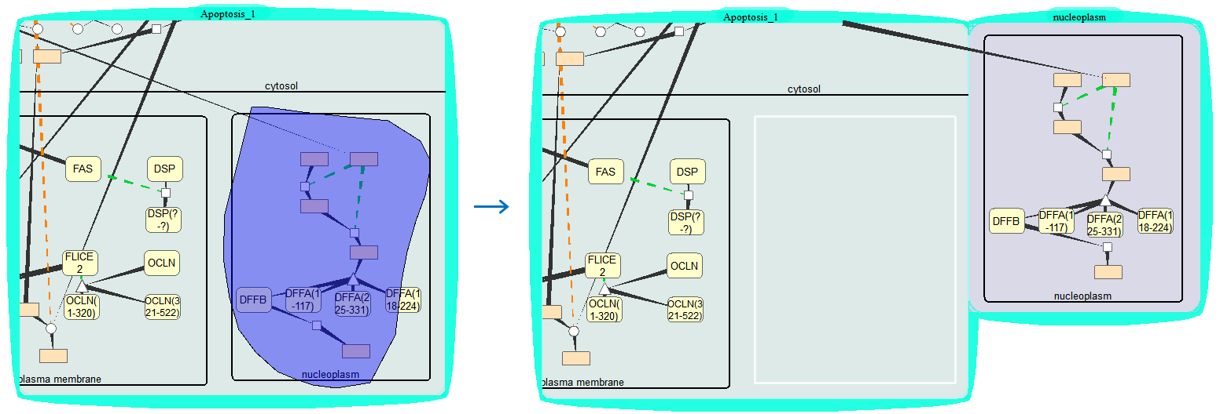

Fig. 14. Select a sub-graph in a pathway. Left: after circling a group of node using pen. Right: after dragging the selected sub-graph out of the original pathway bubble to form a new bubble.

(2) You can directly drag out a compartment or an item out of the bubble to form a new bubble containing the sub-graph of the items dragged out.

**5. Pathway Editing**

You can move a node when pressing the mouse or multiple nodes after using pen selection in a pathway graph by directly dragging items through mouse. You can also resize the whole pathway graph by rolling the mouse wheel inside the pathway bubble. You can also resize any item by dragging its corner using mouse.

To reset the current graph to the original layout, you can use menu item "reset" under Edit to reset the current graph to the original layout.

You can aggregate a group of nodes into one node and expand the aggregated node into to a group of nodes later. First, select a group of nodes and/or one or more compartments using mouse. Then, use menu options, “Edit -> Aggregate”, to aggregate the selected into one node (Fig. 15).

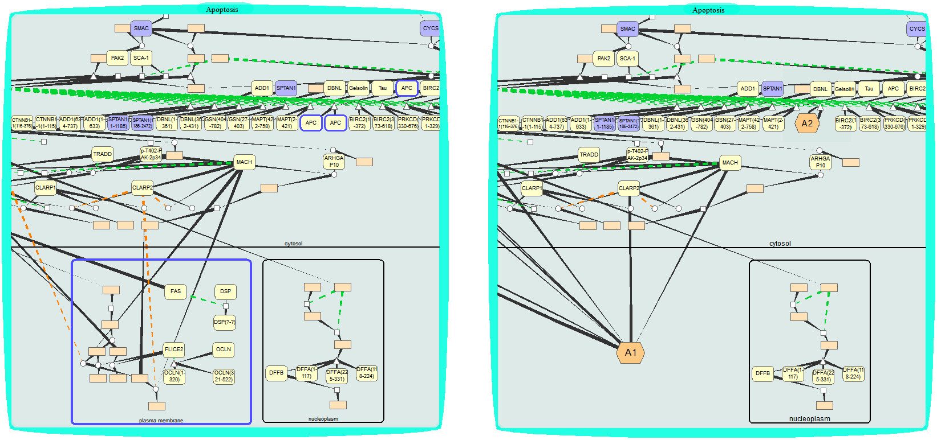

Fig. 15. Aggregating nodes. Left: before aggregations. Right: after aggregations.

You can color the protein by options in menu “Edit 🡪 Regulation by color”. Use “Edit 🡪 Regulation by color 🡪 Up”, you can color proteins in a red color with mouse cursor (changed to C:\Users\keqin\Desktop\PathBubble\igraph_22\winQt_Test\icon\GoUp - Copy.png in this case), the same color as a protein is up-expressed when linked with an expression dataset. Use “Edit 🡪 Regulation by color 🡪 Down”, you can color proteins in a blue color with mouse cursor (changed to C:\Users\keqin\Desktop\PathBubble\igraph_22\winQt_Test\icon\GoDown - Copy.png in this case), the same color as a protein is down-expressed when linked with an expression dataset. Use “Edit 🡪 Regulation by color 🡪 Even”, you can color proteins in its original color with mouse cursor (changed to C:\Users\keqin\Desktop\PathBubble\igraph_22\winQt_Test\icon\GoEven-2.png in this case), the same color as a protein is considered unchanged when linked with an expression dataset. Right Click mouse button will disable this option.

You can decide to show small molecules in the graph or not. By default, small molecule is hidden in a pathway graph. To show small molecules, check on menu “Tools 🡪 View 🡪 Small molecule”.

To save or retrieve the changes you made to the graph, you can use menu options “Save 🡪 Graph” or “Open 🡪 Graph”.

If a graph is saved for a pathway, the latest saved graph will be automatically loaded to a pathway bubble which is opened afterwards.

**6. Matched and expressed protein/complex**

To find the matched or expressed protein in a pathway, you first need to link the pathway with the expression data by grouping them together. Moving one bubble to overlap other bubbles will group the bubble with overlapped bubbles into one group where most operations applied to one bubble will automatically applied to others.

We do not only color proteins but also color the complexes which contain those proteins so we will know whether an effect is propagated along a path. A simple logic rules (Fig. 16) to decide if a complex is differentially expressed is used. The complex is down-expressed when any of the component is down-expressed. The complex is up-expressed if there are no component that is down and at least one of its components is up. The complex is considered unchanged if all the components are not differentially expressed.

1. Once an expression bubble is grouped with a bubble containing a pathway, all the matched gene found in the pathway will be highlighted in white in expression bubble.
2. Open menu at any location within grouped bubbles. Choosing “Selection -> Expression” will highlight all expressed proteins in the pathway bubbles within the group in yellow. The font inside the expressed proteins or complexes will become red or blue depending on whether it is “up” or “down” if they are differentially expressed.

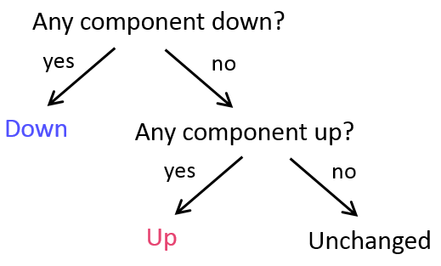

Fig. 16. Judge whether a complex is differentially expressed (up or down).

**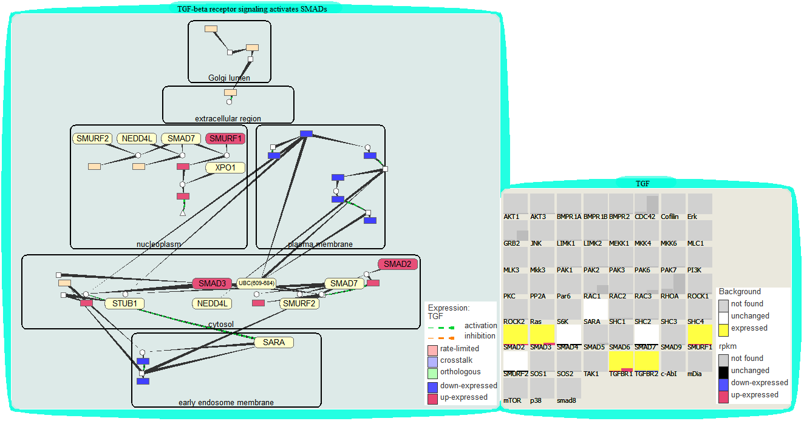**

Fig. 17. Link pathway and expression data. Top: Grouping a pathway bubble and an expression bubble highlights a matched protein in white. Bottom: All the differentially expressed proteins are highlighted in yellow. Red and blue indicate that a protein or complex is up-expressed or down-expressed.

**7. Cross-talking proteins, Cross-talking pathways, and Rate-limiting proteins**

Cross-talking proteins are colored in purple and the rate-limiting proteins are colored in pink. If a protein is both cross-talking and rate-limiting protein, it will be colored in both purple and pink as shown in Fig. 4. If you mouse-over a cross-talking protein and open menu, you are allowed to open any or all of the cross-talking pathway with the pathway though this protein (Fig. 3).

**8. Selecting item of interest in pathways according to their relationships**

You can find linked/shared/differed items of selected nodes in a pathway graph through menu operations under “Selection”. By default, those item of interest are proteins. You can set compartment or pathways as item type that you want to search by check “Compartment” or “Pathway” under “Selection 🡪 Settings” on menu. Multiple items can be selected after you use “mouse left button + control key” to select them.

For example, if you want to find the nodes connecting a selected node, click the node to highlight it, then select menu items “Link”, the nodes linked with the selected nodes and the linking edges will be highlighted. Repeat selecting “Links” on menu will highlight paths linked to previously highlighted nodes (Fig. 18a).

If you want to select nodes shared by different pathways. Group bubbles containing those pathways. Then, open menu at any location within the group and select on “Selection🡪Share”. The nodes shared by the pathways are highlighted and the each pair of matched items are linked with straight lines (Fig.18b)

Similarly, you can find the items that are not shared by different pathways or compartments by select the option “difference” under “Selection”.

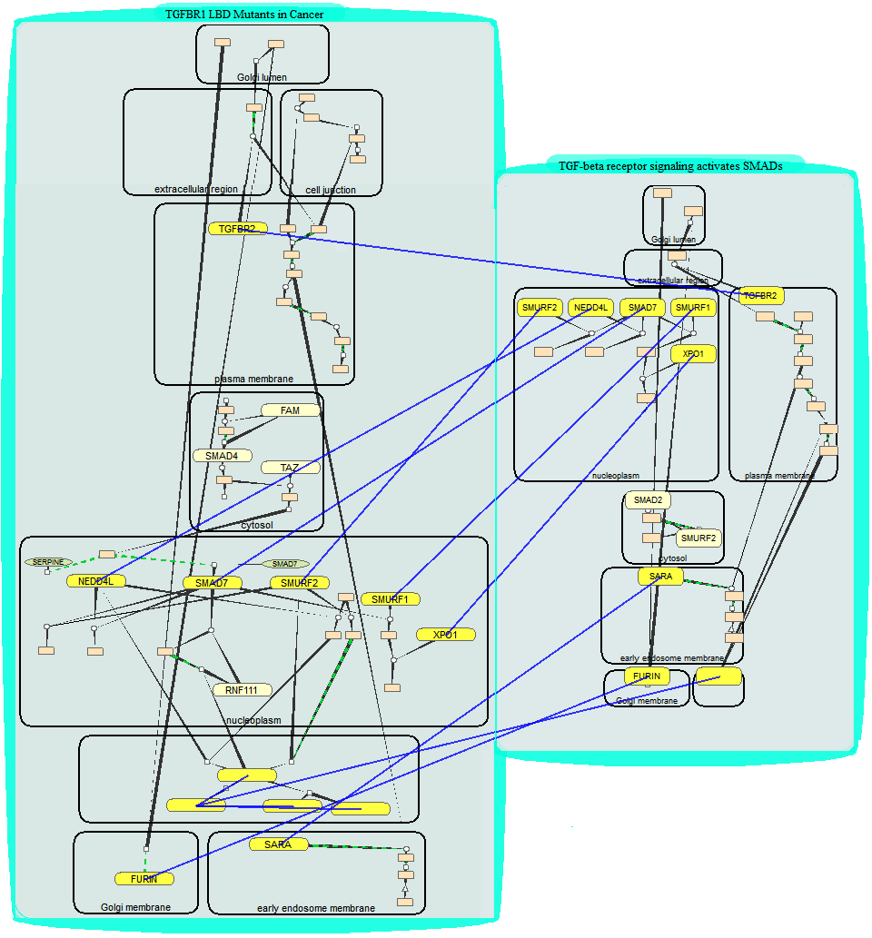 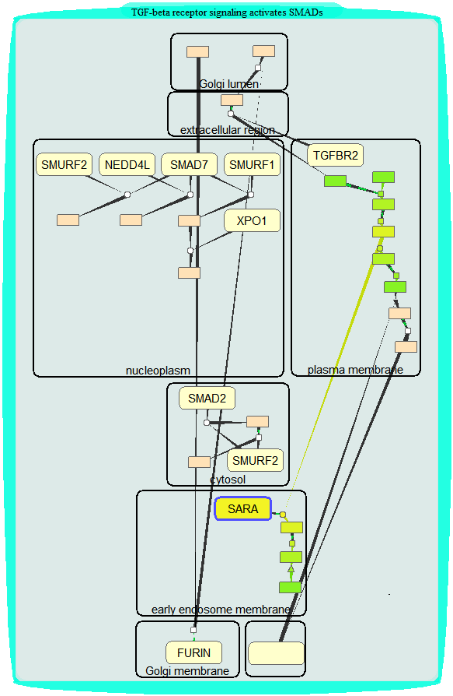

Fig. 18. Find items of interest. Left: search shared items. The shared items by two pathways are highlighted after selecting “Selection 🡪 Share” on menu. Right: Find paths of interest. Paths connecting SARA revealed after six “Link” operations are highlighted.

If you set compartment or pathway as the type of item that you want to search, the items highlighted as the results will be compartments or pathways.

**9. Search item through keyword**

You can search any item shown in the interface by their names. You will open a search dialog by menu options “Tools 🡪 Find”; then, type the name you want to search. For example, typing “RPL10A” in the dialog and clicking “search” will highlight any nodes with extract the same name. You can search any item with name that starts at “RPL10A”, ends at “RPL10A”, or contains “RPL10A” by typing in “RPL10A\*”, “\*RPL10A”, and “\*RPL10A\*”. The found items, which could be pathway components in pathway graph, genes in the expression gene table, and pathway node which names matching the search or containing proteins with the searched names, will be highlighted in blue.