Execute the following command as appropriate:

"C:\Program Files (x86)\Java\jdk1.8.0_131\bin\keytool.exe" -list -v -keystore "C:\Users\Umberto\AppData\Local\Xamarin\Mono for Android\debug.keystore"

password=android

to show a screen looking as follows:

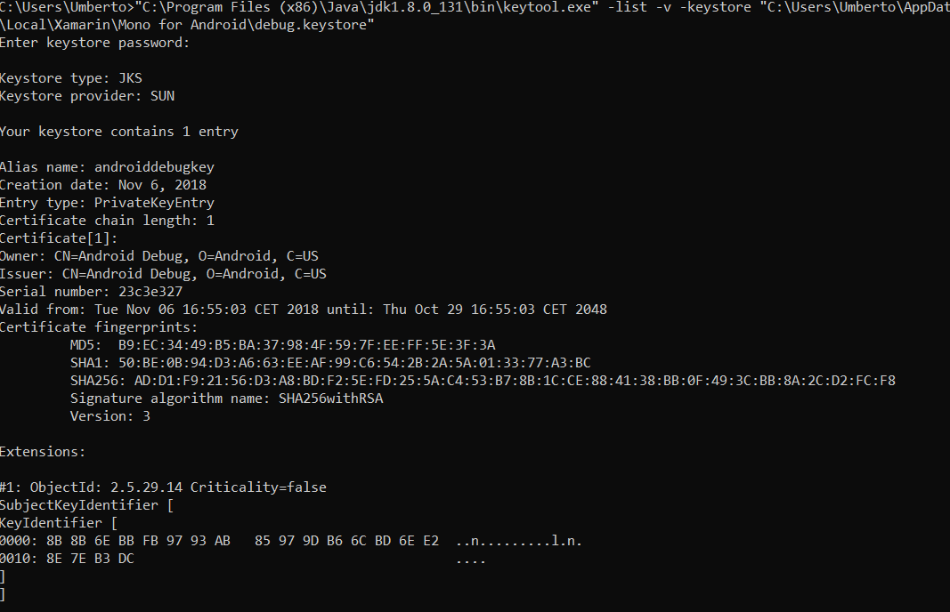

Take a note of the SHA1 fingerprint.

Open the Google Cloud Platform (https://cloud.google.com/), create an account and select APIs & Services->Credentials.

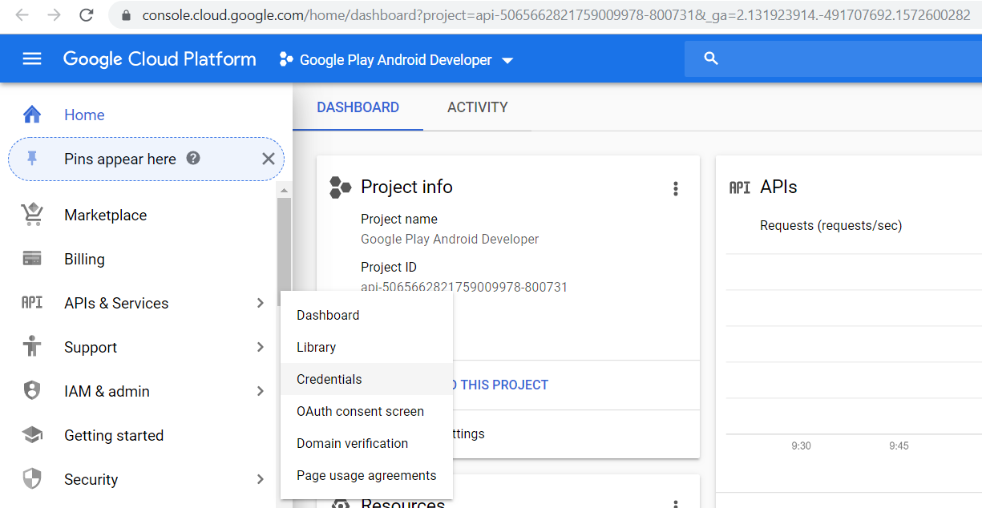

Then Create Credentials => API Key.

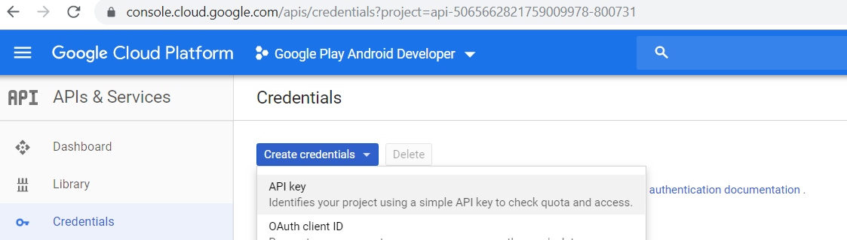

Copy the created API Key somewhere safe. Click on the created API Key and on the next screen select Adroid apps and click on Add package name and fingerprint. The fingerprint is the code generated before and the package name is name of the application as per your manifest file:

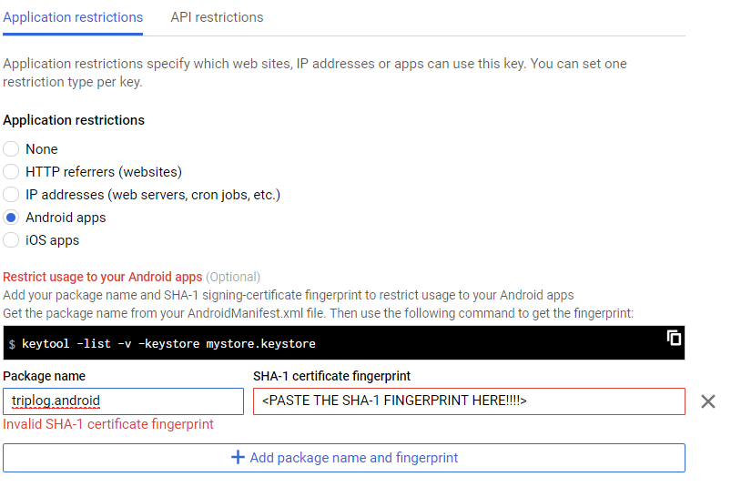
The key generated before is to be pasted in the android manifest file:

<?xml version="1.0" encoding="utf-8"?>
<manifest xmlns:android="http://schemas.android.com/apk/res/android" android:versionCode="6" android:versionName="1.2" package="triplog.android" android:installLocation="auto">
<uses-sdk android:minSdkVersion="21" android:targetSdkVersion="28" />
<!-- Missing in the book. -->
<!-- Google Maps for Android v2 requires OpenGL ES v2 -->
<uses-feature android:glEsVersion="0x00020000" android:required="true" />
<!-- Necessary for apps that target Android 9.0 or higher -->
<!-- These are optional, but recommended. They will allow Maps to use the My Location provider. -->
<uses-permission android:name="android.permission.WRITE_EXTERNAL_STORAGE" />
<uses-permission android:name="triplog.android.permission.MAPS_RECEIVE" />
<uses-permission android:name="android.permission.ACCESS_COARSE_LOCATION" />
<uses-permission android:name="android.permission.ACCESS_FINE_LOCATION" />
<permission android:name="triplog.android.permission.MAPS_RECEIVE" android:protectionLevel="signature" />
<application android:label="triplog.android">
<meta-data android:name="com.google.android.maps.v2.API_KEY" android:value="Paste your key here" />
<meta-data android:name="com.google.android.gms.version" android:value="@integer/google_play_services_version" />
<uses-library
android:name="org.apache.http.legacy"
android:required="false" />
</application>
</manifest>

To complete the setup ensure to enable the maps API by clicking Enable APIS and Services and selecting Android and iOS:

