Xamarin

Why:

The framework grants the possibility to write cross-platform applications in a single programming language, C#. Furthermore the framework leaves the possibility for platform-specific implementations.

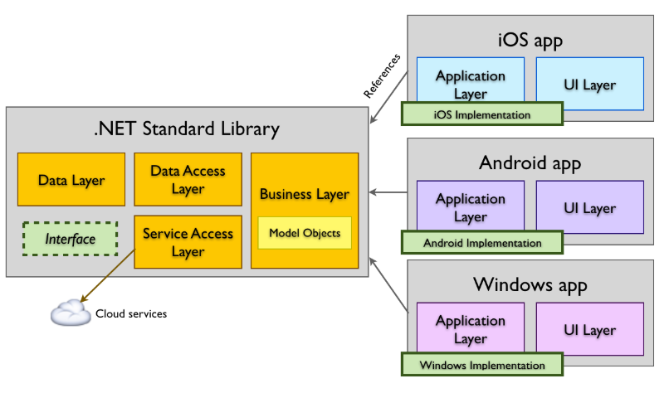

Main Elements:

Label: Used to display text in a simple way
Main attributes:
- Text
- TextColor
- FontSize
- HorizontalOptions
- VerticalOptions
- BackgroundColor
- Margin
Here the official docs: https://docs.microsoft.com/en-us/dotnet/api/xamarin.forms.label?view=xamarin-forms

Here an example:
<?xml version="1.0" encoding="utf-8" ?>
<ContentPage xmlns="http://xamarin.com/schemas/2014/forms"
xmlns:x="http://schemas.microsoft.com/winfx/2009/xaml"
xmlns:d="http://xamarin.com/schemas/2014/forms/design"
xmlns:mc="http://schemas.openxmlformats.org/markup-compatibility/2006"
mc:Ignorable="d"
x:Class="XamarinIntro.MainPage">

<StackLayout Orientation="Vertical">
<StackLayout>
<Label x:Name="MainLabel1" Text="This is my title"
FontSize="Title"
HorizontalOptions="Center"
VerticalOptions="Start"
BackgroundColor="Accent"
Margin="10,10,10,10"/>
<Label x:Name="MainLabel2" Text="This is my second label"
FontSize="Large"
HorizontalOptions="Center"
VerticalOptions="Start"
BackgroundColor="Bisque"
Margin="10,10,10,10"/>
<Label x:Name="MainLabel3" Text="This is my third label ad I need more space than my siblings"
FontSize="Subtitle"
HorizontalOptions="Center"
VerticalOptions="Start"
BackgroundColor="Chocolate"
Margin="10,10,10,10"/>
</StackLayout>

<StackLayout Orientation="Horizontal">
<Label x:Name="MainLabel4" Text="Horizontally-oriented label n1"
FontSize="Medium"
HorizontalOptions="Center"
VerticalOptions="Start"
BackgroundColor="Accent"
Margin="10,10,10,10"/>
<Label x:Name="MainLabel5" Text="Horizontally-oriented label n2"
FontSize="Medium"
HorizontalOptions="Center"
VerticalOptions="Start"
BackgroundColor="Bisque"
Margin="10,10,10,10"/>
</StackLayout>
</StackLayout>
</ContentPage>

Button:
Used to provide a clickable element of interaction. The button occupies all the space available as defined by its parent, unless limited by something different than Fill. The widthrequest and heightrequest properties are platform and device specific, like every dimension inXamarin.

Main properties:
- HorizontalOptions
- VerticalOptions
- HeightRequest
- WidthRequest
- Text
- Events:
- Clicked
- Pressed
- Released

Example:

<?xml version="1.0" encoding="utf-8" ?>
<ContentPage xmlns="http://xamarin.com/schemas/2014/forms"
xmlns:x="http://schemas.microsoft.com/winfx/2009/xaml"
x:Class="XamarinIntro.MainPage">

<StackLayout Orientation="Horizontal">
<Button x:Name="Button1"
HorizontalOptions="Start"
VerticalOptions="Start"
HeightRequest="50"
WidthRequest="50"
Text="B1"
Clicked="Button1_Clicked"
Pressed="Button1_Pressed"
Released="Button1_Released">
</Button>
<Button x:Name="Button2"
HorizontalOptions="Start"
VerticalOptions="Start"
HeightRequest="50"
WidthRequest="50"
Text="B2"
Clicked="Button2_Clicked"
Pressed="Button2_Pressed"
Released="Button2_Released">
</Button>
</StackLayout>
</ContentPage>

Meaning of widthrequest and heightrequest:
https://stackoverflow.com/questions/29808498/xamarin-forms-widthrequest-value-meaning

Changing emulator with different pixel densities will lead to different scaling.

1) MS (tutorial): https://docs.microsoft.com/en-us/xamarin/xamarin-forms/user-interface/button
2) MS (class): https://docs.microsoft.com/en-us/dotnet/api/xamarin.forms.button?view=xamarin-forms

StackLayout:
Used to partition the screen in a stack-oriented fashion. Here some documentation:
Main attributes:
- Orientation
- Margin
- Padding (https://docs.microsoft.com/en-us/xamarin/xamarin-forms/user-interface/layouts/margin-and-padding)

Example above.

1) MS (tutorial): https://docs.microsoft.com/en-us/xamarin/xamarin-forms/user-interface/layouts/stack-layout
2) MS (class): https://docs.microsoft.com/en-us/dotnet/api/xamarin.forms.stacklayout?view=xamarin-forms

Grid:
Used to partition the screen in a grid. The number of columns and rows as well as their relative or absolute size can be configured.
Main attributes:
- RawDefinitions
- ColumnsDefinitions
- ColumnSpan in case an element needs to cover more than one column
- RawSPan in case an element needs to span more than raw

Here an example:

<Grid ColumnSpacing="10" RowSpacing="20">
<Grid.RowDefinitions>
<RowDefinition Height="*"/>
<RowDefinition Height="*"/>
<RowDefinition Height="*"/>
</Grid.RowDefinitions>
<Grid.ColumnDefinitions>
<ColumnDefinition Width="*"/>
<ColumnDefinition Width="*"/>
</Grid.ColumnDefinitions>
<Label x:Name="MainLabel6" Grid.Row="0" Grid.RowSpan="2" Grid.Column="0"
Text="Horizontally-oriented label n2"
FontSize="Medium"
HorizontalOptions="CenterAndExpand"
VerticalOptions="CenterAndExpand"
BackgroundColor="Bisque"
Margin="10,10,10,10"/>
<Label x:Name="MainLabel6" Grid.Row="0" Grid.Column="1"
Text="Horizontally-oriented label n2"
FontSize="Medium"
HorizontalOptions="CenterAndExpand"
VerticalOptions="CenterAndExpand"
BackgroundColor="Bisque"
Margin="10,10,10,10"/>
<Label x:Name="MainLabel6" Grid.Row="1" Grid.Column="1"
Text="Horizontally-oriented label n2"
FontSize="Medium"
HorizontalOptions="CenterAndExpand"
VerticalOptions="CenterAndExpand"
BackgroundColor="Bisque"
Margin="10,10,10,10"/>
<Label x:Name="MainLabel7" Grid.Row="1" Grid.Column="1"
Text="Horizontally-oriented label n2"
FontSize="Medium"
HorizontalOptions="CenterAndExpand"
VerticalOptions="CenterAndExpand"
BackgroundColor="Bisque"
Margin="10,10,10,10"/>
<Label x:Name="MainLabel6" Grid.Row="2" Grid.Column="0" Grid.ColumnSpan="2"
Text="Horizontally-oriented label n2"
FontSize="Medium"
HorizontalOptions="CenterAndExpand"
VerticalOptions="CenterAndExpand"
BackgroundColor="Bisque"
Margin="10,10,10,10"/>
</Grid>

Here some documentation:
1) MS (tutorial): https://docs.microsoft.com/en-us/xamarin/xamarin-forms/user-interface/layouts/grid
2) MS (class): https://docs.microsoft.com/en-us/dotnet/api/xamarin.forms.grid?view=xamarin-forms

Exercise1:

Implement the following simple calculator:

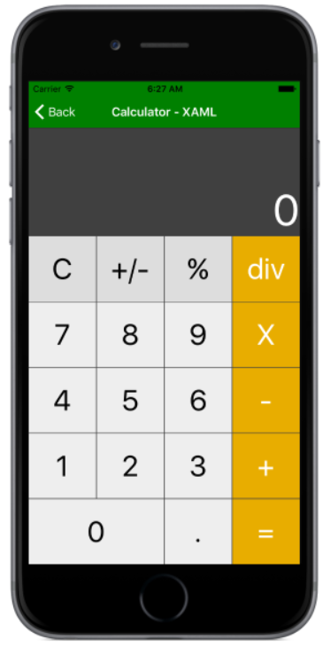

Load the application to your mobile by following the instructions here: -https://riptutorial.com/xamarin-android/example/29653/preparing-your-apk-in-the-visual-studio
-https://stackoverflow.com/questions/9718104/how-to-install-apk-from-pc

BoxView:
Minimal control to display raw graphics.

Main attributes:
- Color
- Margin

Here an example:

<ContentPage xmlns="http://xamarin.com/schemas/2014/forms"
xmlns:x="http://schemas.microsoft.com/winfx/2009/xaml"
xmlns:local="clr-namespace:BasicBoxView"
x:Class="BasicBoxView.MainPage">

<BoxView Color="CornflowerBlue"
CornerRadius="10"
WidthRequest="160"
HeightRequest="160"
VerticalOptions="Center"
HorizontalOptions="Center" />

</ContentPage>

Here some references:
1) MS (tutorial): https://docs.microsoft.com/en-us/xamarin/xamarin-forms/user-interface/boxview
2) MS (class): https://docs.microsoft.com/en-us/dotnet/api/xamarin.forms.boxview?view=xamarin-forms

ListView:
Important control to display standard or custom elements as a list.
Main attributes:
- ItemTemplate
- DataTemplate
- TextCell or ImageCell
- ViewCell for customizing the content

Example TextCell:
Xaml:

<?xml version="1.0" encoding="utf-8" ?>
<ContentPage xmlns="http://xamarin.com/schemas/2014/forms"
xmlns:x="http://schemas.microsoft.com/winfx/2009/xaml"
xmlns:d="http://xamarin.com/schemas/2014/forms/design"
xmlns:mc="http://schemas.openxmlformats.org/markup-compatibility/2006"
mc:Ignorable="d"
Title="Main Page"
x:Class="XamarinIntro.MainPage">

<StackLayout >
<Label
Text="This is a page with a simple text list"
VerticalOptions="Center"
HorizontalOptions="Center"
Margin="10,10,10,10"/>
<ListView x:Name="SimpleList">
<ListView.ItemTemplate>
<DataTemplate>
<TextCell
Text="{Binding Name}"
Detail="{Binding Detail}">
</TextCell>
</DataTemplate>
</ListView.ItemTemplate>
</ListView>
</StackLayout>
</ContentPage>

Code behind:

using System;
using System.Collections.Generic;
using System.ComponentModel;
using System.Linq;
using System.Text;
using System.Threading.Tasks;
using Xamarin.Forms;

namespace XamarinIntro
{
public class Article
{
public string Name { get; set; }
public string Detail { get; set; }
}

// Learn more about making custom code visible in the Xamarin.Forms previewer
// by visiting https://aka.ms/xamarinforms-previewer
[DesignTimeVisible(true)]
public partial class MainPage : ContentPage
{
public MainPage()
{
var articleList = new List<Article>
{
new Article()
{
Name = "Shoes",
Detail = "Cheap shoes"
},

new Article()
{
Name = "Pants",
Detail = "Expensive pants"
},
};

InitializeComponent();
this.SimpleList.ItemsSource = articleList;
}
}
}

Example with ViewCell:
Xaml:

<?xml version="1.0" encoding="utf-8" ?>
<ContentPage xmlns="http://xamarin.com/schemas/2014/forms"
xmlns:x="http://schemas.microsoft.com/winfx/2009/xaml"
xmlns:d="http://xamarin.com/schemas/2014/forms/design"
xmlns:mc="http://schemas.openxmlformats.org/markup-compatibility/2006"
mc:Ignorable="d"
x:Class="XamarinIntro.MainPage">
<ListView x:Name="CustomList" HasUnevenRows="True">
<ListView.ItemTemplate >
<DataTemplate>
<ViewCell>
<StackLayout
Orientation="Horizontal"
Padding="5,0,0,0" >
<Image Source="{Binding ImageUrl}" Aspect="AspectFit" />
<StackLayout
HorizontalOptions="StartAndExpand">
<Label Text="{Binding Name}"
FontSize="12"
FontAttributes="Bold"/>
<Label Text="{Binding Slogan}"
FontSize="10" />
</StackLayout>
<Button Text="Follow"/>
</StackLayout>
</ViewCell>
</DataTemplate>
</ListView.ItemTemplate>
</ListView>
</ContentPage>

Code behind:

using System;
using System.Collections.Generic;
using System.ComponentModel;
using System.Linq;
using System.Text;
using System.Threading.Tasks;
using Xamarin.Forms;

namespace XamarinIntro
{
public class Contact
{
public string Name { get; set; }
public string Slogan { get; set; }
public ImageSource ImageUrl { get; set; }
}

// Learn more about making custom code visible in the Xamarin.Forms previewer
// by visiting https://aka.ms/xamarinforms-previewer
[DesignTimeVisible(true)]
public partial class MainPage : ContentPage
{
public MainPage()
{
InitializeComponent();

var list = new List<Contact>()
{
new Contact()
{
Name = "Umberto",
Slogan = "I am here",
ImageUrl = ImageSource.FromUri(new Uri("http://lorempixel.com/100/100/people/1"))
},

new Contact()
{
Name = "John",
Slogan = "I am there",
ImageUrl = ImageSource.FromUri(new Uri("http://lorempixel.com/100/100/people/2"))
},
};

this.CustomList.ItemsSource = list;
}
}
}

Here some references:
1) MS (tutorial): https://docs.microsoft.com/en-us/xamarin/xamarin-forms/user-interface/listview/
2) MS (class): https://docs.microsoft.com/en-us/dotnet/api/xamarin.forms.listview?view=xamarin-forms

TableView:
Important form used to display heteogeneous elements (elements that do not share the same template)and acquire data from the outside as a list of cells.

Here an example
Xaml:

<?xml version="1.0" encoding="utf-8" ?>
<ContentPage xmlns="http://xamarin.com/schemas/2014/forms"
xmlns:x="http://schemas.microsoft.com/winfx/2009/xaml"
x:Class="XamarinIntro.MainPage">

<TableView Intent="Form">
<TableRoot>
<TableSection Title="Basics">
<TextCell Text="Name" Detail="Umberto"/>
<EntryCell Label="Activity" Placeholder="(Shopping)" HorizontalTextAlignment="Center" />
<SwitchCell Text="Notifications" On="True" />
<ViewCell Tapped="Cell_OnTapped">
<StackLayout Orientation="Horizontal" Margin="0,10,0,0" Padding="15,5">
<Label Text="Contact Method" VerticalOptions="Center"/>
<Label VerticalOptions="Center"
HorizontalOptions="EndAndExpand"
Text="None"
TextColor="Gray"/>
</StackLayout>
</ViewCell>
</TableSection>
<TableSection Title="Advanced">
<EntryCell Label="Location" Placeholder="(Zürich)" HorizontalTextAlignment="Center" />
<SwitchCell Text="Looking for a new job" On="False" />
</TableSection>
</TableRoot>
</TableView>
</ContentPage>

Code behind:

using System;
using System.Collections.Generic;
using System.ComponentModel;
using System.Linq;
using System.Text;
using System.Threading.Tasks;
using Xamarin.Forms;

namespace XamarinIntro
{
// Learn more about making custom code visible in the Xamarin.Forms previewer
// by visiting https://aka.ms/xamarinforms-previewer
[DesignTimeVisible(true)]
public partial class MainPage : ContentPage
{
public MainPage()
{
InitializeComponent();

}

private void Cell_OnTapped(object sender, EventArgs e)
{
var basicsSection = MyTableView.Root.First(f => f.Title == "Basics");
var advancedSection = MyTableView.Root.First(f => f.Title == "Advanced");

var textCell = basicsSection[0];
var entryCell = basicsSection[1];
var switchCell = basicsSection[2];
var viewCell = basicsSection[3];

var entryCell2 = advancedSection[0];
var switchCell2 = advancedSection[1];
}
}
}

Here some references:
1) MS (tutorial): https://docs.microsoft.com/en-us/xamarin/xamarin-forms/user-interface/tableview
2) MS (class): https://docs.microsoft.com/en-us/dotnet/api/xamarin.forms.tableview?view=xamarin-forms

Navigation
Used to move from one page to another in a stack-based controlled fashion.

The main page shall be created in the following way:

return new NavigationPage(new HierarchicalNavigation())

Here the an example of two different content pages calling each other:
Xaml:

<?xml version="1.0" encoding="utf-8" ?>
<ContentPage xmlns="http://xamarin.com/schemas/2014/forms"
xmlns:x="http://schemas.microsoft.com/winfx/2009/xaml"
x:Class="XamarinCourse.Navigation.Hierarchical.HierarchicalNavigation"
Title="Welcome"
NavigationPage.HasNavigationBar="False">
<StackLayout HorizontalOptions="Center" VerticalOptions="Center">
<Label Text="Welcome" HorizontalOptions="Center"/>
<Button Text="Next" Clicked="Handle_Clicked" />
</StackLayout>
</ContentPage>

Code behind:

using System;
using System.Collections.Generic;
using System.Linq;
using System.Text;
using System.Threading.Tasks;

using Xamarin.Forms;
using Xamarin.Forms.Xaml;

namespace XamarinCourse.Navigation.Hierarchical
{
[XamlCompilation(XamlCompilationOptions.Compile)]
public partial class HierarchicalNavigation : ContentPage
{
private async void Handle_Clicked(object sender, EventArgs args)
{
await Navigation.PushAsync(new IntroductionPage());
}

public HierarchicalNavigation ()
{
InitializeComponent ();
}
}
}

<?xml version="1.0" encoding="utf-8" ?>
<ContentPage xmlns="http://xamarin.com/schemas/2014/forms"
xmlns:x="http://schemas.microsoft.com/winfx/2009/xaml"
x:Class="XamarinCourse.Navigation.Hierarchical.IntroductionPage"
Title="Introduction"
NavigationPage.HasBackButton="false">
<StackLayout HorizontalOptions="Center" VerticalOptions="Center">
<Label Text="This is how the app works" />
<Button Text="Back" Clicked="Handle_Clicked" />
</StackLayout>
</ContentPage>

using System;
using System.Collections.Generic;
using System.Linq;
using System.Text;
using System.Threading.Tasks;

using Xamarin.Forms;
using Xamarin.Forms.Xaml;

namespace XamarinCourse.Navigation.Hierarchical
{
[XamlCompilation(XamlCompilationOptions.Compile)]
public partial class IntroductionPage : ContentPage
{
private async void Handle_Clicked(object sender, EventArgs args)
{
await Navigation.PopAsync();
}

public IntroductionPage ()
{
InitializeComponent ();
}

protected override bool OnBackButtonPressed()
{
return true;
}
}
}

Exercise:
Create a Xamarin application made up of three pages:
- MainPage with a list of TextCell and a button. Clicking on one of the displayed entries will move to the DetailPage. Clicking on the button will navigate the user to the NewEntryPage
- DetailPage with a custom list containing 4 labels and a return button (back to the MainPage).
- NewEntryPage with TableView allowing the user to provide 6 pieces of information and a button which stores the new entry and allows the user to go back to the MainPage.

