Build a Server on a VM

Google Drive shareable link:
https://drive.google.com/open?id=14vcIS58lfHji5daNFGzj5bTTceiylhfV

Links:
- VirtualBox: https://www.virtualbox.org/wiki/Downloads
- Windows Media Creator: https://www.microsoft.com/sv-se/software-download/windows10

Create an image on a fast hard drive, assign it as much memory as possible, create a virtual hard drive with at least 150Gb of space and click create:
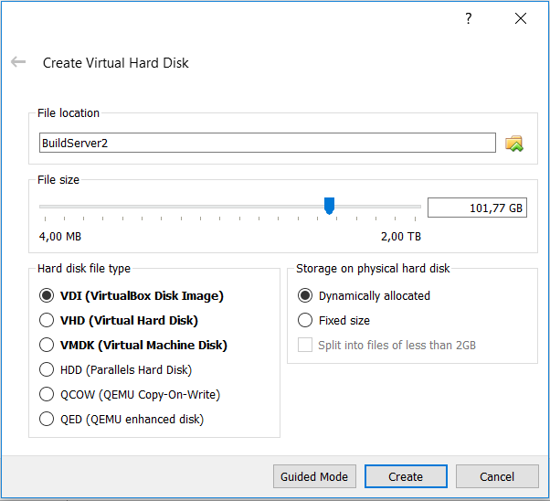
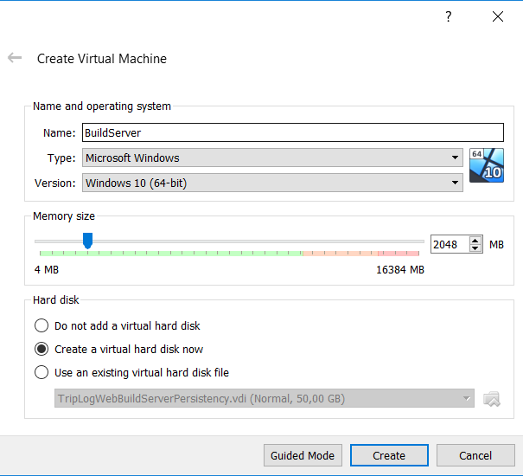

Use Windows Media Creator to create an iso of Windows 10. Choose settings, navigate to Storage and browse to the Windows iso as shown here:
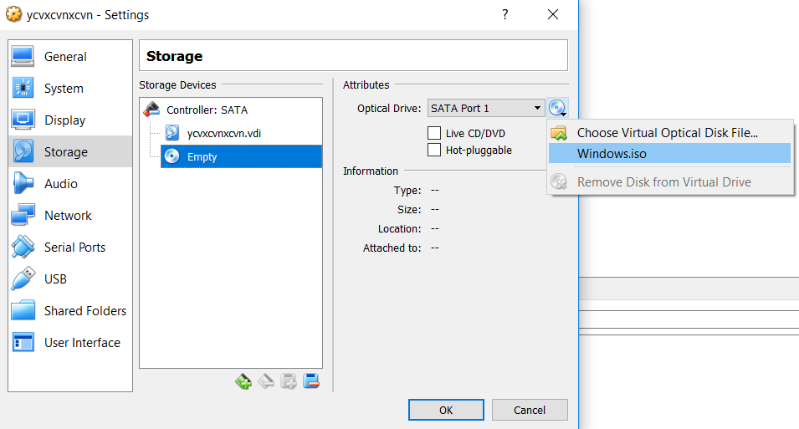

Then choose network and create a second interface of type Host-only adapter:

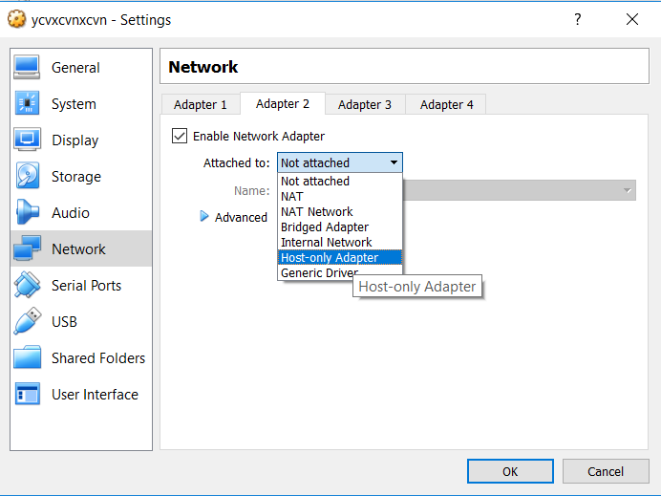

Click OK and start the VM. This will initiate the installation of Windows. Finalize the installation. Then click on Devices and select Insert Guest Addition CD Image:
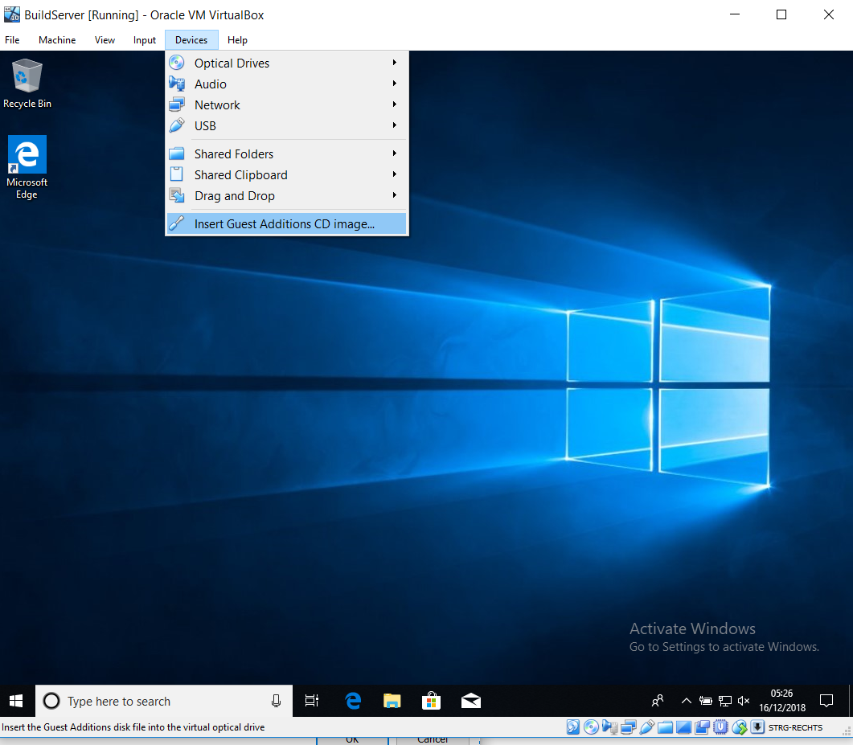

Browse to D and double-click Vbox WindowsAdditions and finalize the installation:

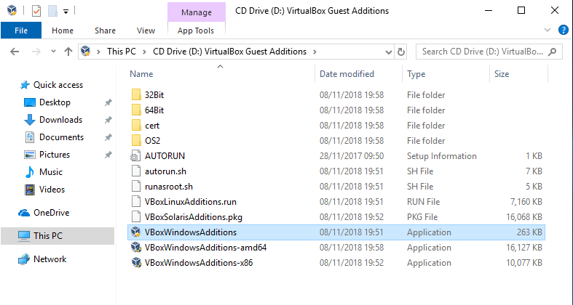

Now close the VM and go back to VirtualBox, select the VM and click settings and choose shared folders and point to a folder:

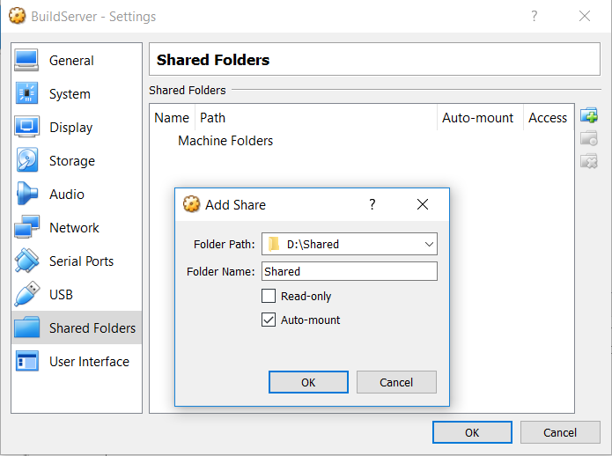

This completes the creation of the Build Server VM. From this moment on there is no difference between configuring a build server on a VM and on a standard server.

