Creating the Build with a Xamarin Template

Go to your GitHub account, select developer settings and personal access token. Select Generate new token and tick the following options:

- repo, user, admin:repo_hook

Type in a name such as TfsBuildTokenJuventus.

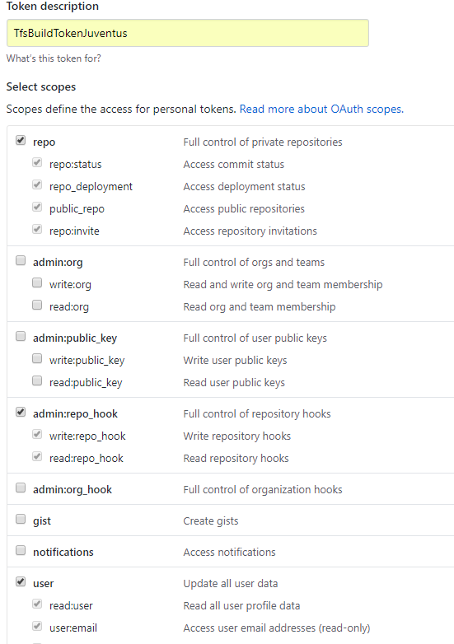

-

Click Generate token.
On the following screen ensure to copy the text on a safe place since it will only be displayed once.

This setup will allow TFS to poll the repository for changes and trigger a build every time a new check in takes place.

Open TFS by pasting the following URL (or similar): http://desktop-kj5q2iu:8080/tfs/

Choose create new project, fill out the necessary fields and click create:

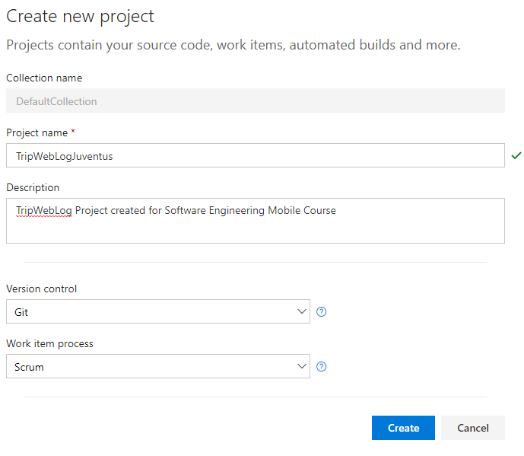

Since the main architecture of the build is to pull code from a gitHub repository choose "Build Code from an external Repository" and then "External Git". On the next screen provide the path of the repository along with the token generated before:

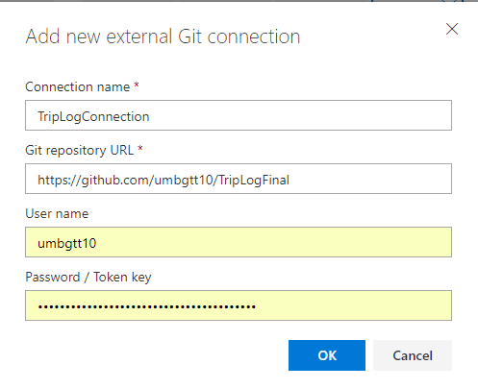

Click Continue. On the next screen select Xamarin.Android and click apply.

On the next screen click "New Definition", then choose "Xamarin.Android" and lick Next. This will create a new build definition containing a predefined set of build steps.

Let's start by removing/disabling some unnecessary steps so that the build looks as follows:

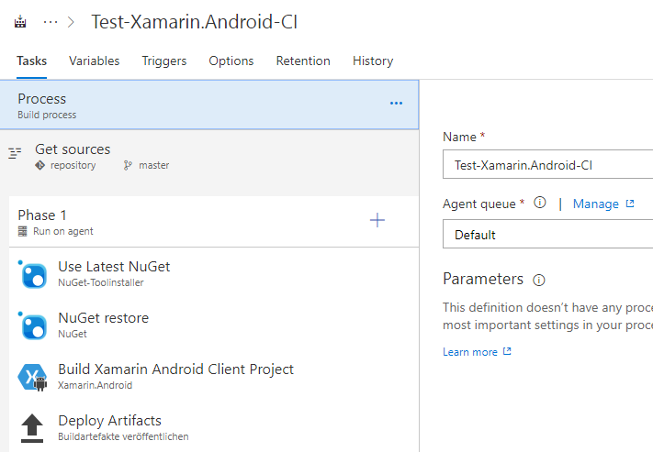

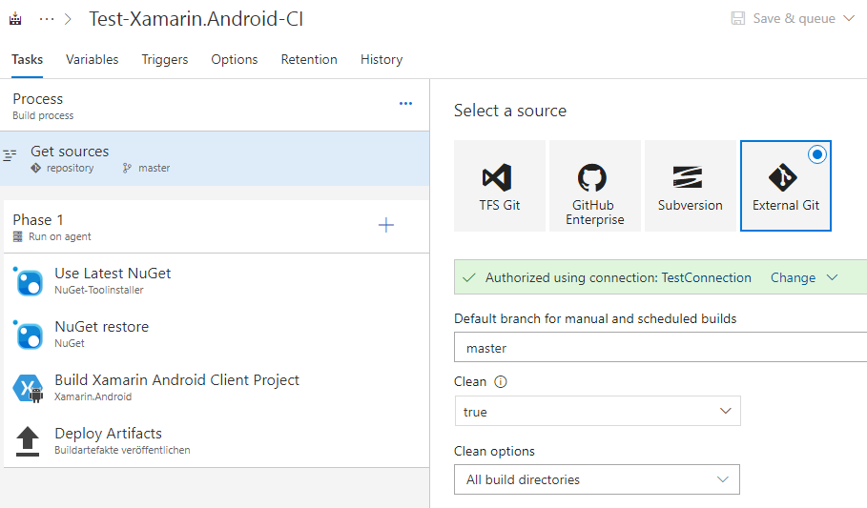

And then by updating the specific steps:

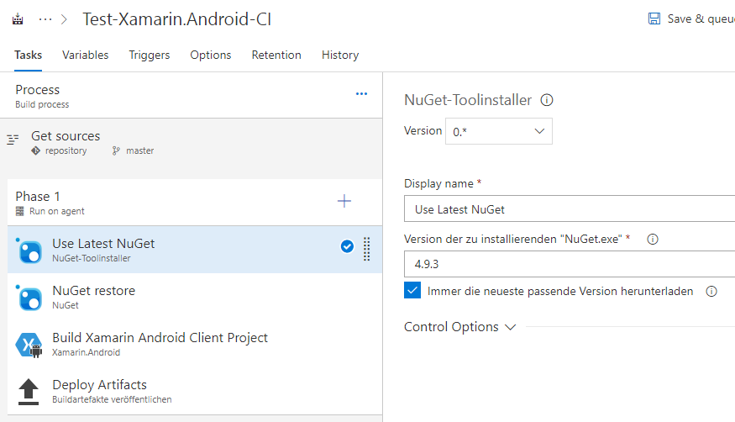

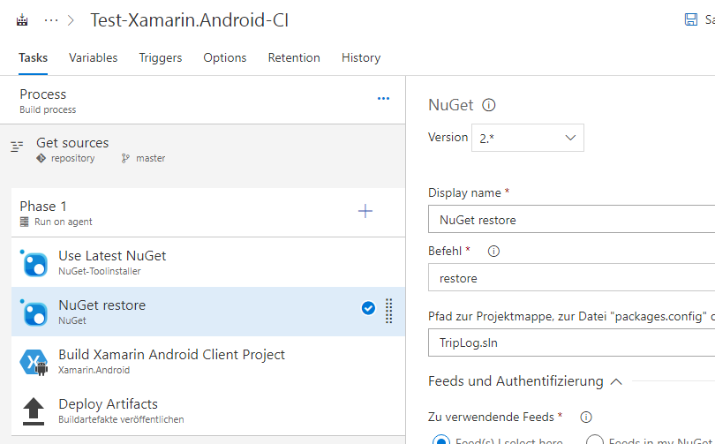

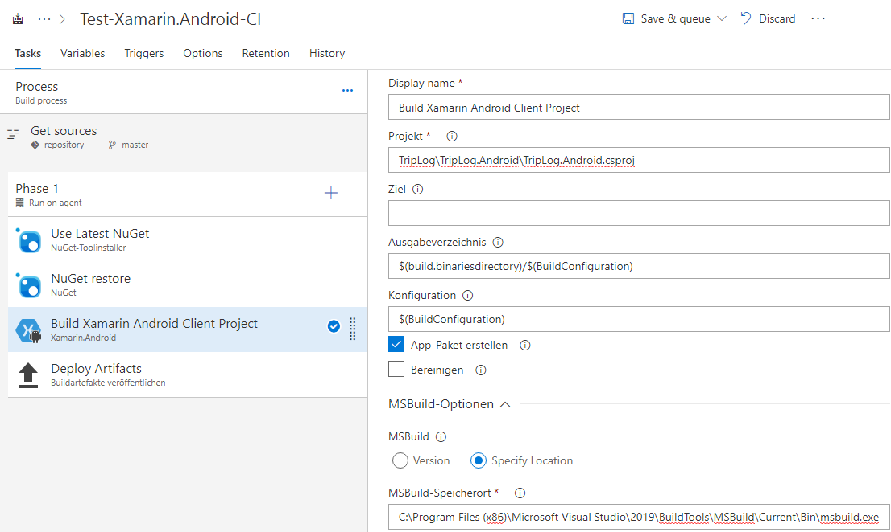

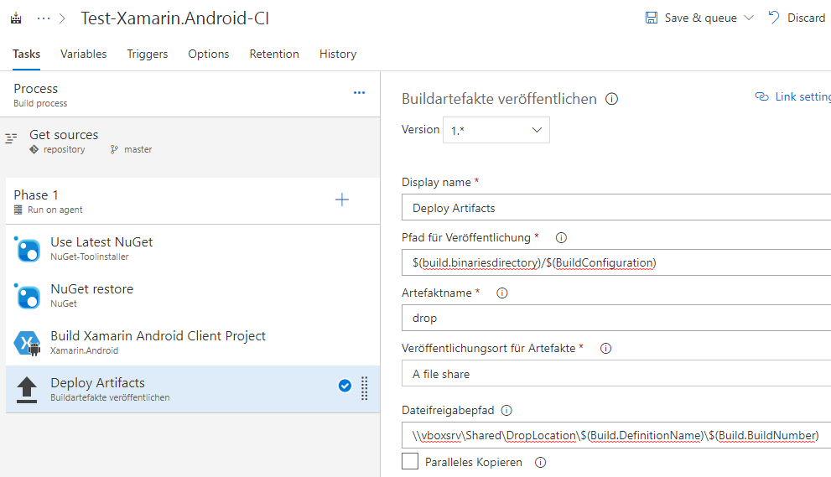

Enqueuing a build schould now succeed.

