Configuring a Build Server

Links:
- MS Build Tools 2015 Installer: https://www.microsoft.com/de-de/download/details.aspx?id=48159
- TFS Express: http://www.foreverything.technology/2016/11/team-foundation-server-2017-yaynland.html
- JDK: https://www.oracle.com/technetwork/java/javase/downloads/jdk8-downloads-2133151.html
- Android SDK: https://filehippo.com/de/download_android_sdk/
- Android Studio: https://developer.android.com/about/
- Node: https://nodejs.org/en/download/
- Insomnia: https://insomnia.rest/download/
- Chrome: https://www.google.de/chrome/?brand=CHBD&gclid=EAIaIQobChMI2NqSkOWk3wIVwoGyCh1BQAaDEAAYASAAEgLUj_D_BwE&gclsrc=aw.ds

Copy all the following installers onto a shared/temp folder
- MS Build Tools 2015 Installer
- TFS Express
- JDK
- Android SDK
- Android Studio
- Node
- Insomnia
- Chrome

and log back onto the VM.

Create a user named TFS_USER and add it to the administrator group. Log in with that user.

Start by installing JDK onto the default folder. Proceed by installing the build tools. Tick:
- Web development build tools.
- Universal Windows Platform build tools.
- .NET Desktop build tools.
- Mobile Development with .NET.
- .NET Core build tools.
Switch to individual components and choose:
- Windows 10 SDK (10.0.17134.0).
- All the .NET frameworks.
Click install and wait patiently for the installer to complete.

Now install Android studio and start it. Choose Oreo as platform. Install all the necessary packages so that the following highlighted option becomes available:
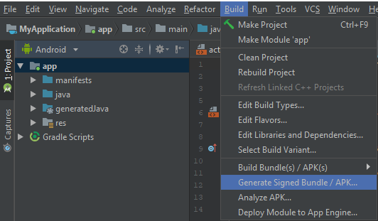

Click it and on the next screen, choose APK and click Next:
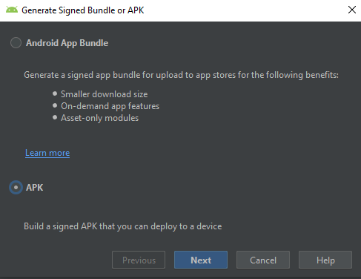

On the next screen choose Create new, define a path and choose password, alias and alias´ password:
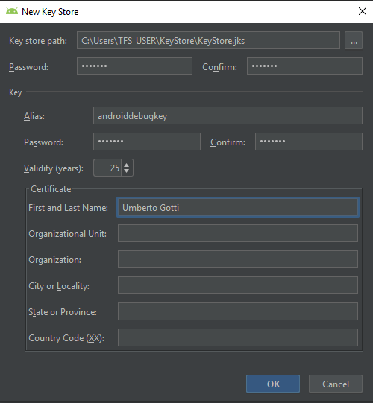

Defaults:
Keystore password: "android"
Key alias: "androiddebugkey"
Key password: "android"

Porceed, choose V2 and then finish:

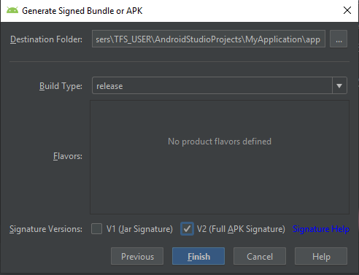

This will enable the build server to sign Android packages.

Now install Android SDK and start SDK Manager. Start by installing the proposed updates. Then install API 27 as displayed below:

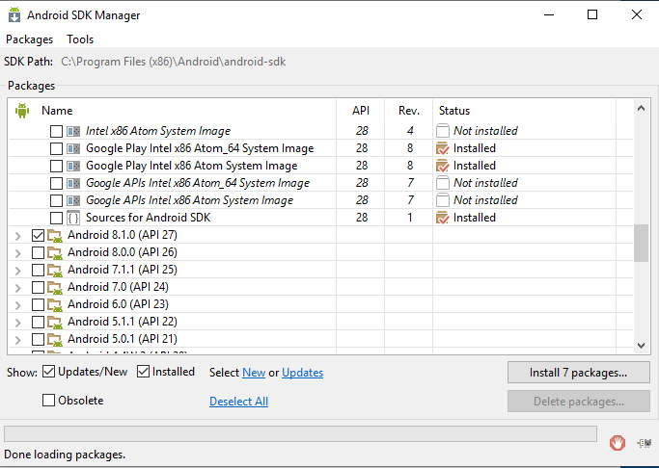

Now proceed by installing TFS Express. Choose Basic Deployment and click Next, choose SQL Server Express and click next:
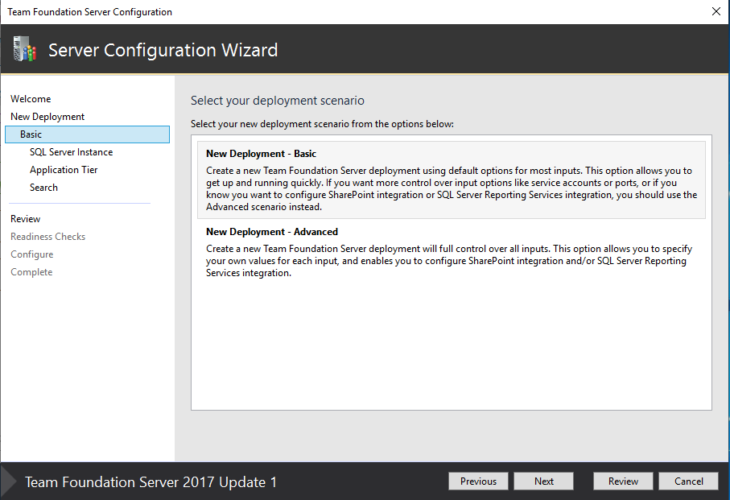

Accept the default configuration and click configure. Wait patiently for the installation to complete.

At this point it is possible to configure TFS. Start by pasting the default url onto the browser as displayed by the management console:

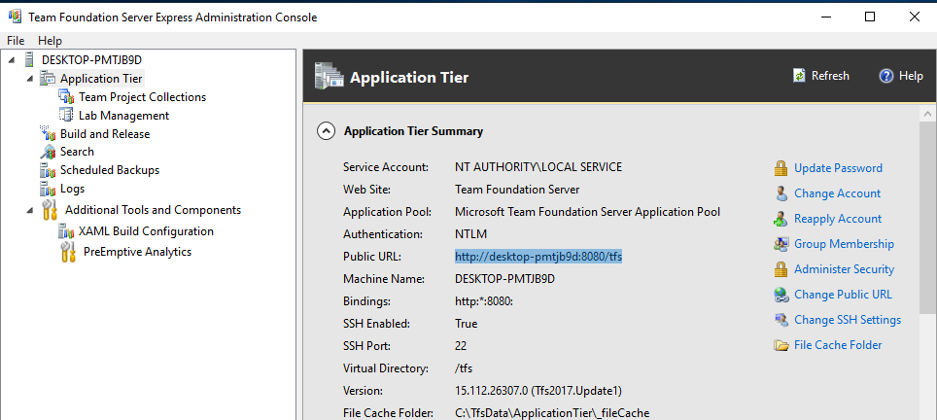
Select Agent Pools:

Click Download Agent and then Download. Browse to where the archive was deployed, create a folder TfsAgent for example in C: and copy the archive there. Extract it, open powershell with Admin privileges, browse to the folder and execute config.cmd.
Configure the service by providing reasonble answers such as:

The agent should now be visible:

Click capabilities, click add capability a sufficient number of times so as to have the following paths set correctly:

AndroidSDK: "C:\Program Files (x86)\Android\android-sdk"
MSBuild: "C:\Program Files (x86)\Microsoft Visual Studio\2017\BuildTools\MSBuild\15.0\Bin"
npm: "C:\Program Files\nodejs"
SDK: "C:\Program Files\Java\jdk1.8.0_191"
vstest : "C:\TfsAgent\VsTest"
Xamarin.Android: "C:\Program Files (x86)\Microsoft Visual Studio\2017\BuildTools\Common7\IDE\ReferenceAssemblies\Microsoft\Framework\MonoAndroid\v8.1"
Xamarin.iOS: "C:\Program Files (x86)\Microsoft Visual Studio\2017\BuildTools\Common7\IDE\ReferenceAssemblies\Microsoft\Framework\Xamarin.iOS\v1.0"

(NOTE: The contents of the folder vstest are to be copied from a machine where VS Studio Community is unstalled from the following location:
"C:\Program Files (x86)\Microsoft Visual Studio\2017\Community\Common7\IDE\CommonExtensions\Microsoft\TestWindow" or from the provided archive.)

Add two environment variables ANDROID_HOME and JAVA_HOME as shown on the following screen:

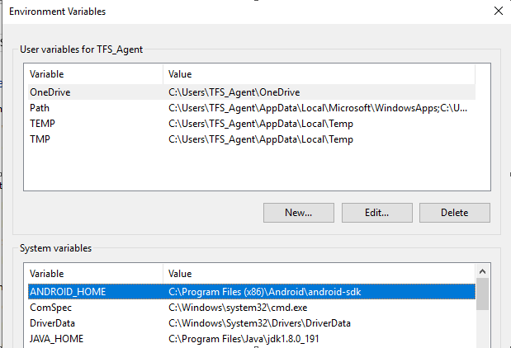

This finalizes the base configuration of TFS.

Finalize the configuration of the build server by installing Node, Insomnia and Chrome.

