Most Common Controls

Text Input

TextBlock
Lightweight control to display text.

<TextBlock FontFamily="Verdana" FontSize="18" FontStyle="Italic" FontWeight="Bold" />

TextBox
Allows input and possibly spell checking, text wrapping.

<TextBox Width="120" Margin="6" Text="This is the best WPF course" TextWrapping="NoWrap"/>

Label
Allows refocusing to another control defined in the target.

<Label Content="_Input" Target="InputTxt" Width="120"/>

Buttons

Button

<Button Height="" Width="" VerticalAlignment="" .../>

RepeatButton

<RepeatButton .../>

ToggleButton

<ToggleButton ..../>

RepeatButton

<RadioButton .../>

ComboBox

Simple control to create a drop down menu with a predefined set of selectable items.

<ComboBox>
<ComboBoxItem>ComboBox Item #1</ComboBoxItem>
<ComboBoxItem IsSelected="True">ComboBox Item #2</ComboBoxItem>
<ComboBoxItem>ComboBox Item #3</ComboBoxItem>
</ComboBox>

HeaderedContentControls

Expander

<Expander Header="This is an expander">
<StackPanel>
<RadioButton .../>
<RadioButton .../>
</StackPanel>
</Expander>

GroupBox

<GroupBox>
<GroupBox.Header ="This is a header" />
<StackPanel>
<ToggleButton .../>
<ToggleButton .../>
</StackPanel>
</GroupBox>

ProgressBar

Intuitive control. Minimum and Maximum should be set.
<ProgressBar Value="20" Minimum="0" Maximum="100" />

Slider

Also intuitive. Minimum, Maximum as well as the Orientation and size(SmallChange) of a step should be defined.

<Slider TickPlacement="Both"
SmallChange="20" LargeChange="50"
ValueChanged="OnValueChanged"
Minimum="0" Maximum="100"/>

TabControl

This is the usual tab-based Windows control. Here a possible example:

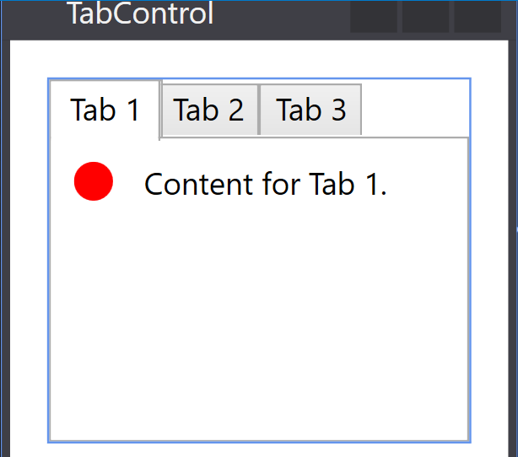

<Grid Margin="15">
<TabControl>
<TabItem Header="Tab 1">
<StackPanel HorizontalAlignment="Left" VerticalAlignment="Top"
Orientation="Horizontal">
<Ellipse Height="15" Width="15" Margin="6" Fill="Red"/>
<TextBlock Text="Content for Tab 1." Margin="6" />
</StackPanel>
</TabItem>
<TabItem Header="Tab 2">Content for Tab 2.</TabItem>
<TabItem Header="Tab 3">Content for Tab 3.</TabItem>
</TabControl>
</Grid>

Menus
This is the usual Windows-style menu with tree-like menu items and icons. The definition is intuitive and heirarchical. Menus are usually plugged inside DockPanels and nailed to the top.
The status bar at the bottom is not mandatory. Here a possible implementation of the following menu.

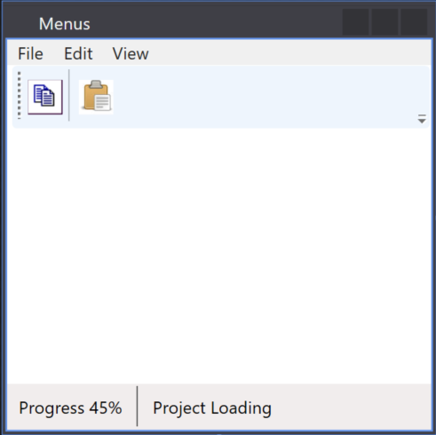

<DockPanel LastChildFill="False">
<StackPanel DockPanel.Dock="Top">
<Menu>
<MenuItem Header="File">
<MenuItem Header="New">
<MenuItem Header="Project" />
</MenuItem>
<MenuItem Header="Open" />
</MenuItem>
<MenuItem Header="Edit" />
<MenuItem Header="View" />
</Menu>
<ToolBar Height="45" DockPanel.Dock="Left">
<Button>
<Image Source="Images\copy.png" Width="25" Height="25" />
</Button>
<Separator />
<Button>
<Image Source="Images/paste.jpg" Width="25" Height="25" />
</Button>
</ToolBar>
</StackPanel>
<StatusBar DockPanel.Dock="Bottom">
<Label>Progress 45%</Label>
<Separator />
<Label>Project Loading</Label>
</StatusBar>
</DockPanel>

ListBox

Generalization of the ComboBox. Each element of the list is itself a complex control, such as picture with a text block as in the following example:

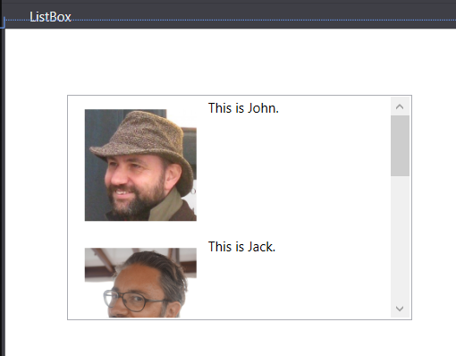

<Grid>
<ListBox x:Name="ComboBox" HorizontalAlignment="Left" Height="202" Margin="55,59,0,0" VerticalAlignment="Top"
Width="309" SelectionChanged="Box_OnSelectionChanged">
<StackPanel Orientation="Horizontal" TextSearch.Text="John">
<Image Source="Images/John.jpg" Width="100" Height="100"
RenderOptions.BitmapScalingMode="HighQuality" Margin="10" />
<TextBlock Text="This is John." />
</StackPanel>
<StackPanel Orientation="Horizontal" TextSearch.Text="Jack">
<Image Source="Images/Jack.jpeg" Width="100" Height="100"
RenderOptions.BitmapScalingMode="HighQuality" Margin="10" />
<TextBlock Text="This is Jack." />
</StackPanel>
<StackPanel Orientation="Horizontal" TextSearch.Text="Bob">
<Image Source="Images/Bob.jpg" Width="100" Height="100"
RenderOptions.BitmapScalingMode="HighQuality" Margin="10" />
<TextBlock Text="This is Bob." />
</StackPanel>
</ListBox>
</Grid>

TreeView
Customizable complex control allowing the representation of data as trees. A data item can be customized. Here a simple exmaple of string-based tree:
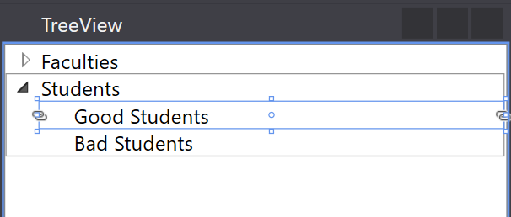

<TreeView>
<TreeViewItem Header="Faculties">
<TreeViewItem Header="Chairs">
<TreeViewItem Header="ComputerScience" />
</TreeViewItem>
</TreeViewItem>
<TreeViewItem Header="Students">
<TreeViewItem Header="Good Students" />
<TreeViewItem Header="Bad Students" />
</TreeViewItem>
</TreeView>

Layout

This section contains containers which are used to package other controls in specific way.

ViewBox

Mostly used to allow stretching pictures in different ways.

<Viewbox Stretch="Uniform" StretchDirection="Both">
// Other controls and images here!
</Viewbox>

StackPanel

This is the most used layout method and is used to stack controls vertically (default) or horizontally.

<StackPanel Orientation="Horizontal">

// More controls here!!!!!

</StackPanel>

DockPanel

Similar to the StackPanel but allows docking of controls based on properties. The LastChildFill property can be used to let the last child element to fill the remaining space. Here an example:

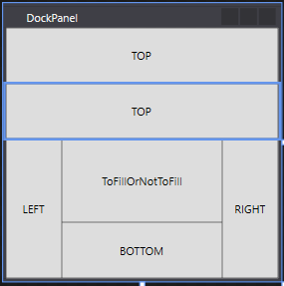

<DockPanel LastChildFill="True">
<Button DockPanel.Dock="Top" Content="TOP" Height="60"/>
<Button DockPanel.Dock="Top" Content="TOP" Height="60"/>
<Button DockPanel.Dock="Left" Content="LEFT" Width="60"/>
<Button DockPanel.Dock="Right" Content="RIGHT" Width="60"/>
<Button DockPanel.Dock="Bottom" Content="BOTTOM" Height="60"/>
<Button DockPanel.Dock="Left" Content="ToFillOrNotToFill"/>
</DockPanel>

WrapPanel

//TBD

Grid

The grid is most flexible panel and allows the partitioning of the space in a grid with configurable raws and columns. Here an example:

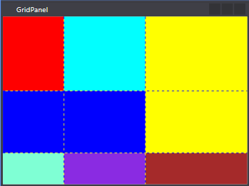

<Grid ShowGridLines="True">
<Grid.RowDefinitions>
<RowDefinition Height="Auto"/>
<RowDefinition Height="100"/>
<RowDefinition/>
</Grid.RowDefinitions>
<Grid.ColumnDefinitions>
<ColumnDefinition Width="3*"/>
<ColumnDefinition Width="4*"/>
<ColumnDefinition Width="5*"/>
</Grid.ColumnDefinitions>

<Rectangle Fill="Red" Height="120"/>
<Rectangle Fill="Aqua" Grid.Row="0" Grid.Column="1" Height="120"/>
<Rectangle Grid.Row="0" Grid.Column="2" Grid.RowSpan="2" Fill="Yellow"/>
<Rectangle Grid.Row="1" Grid.Column="0" Grid.ColumnSpan="2" Fill="Blue"/>
<Rectangle Grid.Row="2" Grid.Column="2" Fill="Brown"/>

<Rectangle Grid.Row="2" Grid.Column="0" Fill="Aquamarine"/>
<Rectangle Grid.Row="2" Grid.Column="1" Fill="BlueViolet"/>
</Grid>

The raws and column definitions need an explanation:
- An explicit number defines the size in pixels.
- Auto means the size of the contained control
- a number follows by a star means prroportionality.

Please note that almost each control inside the grid is assigned a position in the grid. Those which do not have defaults.

