<Pharmacy Management and Control System> (PMACS)

Use Case Specification Document

<Use Case ID>
<Sales Manager -Update Sales Promotions and Related Items content >
Version No. <0.6 >

Project Document Revision History
Version Number | Date | Revision Author | Description of Revision
0.1 | 3/3/17 | Cindy Samano | First draft of document
0.2 | 3/4/17 | Cindy Samano | Update
0.3 | 3/5/17 | Cindy Samano | Adding more detail based on reviewing other team member use cases.
0.4 | 3/7/17 | Cindy Samano | Creating Swimlane Diagram, further defining the happy path, adding in more pre-conditions and Table of Contents.
0.5 | 3/8/17 | Cindy Samano | Adding in team revisions. Removing predecessors, removing some Pre-conditions and breaking apart post conditions.
0.6 | 3/9/17 | Cindy Samano | Adding in the Happy Path and Alternative flows. Finishing Swimlane Diagram to include error states.

Table of Contents
1. Introduction 4
2. Use Case Information 4
2.1 Actor 4
2.2 Use Case Interaction 4
3. Trigger 4
4. Pre-condition(s) 4
5. Post-condition(s) 5
6. Use Case Swimlane (Activity) Diagram 5
7. Main/Basic Flow(s) of Events (Happy Path) 5
8. Alternate/Exception Flow of Events 7
9. Assumptions/Business Rules including Non-Functional Requirements 8
10. Use Case Specification Review and Signoff 8

Introduction
The purpose of this use case will be to describe the functional and non-functional business requirements that occur when updating sales promotions and related items. This functionality will cover creating a set number of Coupons that will provide discounts across whole orders, applying company-wide sales on a particular item, and determining which items are related with which.

Use Case Information

Actors
Actor Name | Role | Description
Sales Manager | Main | The individual that runs sales reports, adjusts promotional settings such as Customer Coupons and Company-wide Sales/Discounts, and manages the Related Items feature.

Use Case Interaction
No predecessors/successors or interaction with other used cases.

Trigger
This use case if trigger whenever the Sales Manager selects the “Update Sales Promotion” menu item from the main menu.

Pre-condition(s)

Items to receive company-wide discount must be in the system.
4.2 Both items to be paired together must be in the system.

Post-condition(s)

Coupons added into the system.

Coupons deleted from system.

Company-Wide discount applied on item.

Company-Wide discount removed.

Select related items will be coupled.

Uncouple related items.

If an item does not exist an error message will display.

Error creating Coupon – Coupon already exists, Error Message Displayed.

5.10 Error deleting Coupon - Coupon does not exist, Error Message Displayed.

5.11 Error Coupling items - Item already coupled with another item, Error Message Displayed.

5.12 Error Coupling items- Item X does not exist, Error Message Displayed.

5.12 Error Applying Company-Wide Discount - Item already has a discount, Error Message Displayed.

Use Case Swimlane (Activity) Diagram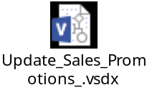
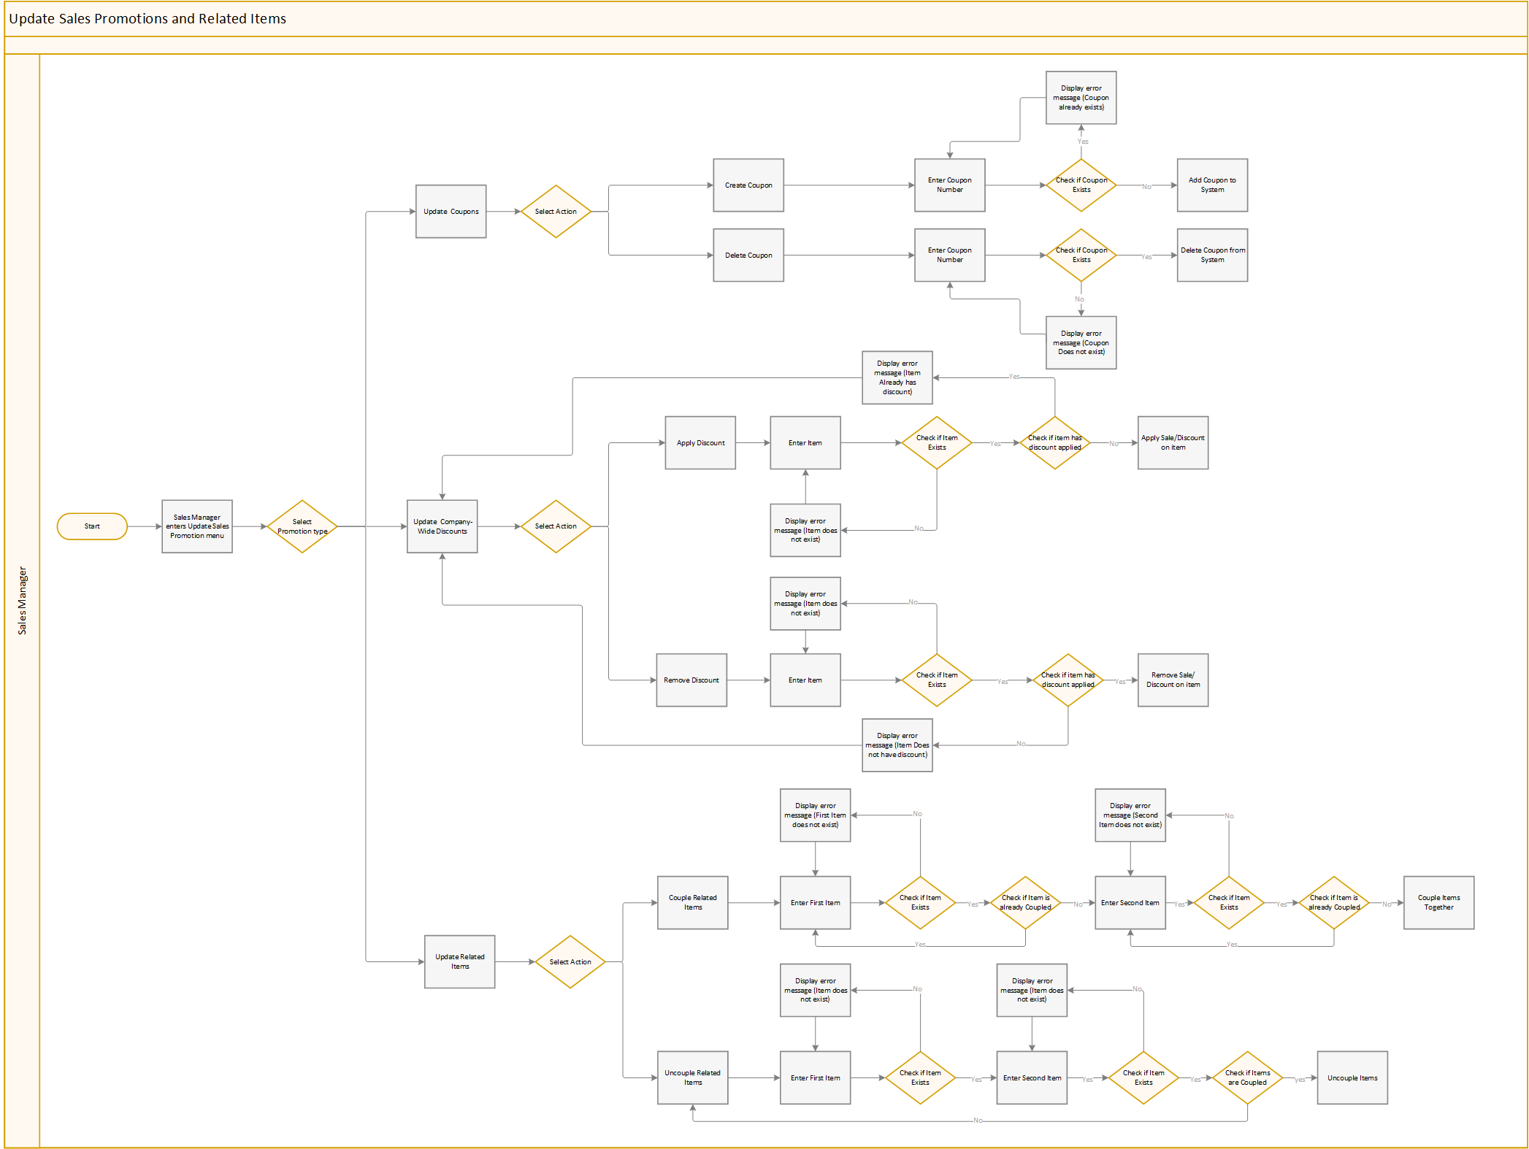

Main/Basic Flow(s) of Events (Happy Path)

Update Coupons: Sales manager selects Create Coupon or Delete Coupon.
7.3.1 Create Coupon: Sales manager adds Coupon to System.
7.3.2 Delete Coupon: Sales manager deletes Coupon from System.
7.4 Update Company-Wide Discounts on items: Sales Manager selects Apply Discount or Remove Discount.
7.4.1 Apply Discount: Sales Manager applies discount on item.
7.4.2 Remove Discount: Sales Manager removes discount on item.
7.5 Update Related Items: Sales Manager selects Couple Related Items or Uncouple Related Items.
7.5.1 Couple Related Items: Sales Manager Couples Items together
7.5.2: Uncouple Related Items: Sales Manager Uncouples Items.

Alternate/Exception Flow of Events

Coupon already exists:

Error message Displayed.

Re-enter Coupon Number.

Coupon does not exist:

Error message Displayed.

Re-enter Coupon Number

Item does not exist:

8.3.1 Error message Displayed.

8.3.2 Re-enter Item.

Item already has discount applied:

8.4.1 Error message Displayed.

8.4.2 Re-select Update Company-Wide Discounts menu item. (NOTE: This step is to remove discount from item before adding a new discount to it, this is the alternative if we don’t want to overwrite. Discount will have to be deleted before adding a new discount to an item)

Item does not have discount applied:

Error message Displayed.

Re-select Update Company-Wide Discounts menu item.

First item does not exist:

Error message Displayed.

Re-enter First Item.

Second item does not exist:

Error message Displayed.

Re-enter Second Item.

Item is already Coupled:

8.8.1 Error message Displayed.

8.8.2 Re-enter Item

Items are not Coupled:

Error message Displayed.

Re-select Update Related Items menu item.

Assumptions/Business Rules including Non-Functional Requirements
Be sure to number the assumption/business rules to allow easy reference to them. Business rules will be where non-functional requirements are recorded – have a way to specifically identify non-functional requirements.
9.1 Should be able to view an item under 5 sec.
9.2 Should be able to enter through the main screen in under 5 sec.

Use Case Specification Review and Signoff
Review and Signoff of the Use Case Specification
Name | Project Team Role | Signature | Date
 | Business Analyst
 | Systems Analyst
 | …..

