Pharmacy Management and Control System (PMACS)

Use Case Specification Document

UCSD-2-1
Sales Manager – Run Sales Reports
Version No. 0.7

Project Document Revision History
VersionNumber | Date | Revision Author | Description of Revision
0.1 | 3/1/2017 | Erik Johnson | Initial draft of document
0.2 | 3/4/2017 | Erik Johnson | Update
0.3 | 3/12/2017 | Erik Johnson | Use Case Diagram revision & flow updates
0.4 | 3/15/2017 | Erik Johnson | Use Case Diagram FINAL revision & subsequent flow updates, add System as actor
0.5 | 3/16/2017 | Erik Johnson | Use Case Specification flow updates and formatting changes
0.6 | 3/17/2017 | Erik Johnson | Use Case Specification more flow updates
0.7 | 3/17/2017 | Erik Johnson | Final draft for team signoff

Table of Contents
1 Introduction 5
2 Use Case Information 5
2.1 Actors 5
2.2 Use Case Interaction 5
3 Trigger 5
4 Pre-condition(s) 6
4.1 Sales Manager Pre-conditions 6
4.1.1 Historical data must be loaded 6
4.2 System Pre-conditions 6
4.2.1 Historical data must be loaded 6
4.2.2 Create/Delete store portion of Offline Batch Process complete 6
4.2.3 Item/Inventory Store Restock portion of Offline Batch Process complete 6
4.2.4 Item/Inventory Warehouse Restock/Transfer portion of Offline Batch Process complete 6
4.2.5 Item/Inventory Warehouse Inventory Level Check & Reorder portion of Offline Batch Process complete 6
4.2.6 Mass Inventory Item Data Update portion of Offline Batch Process complete 6
5 Post-condition(s) 6
5.1 Sales Manager Post-conditions 6
5.1.1 By-Store Daily Report Output 6
5.1.2 By-Store Weekly Report Output 6
5.1.3 By-Store Monthly Report Output 6
5.1.4 By-Store Yearly Report Output 6
5.1.5 By-Item Daily Report Output 6
5.1.6 By-Item Weekly Report Output 6
5.1.7 By-Item Monthly Report Output 6
5.1.8 By-Item Yearly Report Output 6
5.1.9 Error Running Report – Unable to create report file 6
5.2 System Post-conditions 6
5.2.1 Nothing to do (output to log) 6
5.2.2 Error reading params files (output to log) 6
5.2.3 Error Running Report – Unable to create report file (output to log) 7
5.2.4 Sales report creation successful (output to log with parameters used) 7
6 Use Case Swimlane (Activity) Diagram 7
7 Main/Basic Flow(s) of Events (Happy Path) 7
7.1 Sales Manager Flow 7
7.1.1 Sales Reports workflow begins (Run Sales Reports selected from Main Menu) 7
7.1.2 SM selects report type 7
7.1.3 SM selects period type D/W/M/Y 7
7.1.4 Enters date (day) or start date (week/month/year) 7
7.1.5 Validate date format, date existence 7
7.1.6 Attempt report creation 7
7.1.7 Display filename of successfully output report 7
7.2 System Flow (Data output) 8
7.2.1 Sales Reports workflow begins (Initiated from offline batch process) 8
7.2.2 Check if parameter file exists 8
7.2.3 Check if parameter file is readable 8
7.2.4 Check if there is data to report using parameters given 8
7.2.5 Attempt report creation 8
7.2.6 Log success (Output report filename, parameters used) 8
8 Alternate/Exception Flow of Events 8
8.1 Sales Manager Flow (Success, Store/Item not found) 8
8.1.1 Sales Reports workflow begins (Run Sales Reports selected from Main Menu) 8
8.1.2 SM selects report type 8
8.2 Sales Manager Flow (Success, Invalid date entered) 8
8.2.1 Sales Reports workflow begins (Run Sales Reports selected from Main Menu) 8
8.2.2 SM selects report type 8
8.2.3 SM selects period type D/W/M/Y 9
8.2.4 Enters date (day) or start date (week/month/year) 9
8.2.5 Validate date format, date existence 9
8.2.6 Display error message (Invalid date format OR nonexistent date) 9
8.2.7 Return to 8.2.4 9
8.3 Sales Manager Flow (Failure, Unable to create report file) 9
8.3.1 Sales Reports workflow begins (Run Sales Reports selected from Main Menu) 9
8.3.2 SM selects report type 9
8.3.3 SM selects period type D/W/M/Y 9
8.3.4 Enters date (day) or start date (week/month/year) 9
8.3.5 Validate date format, date existence 9
8.3.6 Attempt report creation 9
8.3.7 Log error (“Unable to create report file” with file information and parameters) 9
8.3.8 Display error (“Unable to create report file, please check log”) 9
8.4 System Flow (Success, No data output, no params file) 10
8.4.1 Sales Reports workflow begins (Initiated from offline batch process) 10
8.4.2 Check if parameter file exists 10
8.4.3 Log success (Output “No parameter file exists” message) 10
8.5 System Flow (Success, No data output, no data matches params) 10
8.5.1 Sales Reports workflow begins (Initiated from offline batch process) 10
8.5.2 Check if parameter file exists 10
8.5.3 Check if parameter file readable 10
8.5.4 Check if there is data to report using params 10
8.5.5 Log success (Output “No data to report” message with params) 10
9 Assumptions/Business Rules including Non-Functional Requirements 10
9.1 Each report must be output within 30 seconds. 10
10 Use Case Specification Review and Signoff 10

Introduction
This document captures detailed functional and non-functional BUSINESS requirements. Technical or application IT requirements should not be detailed here. A separate Use Case Summary document ties LL the individual use cases together. First create the Use Case Summary document using application decomposition. Then increase the detail by creating the individual use case specifications – be careful not to create too many or not create enough use cases.
Sales Managers need a way to summarize and present historical sales information based on information as recent as possible. The information needs to be presented in a report, and categorized by either store (listing all item sales for that particular store) or item (listing sales of a particular item across stores). The report should be able provide information for specific time periods, initially given as daily, weekly, monthly and yearly. If a yearly report is requested for a previous year, the report should be labeled for Jan. 31 - Dec 31 of that year. If for the current year, a year to date should be calculated the report should be labeled as such.
Additionally, as part of the Sales Reports functionality, PMACS, running an automated offline batch process, will need to create Sales Reports based on a parameter file received during the day. The reports will list all stores as well as grand totals for the entire company and will be specified by the parameter filer to use a weekly, monthly or yearly period.

Use Case Information

Actors
An actor is someone or something (e.g. application system) outside the system or business that interacts with the application. For every Use Case, there must be at least one Main Actor and zero or more Secondary Actors. Actors should be a person, system, or time.
Actor Name | Role | Description
Sales Manager (SM) | Main | The individual that runs sales reports, adjusts promotional settings such as Customer Coupons and Company-wide Sales/Discounts, and manages the Related Items feature.
System (S) | Secondary | The subsystem within PMACS that will perform automated offline batch processing.

Use Case Interaction
Predecessors: None
Successors: None

Trigger
This use case is triggered when a Sales Manager selects the "Sales Reports" menu item on the main menu.

Pre-condition(s)
What use cases or other pre-conditions must be met before use can initiate?

Sales Manager Pre-conditions

Historical data must be loaded

System Pre-conditions

Historical data must be loaded

Create/Delete store portion of Offline Batch Process complete

Item/Inventory Store Restock portion of Offline Batch Process complete

Item/Inventory Warehouse Restock/Transfer portion of Offline Batch Process complete

Item/Inventory Warehouse Inventory Level Check & Reorder portion of Offline Batch Process complete

Mass Inventory Item Data Update portion of Offline Batch Process complete

Post-condition(s)
What are ALL the possible output states upon completion of the use case flows?

Sales Manager Post-conditions

By-Store Daily Report Output

By-Store Weekly Report Output

By-Store Monthly Report Output

By-Store Yearly Report Output

By-Item Daily Report Output

By-Item Weekly Report Output

By-Item Monthly Report Output

By-Item Yearly Report Output

Error Running Report – Unable to create report file

System Post-conditions

Nothing to do (output to log)

Error reading params files (output to log)

Error Running Report – Unable to create report file (output to log)

Sales report creation successful (output to log with parameters used)

Use Case Swimlane (Activity) Diagram
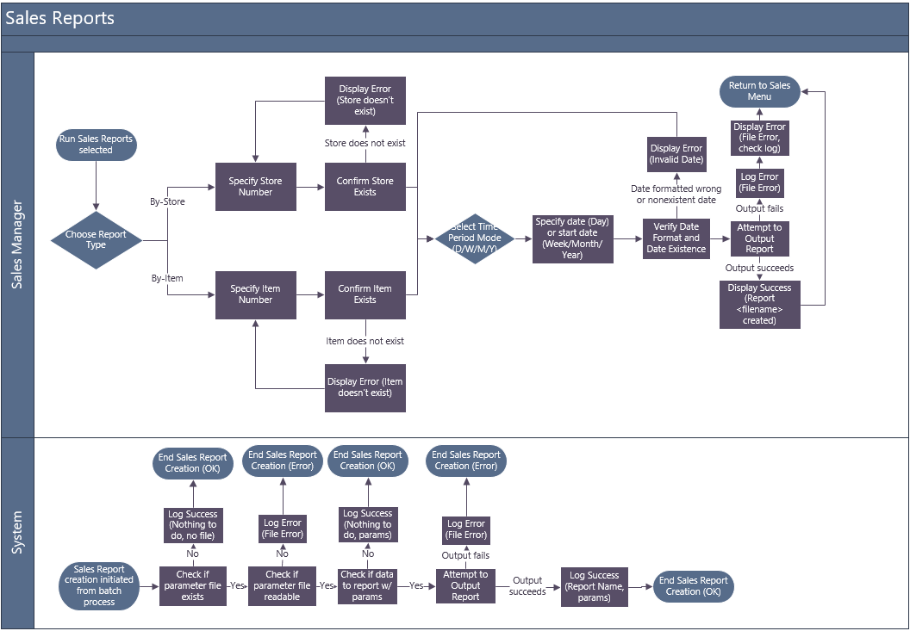

Main/Basic Flow(s) of Events (Happy Path)
For each main flow (usually ONE flow) write the list of steps that occur – describe WHAT occurs not HOW to do it!

Sales Manager Flow

Sales Reports workflow begins (Run Sales Reports selected from Main Menu)

SM selects report type

If By-Store:

SM specifies store number

Store existence is validated

Store exists, proceed to 7.1.3

If By-Item:

SM specifies item number

Item existence is validated

Item exists, proceed to 7.1.3

SM selects period type D/W/M/Y

Enters date (day) or start date (week/month/year)

Validate date format, date existence

Attempt report creation

Display filename of successfully output report

System Flow

Sales Reports workflow begins (Initiated from offline batch process)

Check if parameter file exists

Check if parameter file is readable

Check if there is data to report using parameters given

Attempt report creation

Log success (Output report filename, parameters used)

Alternate/Exception Flow of Events
For each alternative flow (can be zero or more) write the list of steps that occur – describe WHAT occurs not HOW to do it!

Sales Manager Flow (Success, Store/Item not found)

Sales Reports workflow begins (Run Sales Reports selected from Main Menu)

SM selects report type

If By-Store:

SM specifies store number

Display error message (Store doesn’t exist)

Return to 8.1.2.1.1

If By-Item:

SM specifies item number

Display error message (Item doesn’t exist)

Return to 8.1.2.2.1

Sales Manager Flow (Success, Invalid date entered)

Sales Reports workflow begins (Run Sales Reports selected from Main Menu)

SM selects report type

If By-Store:

SM specifies store number

Store existence is validated

Store exists, proceed to 8.2.3

If By-Item:

SM specifies item number

Item existence is validated

Item exists, proceed to 8.2.3

SM selects period type D/W/M/Y

Enters date (day) or start date (week/month/year)

Validate date format, date existence

Display error message (Invalid date format OR nonexistent date)

Return to 8.2.4

Sales Manager Flow (Failure, Unable to create report file)

Sales Reports workflow begins (Run Sales Reports selected from Main Menu)

SM selects report type

If By-Store:

SM specifies store number

Store existence is validated

Store exists, proceed to 8.3.3

If By-Item:

SM specifies item number

Item existence is validated

Item exists, proceed to 8.3.3

SM selects period type D/W/M/Y

Enters date (day) or start date (week/month/year)

Validate date format, date existence

Attempt report creation

Log error (“Unable to create report file” with file information and parameters)

Display error (“Unable to create report file, please check log”)

System Flow (Success, No data output, no params file)

Sales Reports workflow begins (Initiated from offline batch process)

Check if parameter file exists

Log success (Output “No parameter file exists” message)

System Flow (Success, No data output, no data matches params)

Sales Reports workflow begins (Initiated from offline batch process)

Check if parameter file exists

Check if parameter file readable

Check if there is data to report using params

Log success (Output “No data to report” message with params)

Assumptions/Business Rules including Non-Functional Requirements

Each report must be output within 30 seconds.

Use Case Specification Review and Signoff
Review and Signoff of the Use Case Specification
Name | Project Team Role | Signature | Date
Erik Johnson | Team Lead | EJ | 3/17/2017
 | …..

