Pharmacy Management and Control System (PMACS)

Use Case Specification Document

UCSD-5-1
Facility Management
Version No. 0.1

Project Document Revision History
VersionNumber | Date | Revision Author | Description of Revision
1 | 3- | Durwin Johnson | First use case version

Table of Contents
1. Introduction 4
2. Use Case Information 4
2.1 Actors 4
2.2 Use Case Interaction 4
3. Trigger 5
4. Pre-condition(s) 5
4.1 Batch process must be in progress 5
5. Post-condition(s) 5
5.1 Store created 5
5.2 Store deleted 5
5.3 Store priority list updated 5
5.4 No store changes 5
5.5 Errors 5
6. Use Case Swimlane (Activity) Diagram 6
7. Main/Basic Flow(s) of Events (Happy Path) 6
7.1 Stores modified 6
8. Alternate/Exception Flow of Events 6
8.1 Store cannot be created 6
8.2 Store cannot be deleted 7
9. Assumptions/Business Rules including Non-Functional Requirements 7
10. Use Case Specification Review and Signoff 7

Introduction
This use case expresses the requirements surrounding store facility processing. This involves adding stores and deleting stores, as well as creating inventory orders for stores created, and deallocating inventory for stores being deleted. This use case is performed during offline batch processing.

Use Case Information

Actors
Actor Name | Role | Description
System | Main | The system is the automated batch process that updates inventory and store information upon company closing for the day.
Vendor | Secondary | Provides files used in the creation and deletion of stores

Use Case Interaction
Interacts with Manage Inventory, through generation of order files to be sent to the warehouse for batch inventory processing.
Successors:
- Manage inventory

Trigger
Nightly batch process encounters store creation or deletion file data

Pre-condition(s)

Batch process must be in progress

Post-condition(s)

Store created
    - Store added to the list of stores
      - Order for store inventory placed
      - Store priority set

Store deleted
    - Store removed from the list of stores
      - Order for deallocation placed

Store priority list updated

No store changes

Errors
    - Report store add error
    - Report store delete error

Use Case Swimlane (Activity) Diagram
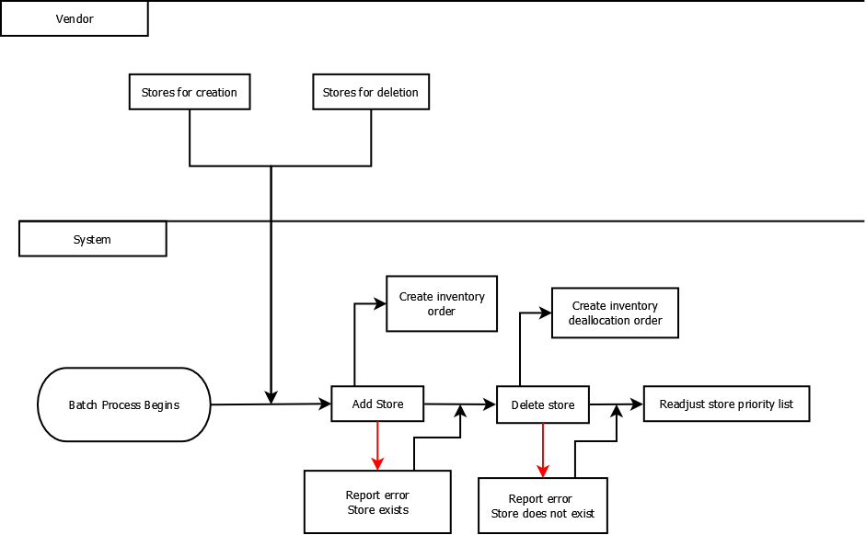

Main/Basic Flow(s) of Events (Happy Path)

Stores modified
- Create stores
  - Create store inventory order
- Delete stores
  - Create store inventory deallocation order
- Readjust store priority list

Alternate/Exception Flow of Events

Store cannot be created
      - Add stores
      - Report error: Store cannot be added; already exists
      - Delete stores
      - Readjust store priority list

Store cannot be deleted
      - Add stores
      - Delete stores
      - Report error: Cannot delete store; does not exist
      - Readjust store priority list

Assumptions/Business Rules including Non-Functional Requirements
    - Process must take no longer than 5 minutes
    - Store creation happens instantaneously and opens next day
    - Inventory deallocation happens instantaneously
    - If store priority is equivalent, sorting is in ascending numerical order.

Use Case Specification Review and Signoff
Review and Signoff of the Use Case Specification
Name | Project Team Role | Signature | Date
 | Business Analyst
 | Systems Analyst
 | …..

