Pharmacy Management and Control System (PMACS)

Use Case Specification Document

UCSD-4-1
Inventory Manager - View/Update Inventory
Version No. 0.1

Project Document Revision History
Version Number | Date | Revision Author | Description of Revision
1 | 3- | Durwin Johnson | First Use-case version

Table of Contents
1. Introduction 4
2. Use Case Information 4
2.1 Actors 4
2.2 Use Case Interaction 4
3. Trigger 4
4. Pre-condition(s) 4
4.1 < Pre-condition One > 4
5. Post-condition(s) 4
5.1 < Post-condition One > 5
5.2 < Post-condition Two > 5
6. Use Case Swimlane (Activity) Diagram 5
7. Main/Basic Flow(s) of Events (Happy Path) 5
7.1 <First Main Flow Name> 5
7.2 <Second Main Flow Name> 5
7.3 <Third Main Flow Name> 5
8. Alternate/Exception Flow of Events 6
9. Assumptions/Business Rules including Non-Functional Requirements 6
10. Use Case Specification Review and Signoff 6

Introduction
This use case expresses the requirements surrounding managing the inventory. This includes displaying inventory information, as well as modifying this information. The user should be able to input an item number or name, be presented with the corresponding item’s information, and have the option to edit this information. The user should also be able to remove items from the inventory list at either a store or a company level.

Use Case Information

Actors
Actor Name | Role | Description
Inventory Manager | Main | User involved in managing inventory related aspects of the business.

Use Case Interaction
After initial run, must succeed the System use case. Can only be run when stores are open for business. Successor use case is Store Manager, since this use case is the last use case to be used before store closing.

Trigger
Inventory Manager is selected from the menu.

Pre-condition(s)

< Pre-condition One >
Company must be open for business.

Post-condition(s)

Inventory Updated
    - Inventory item information edited
    - Inventory item added to a store
    - Inventory item deleted from a store
    - Inventory item added to multiple stores
    - Inventory item deleted from multiple stores
    - Inventory item added to all stores
    - Inventory item deleted from all stores

No Change
    - No changes made to the system.

Use Case Swimlane (Activity) Diagram
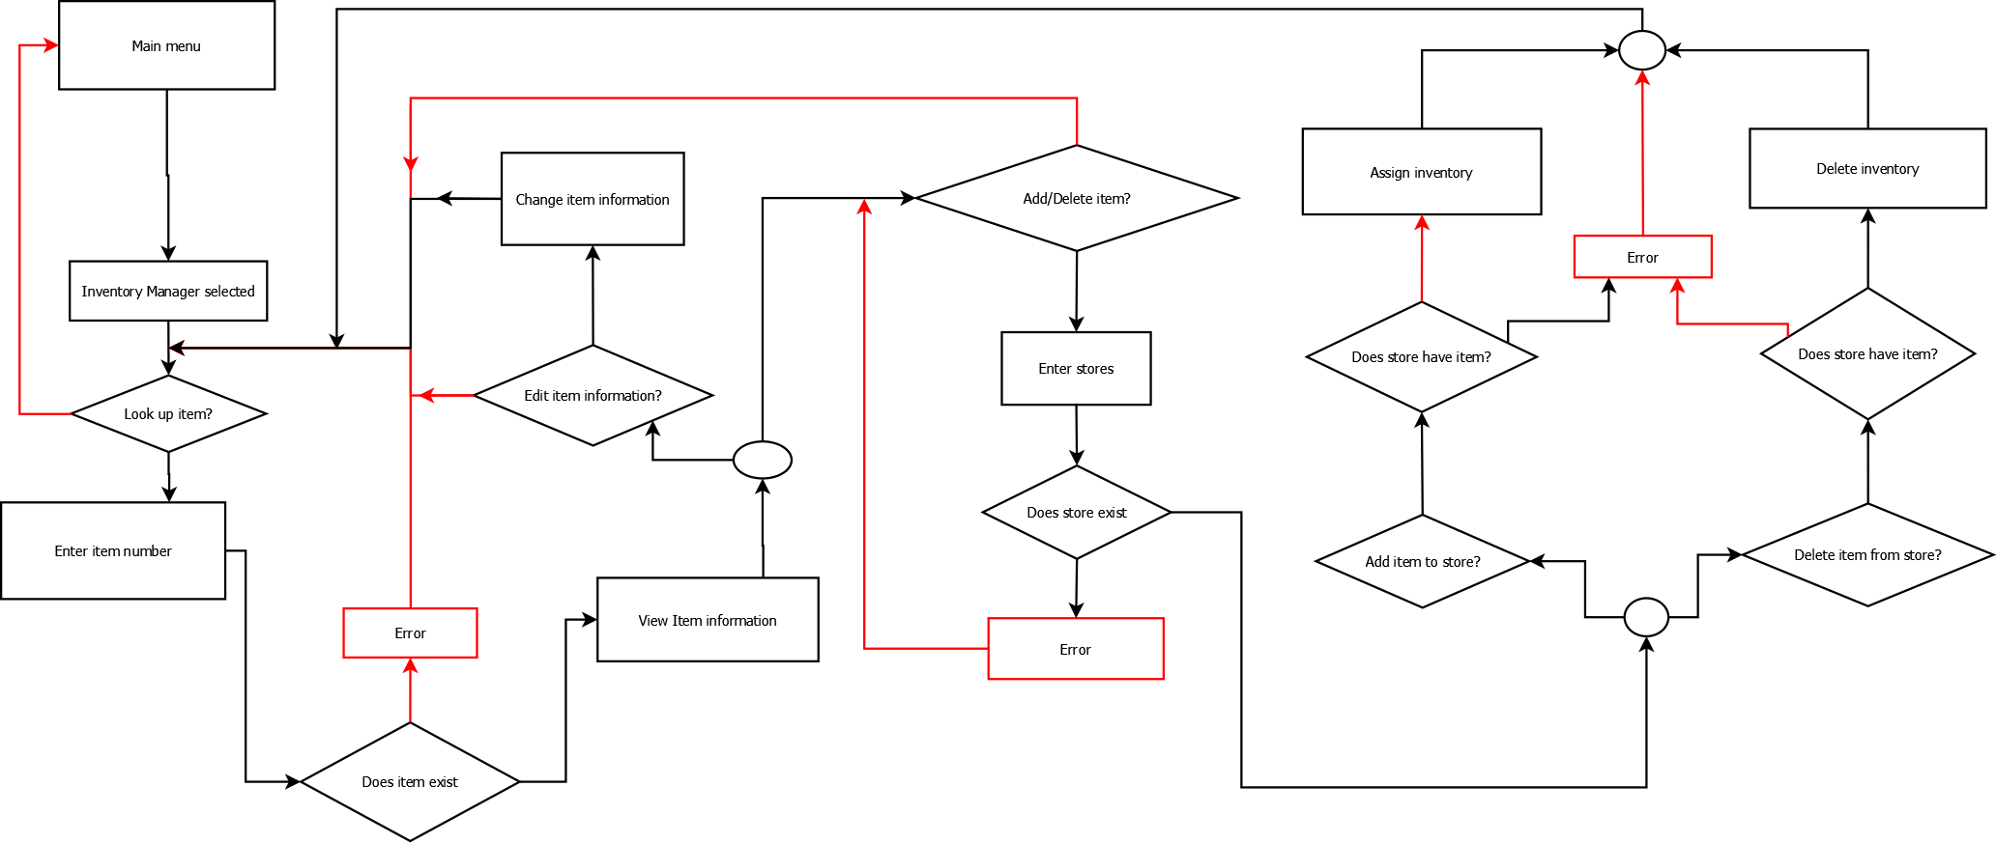

Main/Basic Flow(s) of Events (Happy Path)

Change Inventory Information
- Inventory manager selected from menu
- Input an item number or name
- Item information is displayed
- Select option to edit item information
- Edit information
- Return to item look up

Add Item
- Inventory manager selected from menu
- Input an item number or name
- Item information is displayed
- Select option to add/delete an item
- Enter store numbers
- Select option to add item
- Item is added
- Return to item look up

Delete Item
- Inventory manager selected from menu
- Input an item number or name
- Item information is displayed
- Select option to add/delete an item
- Enter store numbers
- Select option to delete item
- Item is deleted
- Return to item look up

Alternate/Exception Flow of Events
N/A

Assumptions/Business Rules including Non-Functional Requirements
    - Updates must be applied before next inventory item viewing.

Use Case Specification Review and Signoff
Review and Signoff of the Use Case Specification
Name | Project Team Role | Signature | Date
 | Business Analyst
 | Systems Analyst

