<ProjectName> (<ProjectAcronym (if there is one)>)

Use Case Specification Document

<Use Case ID>
System - Nightly Batch Processing
Version No. <DocumentVersionNo.>

Project Document Revision History
VersionNumber | Date | Revision Author | Description of Revision
1 | 3- | Durwin Johnson

Table of Contents
1. Introduction 4
2. Use Case Information 4
2.1 Actors 4
2.2 Use Case Interaction 4
3. Trigger 4
4. Pre-condition(s) 4
4.1 < Pre-condition One > 4
4.2 < Pre-condition Two > 5
5. Post-condition(s) 5
5.1 < Post-condition One > 5
5.2 < Post-condition Two > 5
5.3 <Post-condition Three> 5
…… 5
6. Use Case Swimlane (Activity) Diagram 5
7. Main/Basic Flow(s) of Events (Happy Path) 5
7.1 <First Main Flow Name> 5
7.2 <Second Main Flow Name> 6
8. Alternate/Exception Flow of Events 6
8.1 <First Alternative Flow Name> 6
8.2 <Second Alternative Flow Name> 6
9. Assumptions/Business Rules including Non-Functional Requirements 6
10. Use Case Specification Review and Signoff 6

Introduction
This use case expresses the requirements surrounding the post-operation batch processing. This process involves taking the collective store inventory requests, any updates to the inventory or stores themselves, creating sales reports, and creating warehouse orders. This process should be run after store opening and conclude before company opening.

Use Case Information

Actors
Actor Name | Role | Description
System | Main

Use Case Interaction
This use-case succeeds the Store Manager use-case, then precedes all other use cases after the first program run cycle. After the stores have closed, the system runs. After the system completes, the stores may open again.
Predecessors:
- Store Manager
Successors:
- Store Manager
- Inventory Manager
- Cashier
- Sales
- Sales

Trigger
End of business day reached (All stores closed)

Pre-condition(s)

< Pre-condition One >
Each store manager must close the store

Post-condition(s)
What are ALL the possible output states upon completion of the use case flows?

< Post-condition One >
Store information updated

< Post-condition Two >
Company inventory updated

<Post-condition Three>
No updates made

Use Case Swimlane (Activity) Diagram
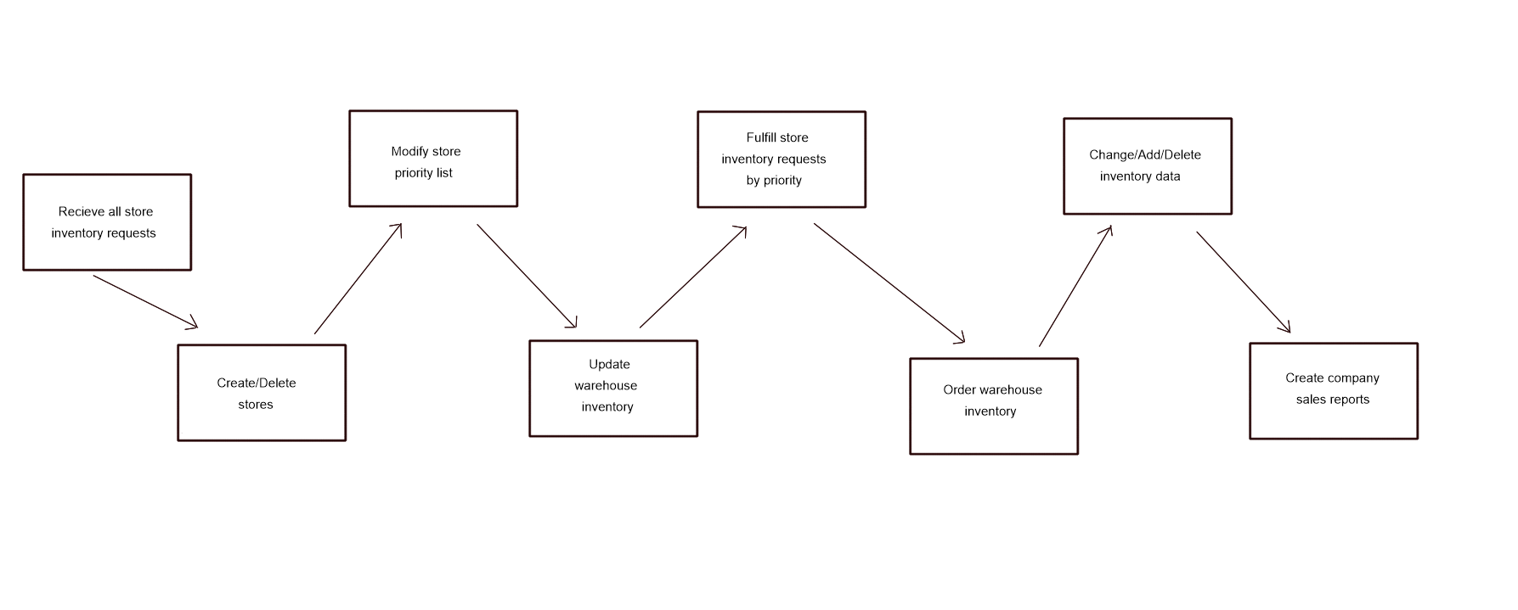

Main/Basic Flow(s) of Events (Happy Path)

<First Main Flow Name>
Create/delete stores > Readjust store priority list > update warehouse inventory > Fulfill store inventory by priority > warehouse inventory generation > Change/add/delete item data > create company sales reports (by week|month|year)

Alternate/Exception Flow of Events
N/A

Assumptions/Business Rules including Non-Functional Requirements
Be sure to number the assumption/business rules to allow easy reference to them. Business rules will be where non-functional requirements are recorded – have a way to specifically identify non-functional requirements.
    - Process must be completed before time business opens next day.

Use Case Specification Review and Signoff
Review and Signoff of the Use Case Specification
Name | Project Team Role | Signature | Date
 | Business Analyst
 | Systems Analyst
 | …..

