Pharmacy Management and Control System (PMACS)

Use Case Specification Document

<Use Case ID>
Cashier – Ring Up Customer
Version No. <DocumentVersionNo.>

Project Document Revision History
VersionNumber | Date | Revision Author | Description of Revision

Table of Contents

Introduction Page 4

Use Case Information Page 4

2.1 Actors Page 4
2.2 Use Case Interactions Page 4
3. Trigger Page 4
4. Pre-Conditions Page 5
5. Post-Conditions Page 5
6. Use Case Swimlane Page 5
7. Main Flow of Events Page 5
8. Alternate Exception of Flows Page 5
9. Assumption Rules including Non-Functional Requirements Page 6
10. Use Case Review and Sign Off Page 6

Introduction
This use case handles the interaction between a store cashier, the system, and an additional store employee. This use case is called when a transaction is in process with a customer. It will also be used to produce prescription labels, and create and modify customer accounts. The system will create identification numbers for new accounts and notify the cashier if a customer is eligible for a refill based on the information in their account. The additional employee must approve prescription refills when they are requested.

Use Case Information

2.1 Actors
Actor Name | Role | Description
Cashier | Main | Cashier running the transaction. Will take information from customer to produce prescription labels. Also, will be able to create new accounts for new customers.
System | Secondary | System will assign account number automatically for new accounts. If the customer is eligible for refills, the system will automatically prompt the cashier.
Pharmacist | Approval | If a refill is requested, additional personnel must approve the request passed on from the cashier.

2.2 Use Case Interaction
How does this use case relate to other uses cases? List predecessor and successor use cases.

Trigger
This use case is triggered during any transaction with a customer. The cashier will be able to edit and change customer information on their account. Creation of prescription labels and new customer accounts will be prompted and carried through by the cashier during a transaction. The system will trigger this use case to assign new accounts an account number and to notify the cashier if the customer is eligible for another refill. If a refill is requested, it must be approved by an additional employee of the pharmacy.

Pre-condition(s)

Items the customer is purchasing must be in the system.

Post-condition(s)

Items purchased will be subtracted from stores inventory.

If customer is eligible for refill, the system will notify the cashier.

If the customer does not have an account, the cashier will prompt creation through the system.

Prescription labels will be created based off customer information.

Use Case Swimlane (Activity) Diagram
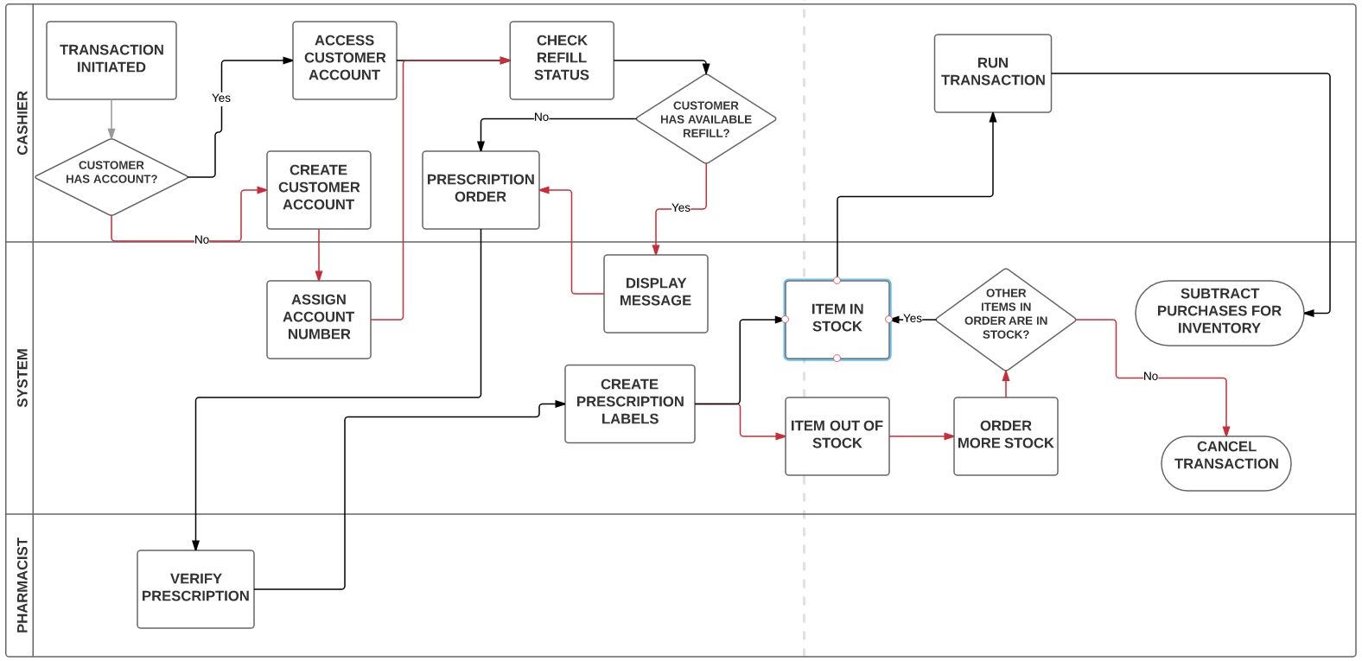

Main/Basic Flow(s) of Events (Happy Path)

Cashier initiates transaction.

Cashier will access the customer’s account.

Cashier will send prescription order to pharmacist for approval.

Prescription label created by system.

Run transaction.

Subtract purchases from inventory.

Alternate/Exception Flow of Events

Customer does not have account:
1.1 Create customer account.
1.2. System assign account number.
2. Customer has refill available:
2.1 System will display message for cashier.
3. Item in customer’s order is out of stock:
3.1 System automatically puts order in for more stock.
4. Customer has no items in order that are in stock
4.1 Cancel transaction.

Assumptions/Business Rules including Non-Functional Requirements
POS System must run purchases in less than 5 seconds. Prescription labels must be accurate to information given from customer.

Use Case Specification Review and Signoff
Review and Signoff of the Use Case Specification
Name | Project Team Role | Signature | Date
 | Business Analyst
 | Systems Analyst
 | …..

