Pharmacy Management and Control System (PMACS)

Use Case Specification Document

UCSD-4-1
Manage Inventory
Version No. 0.1

Project Document Revision History
Version Number | Date | Revision Author | Description of Revision
1 | 3- | Durwin Johnson | First Use-case version

Table of Contents
1. Introduction 5
2. Use Case Information 5
2.1 Actors 5
2.2 Use Case Interaction 5
3. Trigger 5
4. Pre-condition(s) 6
4.1 Inventory manager is selected in application 6
4.2 Midnight occurs 6
5. Post-condition(s) 6
5.1 Store information updated 6
5.2 Company inventory updated 6
5.3 No updates/error reports created 6
5.4 No Change 7
6. Use Case Swimlane (Activity) Diagram 7
7. Main/Basic Flow(s) of Events (Happy Path) 7
7.1 Inventory batch processing 7
7.2 View item information 8
7.3 Edit item information 8
7.4 Add item to company 8
7.5 Add item to store 9
7.6 Delete item from company 9
7.7 Delete item from store 9
8. Alternate/Exception Flow of Events 9
8.1 Store cannot be added 9
8.2 Store cannot be deleted 10
8.3 Item cannot be added 11
8.4 Item cannot be deleted 11
8.5 Warehouse order processing error 12
8.6 Store order processing error 12
8.7 Inventory shortage 13
8.8 Store does not exist 13
8.9 Item cannot be added (2) 14
8.10 Item cannot be deleted (2) 14
9. Assumptions/Business Rules including Non-Functional Requirements 14
10. Use Case Specification Review and Signoff 15

Introduction
This use case expresses the requirements surrounding managing the inventory. This includes displaying inventory information, as well as modifying this information. The user should be able to input an item number or name, be presented with the corresponding item’s information, and have the option to edit this information. The user should also be able to remove items from the inventory list at either a store or a company level.

Use Case Information

Actors
Actor Name | Role | Description
System | Main | Automated system responsible for batch processing
Inventory Manager | Main | User involved in managing inventory related aspects of the business.

Use Case Interaction
This use case modifies the inventory used by the Update Sales Promotions and Related Items, and Ring up customer, and Print sales reports use cases.

Trigger
    - Inventory Manager is selected from the menu.
    - Midnight batch processing begins

Pre-condition(s)

Inventory manager is selected in application

Midnight occurs

Post-condition(s)

Store information updated
    - Store added
      - Report for inventory order created
    - Store deleted
      - Report for inventory return to warehouse created
    - Store priority list updated
    - Store inventory replenished

Company inventory updated
    - Inventory item deleted
    - Inventory item added
    - Inventory item data altered
    - Inventory threshold increased
    - Inventory threshold decreased

No updates/error reports created
    - Report inventory received not sold by company
    - Report file read error
      - Stop processing
    - Report vendor orders from warehouse
    - Report insufficient stock to supply stores
      - Order for next day processing created
    - Report threshold adjustments made
    - Report store add error
    - Report store delete error
    - Report item add error
    - Report item delete error
    - Report sales report creation error

No Change
    - No changes made to the system

Use Case Swimlane (Activity) Diagram
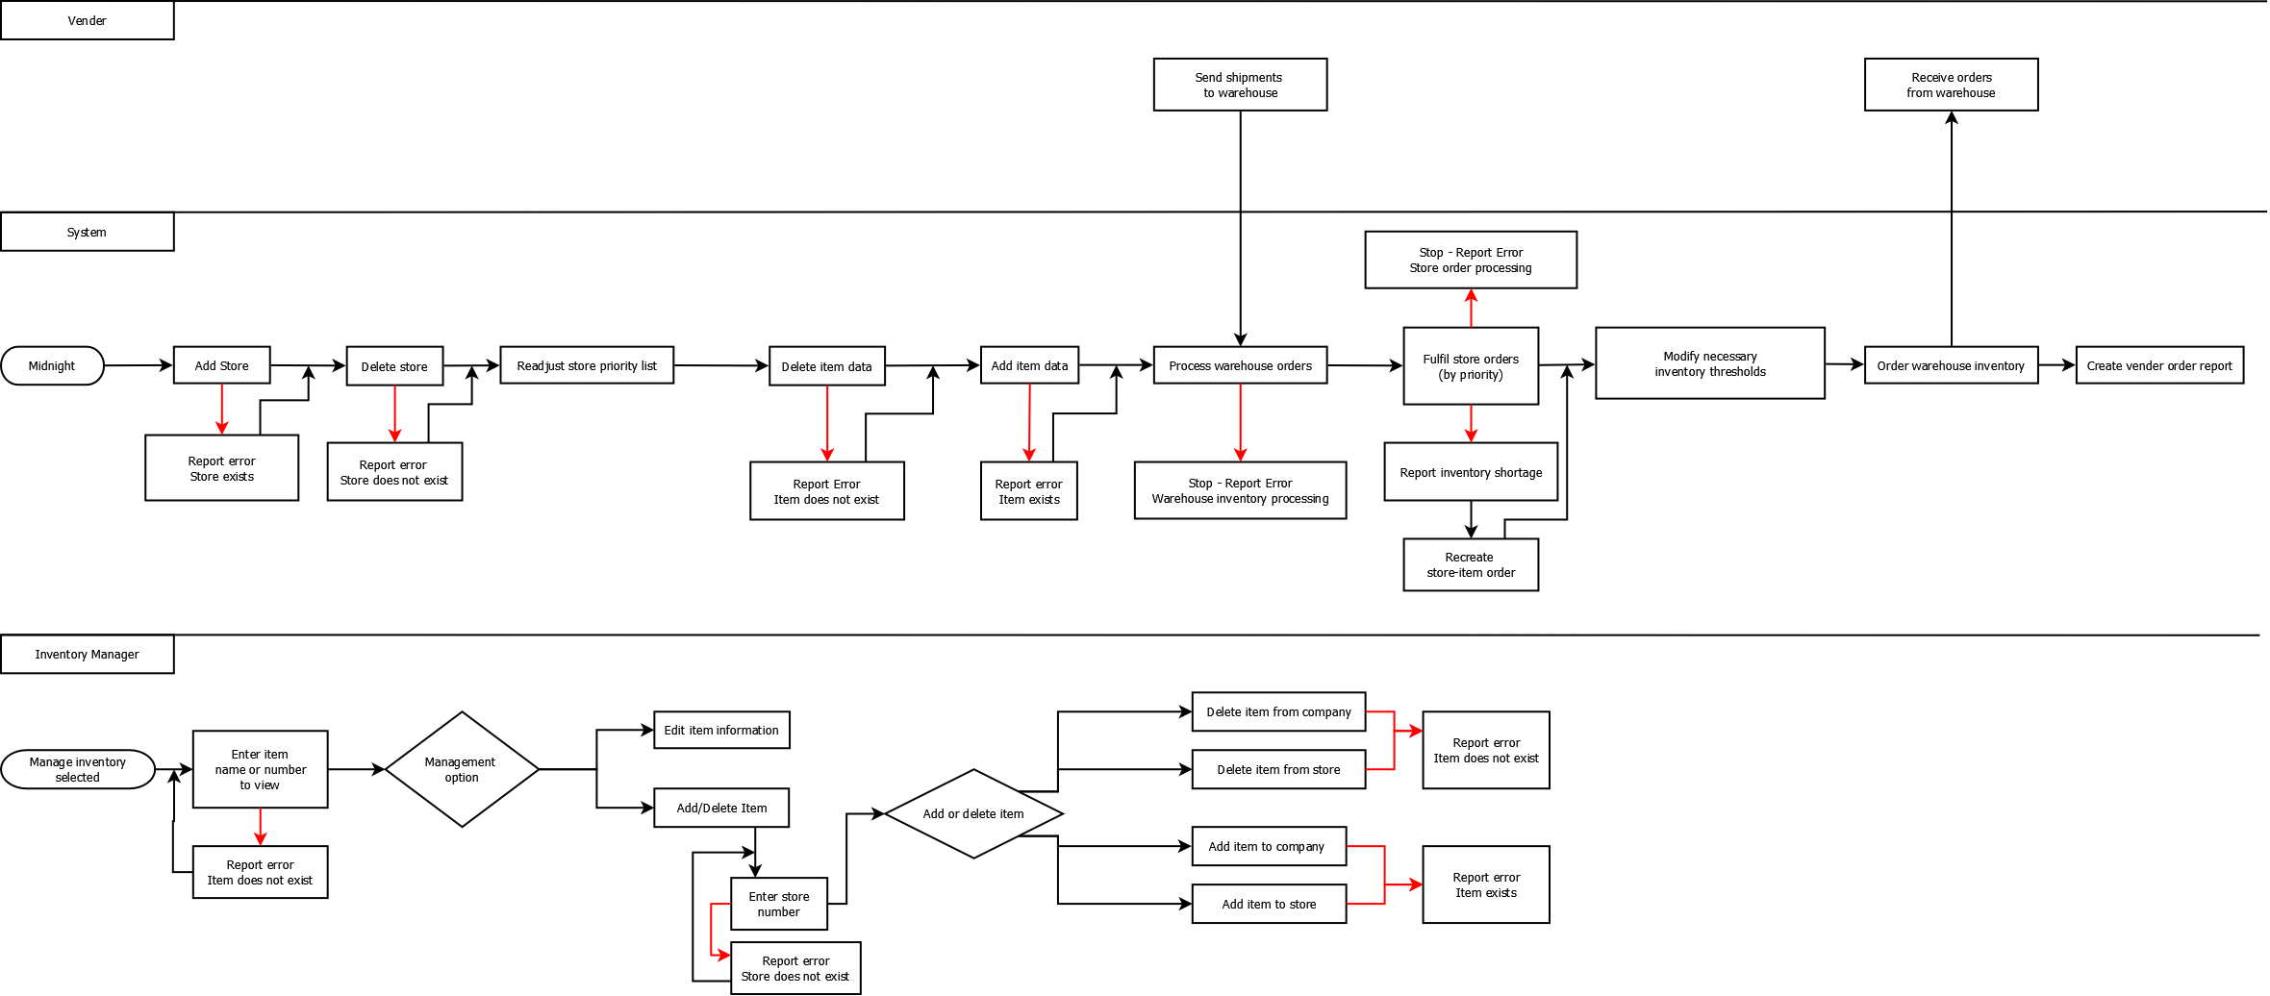

Main/Basic Flow(s) of Events (Happy Path)

Inventory batch processing
      - Midnight batch processing begins
      - Add stores
      - Delete stores
      - Readjust store priority list
      - Delete item data
      - Add item data
      - Process warehouse orders
      - Fulfill store orders by priority
      - Modify necessary inventory thresholds
      - Order warehouse inventory
      - Create vender order report

View item information
- Inventory manager selected from menu
- Enter item to view (name or number)

Edit item information
- Inventory manager selected from menu
- Enter item to view (name or number)
- Edit item information

Add item to company
- Inventory manager selected from menu
- Enter item to view (name or number)
- Choose to add/delete an item
- Enter store number
- Select option to add item
- Item is added to all stores

Add item to store
- Inventory manager selected from menu
- Enter item to view (name or number)
- Choose to add/delete an item
- Enter store number
- Select option to add item
- Item is added to store

Delete item from company
- Inventory manager selected from menu
- Enter item to view (name or number)
- Choose to add/delete an item
- Enter store number
- Select option to delete item
- Item is deleted from all stores

Delete item from store
- Inventory manager selected from menu
- Enter item to view (name or number)
- Choose to add/delete an item
- Enter store number
- Select option to add item
- Item is deleted from store

Alternate/Exception Flow of Events

Store cannot be added
      - Midnight batch processing begins
      - Add stores
      - Report error: Store cannot be added; already exists
      - Delete stores
      - Readjust store priority list
      - Delete item data
      - Add item data
      - Process warehouse orders
      - Fulfill store orders by priority
      - Modify necessary inventory thresholds
      - Order warehouse inventory
      - Create vender order report

Store cannot be deleted
      - Midnight batch processing begins
      - Add stores
      - Delete stores
      - Report error: Cannot delete store; does not exist
      - Readjust store priority list
      - Delete item data
      - Add item data
      - Process warehouse orders
      - Fulfill store orders by priority
      - Modify necessary inventory thresholds
      - Order warehouse inventory
      - Create vender order report

Item cannot be added
      - Midnight batch processing begins
      - Add stores
      - Delete stores
      - Readjust store priority list
      - Delete item data
      - Report error: Cannot add item, already exists
      - Add item data
      - Process warehouse orders
      - Fulfill store orders by priority
      - Modify necessary inventory thresholds
      - Order warehouse inventory
      - Create vender order report

Item cannot be deleted
      - Midnight batch processing begins
      - Add stores
      - Delete stores
      - Readjust store priority list
      - Delete item data
      - Report error: Item cannot be deleted, does not exist
      - Add item data
      - Process warehouse orders
      - Fulfill store orders by priority
      - Modify necessary inventory thresholds
      - Order warehouse inventory
      - Create vender order report

Warehouse order processing error
      - Midnight batch processing begins
      - Add stores
      - Delete stores
      - Readjust store priority list
      - Delete item data
      - Add item data
      - Process warehouse orders
      - STOP. Report error: Warehouse inventory processing
      - Fulfill store orders by priority
      - Modify necessary inventory thresholds
      - Order warehouse inventory
      - Create vender order report

Store order processing error
      - Midnight batch processing begins
      - Add stores
      - Delete stores
      - Readjust store priority list
      - Delete item data
      - Add item data
      - Process warehouse orders
      - Fulfill store orders by priority
      - STOP: Report error: Store order processing
      - Modify necessary inventory thresholds
      - Order warehouse inventory
      - Create vender order report

Inventory shortage
      - Midnight batch processing begins
      - Add stores
      - Delete stores
      - Readjust store priority list
      - Delete item data
      - Add item data
      - Process warehouse orders
      - Fulfill store orders by priority
      - Report error: Inventory shortage
      - Create order for short items for next batch process
      - Modify necessary inventory thresholds
      - Order warehouse inventory
      - Create vender order report

Store does not exist
- Inventory manager selected from menu
- Enter item to view (name or number)
- Choose to add/delete an item
- Enter store number
- Report error: Store does not exist
- Return to “Enter store number”

Item cannot be added (2)
- Inventory manager selected from menu
- Enter item to view (name or number)
- Choose to add/delete an item
- Enter store number
- Select option to add item
- Report error: Cannot add item; already exists

Item cannot be deleted (2)
- Inventory manager selected from menu
- Enter item to view (name or number)
- Choose to add/delete an item
- Enter store number
- Select option to delete item
- Report error: Cannot delete item; does not exist

Assumptions/Business Rules including Non-Functional Requirements
    - Batch process must occur after 12am, and end before 6am
    - On-line inventory management must occur between 6am and 9pm
    - Store deliveries are instantaneous
    - Vender orders take 3 weeks to arrive
    - On-line transactions cannot occur until batch process is completed
    - Company has a “store number” that applies updates to all stores within the company

Use Case Specification Review and Signoff
Review and Signoff of the Use Case Specification
Name | Project Team Role | Signature | Date
 | Business Analyst
 | Systems Analyst

