Interpretable Churn Prediction for Telecom Decision Support: Regularized Logistic Models, Uplift Modeling, and Revenue-Aware Retention Optimization

Moeez Islam Malik
Muhammad Umer Hammad
Muhammad Abdullah Saleem

CSC 398 - Independent Study
Instructor: Professor Mehmet
Spring 2026

Abstract
Telecommunication providers face persistent revenue erosion from customer churn, yet many predictive systems remain disconnected from intervention design and economic decision support. We develop an interpretable churn intelligence framework using the Telco Customer Churn dataset with 7,043 customers and 33 variables. Our baseline modeling stage compares class-balanced logistic regression, Ridge, Lasso, and Elastic Net under a stratified 80/20 split and five-fold cross-validation. The best predictive model is calibrated Elastic Net, achieving a test ROC AUC of 0.8484 and a calibrated Brier score of 0.1361. We extend this baseline with four novelty modules: SHAP-based instance-level explainability, uplift modeling via a T-learner, survival analysis for time-to-churn estimation, and revenue-at-risk plus ROI simulation. SHAP shows Tenure_Months as the strongest global contributor with mean absolute SHAP value 0.9162. The uplift segmentation identifies 474 Persuadables and 231 Sure Things, enabling intervention triage beyond risk ranking. Cox survival modeling yields a test concordance index of 0.9028, supporting actionable churn timing estimates. At a 0.4 threshold, annualized revenue at risk is $242,525.92, and threshold-specific campaign simulations show positive net ROI across all tested policies. The resulting framework integrates interpretability, causally aware targeting, temporal risk, and financial prioritization for deployable retention strategy in modern telecom operations at scale.
1. Introduction
Customer churn is a structural challenge in the telecommunications sector because recurring revenue models amplify the financial impact of each lost subscriber. As competitive switching costs decline and service parity increases, providers require predictive systems that identify not only likely churners but also operationally meaningful intervention opportunities. Many production workflows still rely on static risk ranking, which captures correlation with churn yet often omits treatment responsiveness, temporal urgency, and value-weighted targeting.
This study addresses that gap by extending a calibrated regularized logistic baseline into a decision-support architecture that links prediction to action. We first establish a strong interpretable benchmark with Elastic Net and probability calibration, then introduce four contributions. Contribution 1 is SHAP-based explanation at both global and individual levels, allowing analyst and manager interpretation beyond coefficient summaries. Contribution 2 is uplift modeling that estimates incremental intervention impact and separates persuadable customers from non-actionable cohorts. Contribution 3 is survival analysis that reframes churn as a time-to-event process and supports intervention scheduling. Contribution 4 is revenue-at-risk and return-on-investment simulation to align model outputs with campaign economics.
The remainder of the paper proceeds from related literature to dataset and baseline methods, then presents each novelty module with empirical findings and managerial implications. We conclude with an integrated deployment framework, limitations, and future work toward experimentally validated causal retention optimization.
1.1 Novelty Positioning
The project's novelty is primarily integrative rather than algorithmic. Prior literature has independently studied churn prediction, SHAP-based explainability, uplift modeling, survival analysis, and campaign economics. However, most studies do not operationalize these components in a unified telecom decision pipeline anchored to a calibrated base model. Our contribution is the end-to-end coupling of discrimination, interpretability, intervention response estimation, time-to-churn modeling, and revenue-aware policy simulation within one reproducible workflow.
Accordingly, we position this work as methodological integration and operationalization novelty. This framing is academically precise: we do not claim a new learning algorithm, but we do contribute a practically deployable architecture that addresses critical gaps left by single-module churn studies.
2. Related Work
Prior churn research demonstrates that logistic regression remains competitive when feature engineering and calibration are handled rigorously, while retaining interpretability that is often absent in higher-capacity black-box systems. Classical marketing analytics work established customer lifetime risk and retention propensity modeling as a core mechanism for subscription businesses, and subsequent telecom studies adapted these methods to service-level and billing behavior features.
Explainable AI literature provides methods that localize model reasoning to individual predictions. SHAP, grounded in Shapley values from cooperative game theory, offers additive attributions that satisfy local accuracy and consistency properties, making it suitable for audit-sensitive churn operations where case-level rationale is required.
Uplift modeling extends beyond risk prediction by estimating differential treatment response, which has been widely used in direct marketing and policy targeting. This distinction is critical in retention settings because high-risk customers are not necessarily the customers most likely to respond to intervention.
Survival analysis has also matured in customer analytics, providing interpretable hazard and survival-time estimates for attrition processes. Kaplan-Meier and Cox models offer transparent temporal dynamics that can be operationalized in contact scheduling. Despite this progress, prior work often examines these strands in isolation rather than integrating discrimination, explanation, uplift, timing, and economic optimization in one end-to-end telecom pipeline, which is the central contribution of this project.
3. Dataset and Data Preparation
We use the Telco Customer Churn benchmark dataset containing 7,043 observations and 33 columns spanning demographics, subscribed services, contract and billing behavior, and churn outcomes. The target is binary churn status, with approximately 26.5% churners and 73.5% non-churners, creating moderate class imbalance that motivates balanced learning and threshold-aware evaluation.
Data preparation standardized schema naming, coerced Total_Charges into numeric form, and handled tenure-linked edge cases in cumulative billing values. To prevent leakage, we excluded identifiers and post-outcome signals, including CustomerID, Churn_Label, Churn_Score, and Churn_Reason. We used a stratified 80/20 split with random_state=42 and embedded imputation, scaling, and one-hot encoding inside a scikit-learn pipeline so transformations were always learned only from training folds.
4. Baseline Modeling and Evaluation
The baseline stage compared class-balanced logistic regression variants: unregularized baseline, Ridge (L2), Lasso (L1), and Elastic Net. Each model used consistent preprocessing and was evaluated with five-fold cross-validation and held-out test metrics, including ROC AUC, PR AUC, precision, recall, F1-score, and Brier score.
Elastic Net achieved the highest test ROC AUC at 0.8484, while Ridge and Lasso were very close at 0.8477 and 0.8476. Baseline logistic reached 0.8366, confirming the value of regularization under sparse one-hot feature expansion. Calibration materially improved reliability: isotonic-calibrated Elastic Net reduced Brier score from 0.1641 to 0.1361, supporting downstream probability-based intervention budgeting.
Threshold analysis reinforced that 0.5 is not universally optimal in retention operations. For Elastic Net, reducing threshold from 0.5 to 0.4 increased recall from 0.7807 to 0.8690 at expected precision cost, reflecting a tractable policy trade-off where missing churners is expensive. These results support selecting calibrated Elastic Net as the production scoring core before extending to novelty modules.
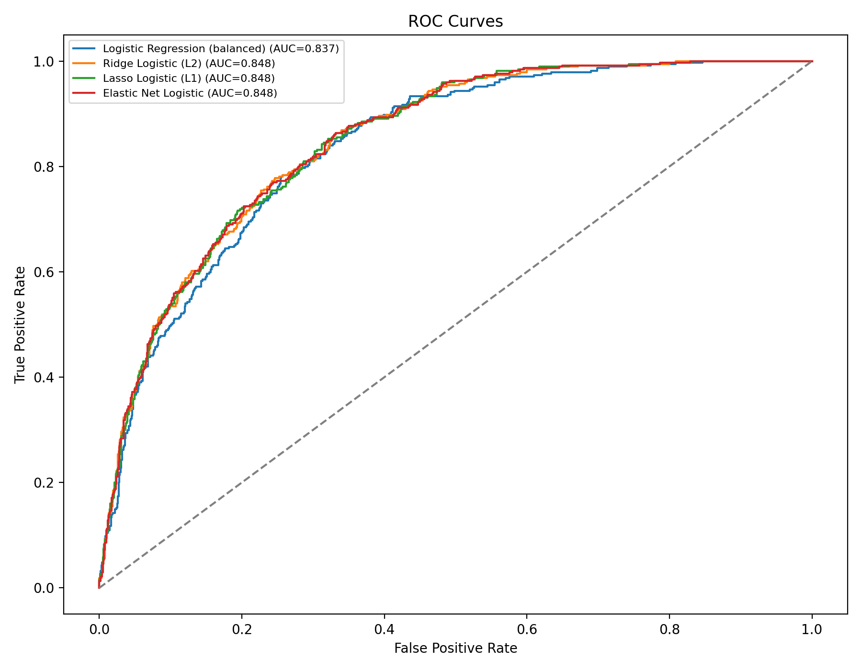
Figure 1. ROC curves for baseline and regularized logistic models.
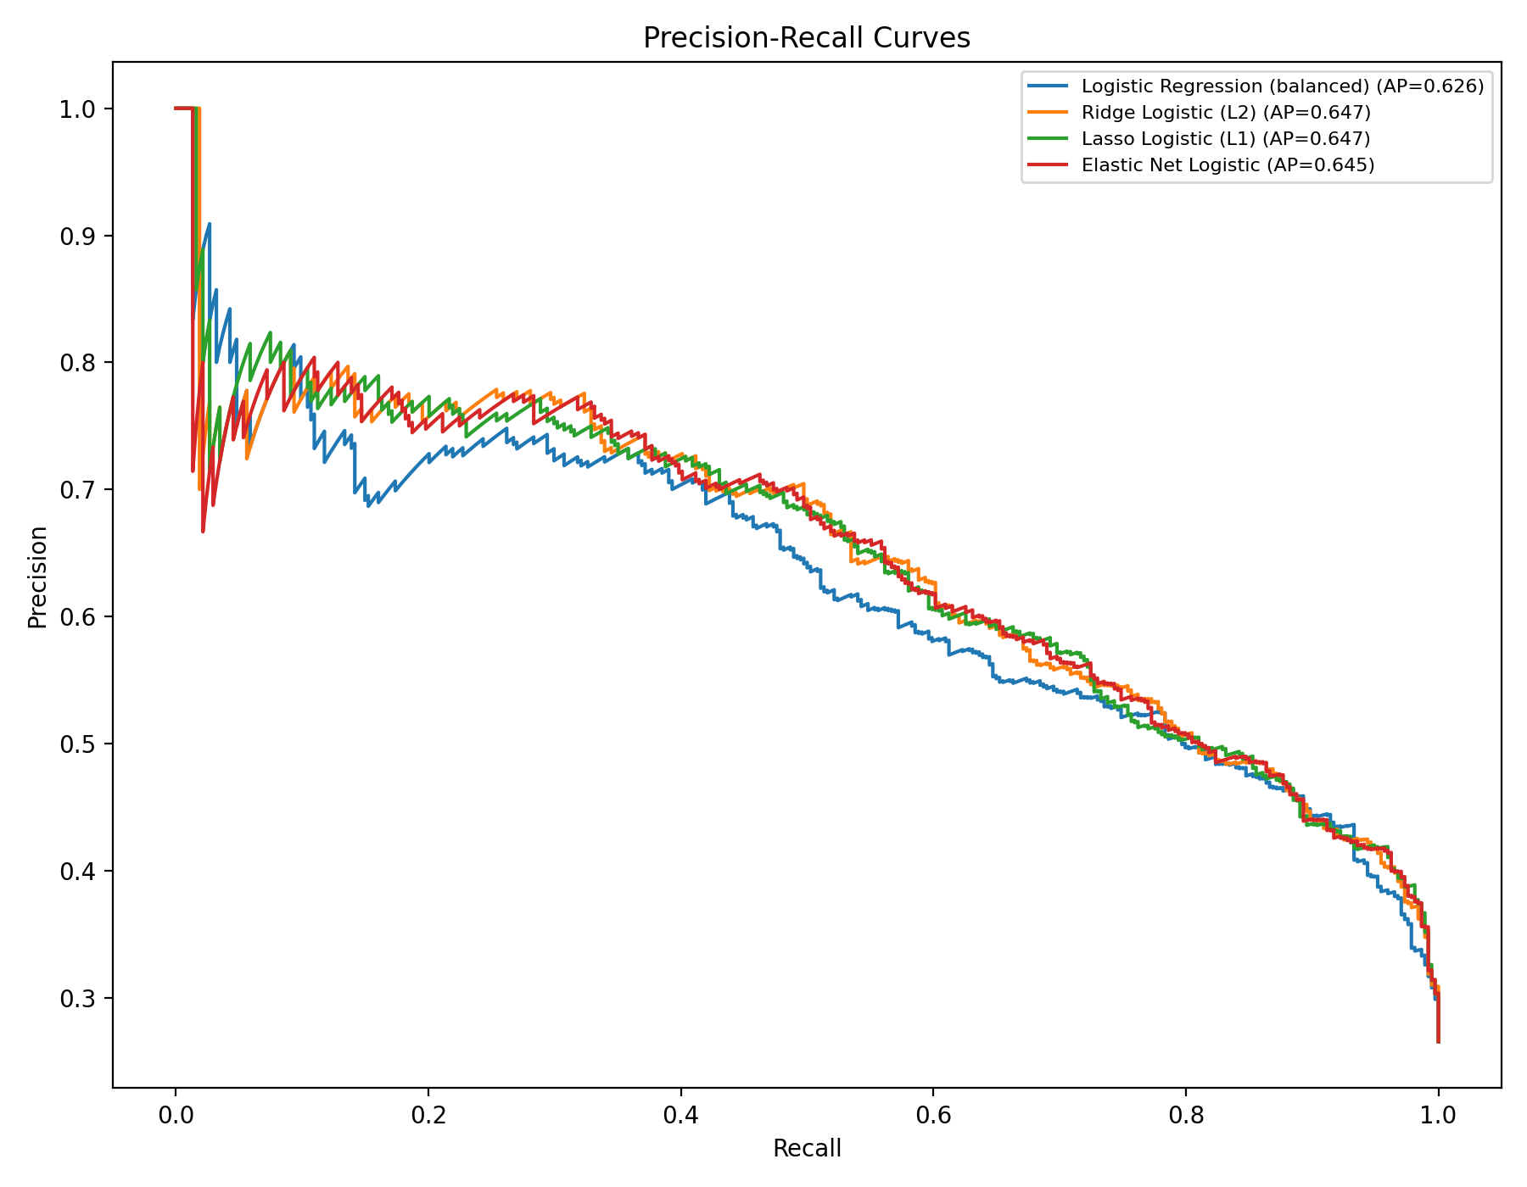
Figure 2. Precision-Recall curves for baseline and regularized logistic models.
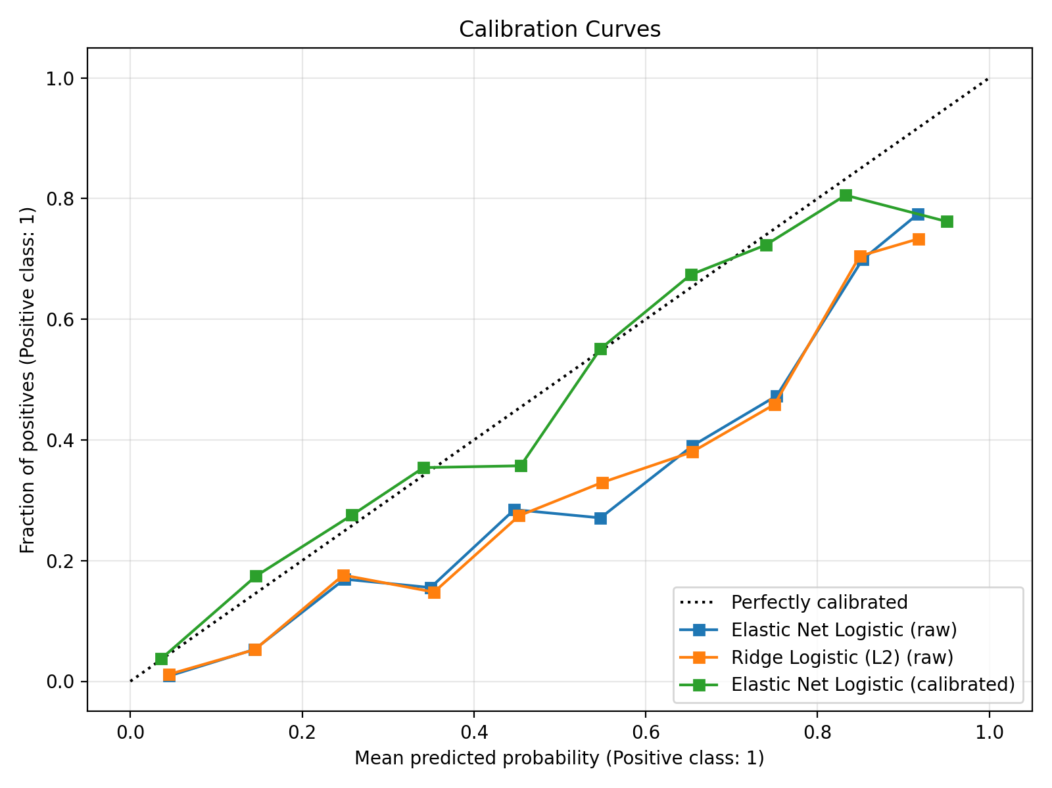
Figure 3. Calibration curves for raw and calibrated top models.
5. SHAP-Based Explainability
Coefficient inspection is useful for global directionality, yet it cannot fully explain non-uniform local feature contributions after preprocessing and regularization interactions. We therefore implemented SHAP LinearExplainer on the calibrated Elastic Net base estimator using transformed training data, then computed test-set SHAP values for global and case-level interpretation.
Global SHAP analysis identified Tenure_Months as the strongest driver with mean absolute SHAP value 0.9162. Dependents_Yes, Contract_Two_year, Internet_Service_Fiber_optic, and Contract_One_year followed, confirming that relationship maturity and contract structure dominate churn propensity. Waterfall decompositions for the three highest-risk customers showed heterogeneous combinations of short tenure, contract type, service mix, and payment behavior, demonstrating why individual intervention narratives are more nuanced than a single coefficient ranking.
SHAP rankings aligned with coefficient-based findings while adding case-specific magnitude and sign context, which improves analyst trust and frontline actionability. In operational settings, this supports transparent customer-contact rationale and improves compliance readiness for model-assisted decision systems.
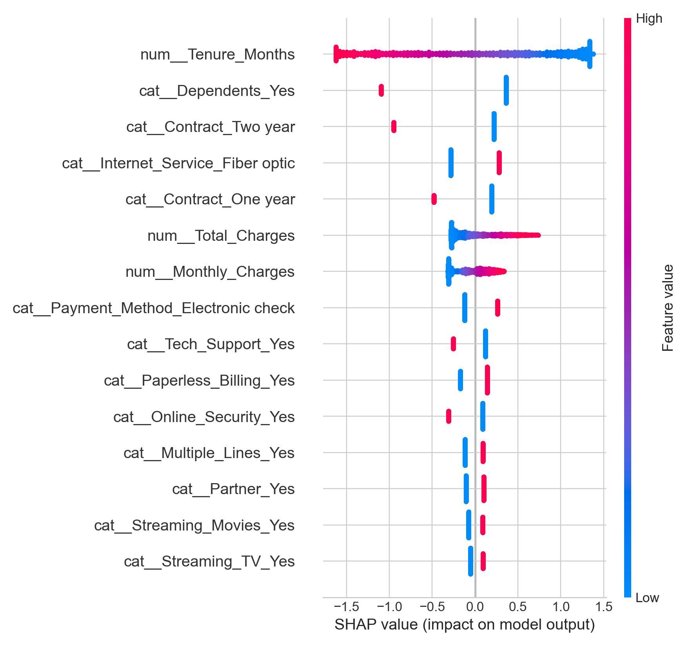
Figure 4. SHAP beeswarm summary plot for top 15 features by mean absolute attribution.
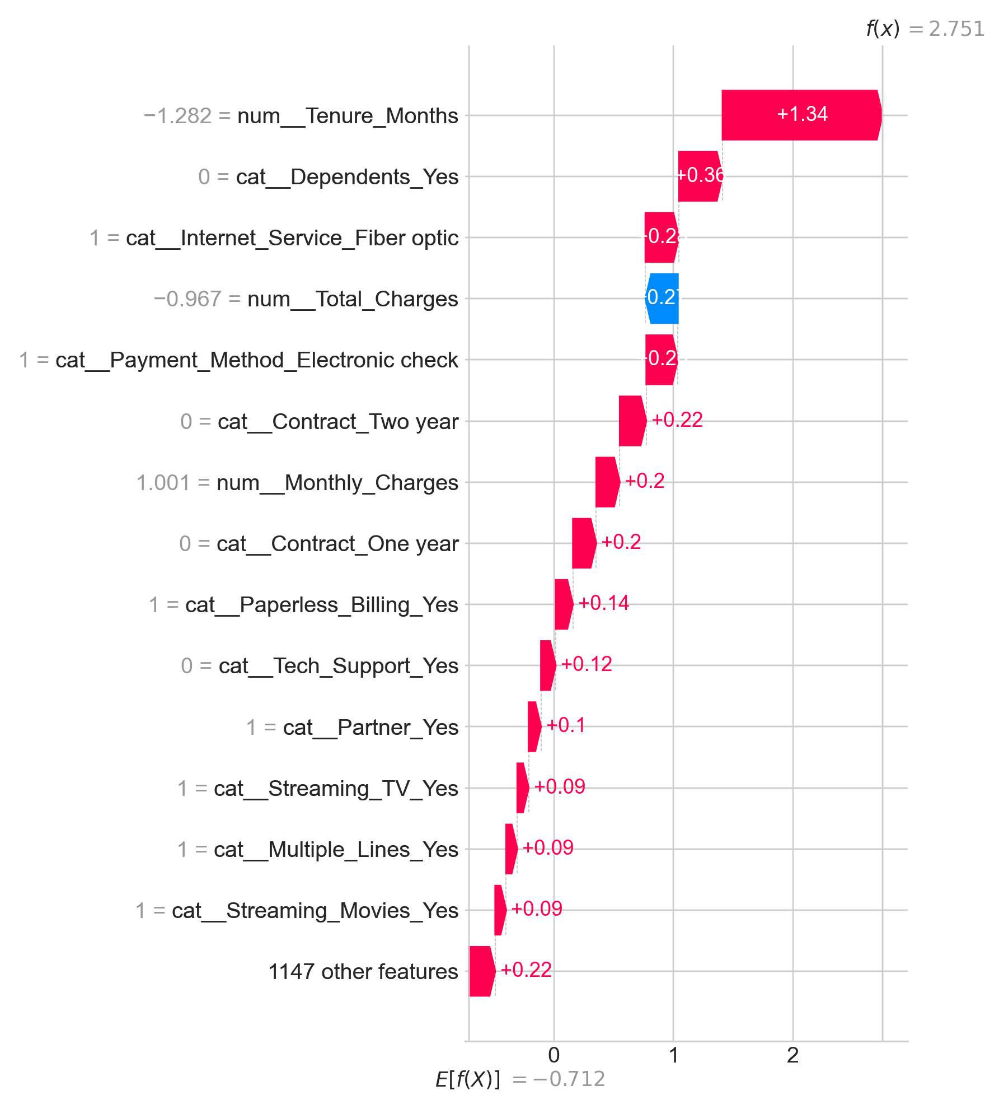
Figure 5. SHAP waterfall plot for the highest-risk test customer.
6. Uplift Modeling
Churn prediction estimates who is likely to leave, whereas uplift modeling estimates who is likely to change outcome under intervention. This distinction matters because retention resources are scarce and some high-risk customers are either inherently retainable or effectively non-responsive.
Because the benchmark dataset does not include treatment logs, we implemented a transparent simulation for method development. We assigned treatment to approximately half of training customers, simulated average churn-risk reduction near 25% with controlled noise, and trained a T-learner using separate treated and control logistic models. We then scored the untouched test set with uplift estimates defined as P(churn|treated) minus P(churn|control), where more negative values imply greater expected treatment benefit.
The resulting segmentation yielded 474 Persuadables, 473 Lost Causes, 231 Sure Things, and 231 Do Not Disturb customers. This distribution shows that risk ranking alone would over-target non-incremental cohorts. The Qini-style cumulative gains curve further indicated stronger incremental benefit when targeting by modeled uplift than random contact policy. Managerially, these results support prioritizing Persuadables and de-prioritizing Sure Things and Do Not Disturb segments when budget-constrained.
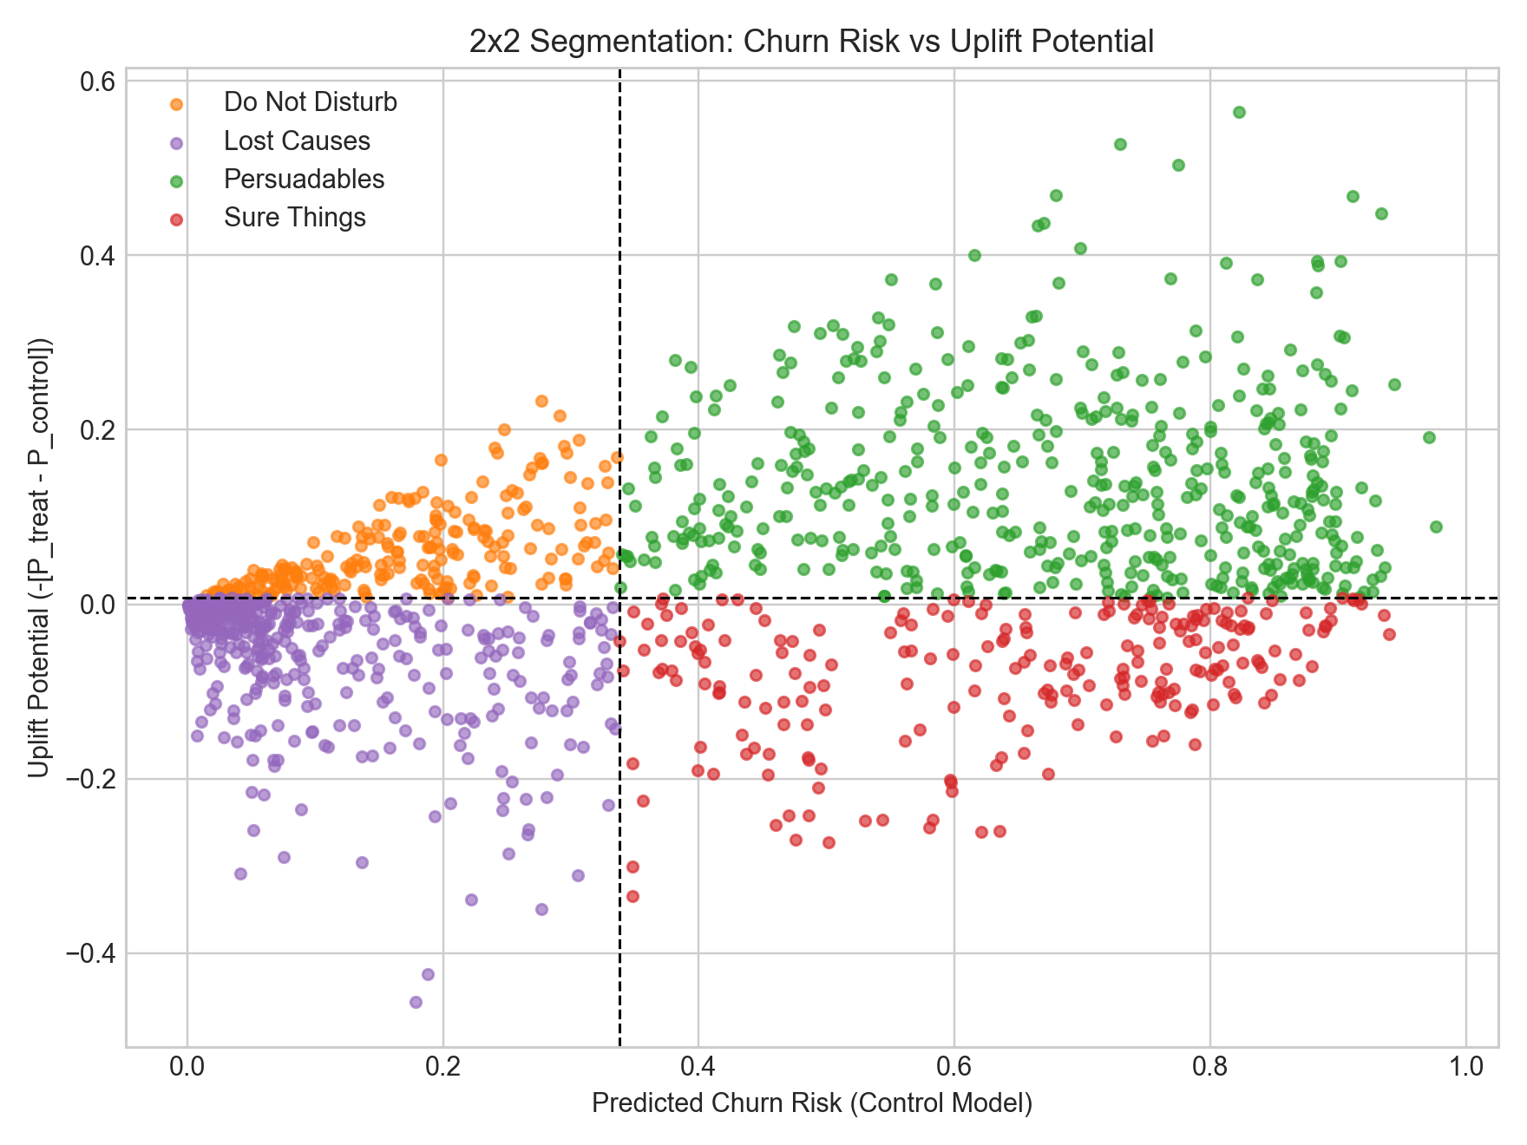
Figure 6. Uplift segmentation map: churn risk by estimated uplift potential.
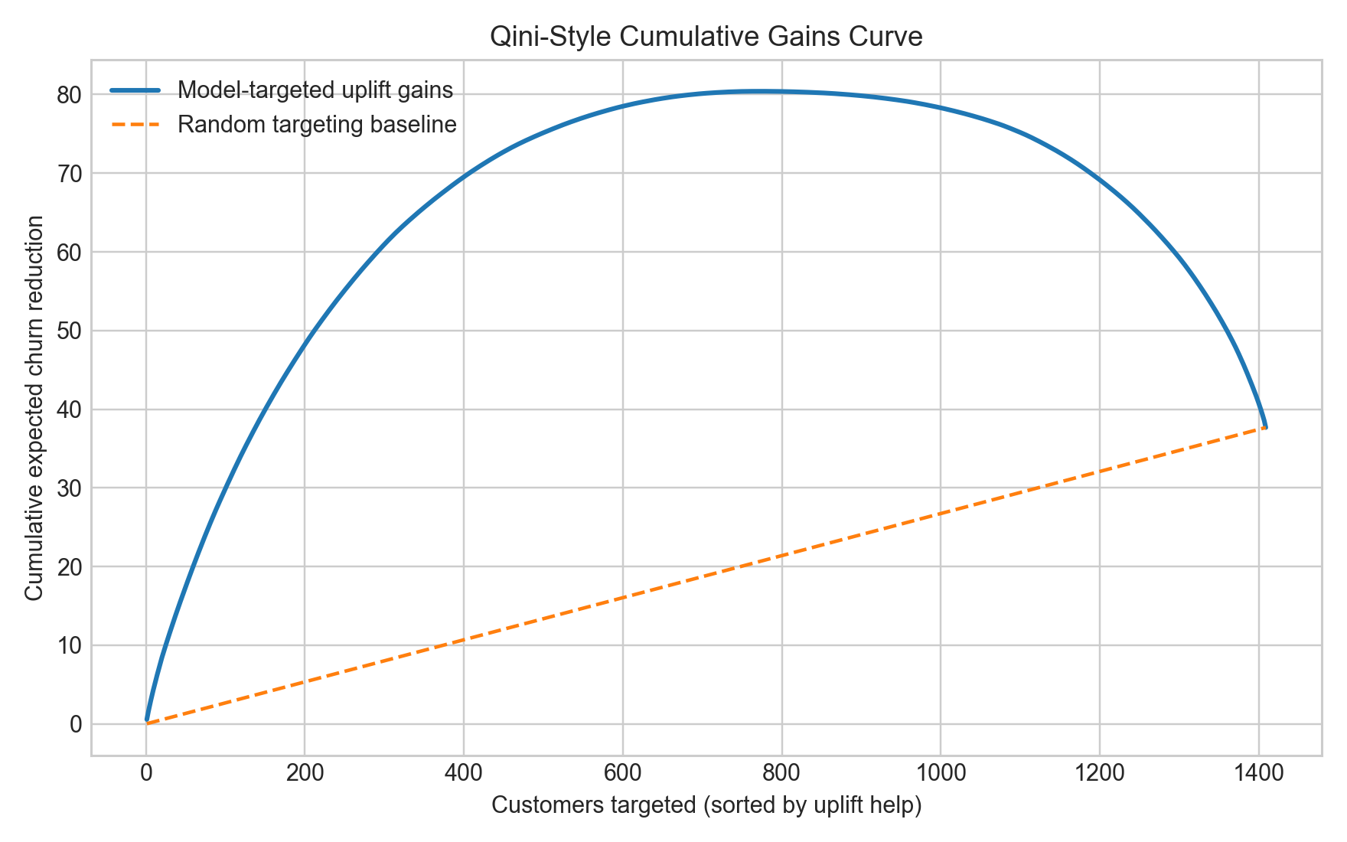
Figure 7. Qini-style cumulative gains curve for uplift-ranked targeting.
7. Survival Analysis
Binary churn classifiers suppress timing information that is central to intervention scheduling. We reframed churn as time-to-event using tenure in months as duration and churn outcome as event indicator, then fitted Kaplan-Meier, Cox proportional hazards, and Weibull AFT models on the training partition.
Kaplan-Meier curves stratified by contract type showed clear separation, with month-to-month customers exhibiting faster survival decline than one-year and two-year cohorts. The Cox model achieved a test concordance index of 0.9028, indicating strong ranking quality for ordering earlier versus later churn events. For the five highest-risk customers from calibrated Elastic Net, predicted median survival ranged from 3.24 to 11.05 months, enabling proactive timing of retention outreach windows.
Temporal risk estimates complement probability scores by answering when intervention should occur, not only whether intervention should occur. This improves campaign cadence design and can reduce both premature and delayed outreach.
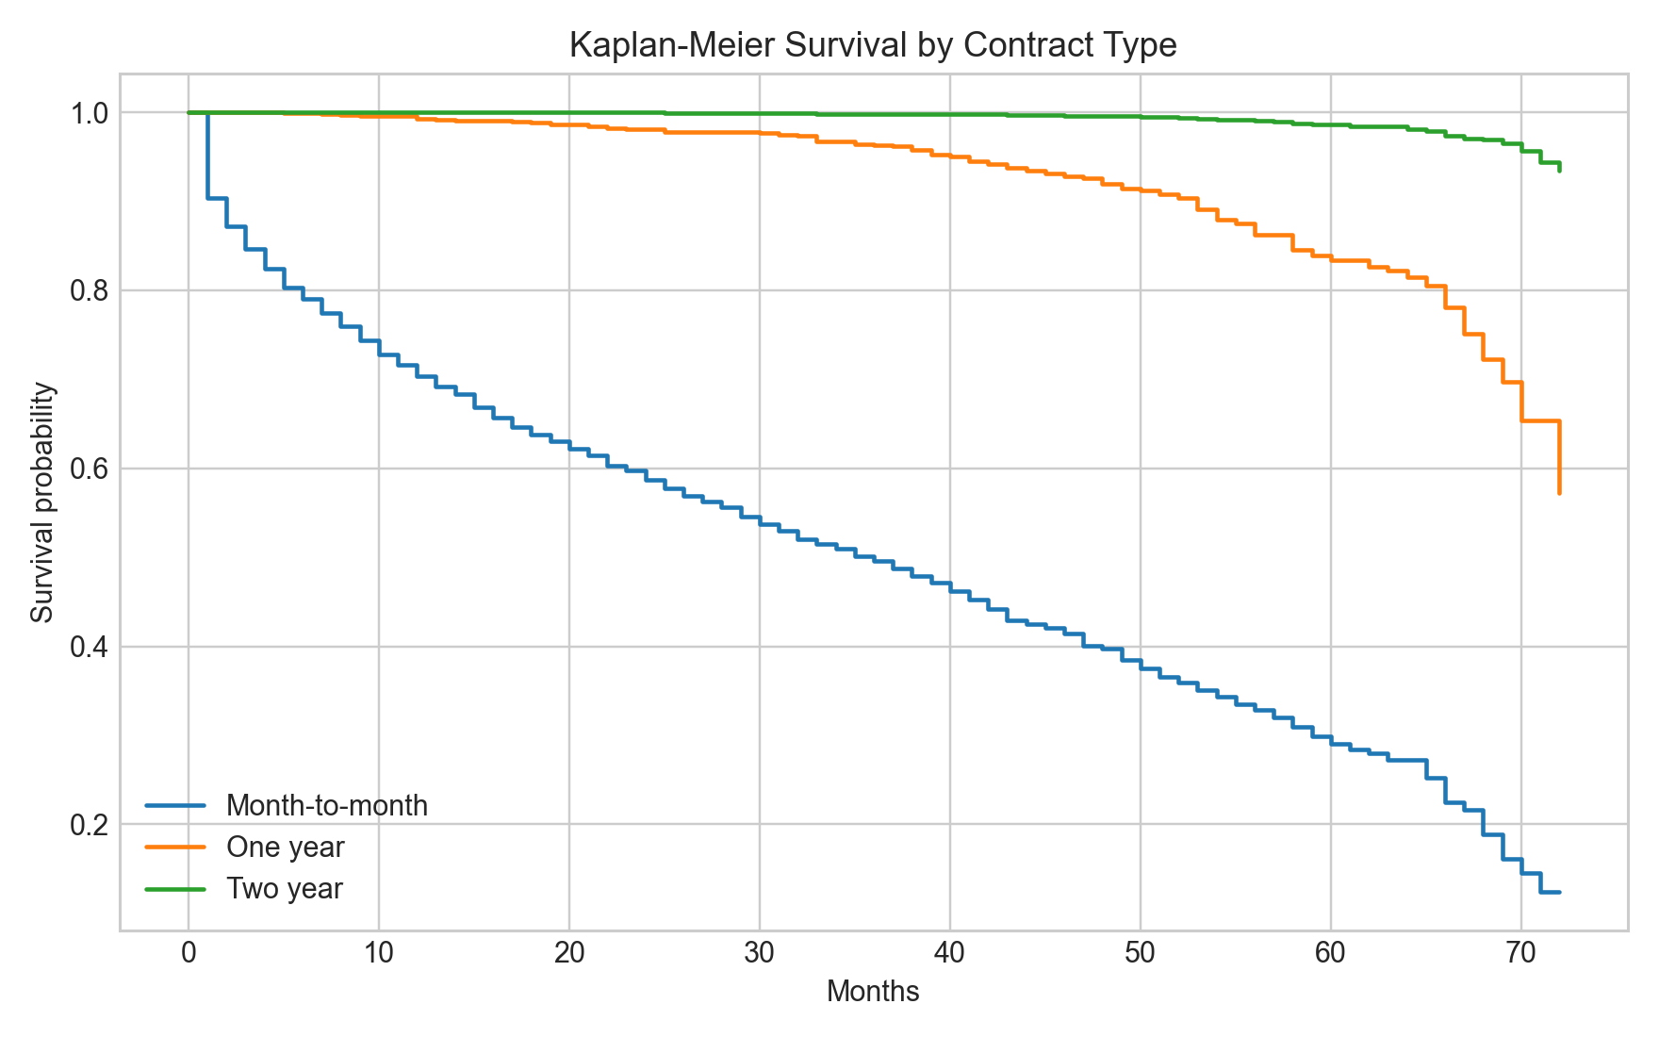
Figure 8. Kaplan-Meier survival curves stratified by contract type.
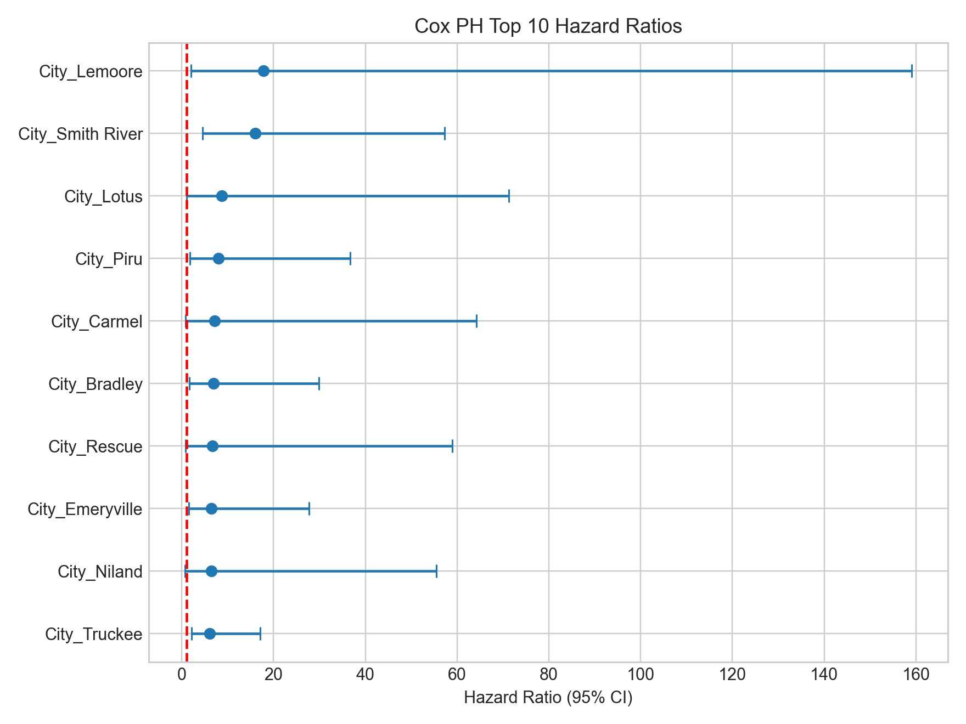
Figure 9. Cox proportional hazards forest plot for top ten covariates.
8. Revenue-at-Risk and ROI Simulation
To align model outputs with business outcomes, we computed customer-level annualized revenue-at-risk as calibrated churn probability multiplied by monthly charges and twelve months. This transformed risk scores into directly interpretable exposure estimates.
At threshold 0.4, total revenue at risk reached $242,525.92 in the held-out test set. We then simulated campaign economics across thresholds from 0.2 to 0.6 with default assumptions of $50 offer cost, 30% retention success among caught churners, $65 monthly revenue, and twelve retained months. All policies produced positive net ROI, with net values from $25,336 to $41,932 and increasing ROI percentage at higher thresholds because contact volume declines faster than expected retained value.
These results suggest policy selection should trade absolute retained revenue against contact intensity and operational capacity. For organizations prioritizing balanced scale and return, thresholds around 0.3 to 0.4 are practical starting points.
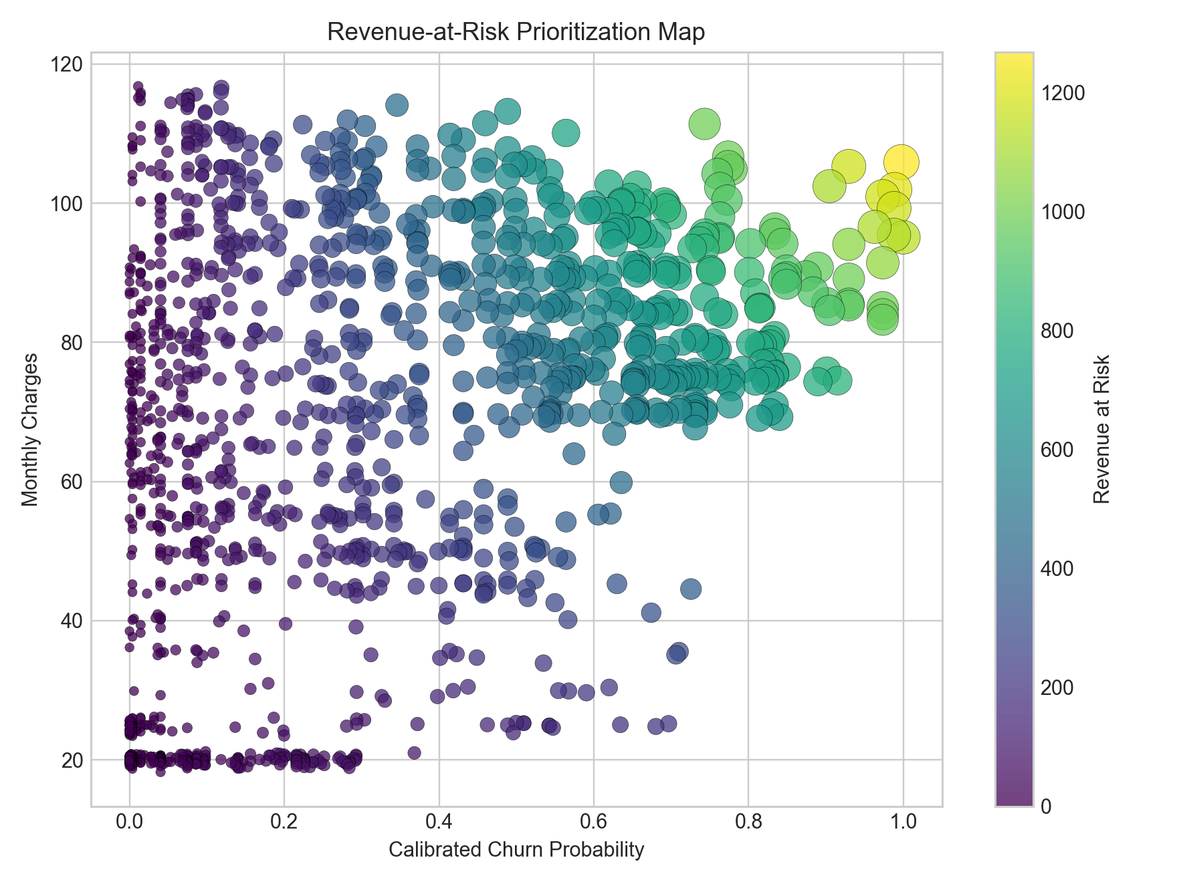
Figure 10. Revenue-at-risk map combining calibrated churn probability and monthly charges.
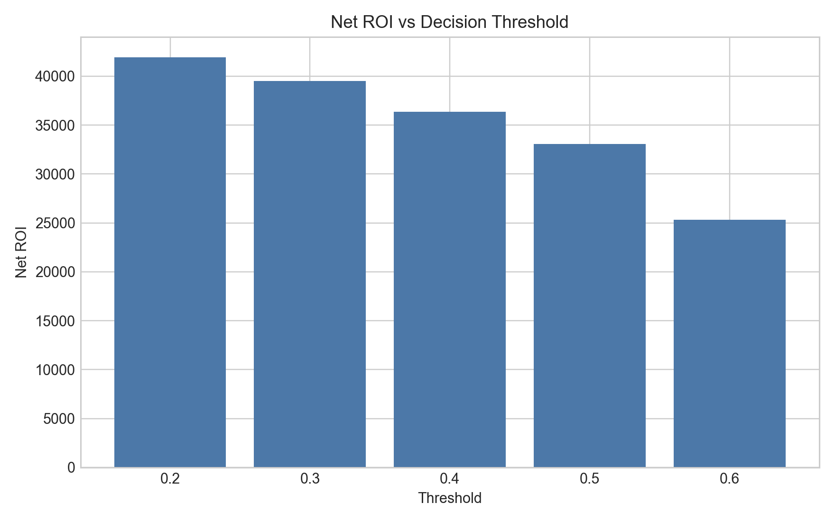
Figure 11. Net ROI under threshold-specific retention policies.
9. Integrated Framework and Business Recommendations
The combined architecture supports an end-to-end retention workflow: score risk with calibrated Elastic Net, explain decisions with SHAP, filter contact candidates by uplift potential, prioritize by revenue-at-risk, and schedule intervention based on survival timing. This sequence links statistical discrimination to intervention incrementality, financial prioritization, and campaign timing.
For deployment, we recommend batch scoring integrated with CRM automation, decision thresholds parameterized by budget, and policy-level monitoring of precision, uplift realization, and realized ROI. Human-in-the-loop review should remain mandatory for high-impact segments, both to audit atypical explanations and to align interventions with regulatory and customer-experience constraints.
10. Limitations
The study uses a benchmark dataset that may not capture provider-specific market dynamics, channel effects, or temporal drift. The uplift component relies on simulated treatment, which is useful for methodological prototyping but does not replace causal identification from real randomized exposure.
Model families are primarily linear in log-odds or semi-parametric hazard form, so nonlinear interactions may remain underrepresented. We also do not perform temporal external validation on a future cohort, which limits inference about post-deployment stability. Finally, causal conclusions about intervention effectiveness remain provisional until tested with controlled experiments.
11. Conclusion
This paper contributes a unified interpretable churn decision framework that combines calibrated regularized logistic prediction, SHAP local-global explanation, uplift-based actionability, survival-based timing, and value-aware economic optimization. The empirical core achieved ROC AUC 0.8484 with calibrated Brier score 0.1361, produced uplift segmentation with 474 Persuadables, reached Cox C-index 0.9028, and identified $242,525.92 in revenue-at-risk at threshold 0.4.
Future work should replace simulated treatment with randomized A/B retention experiments, add drift monitoring and recalibration services, incorporate real intervention cost heterogeneity, and benchmark against non-linear and deep learning alternatives under identical business constraints.
References
Burez, J., & Van den Poel, D. (2009). Handling class imbalance in customer churn prediction. Expert Systems with Applications, 36(3), 4626-4636. https://doi.org/10.1016/j.eswa.2008.05.027
Buckinx, W., & Van den Poel, D. (2005). Customer base analysis: Partial defection of behaviorally loyal clients in a non-contractual FMCG retail setting. European Journal of Operational Research, 164(1), 252-268. https://doi.org/10.1016/j.ejor.2003.12.010
Coussement, K., & Van den Poel, D. (2008). Churn prediction in subscription services: An application of support vector machines while comparing two parameter-selection techniques. Expert Systems with Applications, 34(1), 313-327. https://doi.org/10.1016/j.eswa.2006.09.038
De Caigny, A., Coussement, K., & De Bock, K. W. (2018). A new hybrid classification algorithm for customer churn prediction based on logistic regression and decision trees. European Journal of Operational Research, 269(2), 760-772. https://doi.org/10.1016/j.ejor.2018.02.009
Hosmer, D. W., Lemeshow, S., & Sturdivant, R. X. (2013). Applied logistic regression (3rd ed.). Wiley.
Lundberg, S. M., & Lee, S.-I. (2017). A unified approach to interpreting model predictions. In Advances in Neural Information Processing Systems (pp. 4765-4774).
Radcliffe, N. J., & Surry, P. D. (2011). Real-world uplift modelling with significance-based uplift trees. White paper, Stochastic Solutions.
Rzepakowski, P., & Jaroszewicz, S. (2012). Decision trees for uplift modeling with single and multiple treatments. Knowledge and Information Systems, 32, 303-327. https://doi.org/10.1007/s10115-011-0436-0
Vapnik, V. (1998). Statistical learning theory. Wiley.
Vink, M. A., & Van den Hout, A. (2019). Calibration of risk prediction models in survival analysis. Statistics in Medicine, 38(11), 1969-1982. https://doi.org/10.1002/sim.8083
Verbraken, T., Verbeke, W., & Baesens, B. (2014). A novel profit maximizing metric for measuring classification performance of customer churn prediction models. IEEE Transactions on Knowledge and Data Engineering, 25(5), 961-973. https://doi.org/10.1109/TKDE.2012.50
Witten, I. H., Frank, E., Hall, M. A., & Pal, C. J. (2016). Data mining: Practical machine learning tools and techniques (4th ed.). Morgan Kaufmann.

Appendices
Appendix A. Full Model Comparison Table
Model | CV_ROC_AUC | Test_Accuracy | Test_Precision | Test_Recall | Test_F1 | Test_ROC_AUC | Test_PR_AUC | Brier_Score | Confusion_Matrix | Best_Params
Elastic Net Logistic | 0.8578711385727887 | 0.7459190915542938 | 0.5140845070422535 | 0.7807486631016043 | 0.6199575371549894 | 0.8484460978067117 | 0.6452451440493054 | 0.1641495231722015 | [[759, 276], [82, 292]] | {'model__C': 0.1, 'model__l1_ratio': 0.2}
Ridge Logistic (L2) | 0.857709714962111 | 0.7537260468417317 | 0.5242369838420108 | 0.7807486631016043 | 0.6272824919441461 | 0.8477460022217056 | 0.6465748397992812 | 0.1637024033091375 | [[770, 265], [82, 292]] | {'model__C': 0.1}
Lasso Logistic (L1) | 0.8572134729689423 | 0.7423704755145494 | 0.5095986038394416 | 0.7807486631016043 | 0.6166842661034847 | 0.8476452504585497 | 0.6465527638556547 | 0.1643702995247679 | [[754, 281], [82, 292]] | {'model__C': 0.1}
Logistic Regression (balanced) | 0.8482325476832692 | 0.751596877217885 | 0.522140221402214 | 0.7566844919786097 | 0.6179039301310044 | 0.8366400578676794 | 0.6256507366827931 | 0.1649114092285804 | [[776, 259], [91, 283]] | nan

Appendix B1. Threshold Analysis (Elastic Net)
Model | Threshold | Precision | Recall | F1 | Confusion_Matrix
Elastic Net Logistic | 0.2 | 0.3958560523446019 | 0.9705882352941176 | 0.5623547637490317 | [[481, 554], [11, 363]]
Elastic Net Logistic | 0.3 | 0.4332909783989835 | 0.9117647058823528 | 0.5874246339362619 | [[589, 446], [33, 341]]
Elastic Net Logistic | 0.4 | 0.4751461988304093 | 0.8689839572192514 | 0.6143667296786389 | [[676, 359], [49, 325]]
Elastic Net Logistic | 0.5 | 0.5140845070422535 | 0.7807486631016043 | 0.6199575371549894 | [[759, 276], [82, 292]]
Elastic Net Logistic | 0.6 | 0.5635593220338984 | 0.7112299465240641 | 0.6288416075650118 | [[829, 206], [108, 266]]

Appendix B2. Threshold Analysis (Ridge)
Model | Threshold | Precision | Recall | F1 | Confusion_Matrix
Ridge Logistic (L2) | 0.2 | 0.3978021978021978 | 0.9679144385026738 | 0.5638629283489096 | [[487, 548], [12, 362]]
Ridge Logistic (L2) | 0.3 | 0.4331210191082802 | 0.9090909090909092 | 0.5867126833477135 | [[590, 445], [34, 340]]
Ridge Logistic (L2) | 0.4 | 0.4820895522388059 | 0.8636363636363636 | 0.6187739463601533 | [[688, 347], [51, 323]]
Ridge Logistic (L2) | 0.5 | 0.5242369838420108 | 0.7807486631016043 | 0.6272824919441461 | [[770, 265], [82, 292]]
Ridge Logistic (L2) | 0.6 | 0.5607675906183369 | 0.7032085561497327 | 0.6239620403321471 | [[829, 206], [111, 263]]

Appendix C. Calibration Results
Model | Variant | Brier_Score
Elastic Net Logistic | calibrated | 0.1361364312748304
Ridge Logistic (L2) | raw | 0.1637024033091375
Elastic Net Logistic | raw | 0.1641495231722015

Appendix D. Top 10 SHAP Features
feature | mean_abs_shap | mean_shap | direction
num__Tenure_Months | 0.916173502416431 | 0.0506358388781292 | positive
cat__Dependents_Yes | 0.5326855146045428 | 0.027138272214205 | positive
cat__Contract_Two year | 0.3946270397641794 | -0.0566121474392275 | negative
cat__Internet_Service_Fiber optic | 0.2816126089760654 | -0.0365756617761685 | negative
cat__Contract_One year | 0.2556497167658448 | 0.0519371424738393 | positive
num__Total_Charges | 0.2254997895059425 | -0.0177130758434849 | negative
num__Monthly_Charges | 0.1729412324671164 | -0.0113469739925317 | negative
cat__Payment_Method_Electronic check | 0.1675832051143061 | 0.0101080725913072 | positive
cat__Tech_Support_Yes | 0.159476413338985 | 0.0186202623881204 | positive
cat__Paperless_Billing_Yes | 0.1540389104326015 | 0.0175743727065647 | positive

Appendix E. Uplift Segment Counts
segment | count
Persuadables | 474
Lost Causes | 473
Sure Things | 231
Do Not Disturb | 231

Appendix F. Cox Hazard Ratios
feature | coef | exp(coef) | exp(coef) lower 95% | exp(coef) upper 95% | p
City_Lemoore | 2.878983144982441 | 17.796167853351335 | 1.991171037334756 | 159.0539357626319 | 0.0099872416316713
City_Smith River | 2.7756049615413487 | 16.048332683652056 | 4.501355343748538 | 57.21587438833453 | 1.8739820363906124e-05
City_Lotus | 2.1657779473603296 | 8.72138405614041 | 1.066949620512757 | 71.28972014456112 | 0.0433400133585064
City_Piru | 2.0811977579973564 | 8.014062074948606 | 1.7479556839776635 | 36.743031605342615 | 0.0073896985855041
City_Carmel | 1.9723303660347336 | 7.187406274973309 | 0.8048094695048768 | 64.1876256666146 | 0.0774667791892512
City_Bradley | 1.932738511448934 | 6.908403101604988 | 1.5974703446446643 | 29.87600588283936 | 0.0096832985568265
City_Rescue | 1.9018247623595204 | 6.698105748775103 | 0.761331562447618 | 58.92914839565832 | 0.0864952821697951
City_Emeryville | 1.854404774488186 | 6.387894880801979 | 1.4695939629818435 | 27.76630963111834 | 0.0133807100556466
City_Niland | 1.8540408122070455 | 6.385570351055713 | 0.7353059673751304 | 55.453798170359974 | 0.0927309350479515
City_Truckee | 1.8036245450774704 | 6.071614470503438 | 2.15292456775137 | 17.122988343678948 | 0.0006506400563781

Appendix G. ROI Simulation Grid
threshold | n_targeted | n_true_churners_caught | n_saved | revenue_saved | total_offer_cost | net_roi | roi_percent
0.2 | 673.0 | 323.0 | 96.9 | 75581.99999999999 | 33650.0 | 41931.999999999985 | 124.61218424962848
0.3 | 506.0 | 277.0 | 83.1 | 64818.0 | 25300.0 | 39518.0 | 156.19762845849803
0.4 | 410.0 | 243.0 | 72.89999999999999 | 56861.999999999985 | 20500.0 | 36361.999999999985 | 177.3756097560975
0.5 | 312.0 | 208.0 | 62.4 | 48672.0 | 15600.0 | 33072.0 | 212.0
0.6 | 214.0 | 154.0 | 46.2 | 36035.99999999999 | 10700.0 | 25335.999999999993 | 236.7850467289719

