# MATCH BETWEEN SYSTEM & REAL WORLD:

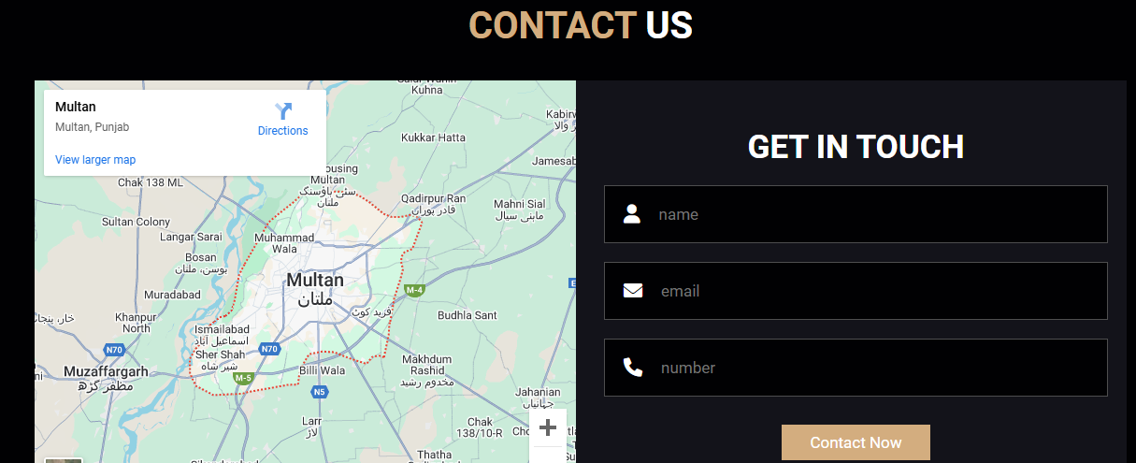

# ERROR PREVENTION:

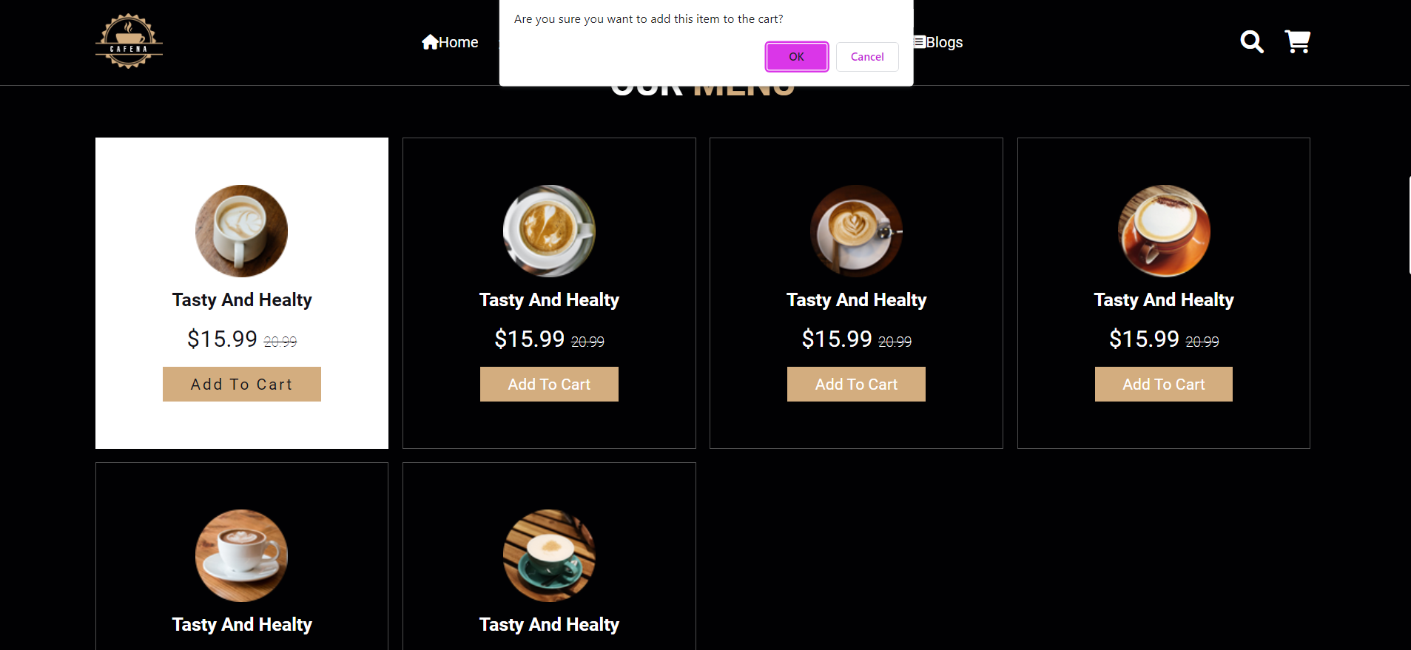

# CONSISTENCY & STANDARDS:

* All pages have the same color.
* All pages have same font size and style.
* All forms have same style.

# FLEXIBILITY & EFFICIENCY OF SYSTEM:

To improve the flexibility of a website, consider factors such as the ability to adapt to different devices and screen sizes.

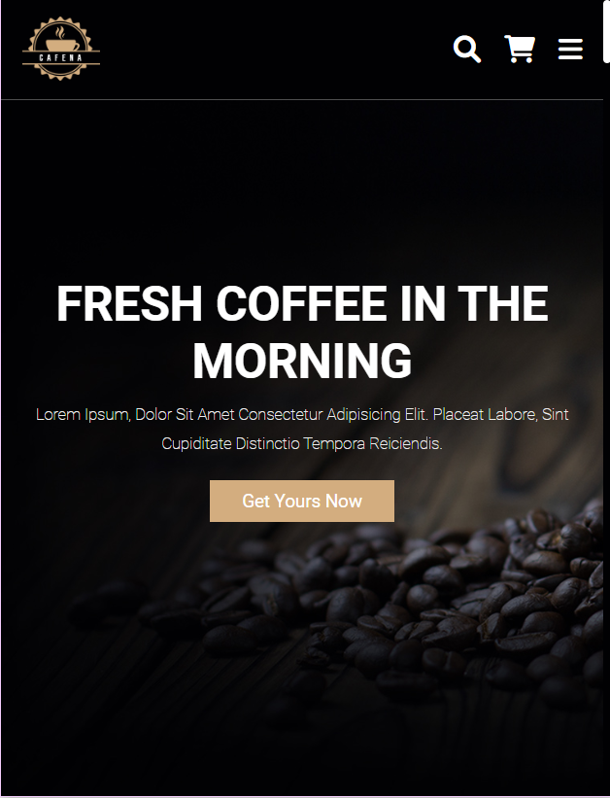

# USEABILITY & EFFECTIVENESS:

* How easy it is for users to navigate and use a website. A website that is usable is easy to learn, efficient to use, and pleasant to interact with.
* Our website is effective that can meet the needs of its users and help them accomplish their goals.

