EXECUTIVE SUMMARY
The term “vote” refers to choose & elect the desired candidate for voting. Electronic Voting System is a web-based voting system, that allows the voters from across the country to cast their respective votes online. The main advantage of this system is the accessibility and security. In countries like Pakistan, the inaccurate and unsecure report makes the whole system corrupt. So, a secure and an effective electronic voting system brings the accuracy in the system. There won’t be any corruption and dishonest result system anymore.

To prevent the voting from corruption and inaccurate vote counting, electronic voting system is developed and provides the safety &user-friendly interfaces to vote for all age groups.

We’ve designed this system at district level, where security is kept concerned. Voter registers into the system with unique CNIC, and votes along with unique Voter_ID provided by the Election Commission. E. Commission shows a good involvement throughout the process. The admin and Election Commission manages the whole voting process and publish the result after valid approvals.

ABBREVIATIONS
EVS | Electronic Voting System
E.C | Election Commission
OTP | One-time Password
P_id | Personal Identity

TABLE OF CONTENTS
1. Introduction 6
1.1. Relevance to Course Modules 6
1.2. Project Background 6
1.3. Literature Review 7
1.4. Methodology and Software Lifecycle for This Project 8
2. Problem Definition 9
2.1. Problem Statement 9
2.2. Deliverables and Development Requirements 9
Deliverables and development requirements. 10
2.3. Activity Plan 11
2.3.1. Work Breakdown Structure (WBS) 12
3. Requirement Analysis 14
3.1. Functional Requirements 14
3.2. Non-Functional Requirements 14
3.3. Use Cases Diagram(s) 15
3.4. Fully dressed and Detailed Use Case 16
4. System Design 17
4.1. Entity Relationship Diagram 17
4.2. Data Flow Diagram 18
4.3. Sequence Diagram 23
4.4 Activity Diagram.…………………………………………………………………………24
4.5 Class Diagram.……..…………………………………………………………….………25
5. Prototyping…….. 26
5.1. User Interface 26
6. Testing and Evaluation 33
6.1. Test Case Scenarios and Test Cases 33
7. Conclusion and Future Work 37
1.1. Conclusion 37
1.2. Future Work 37
8. References 38
9. Appendices 38

LIST OF FIGURES

Fig 1. WBS 12
Fig 2. Gannt Chart 13
Fig 3. Use Case Diagram 15
Fig 4. Entity Relation Diagram 18
Fig 5. Data Flow Diagram (LVL 0) 19
Fig 6. Data Flow Diagram (LVL 1) 20
Fig 7. Data Flow Diagram (LVL 2.2) 21
Fig 8. Data Flow Diagram (LVL 2.3) 22
Fig 9. Sequence Diagram 23
Fig 10. Activity Diagram 24
Fig 11. Class Diagram 25
Fig 12. Inteface Firat page 26
Fig 13. Interface Registration 27
Fig 14. Interface Login 28
Fig 15. Interface Personal Data 29
Fig 16. Interface Election Type 30
Fig 17. Interface Attention 31
Fig 18. Interface Cast Vote 32
Fig 19. Interface About 32

LIST OF TABLES

Table 1. Fully Dressed Use Case 01 16
Table 2. Fully Dressed Use Case 02 16
Table 3. Fully Dressed Use Case 03 16
Table 4. Test Case Scenarios 34
Table 5. Test Case Scenario 01 34
Table 6. Test Case Scenario 02 34
Table 7. Test Case Scenario 03 35
Table 8. Test Case Scenario 04 36

- Introduction

The electronic voting system project was aimed at creating a secure and reliable system for conducting electronic voting. The tools used in the project included programming languages such as Java and C++, The methodology used was V-model, which allowed a flexible and preferable approach to the project.

Highlights of the discussions during the project included the importance of ensuring the security and accuracy of the voting process, as well as the need to comply with relevant laws and regulations regarding electronic voting systems. Additionally, the team discussed the importance of usability and accessibility for the system to be effective.
  - Relevance to Course Modules

The relevance of an electronic voting system project to course modules varies depending on the specific course and program. However, some common course modules that are relevant to our electronic voting system project include:
Computer science and programming: The electronic voting system project likely involve the use of programming languages, frameworks, and tools to develop the system.
Software engineering: The electronic voting system project likely involve the use of software development methodologies and testing and validation to ensure the robustness and reliability of the system.
Human-computer interaction: The electronic voting system project would likely involve the design and development of a user-friendly interface for the system, which is important to ensure the usability and accessibility for the voters.
Overall, the electronic voting system project likely involve the application of various concepts and techniques from different course modules.
  - Project Background

E-voting is a forward-thinking field of study that is constantly updated with new methodology, capabilities, and approaches. Different voting machines, such as electronic ballot printers, VVPAT machines, and internet applications, can be used for online voting.
When punch card systems were originally launched in the 1960s, it was the first time it was used. E-voting in advance is used in numerous nations, including the United States, United Kingdom, and UAE. Numerous nations, including Pakistan, are exploring and may soon use electronic voting to improve many facets of the electoral process.
1.2.1 The Road to Electronic Voting Machines
ECP asked interested vendors to manufacture the EVM according to certain approved specifications. Other interested parties such as academic institutions (COMSATS) and vendors (TIP, KRL, NIE, Smartmatic, and Indra) were also invited to demonstrate their models of EVMs. In 2012, the EVM presented by COMSATS was given a field test in a few polling stations in by-elections in Multan (Jafri, 2012).
After further years of delay and work on the project, the elections had a very low overseas voter turnout of around 1% with only 7,538 votes cast in both the bye-elections. This deployment cost approximately Rs. 95 million. (Election Commission of Pakistan, 2018). EVMs pilot project report was presented in the National Assembly (NA) and Senate in January 2019. Their discussion in parliament however remained pending for 2 years. In 2021, directed by the PM, the Ministry of IT (MoIT) hired Miniates consultant to audit the Internet voting system. The Spanish firm reiterated IVTFs concerns and said the internet 10 voting system does not meet international standards and the recommendations of the IVTF have not been incorporated in any manner (Minsait, 2021).
  - Literature Review

Although the literature study includes a wide range of ideas and investigations, many theories and research have been offered to explain the effective working of different E-voting systems. These assessments will concentrate on important themes that arose periodically during the counting and electronic voting projects' implementation. These themes are making a choice, creating a system, and putting a system in place.
E-voting systems are a busy field of study, with a new methodology, capabilities, and approaches being added year after year. Engineers and researchers who have worked in the field of electronic voting have stated that these systems do not meet the standards of public elections, that there are still some security issues, and that the present sophisticated technologies of these systems need to be improved.

  - Methodology and Software Lifecycle for This Project

The methodology used for E-voting system is “V-Model”. The numerous testing levels of V-model, makes it best for our respective project. Furthermore, this SDLC model is easiest to understand and implement. Phases like like planning, and test designing happens well before coding, which genuinely saves a lot of time.
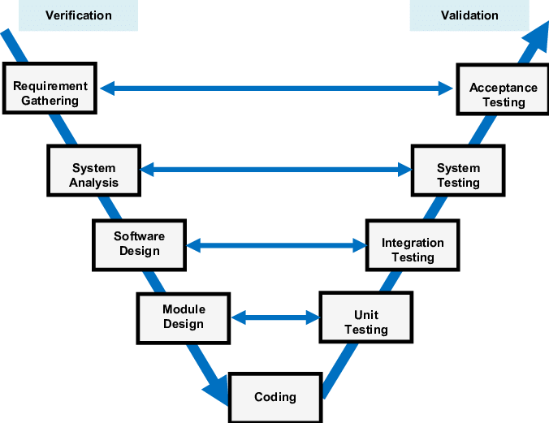

V-model uses sequential phases paired with validation tests that allow the team to set clear expectations and identify potential flaws throughout the process without needing a final build first. V-model means Verification and Validation. Verification activities confirm that the product is built to the stated (documented) specifications and validation confirms that the product actually meets the customer's needs. To put it simply, verification ensures the product is built right and validation ensures the right product is built.

- Problem Definition
This section discusses the Serious electoral fraud, corruption, and unfair practices that bring the reliability of the electoral process into question. This project is based on ensuring that electoral system should be fair enough.

  - Problem Statement
Corruption (while wrong counting and wrong data collection) is the major issue in the on-site voting and accessibility can be another one. In case if members of an organization are spread out across the country. Many voters might not be able to come in a centralized location and cast their votes, and it may prove difficult and costly to set up polling spaces in various states or counties.
Paper ballots and old-fashioned voting will be but a memory. E-Voting machines will display ballots on flat panel displays, and voting will be a simple matter of touching the screen to pick a candidate. And simply saves your travel time!
So, we decided to put our efforts in making an electronic voting system on a district level. So that, voting become:
- Flexible
- More Efficient
- More accurate
- Extremely fast
- Secure and Corruption free

  - Deliverables and Development Requirements

Development Requirements for an E-Voting System
1. Required Programming Language
It's worth noting that it is a complex task that would require a team of experts with diverse skillsets such as computer scientists, security experts, UI/UX designers and legal experts. The team should also have a good understanding of the specific regulations and laws in the region of the voting.

An electronic voting system can be developed using a variety of programming languages, depending on the specific requirements and constraints of the project. The preferable ones are:
- C/C++: C/C++ is a widely used programming language with a strong emphasis on low-level programming and system-level access. It is often used for developing the back-end components of e-voting systems, such as vote counting and reporting.

- Java: Java is a versatile programming language that can be used for developing both the front-end and back-end of e-voting systems. Its cross-platform compatibility and built-in security features make it a popular choice for developing e-voting systems.

2. Hardware And Software Requirements
The hardware and software requirements for developing an electronic voting system will vary depending on the specific system and its design. However, some general requirements that our electronic voting system would need include:
Hardware:
- Secure servers and storage systems for storing and processing voting data
- Secure network infrastructure for transmitting voting data
- Backup systems for ensuring data integrity and availability

Software:
- Secure operating systems for running the voting system
- Database management systems for storing and processing voting data
- Encryption and security software for protecting voting data
- Voting and ballot management software for creating, distributing, and counting votes
- Voter verification and authentication software for ensuring that only eligible voters can cast their ballots

Deliverables Of Our Project
- Manual Of the System
A manual for an electronic voting system must deliver instructions on how to set up, operate, and maintain the system. It should also include information on how to ensure the security and accuracy of the voting process, as well as troubleshooting guidelines for addressing any issues that may arise during use. Additionally, the manual should provide information on how to dispose of the system properly and properly after it is no longer in use.

- Final Report Submission
Our report on submitting an electronic voting system provide an overview of the system's performance during the voting process. Also include information on voter turnout, any issues that arose during the voting process, and any steps taken to address those issues.
It also includes information on the security measures implemented to protect the integrity of the vote, such as encryption and voter verification methods.
Overall, the report provides a clear and comprehensive assessment of the electronic voting system's performance, security, and compliance during the voting process.
- Viva (Oral assessment) of Electronic Voting System

  - Activity Plan

An activity is a scheduled phase in a project plan with a distinct beginning and end. Developing an electronic voting system (EVS) is a complex process that involves several stages and activities. Here's the activity planning for EVS:
Planning: Planning includes all the activities required to select a systems analysis team, assign members of the team to appropriate tasks, estimate the time required to complete each task, and schedule the project so that tasks are completed in a timely fashion.
Requirements Gathering: The next step in developing an EVS is to gather requirements from stakeholders, such as voters, election officials, and government officials. This includes identifying the specific needs and requirements of the system, such as security, accessibility, and scalability.
System Design: The next step is to design the system. This includes creating detailed specifications for the system, such as the hardware and software requirements, and the overall architecture of the system.
Testing: It is important to test the system to ensure that it is functioning correctly. We were involved in black box testing and System testing.

    - Work Breakdown Structure (WBS)

A work-breakdown structure in project management and systems engineering is a deliverable-oriented breakdown of a project into smaller components. A work breakdown structure is a key project deliverable that organizes the team's work into manageable sections.

WBS of Our Project

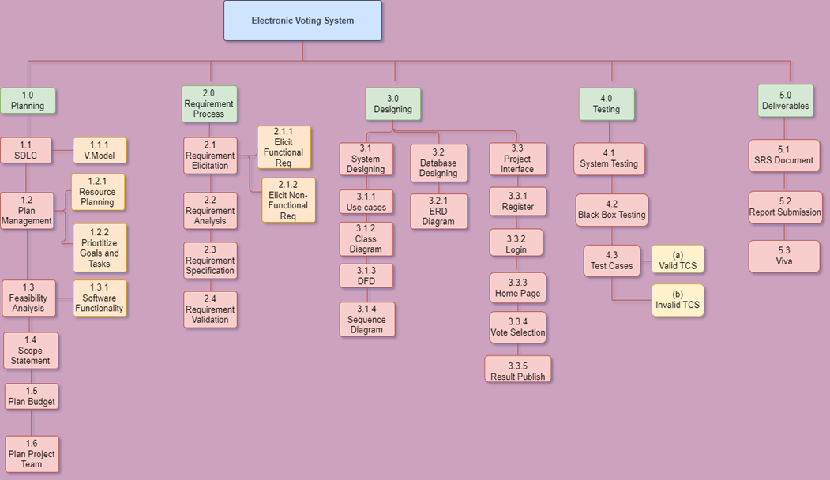Figure:01

- Requirement Analysis

Requirement analysis is the process of determining the needs or requirements of a software project. It is a critical step in the software development process, as it lays the foundation for the design, development, and testing of the system. The goal of requirement analysis is to identify and define the functionality, performance, and constraints of the software system, as well as the stakeholders and their needs.

  - Functional Requirements

- User registration page
The user shall be able to get themselves registered by using a valid CNIC number and OPT
- Contact us page
This will provide the customer to ask for any technical help and comment using given number or email
- Vote Casting
The voter shall be able to vote selected candidate
- Voting Time
The system shall provide information about voting time.
- Publish Result
Election authority will publish the result after voting time

  - Non-Functional Requirements

1. The system shall provide secure access to voter information
2. The system should have capacity run smoothly and shows results after voting time
3. The system shall have more performance-enhancing component design.
4. The system should be accurate, that vote casted by the person should be shown the same.

  - Use Cases Diagram

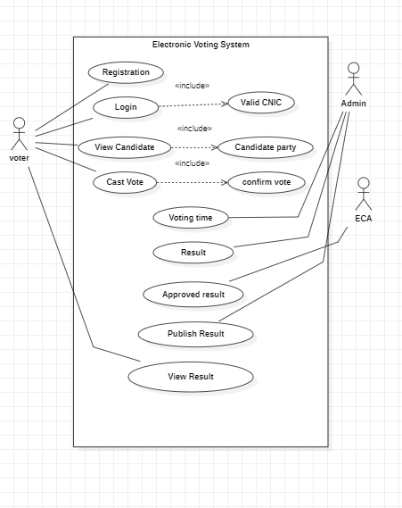
Figure: 03

  - Fully Dressed Use Cases

Fully Dressed Use Case:01
Table :01
use case | Login
Use case id | UC-2
Actors | Registered Voter
Type | Primary actor
Description | The voter has login in system by entering valid CNIC & password
Pre-condition | - The voter has already registered his/her account  - He has stable internet connection
Post-condition | The voter has log into the system
Special requirement | It’s not necessary for the voter to put hyphen while entering CNIC
Flow of events | - The user clicks on the login button on the main page  - The screen will display the login window  - The user will enter his/her CNIC and password  - The user will then press the login button  - This will then open the user’s profile
Alternative flow | When the voter enters the wrong password or CNIC the error message will display while clicking on the login button
Fully Dressed Use Case 02
Use case | Casting vote
Use case id | UC-4
Actors | Voter
Type | Primary actor
Description | The voter can see candidates and select the particular candidate of any party
Pre-condition | The voter must be registered.
Post-condition | The voter has cast the vote
Special requirements | The voter can’t select the multiple candidate
Flow of events | 1. The user will first view the all candidates.  2. Then the user shall select the particular candidate  3.After selection ,voter can confirm the vote.
Alternative flow | In case of any failure try again and if still it is failed then ask admin to check
Table :02
Fully Dressed Use Case 03
Use case | Result
Use case id | UC-7
Actors | Election Commission
Type | Secondary Actor
Description | The voter will be able to see the election result
Pre-condition | Voting time must be completed
Post-condition | Voter can see the result
Special requirements | Voter can see the result ,after login into their profile
Flow of events | 1. The voter must casted the vote  2.Polling time must be completed  3. After login into the profile, Voters can see the result.
Alternative flow | User can’t see the result, after login into the profile
Table: 03

- System Design

This section contains all the designing diagrams of an electronic Voting System.

  - Entity Relationship Diagram

Description
ER Diagram of this online voting system have 4 Entities: Voter, Candidate, Election and Vote. The voter entity has several properties. These are the following attributes: voter name (including father's name ), voter ID, CNIC and DOB and password. Candidate Name includes candidate ID, Candidate name, Candidate Party. Vote includes vote ID, Candidate name, Candidate ID .
- One election is associated with many candidates (one-to-many)
- One Voter can choose one candidate(one-to-one)
- Election have many votes(one -to- many)
- A voter can cast one vote only(one-to-one)
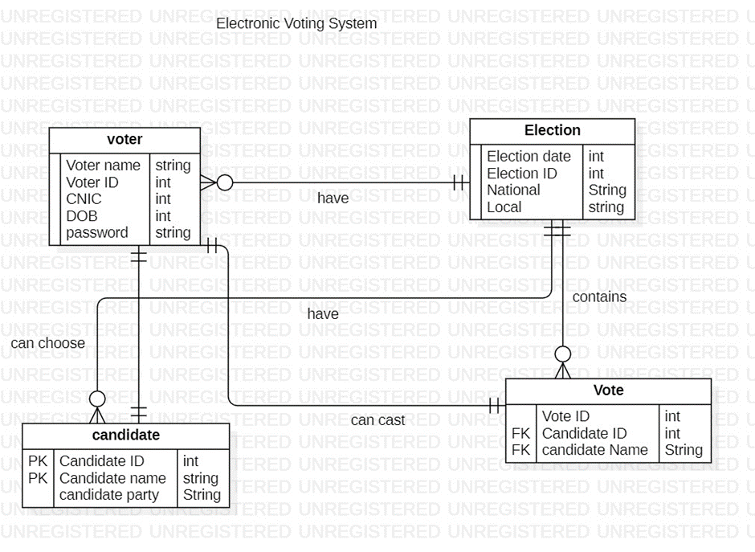Figure: 04

  - Data Flow Diagram

A data flow diagram (DFD) is a graphical or visual representation using a standardized set of symbols and notations to describe a business's operations through data movement.
Description:
Level 0:
DFD Level 0 is also called a Context Diagram. It's a basic overview of the whole system or process being analysed or modelled.
In the level 0 of our project, three external entities are taken all of them are interacting with the system. In such a way that, Voter performs the actions like, registration, login and can cast vote.
The admin is responsible for managing activities including the candidates and the eligibility check of the voter. The Election Commission is involved in the system for managing the voter’s database and also to approve results.

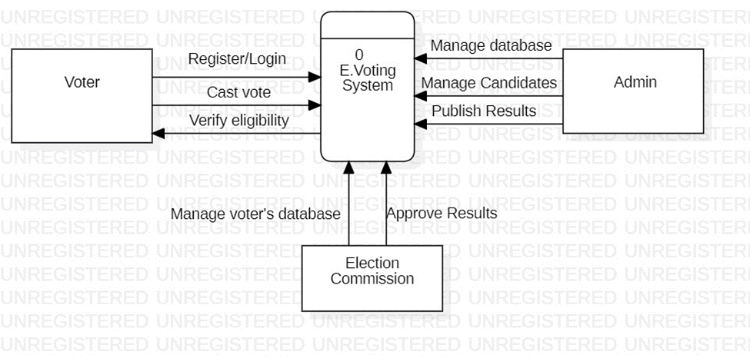
Figure: 05
Level 1 Of DFD
Description:
Along with the three processes, same entities (Voter, Admin, and E.Commission) are used here. In Login process, voter enters the credentials which is checked in the citizen’s database. Voter is registered into the system after entering accurate personal details.
2nd process (Vote Casting) asks the voter to enter voter_id and OTP before casting vote and once this process is done, Admin provides the vote his/her respective constituency, personal details, and allows to vote.
In 3rd Process (Results), Admin send the gathered result to the E.Commission who approves it and orders the admin to publish respective result. The voter is further able to view the result.

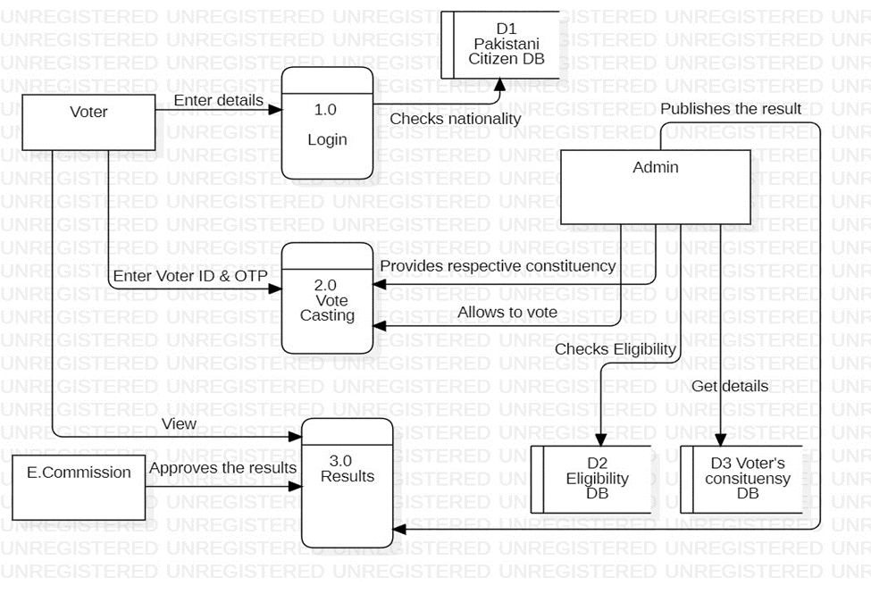Figure: 06
Level 2
Process 02 Vote Casting
Description
Process 2 is all about casting vote, it is divided into further four sub processes, 2.1, 2.2, 2.3, and 2.4.

The admin verifies the eligibility check of the vote before casting vote. And asks for the Voter_Id (provided by the E. Commission) and OTP. After confirmation by the admin, the voting process genuinely starts, the voter selects the candidate to vote and click the confirmation. There can’t be any further changes after clicking the confirmation.
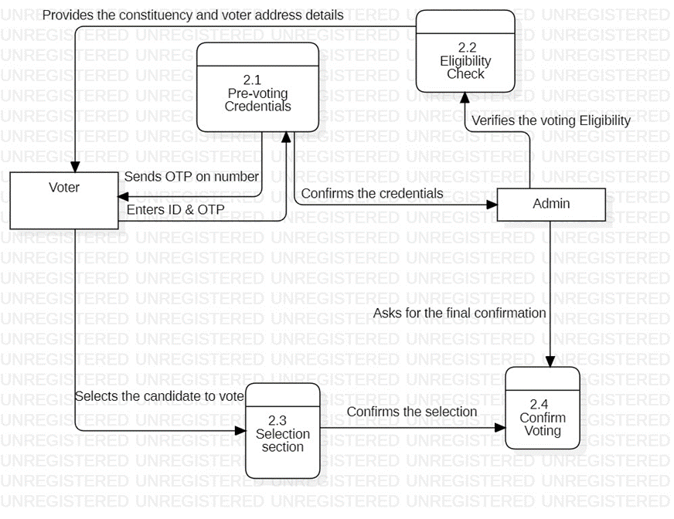Figure: 07
Level 2
Process 3: Results
Description
All three entities are involved in the process 3, its further divided into 3 sub processes. The voter tries to vote, but if the time has closed, he won’t be able to vote anyway. After the completion of voting process, the voter can check the live pool of results until the final result is published.
Final result is published after the approval of E. Commision. It goes through and finalize the whole result then order the admin to publish it on the system.
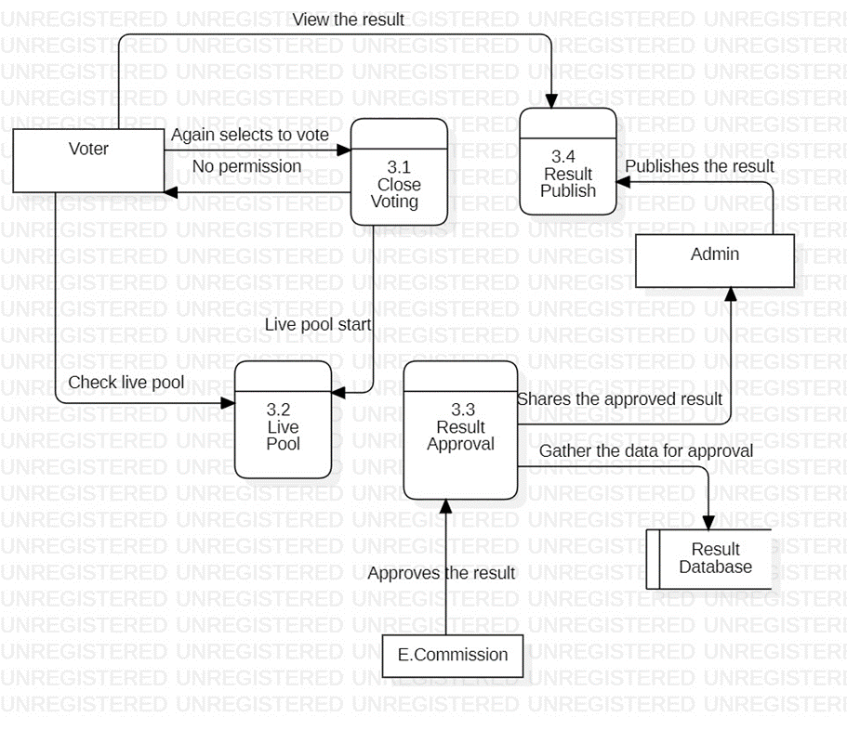
Figure:07

  - Sequence Diagram
A sequence diagram is a Unified Modeling Language (UML) diagram that illustrates the sequence of messages between objects in an interaction. A sequence diagram consists of a group of objects that are represented by lifelines, and the messages that they exchange over time during the interaction.
Description
There are various objects involved in Sequence diagram, their existence is showed by lifeline and activation by activation bar. The actor ( voter ) and other participants interact with each other through sending and returning messages. The voter sends a request for the registration of account on the system. The system verifies the details from database by sending and message. And waits for the response, after the response from the database to the server details are confirmed to the voter.
The alternative box shows the condition of CNIC verification. The E. Commission send a unique voter id to the voter before casting vote. Voter enters OTP & Id to start voting. The voter selects the candidate to vote and confirms to the system. Again, an alternative box includes the condition to asks for the confirmation. The system server sends the gathered results to E. Commission and asks for the approval. After the wait, E. Commission provides the result and sends to the system to publish it.
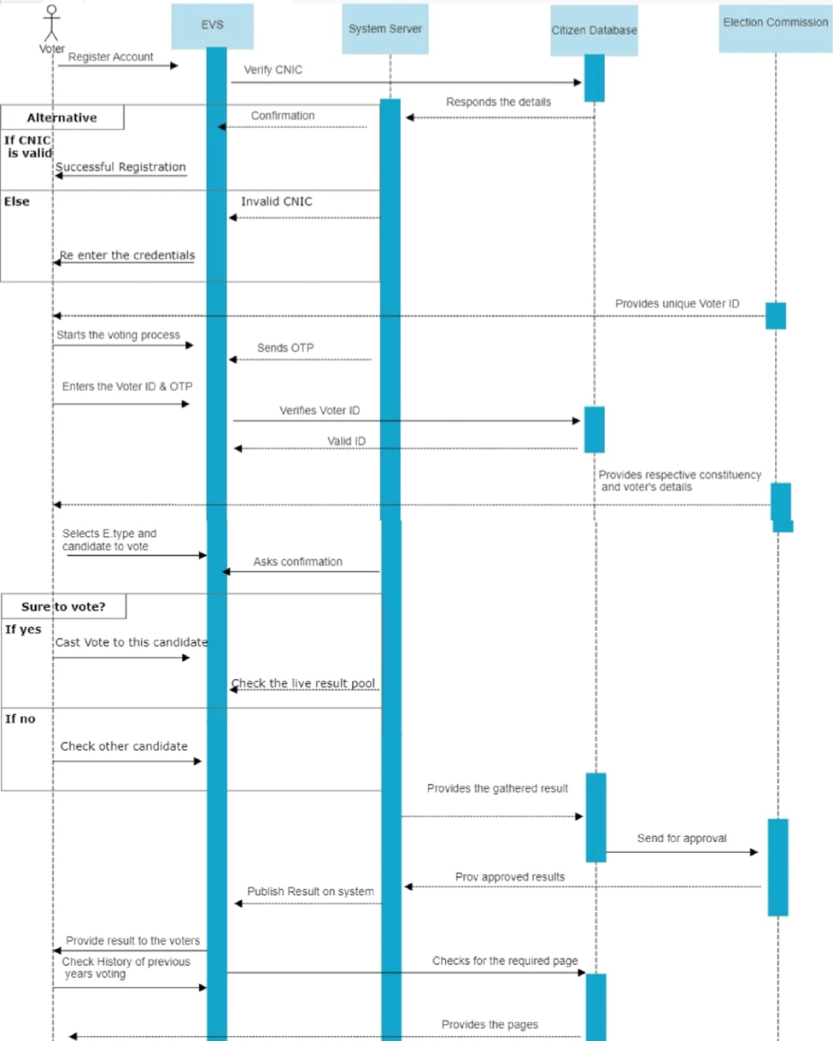Figure: 09

  - Activity Diagram
In UML, an activity diagram provides a view of the behaviour of a system by describing the sequence of actions in a process.
Description:
The initial node in this diagram indicates the start of actions, Login is the first action performed by the voter, in which he/she is required to enter credentials. Here’s a decision shows whether the information is valid or invalid. Then control flows to election selection & candidate to vote. The voter has to put OTP before casting vote. Incase of invalid OTP he is required to renter. And that’s how vote casting action is performed, and process comes to an end
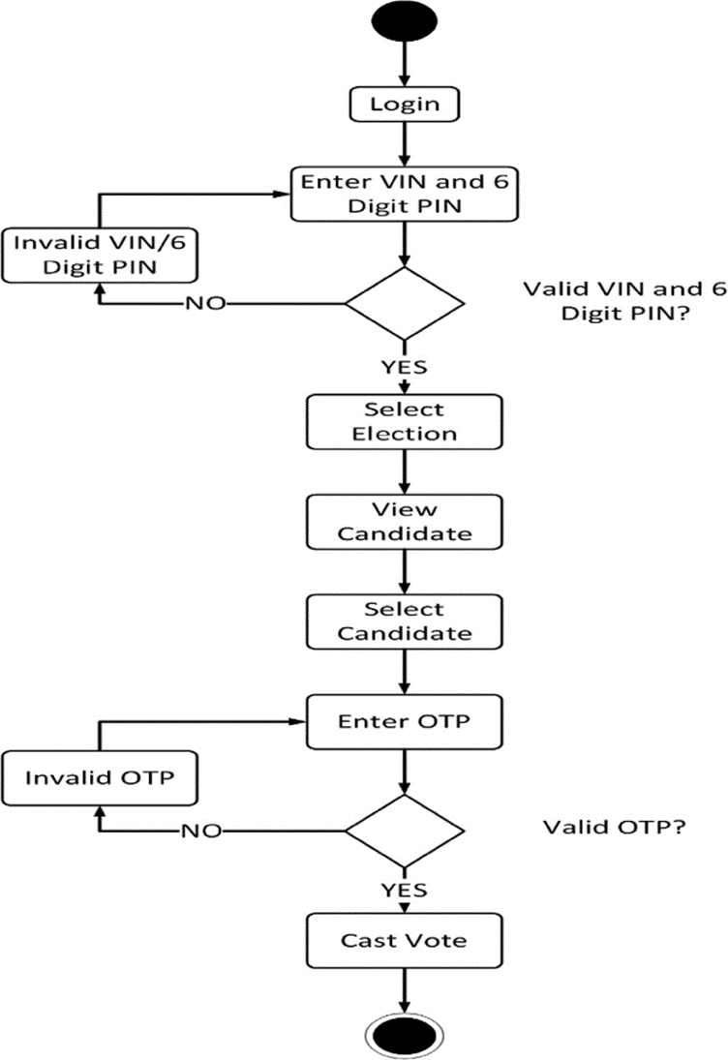

  - Class Diagram

A class diagram is an illustration of the relationships and source code dependencies among classes in the Unified Modeling Language (UML).

Description

This diagram shows illustration of relationships and source code dependencies among class. There is a voter class having attributes like name, CNIC no., and other details and functions like check eligibility, cast vote and view results with which cast class have composition relation which means cast class is dependent on voter class. While the candidate class has simple association with cast class. Voting class having functions send reports and count votes is compositely associated with cast class which has submit vote and cancel vote functions. Candidate can exist independently without admin, so it has aggregation association with admin class. While result class has aggregation relation with admin and composition relation with voting class. Similarly, ECA class has functions like make reports, publish reports and results and has composition association with results class.

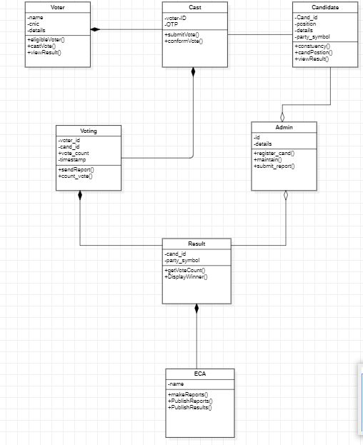
- Prototyping

In software development, a prototype is a rudimentary working model of a product or information system, usually built for demonstration purposes or as part of the development process.

  - User Interfaces Of Our Project
Here are the interfaces of an electronic voting system. The link is also provided at the end.

Interface First Page

This Page contains the starting interface of electronic voting system.

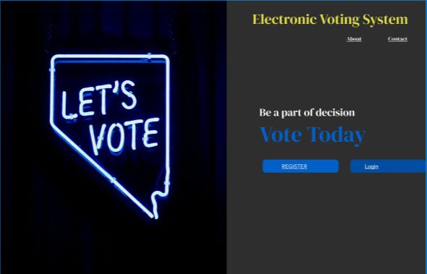Figure: 12

Interface Registration

This page contain the registration information of a voter, Voter has to enter the valid credentials to begin the process

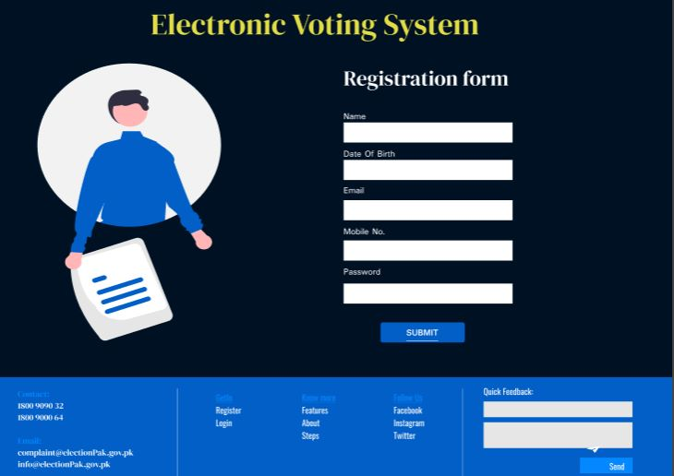Figure: 13

Interface Login
This page contains the login information, voter can access this page after fully registering the System.

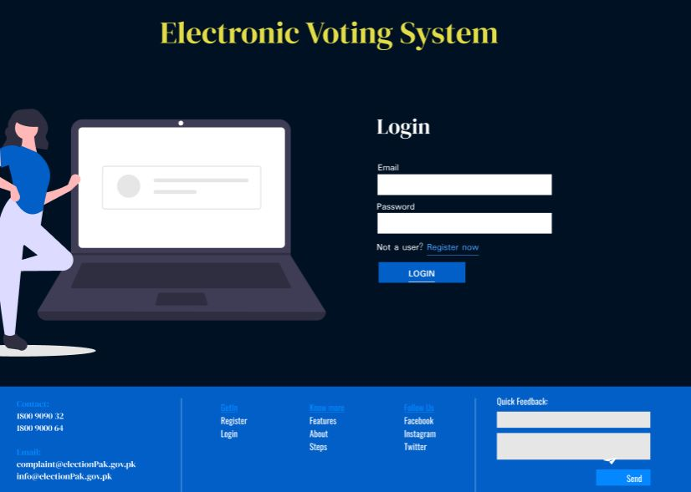Figure: 14

Interface Personal Data

Once the voter has log into the system, he’ll be given all of his details by Election commission before voting.

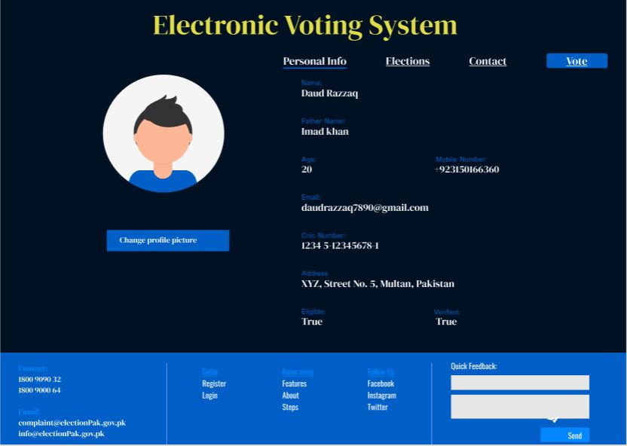Figure:15

Interface Election Type
Now comes the main vote selection page of the system, where voter can select the desired party to vote.

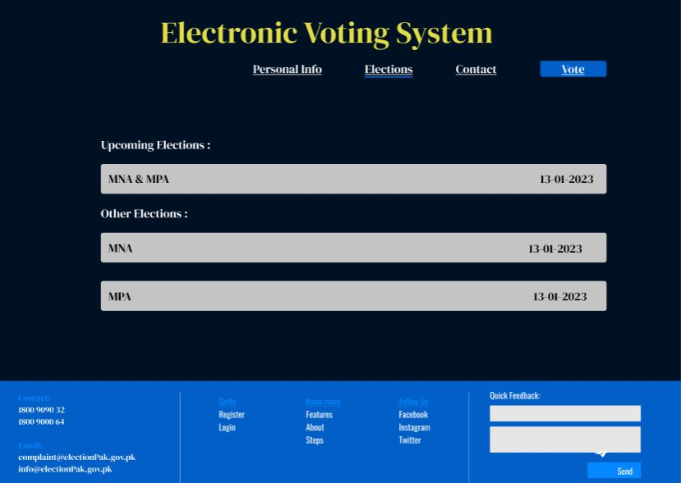
Figure: 16

Interface for Attention

Now there’s a need for a strong agreement by the voter. After this he/she will get the voting interface.

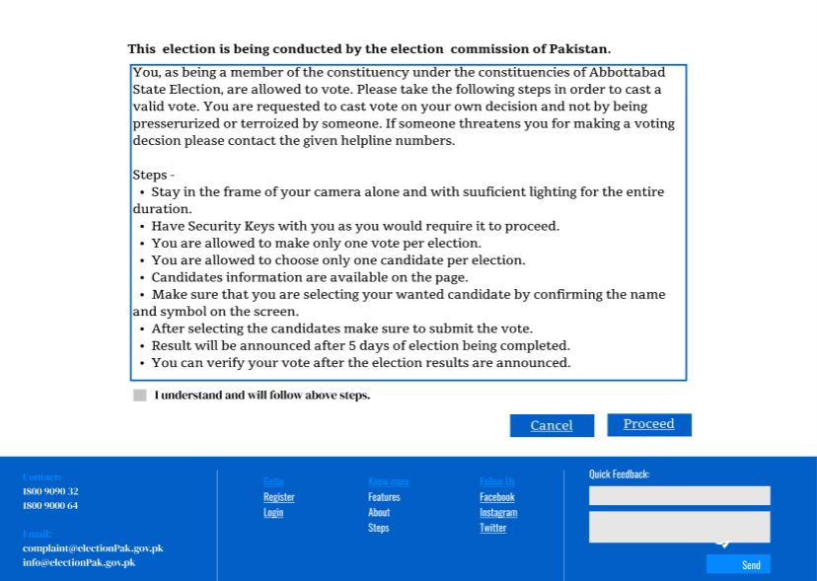
Figure: 17

Interface Cast Vote
Voter is now able to cast vote against the desired candidate through some selections.

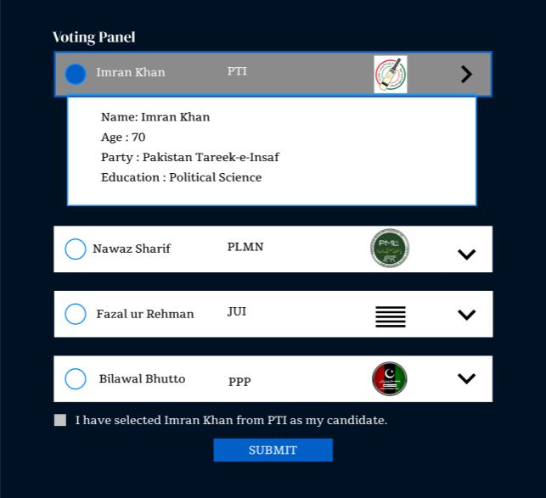

Interface About

Here’s the last and informative about page of an EVS.

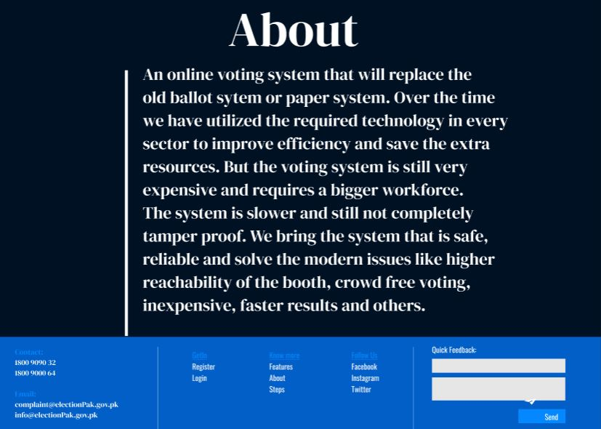

Figure: 19

Link to reach the interfaces:
https://www.figma.com/file/7Tgo6Jl36pWWQxAyuwYRuN/login-(Community)?node-id=152%3A307&t=AA9GwbmjVNeorcHJ-1
- Testing and Evaluation
Black Box Testing:
Black box testing involves testing a system with no prior knowledge of its internal workings. A tester provides an input, and observes the output generated by the system under test. There were several test case scenarios in performing black box testing of our project.
6.1. Test Case Scenarios and Test Cases
Test Case Scenarios of Electronic Voting System:

Scenario ID | Scenario Description
TCS_01 | Authenticate the registration functionality of EVS
TCS_02 | Validates the voter’s eligibility at the time of vote casting through voter’s credentials (Voter Id & OTP)
TCS_03 | Search a particular candidate through candidate’s name &P.party on search bar
TCS_04 | Confirm the right voting details at the time of casting vote
Table: 04
For TCS_01
Test Cases | Description | Pre-Condition | Test input | Expected outcome | Actual outcome | Status
TC_01 | Enter the correct CNIC & D.O.B | Valid URL | - CNIC  - D.O. B | Successful Registration | Successful Registration | Pass
TC_02 | Enter the correct CNIC & incorrect D.O.B | Valid URL | - CNIC  - D.O.B | Unsuccessful Registration | Unsuccessful Registration | Pass
TC_03 | Enter the incorrect CNIC & correct D.O.B | Valid URL | - CNIC  - D.O.B | Unsuccessful Registration | Unsuccessful Registration | Pass
TC_04 | Enter the incorrect CNIC & incorrect D.O.B | Valid URL | - CNIC  - D.O.B | Unsuccessful Registration | Unsuccessful Registration | Pass
Table: 05

For TCS_02
Test Cases | Description | Pre-condition | Test Input | Expected outcome | Actual outcome | Status
TC_01 | Enter correct Voter id & OTP | Successful  Login | -Valid id  -OTP | Verified eligibility | Verified eligibility | Pass
TC_02 | Enter correct Voter id & incorrect OTP | Successful  Login | -Invalid id  -OTP | Unverified eligibility | Verified eligibility | Fail
TC_03 | Enter incorrect Voter id & correct OTP | Successful  Login | -Invalid id  -OTP | Unverified eligibility | Unverified eligibility | Pass
TC_04 | Enter incorrect voter id incorrect OTP | Successful  Login | -Invalid id  -OTP | Unverified eligibility | Unverified eligibility | Pass
Table: 06

For TCS_03
Test Cases | Descriptions | Pre-conditions | Test input | Expected Outcome | Actual Outcome | Status
TC_01 | Search correct candidate’s name &P.Party | -Successful login  - Verified eligibility | -Candidate name  - P.party | Search  Successful | Search  Successful | Pass
TC_02 | Search correct candidate’s name & incorrect P.Party | -Successful login  - Verified eligibility | -Candidate name  - P.party | Search  Unsuccessful | Search  Unsuccessful | Pass
TC_03 | Search incorrect candidate’s name & correct P.Party | -Successful login  - Verified eligibility | - Candidate name  - P.party | Search  Unsuccessful | Search  Successful | Fail
TC_04 | Search incorrect candidate’s name.. | Successful login  - Verified eligibility | Candidate name  - P. party | Search  Unsuccessful | Search  Unsuccessful | Pass
Table: 07

For TCS_04

Test Cases | Description | Pre-condition | Test input | Expected outcome | Actual outcome | Status
TC_01 | Select the valid E.type& constituency | -Login | -E.Type  -Constituency | Confirmed Selection | Confirmed Selection | Pass
TC_02 | Select invalid E.type& valid constituency | -Login | -E.Type  -Constituency | Unconfirmed Selection | Unconfirmed Selection | Fail
TC_03 | Select valid E.type& invalid constituency | -Login | -E.Type  -Constituency | Unconfirmed Selection | Unconfirmed Selection | Fail
TC_04 | Select invalid E.type& invalid constituency | -Login | -E.Type  -Constituency | Unconfirmed Selection | Unconfirmed Selection | Fail
- Conclusion and Future Work

In Conclusion, Online voting system is a most significant technology and the progress over the year to provide voter a better voting experience and will continue to do so. People have speculated that online voting will overcome the urge and difficulty to vote physically. While online voting systems have the potential to increase accessibility and convenience for voters, it is important to ensure that the security and integrity of the system are maintained in order to ensure that the results of an election are accurate and can be trusted by all parties involved.

Future Work

Electronic voting, to be successful, requires a more transparent and secure approach, than is offered by current protocols. Improvements must be made for a system to become more efficient and dependable. As a result, we intend to migrate this system to a cloud-based ERP solution. This online system will allow voters to cast their ballots in a variety of technological means, including mobile phones, home computers, Internet cafés, and Kiosk machines, allowing the voter to vote from any location, inside the city, or even outside the nation, using his secret ID and password. Every system will be connected to the main server through the internet, allowing several users to vote at the same time. In online voting all the voting results throughout the country can be calculated in Central Count System at a time and displayed on Election Management Sites.
- References:

- https://www.google.com/url?sa=t&rct=j&q=&esrc=s&source=web&cd=&cad=rja&uact=8&ved=2ahUKEwj8-YOyhL38AhVPQaQEHQsuBmMQFnoECCYQAQ&url=https%3A%2F%2Fkuorum.org%2Fen%2Fe-voting%2F5-reasons-to-implement-electronic-voting-in-your-organization%2F&usg=AOvVaw1dg9zNeDhOkoJavsn1SuvQ (Main idea)
- https://www.aaas.org(Future of E-Voting)

- https://www.google.com/url?sa=t&rct=j&q=&esrc=s&source=web&cd=&cad=rja&uact=8&ved=2ahUKEwjG5-78hL38AhXTVaQEHXaOBjwQFnoECAoQAQ&url=https%3A%2F%2Fwww.geeksforgeeks.org%2Fsoftware-engineering-sdlc-v-model%2F&usg=AOvVaw1o07l_ap_h7WgI5sKLC3HS (V-MODEL)
- Appendices:

9.1 Further Test Case Scenarios:

TCS_05 | Validates the profile approval functionality of candidates (to be voted)
TCS_06 | Shows the results at the Result page

(P_id is the personal ID given to the candidates by Election Committee)
For TCS_05
Test Case | Description | Pre-condition | Test Input | Expected outcome | Actual outcome | Status
TC_01 | Enter correct Name, CNIC, & PID | Valid URL | - Name  - CNIC  - P_ID | Approved candidate | Approved candidate | Pass
TC_02 | Enter correct Name and incorrect CNIC, & PID | Valid URL | - Name  - CNIC  - P_ID | Disapproved candidate | Disapproved candidate | Pass
TC_03 | Enter incorrect Name, correct CNIC, & PID | Valid URL | - Name  - CNIC  - P_ID | Disapproved candidate | Approved candidate | Fail
TC_04 | Enter incorrect Name, incorrect CNIC, & PID | Valid URL | - Name  - CNIC  - P_ID | Disapproved  candidate | Disapproved candidate | Pass

For TCS_06
Test Case | Description | Pre-condition | Test input | Expected outcome | Actual outcome | Status
TC_01 | Voting is closed & E.C has approved it | -Login  -Show results | -Voting status  -Result approval | Shown Results | Shown Results | Pass
TC_02 | Voting is not closed & E.C has approved it | -Login  -Show results | -Voting status  -Result approval | Not shown Results | Not shown Results | Pass
TC_03 | Voting is closed & E.C has not approved it | -Login  -Show results | -Voting status  -Result approval | Not shown Results | Not shown Results | Pass
TC_04 | Voting is not closed & E.C has not approved it | -Login  -Show results | -Voting status  -Result approval | Not shown Results | Not shown Results | Pass

9.2. DFD
Description:
Level 2 Process 1
The very first process in the DFD level 2 diagram is Login. The unregistered voters enter the valid CNIC and D.O.B to get into the system, the admin checks the details from Citizen’s database and then the verification process starts. E. Commission provides the voters with unique voter_id which is used to login and before casting vote.
The registered voter enters his/her voter_id and strong password for the successful login.

