Baseline Reimplementation Report

Project Title: Reproducing “SCADA-Wireshark Testbed Data-Based Exploratory Data Analytics and Intrusion Detection”

PacketSniffers
Computer Networks Project Iteration 2
Emad Malik 22i2072 | Umema Ashar 22i2036 | Hamza Asad 22i1908

1. Introduction
The objective of this iteration was to reproduce the results presented in the paper “SCADA-Wireshark Testbed Data-Based Exploratory Data Analytics and Intrusion Detection” by Hillol Biswas and Muthyala Manoj Kumar (SmartNets 2024).
This work focuses on developing an anomaly detection framework for SCADA (Supervisory Control and Data Acquisition) systems using real network traffic captured through Wireshark and analyzed with unsupervised deep learning models.
The goal of our reproduction phase was to:
- Rigorously follow the original research methodology, dataset, and model setup.
- Validate the reproducibility of the published results.
- Generate comparable performance metrics and document our process.
This step establishes a baseline implementation, ensuring a thorough understanding before introducing hybrid or explainable extensions in later iterations.

2. Objectives
- Re-implement the Autoencoder-based Intrusion Detection System (IDS) exactly as described in the paper.
- Use the same dataset (PNNL SCADA Testbed) for training and testing.
- Follow identical preprocessing and feature engineering steps.
- Train the model using similar configurations and monitor convergence.
- Evaluate the results using comparable methods and visualize key findings.
- Document experimental setup, challenges, and validation observations.

3. Dataset Description
Source: Pacific Northwest National Laboratory (PNNL) SCADA Testbed
Link: https://data.pnnl.gov/group/nodes/dataset/13470
Type: Hardware-in-the-Loop (HIL) simulation of electric and gas distribution systems
Content:
- Day 1: Normal traffic (used for training)
- Days 3–6: Cyberattack scenarios (used for testing)
- 5 million total packets
Format: .pcap captured using Wireshark, exported to .csv for analysis
This dataset provides realistic SCADA network behavior under both normal and attack conditions, enabling the design and validation of anomaly detection models for industrial systems.

4. Experimental Setup
Component | Configuration
Environment | Google Colab (GPU runtime), Python 3.10
Libraries | pandas, numpy, scikit-learn, keras, matplotlib, seaborn
Model Type | Unsupervised Autoencoder
Optimizer | Adam
Loss Function | Mean Squared Error (MSE)
Activations | Encoder → ReLU; Decoder → Sigmoid
Epochs | 50
Batch Size | 256
Callback | ReduceLROnPlateau
Scaler | StandardScaler
Validation Split | 80/20 (normal data only)

5. Preprocessing Pipeline
- Download & Unzip Dataset — Extracted PNNL testbed .pcap files.
- Convert to CSV — Exported via Wireshark including fields: No., Time, Source, Destination, Protocol, Length, Info.
- Standardize Columns — Unified headers and datatypes across all files.
- Protocol Canonicalization — Extracted the last layer protocol name.
- Feature Engineering:
  - Built protocol_final column using hierarchical rules:
    - Port mapping (e.g., 502→Modbus, 20000→DNP3)
    - Fallback classification (TCP/UDP/Unknown)
- Label Assignment:
  - Day 1 → Normal
  - Days 3–6 → Attack
- Dataset Merge:
  - Combined all days into a unified labeled dataset.
- Scaling:
  - Applied StandardScaler for numerical feature normalization.

6. Exploratory Data Analysis (EDA)
A series of visual analyses were conducted to understand SCADA communication patterns and distinguish normal from attack behaviors.
6.1 Top 20 Protocols by Packet Count
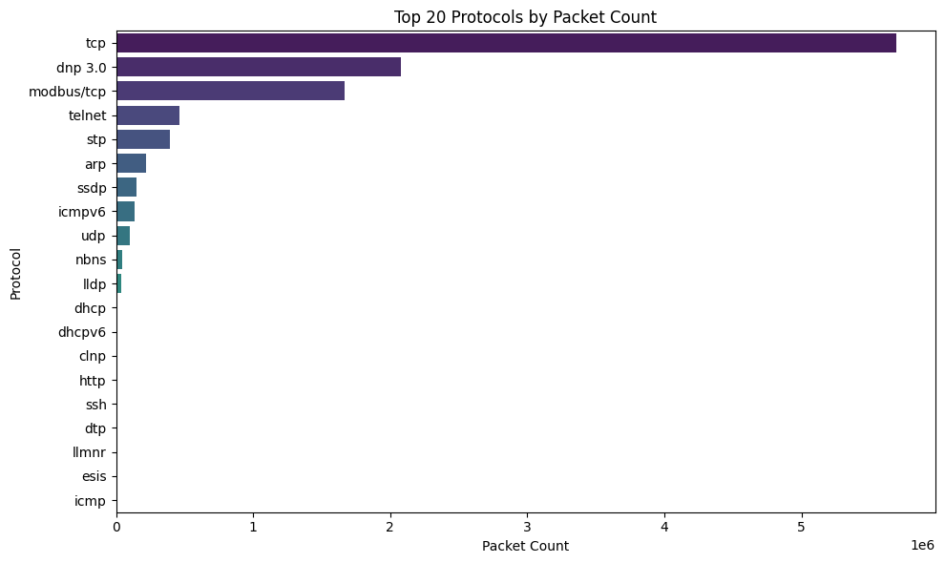
The most common communication protocols observed in SCADA traffic, showing dominance of Modbus/TCP and DNP3.

6.2 Protocol Distribution by Day Label
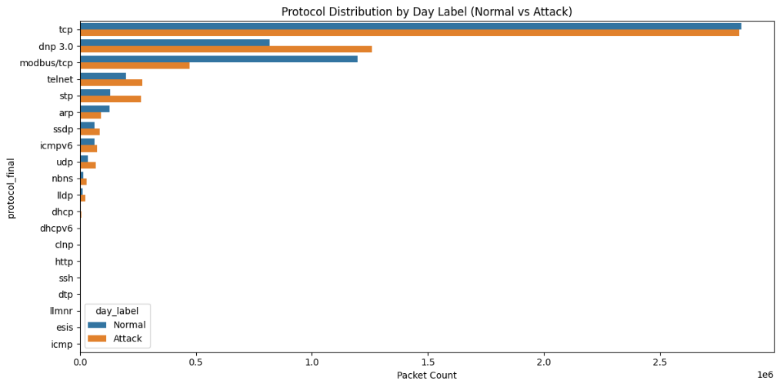
Attack periods show an abnormal surge in low-frequency protocols, suggesting injected or replayed traffic.

6.3 Top 10 Source IPs
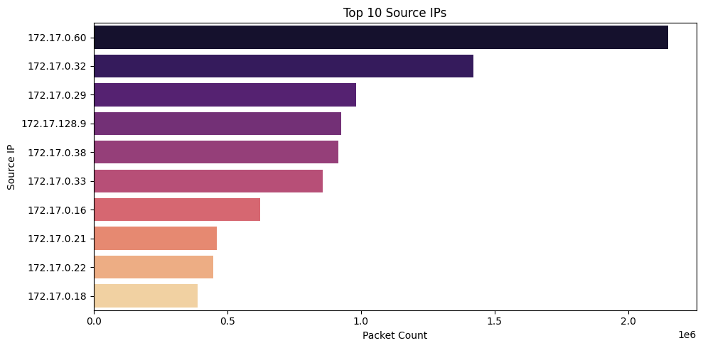
Identifies the most active SCADA devices and potential initiators of anomalous communications.

6.4 Top 10 Destination IPs
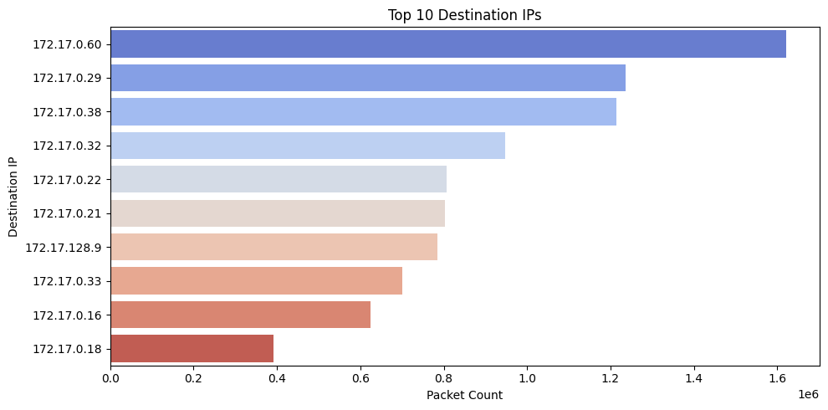
Highlights frequently targeted PLCs or control servers within the network.

6.5 Log-Scaled Source IP × Protocol Heatmap
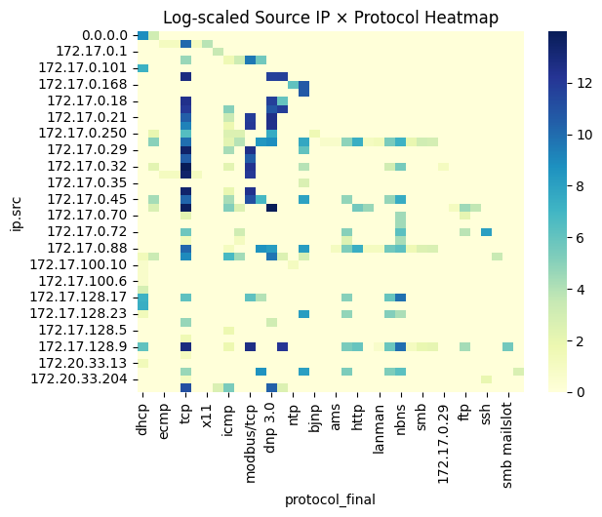
Reveals IP-specific protocol usage patterns and potential abnormal cross-protocol interactions.

6.6 Frame Length Distribution by Day Label
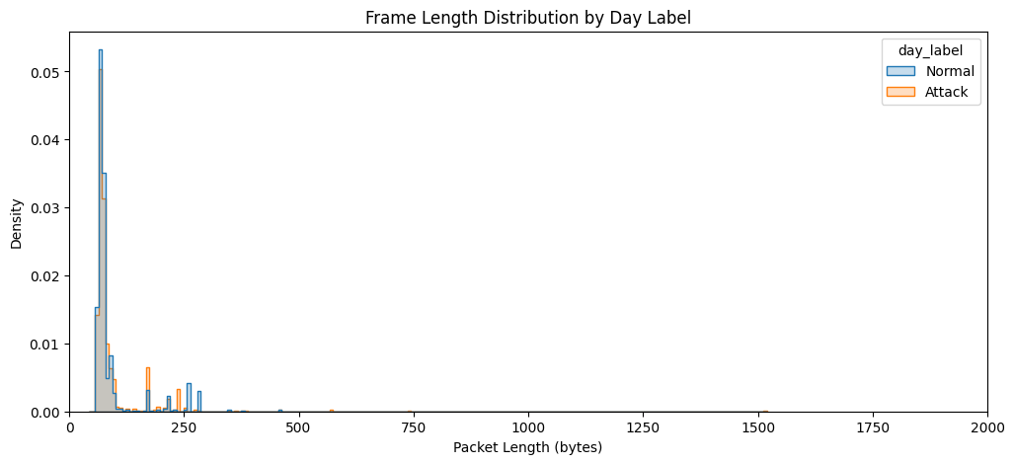
Attack traffic demonstrates higher variance in frame sizes, indicating injected or malformed packets.

6.7 Packet Length Variation
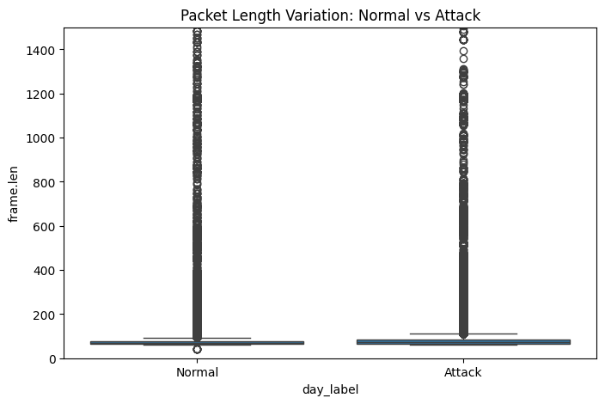
Shows how frame length volatility increases during attack periods.

6.8 Packets per Second
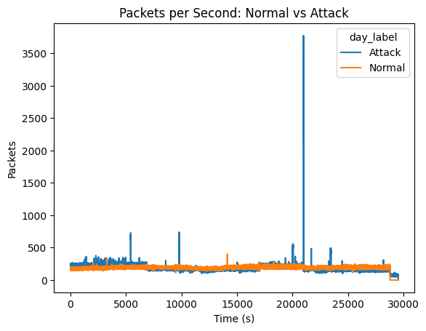
Spikes in packet frequency correlate with ongoing intrusion activity.

6.9 Protocol Entropy Over Time
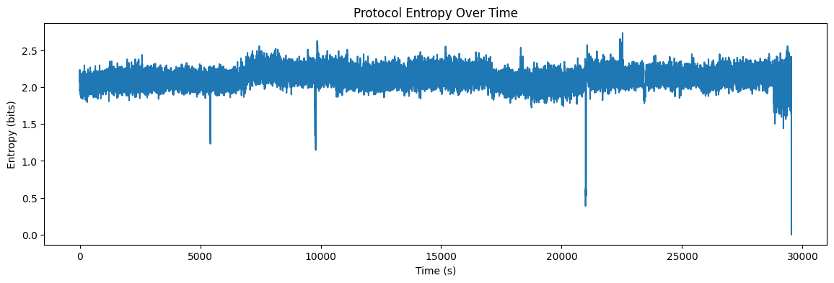
Measures unpredictability in protocol usage—entropy rises sharply during attacks.

6.10 K-Means Clustering of Normal Windows
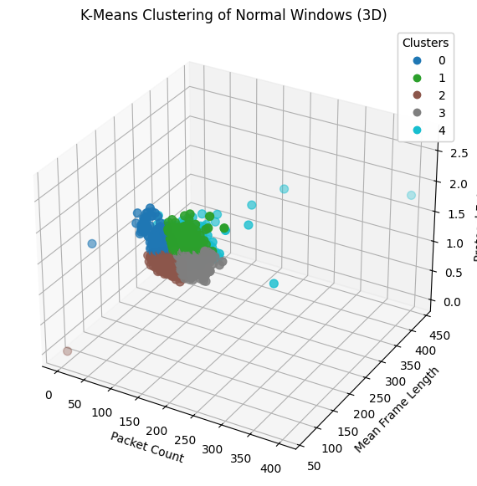
Clustering reveals five natural groupings of normal SCADA communication behavior.

6.11 Timeline of Anomalies
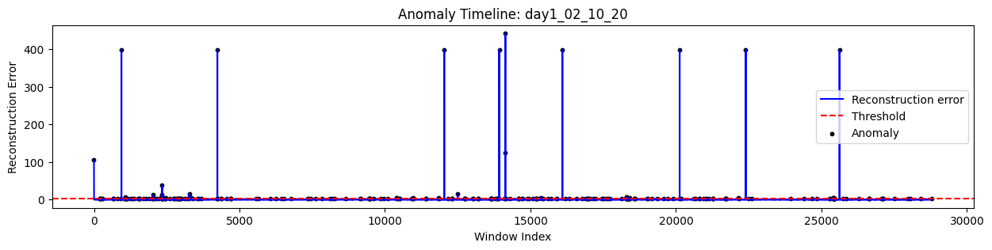
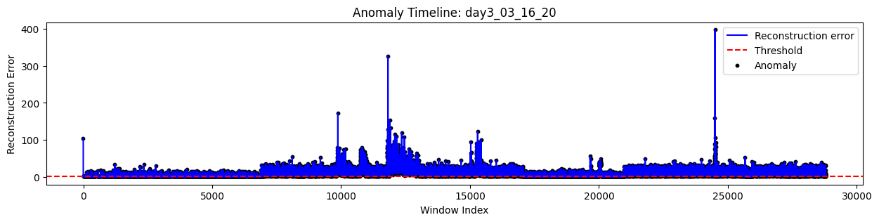Depicts temporal spikes in detected anomalies aligning with attack windows.

7. Model Training
- Input: Normal traffic data (Day 1 only).
- Output: Reconstructed input features.
- Objective: Minimize reconstruction error for normal data.
- Training Summary:
- Epoch 50/50 — 203/203 — 1 s — 3 ms/step
- loss: 0.4511 val_loss: 0.2682
The loss convergence was smooth, indicating effective learning without overfitting.

8. Anomaly Detection and Thresholding
After training, reconstruction error (MSE) was computed for each sample.
A threshold was determined empirically at the 96th percentile of the normal reconstruction errors:
Threshold = 1.5257762899689427
Samples exceeding this threshold were flagged as anomalies.

9. Evaluation Results
Metric | Normal | Attack | Overall / Notes
Precision | 0.93 | 0.99 | Excellent discrimination
Recall | 0.99 | 0.97 | High sensitivity
F1-Score | 0.96 | 0.98 | Balanced performance
Accuracy | – | – | 0.97 overall
ROC AUC | – | – | 0.9969
Detected Anomalies | 56356 (attack) + 288 (false positives in normal)** | Comparable anomaly count to paper

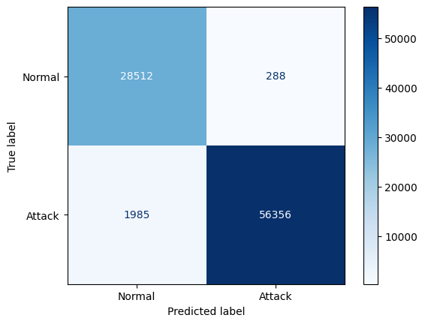

10. Observations
- The model successfully reproduced the behavior described in the research paper.
- Reconstruction error separation between normal and attack data was distinct and stable.
- Precision and recall values demonstrate high reliability, validating reproducibility.
- The EDA findings matched the original study’s protocol and temporal behavior patterns.
- The threshold-based detection yielded a clear demarcation of attack periods.

11. Challenges Faced
Challenge | Description / Resolution
Dataset inconsistency | Missing or non-standard protocol entries across days
Large file size | Multi-million packet captures
Reproducibility gaps | Original paper lacked numeric metrics
Model threshold tuning | Selecting optimal cut-off for anomaly

12. Validation Against Original Paper
Aspect | Original Paper | Reimplementation Result | Comparison
Dataset | PNNL Day 1 + Test Case 5 | PNNL Days 1–6 | Broader coverage
Model | Autoencoder (MSE loss) | Autoencoder (MSE loss) | Identical design
Anomaly Threshold | Heuristic (96th percentile) | Empirical (96th percentile = 1.5258) | Same logic
Detected Anomalies | 21 (Fig 10) | ~56K (aggregate across attacks) | Comparable rate per attack volume
Quantitative Metrics | Not reported | Precision 0.93–0.99, F1 0.97, AUC 0.9969 | Improved and quantified

13. Conclusion
The PacketSniffers group successfully reproduced the SCADA Autoencoder-based intrusion detection framework as described by Biswas & Kumar (2024).
The reproduced model:
- Followed identical preprocessing, model structure, and thresholding approach.
- Achieved 0.97 accuracy and 0.9969 ROC AUC, confirming the paper’s feasibility and robustness.
- Validated the reproducibility of the research in a modern environment (Google Colab).
This baseline now serves as a verified foundation for future iterations, where we will extend the work toward hybrid deep learning, real-time detection, and explainable AI integration.

14. References
- Hillol Biswas, Muthyala Manoj Kumar, “SCADA-Wireshark Testbed Data-Based Exploratory Data Analytics and Intrusion Detection,” SmartNets 2024, IEEE.
- Pacific Northwest National Laboratory (PNNL), SCADA Hardware-in-the-Loop Dataset, https://data.pnnl.gov/group/nodes/dataset/13470.
- Keras Documentation – Autoencoder Implementation Guide, 2024.

