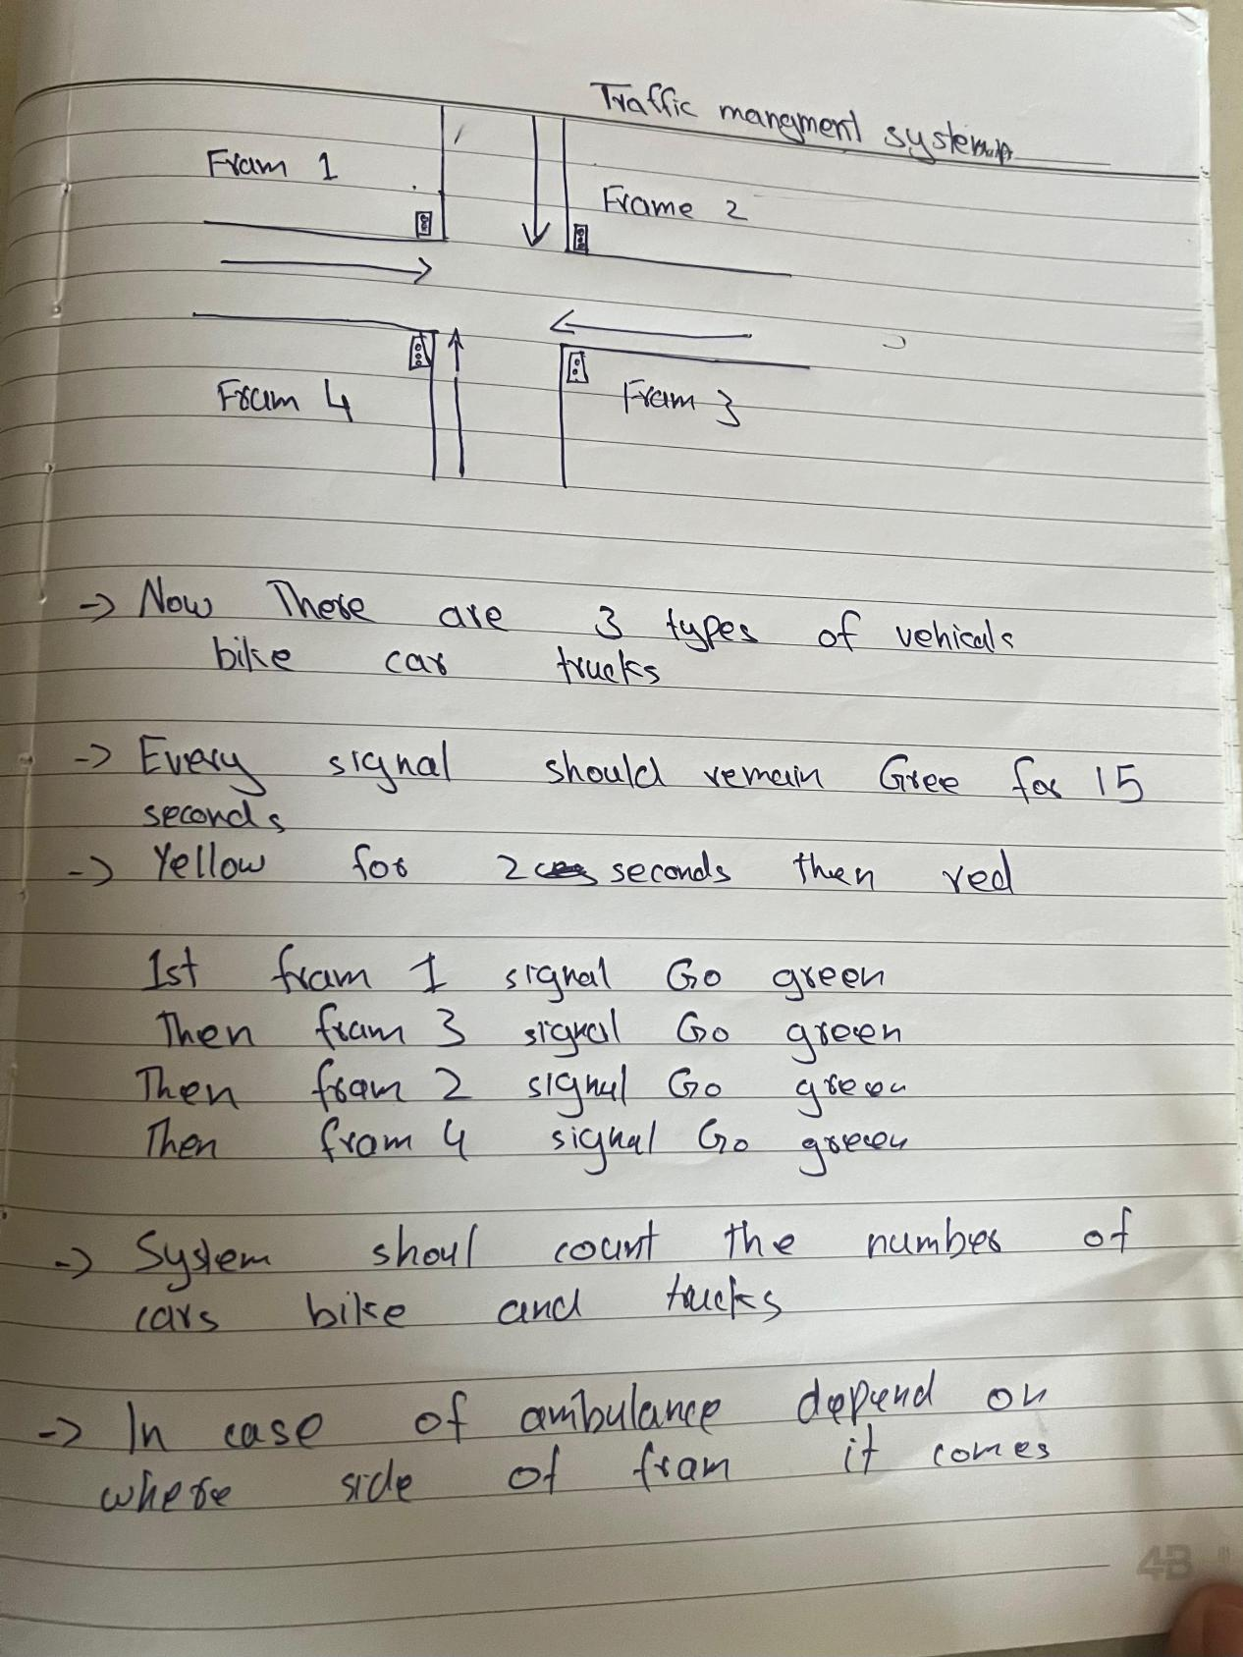

## ****Traffic Management System – Final Description****

This Python program simulates a **4-way traffic signal system** (Frames 1, 2, 3, 4) with the following features:

### ****1. Traffic Light Behavior****

There are **4 frames (roads)**: **Frame 1, Frame 2, Frame 3, and Frame 4.**

Traffic lights operate in a **fixed sequence**:

**Frame 1 → Frame 3 → Frame 2 → Frame 4**

Each signal has:

**GREEN** for **15 seconds** – vehicles are allowed to pass.

**YELLOW** for **2 seconds** – warning before the signal turns red.

**RED** – traffic is stopped for that frame while another frame turns green.

### ****2. Vehicle Types****

The system handles **three types of vehicles**:

**Motorbikes** (light vehicles)

**Cars** (medium vehicles)

**Trucks** (heavy vehicles)

Vehicles are **randomly generated** for each frame and added to a queue, waiting for the green light.

**3 Role of the Decorator**

The decorator is used to automatically log every time a traffic light changes its state. Instead of writing a print statement each time the method is called, the decorator wraps this method and records the old and new light states. This keeps the code cleaner, avoids repetition, and ensures that every signal change is consistently tracked.